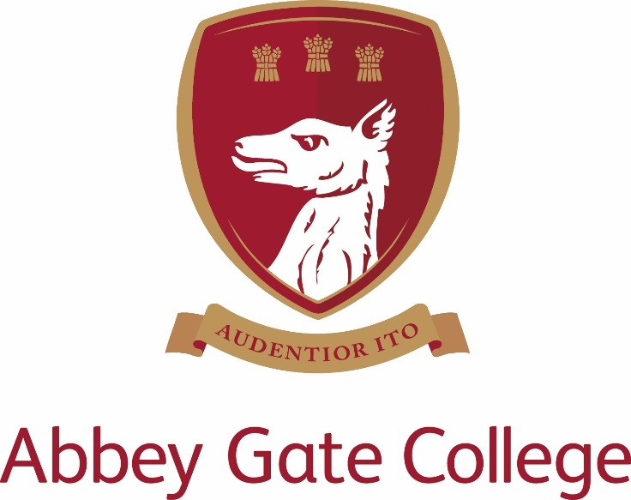
Key Stage 1 Teacher
(Temporary contract- until 31 August 2020)
Required from as soon as possible

TO START AS SOON AS POSSIBLE

Abbey Gate College – Year 2 Class Teacher

(Temporary contract until 31 August 2020)

The College

Abbey Gate College is situated in superb surroundings south of the historic city of Chester. It was founded as an independent coeducational 11-18 School in 1977 under the Deeside House Educational Trust, as a charitable foundation. Our Infant and Junior School is sited at Aldford, 2½ miles from the main site at Saighton. The College now numbers circa 480 pupils, including a Sixth Form. Academic results in all subjects are excellent and 100% pass rate at A level and GCSE is the norm. The majority of our Sixth Form students go on to university or other place of further education. The College has a three form entry at Year 7 from an annual Entrance Examination held in January; places are oversubscribed and there are waiting lists operating at some age groups in the College.

The Infant and Junior School is an integral part of Abbey Gate College and is located close to the Senior School in the beautiful village of Aldford. There is a robust ‘can do’ where parents and staff work together to give children the very best educational opportunities, be they academic, cultural, artistic or sporting. Pupils are encouraged to be ambitious for themselves and, as such, routinely make excellent progress.

The Post

We are seeking a dynamic and committed full time teacher of Year 2 to join our enthusiastic department. We require the candidate to start with us as soon as possible.

The Year 2 teacher will be responsible for teaching the Year 2 curriculum and coordinating Science throughout the school. The successful applicant will be an enthusiastic and capable practitioner with excellent teaching skills and the ability to foster positive relationships with the whole school community.

Key Stage One:

At Abbey Gate College Infant and Junior School we base our teaching on the English National Curriculum, which we adapt to suit the needs of our pupils. The Year 2 teacher is responsible for delivering the majority of the curriculum with French, music and PE being taught by subject specialists.

Key responsibilities:

- To manage and deliver the teaching of Year 2.
- To coordinate, monitor and develop the delivery of Science throughout the school.
- To maintain and manage a caring, supportive, purposeful and stimulating environment which is conducive to children’s learning.
- To promote learning and celebrate achievement through bright, varied and up to date class displays.
- To plan, prepare and deliver high quality, differentiated lessons across the curriculum in line with the Junior Schemes of Work.
- To plan opportunities to develop spiritual, moral, social and cultural aspects of pupils’ learning.
- To enable pupils to develop and maintain positive attitudes towards learning.
- To monitor and be responsible for the progress of individual students, including thorough marking, assessment, recording and reporting.
- To implement strategies to support MAT, SEND and EAL pupils in the classroom.
- To promote high standards of behaviour and discipline among the pupils, safeguarding their health and safety.
- To attend and participate in staff meetings, briefings and planning meetings, INSET days and to share in a range of supervisory duties throughout the day.
- To ensure that school policies are reflected in daily practice.
- To promote strong relationships with parents and carers, communicating with them about all aspects of their child’s education – academic, social and emotional.
- To attend parents’ evenings and information evenings.

Key qualities and person specification:-

The person appointed should demonstrate the following skills and qualities:

Essential:
- Experience of teaching Year 2
- Inspirational teacher
- Enthusiastic, innovative and creative teacher with a commitment to the extra-curricular life of the school
- Committed to raising standards and monitoring pupil progress
- Act as a good role model to staff and pupils
- Have outstanding professional and personal qualities
- Caring, supportive and willing to adapt their teaching to suit the educational and pastoral needs of the pupils
- Excellent standard of Literacy and Numeracy skills
- Interest in and knowledge of Science
- Proficient with the use of ICT in the classroom
- Show good planning skills
- Well organised
- Calm under pressure
- Knowledge of safeguarding procedures

Desirable:
- Experience of outdoor learning
- Experience of leading a subject area

Salary, Terms and Conditions
Core school hours when all teaching staff are expected to be in work are currently 8.30am-4.00pm each day, plus a proportional share of pastoral duties.
Periods of non-contact time for PPA is included in the weekly timetable and may differ for individual staff.
The salary for this position will depend upon the qualifications and relevant experience of the successful candidate.

Child Protection
Abbey Gate College regards as paramount the welfare and safety of children. Whilst criminal convictions are not necessarily a bar, this safety consideration will be key to all decisions regarding the employment of staff, approval of volunteers and standards of external contractors.

Equal Opportunities
We are committed to treating all employees with dignity and respect regardless of race, ethnic background, nationality, colour, gender, transgender status, pregnancy, age, sexual orientation, religion or belief. We therefore welcome applications from all segments of the community.

Applications
Candidates should complete an Abbey Gate College Application Form and submit this together with a letter to Marie Hickey explaining their interest in and suitability for the post.

The closing date for applications is Sunday 1 September 2019; interviews scheduled for Tuesday 10 September 2019.

The interview process will include; the candidates will meet the Headmistress, Head of the Infant and Junior School and have a tour of the Infant and Junior School. Candidates will be asked to prepare and deliver a Year 2 English lesson.

References will be taken up prior to interview, please inform your referees.

Please send your application electronically by email to: - rebecca.upton@abbeygatecollege.co.uk

All details of the College Privacy Notice can be found on the College website at www.abbeygatecollege.co.uk

