WISDOM
HOPE
COMMUNITY
DIGNITY
EQUALITY
Information pack for candidates

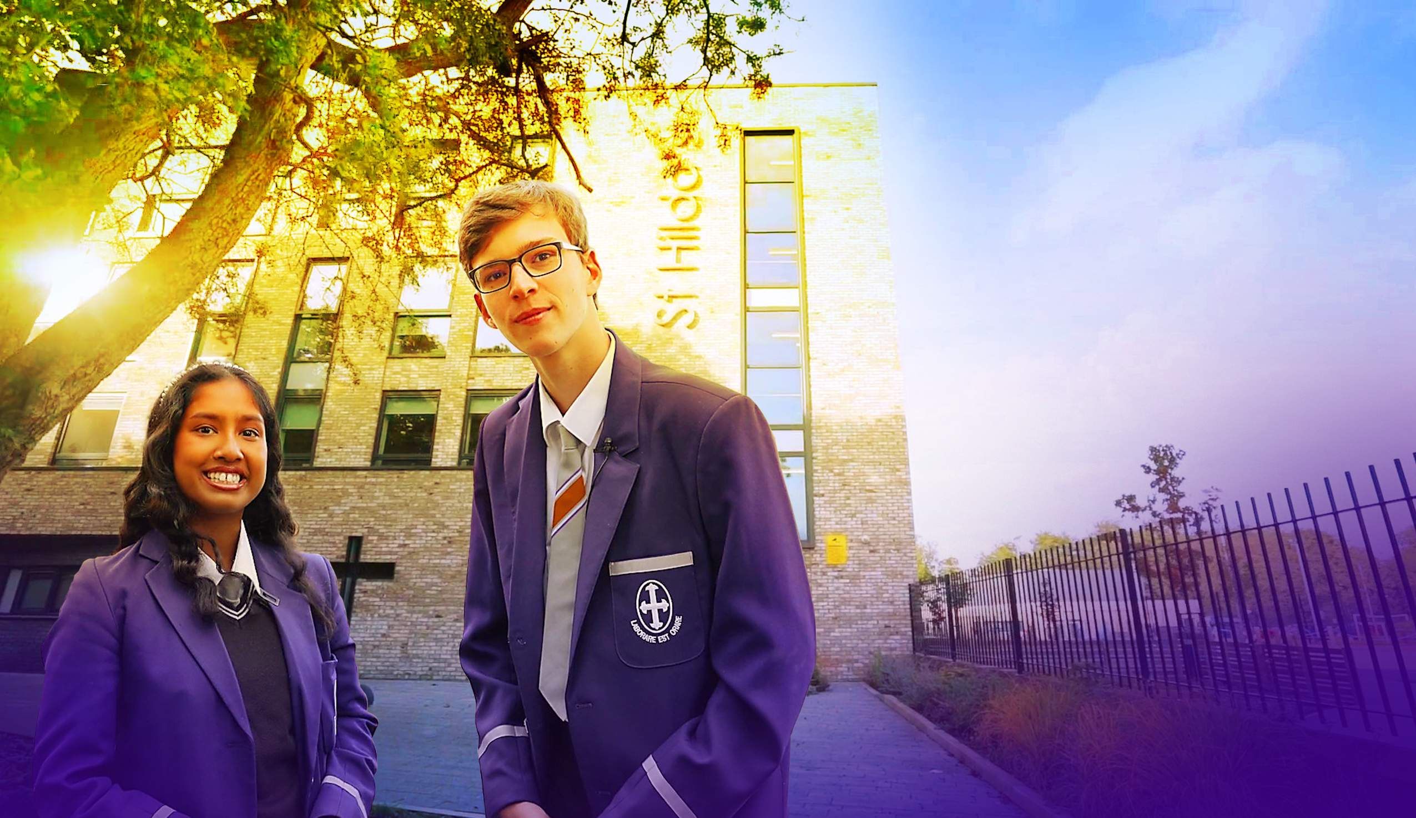

Welcome



Dear Candidate
Many thanks for your interest in St Hilda's and the post of Trauma Informed Mentor.
St Hilda's is unique. St Hilda’s is a family. We are the only co-educational Church of England school in Liverpool in key stages 3 and 4. We welcome students and their family from a Christian background, from other faiths and those who have no faith. Each individual is precious.
Although our reputation in the community is excellent, this does not mean that we do not look for opportunities to improve who we are and what we do. We live by our values and are educating for 'wisdom, hope, community, dignity and equality'. Students helped to choose our 5th value of equality. We changed to a house system to promote a sense of belonging in each of our students and members of staff. Our smaller House families come together to form the larger St Hilda’s family. We chose our 5 Houses very carefully. Each one of these inspirational people embody our values and have helped to shape Liverpool. We speak in more detail about Margaret Aspinall, Gee Walker, Kitty Wilkinson, John Brodie and William Roscoe on our website.
We believe in student voice, in student leadership and in high expectations. Our behaviour systems focus on a Chance to Change and we work hard in ensuring we support our students in making the right decisions, ready to take their place in our society. Our SlAMS Report in March 2017 graded us as outstanding across all areas, and our more recent Keeping on Track report in December 2019 states’ The strong, vibrant and inspirational vision, which proudly celebrates Christ as the cornerstone of this nurturing, inclusive and flourishing school, genuinely lies at the heart of this Christian community.’ We are unashamedly a Christian school.
Our most recent Ofsted report graded us as Good in 2021. Ofsted reported that ‘Pupils, including those students in the sixth form, are full of praise for this school. They feel that it is a happy and safe place to be. Pupils said that staff support them to thrive as individuals.’…‘Leaders, governors and staff have high ambitions for all pupils. They do all that they can to help pupils do well in school and to be prepared for their future lives. Pupils, including those students in the sixth form, receive a strong quality of education and they achieve well. This includes those pupils with special educational needs and/or disabilities (SEND), and disadvantaged pupils.’
We are heavily oversubscribed, but this does not mean that we do not recognise that we can become even better. We are looking for someone who will join the St Hilda's family in the key position as Trauma Informed Mentor who champions all of our students, challenges where necessary and celebrates at every opportunity. You will support and develop the people in your team, ensuring all opportunities are taken to lead and share excellent practice. Your vision to support St Hilda's to the next level is paramount.
Academically, St Hilda's intake is above national average. However, our aspiration is that every single one of our students achieves or exceeds their potential, has exceptional pastoral support and has a wealth of opportunities to support their development. In this role, we are looking for a very special person with the vision and experience to help our vision become a reality. Is this you?
We welcome visits from prospective candidates, but this will not form part of the selection process.

I look forward to receiving your application if you believe that St Hilda's suits your career aspirations and you meet our criteria for selection. We are looking for a very special Trauma Informed Mentor whose vision can take the department to the next level.

Thank you for your time,

Mrs Jo Code, Headteacher

St Hilda’s CE High School
St Hilda’s CE School is an 11-18 co-educational Church of England school that sits on the fringe of Sefton Park in Liverpool. The school currently has 1100 Students. Due to parental demand for places at the school, from September 2018 we increased our Year 7 PAN from 150 to 170. We pride ourselves in being a fully inclusive school that serves our Diocese and beyond. Our vision encapsulates who we are as a school:
We are the St Hilda’s family, with Jesus Christ as our cornerstone.
Building on foundations of wisdom, hope, community, dignity and equality, we nurture and support each other to be or very best. We rejoice in our diversity and celebrate our many achievements.
St Hilda’s also has a sixth form. St Hilda’s College is an integral part of the school and last year, over 88% of Year 11 chose to continue their education at St Hilda’s. The College is growing year on year.
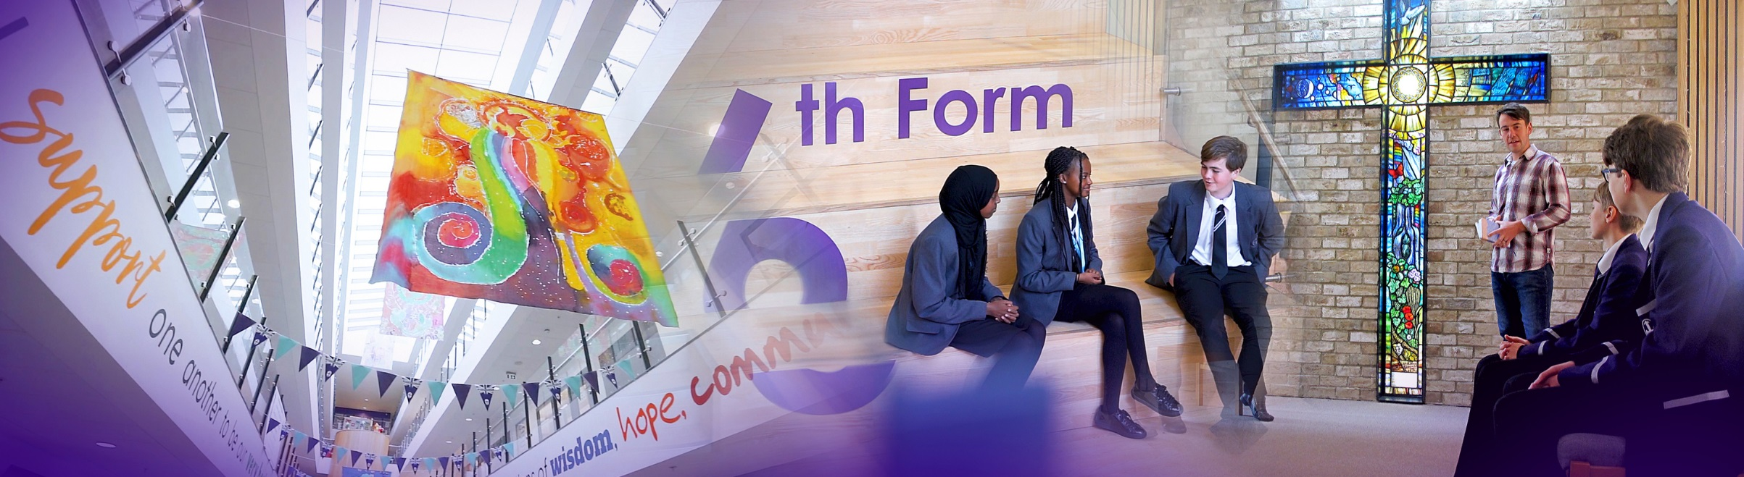

The new school buildings were opened in September 2015. We are incredibly proud of the excellent facilities we have, including excellent sports facilities. St Hilda’s College have dedicated areas in the school, including their own study rooms and café.
Our greatest asset at the school is our staff. St Hilda’s staff are incredibly generous with their time and support of each student. We have an incredibly low turnover of staff and we retain many of our NQTs and former students return to work here.
This is an exciting time to join the school and become part of a hard-working and committed team who embody our vision and values.
_________________________________________________________________________________
Senior Leadership Team
Jo Code, Headteacher
Lynne Noon, School Business Manager
Strategic Finance, Premises; Maintenance, Development and staffing, Health & Safety, School Calendar, Service Contracts and performance, Catering, Lettings.

Roy Bellmon, Deputy Headteacher, Curriculum, Admissions and Appeals, IT Strategy, PHSE.

Suzanne Harrison, Deputy Headteacher
DSL, Behaviour and Inclusion.

John Martin, Assistant Headteacher
Behaviour and Celebration, Deputy DSL, Behaviour support, Student Welfare, House System, Rewards and celebration.

Liz Cowdell, Assistant Headteacher
Curriculum- Teaching and Learning, CPD. Staff Appraisal; Teacher Targets; Mentoring/Support; T & L innovation and development, Development Thursdays.

Andrea Howard, Assistant Headteacher
St Hilda’s College.

Lisa Franks, Assistant Headteacher
SENCo, SEND, Looked after Children.

Carina Bird, Assistant Headteacher Academic Catch-up.
_______________________________________________________________________________

Liverpool

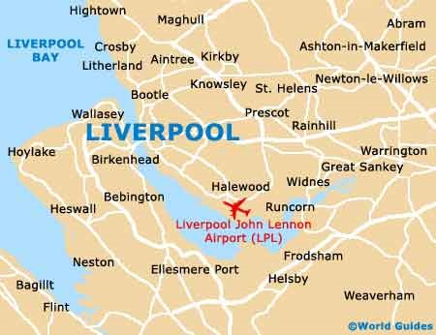
Liverpool is a city with unique attractions, exciting events, world class sport offerings, unrivalled musical heritage and a famously warm welcome!
Location and Transport Links
Liverpool enjoys superb communication links.
St Hilda’s CE School is located close to the M62 and other major roads. There are train and bus links to
St Hilda’s. Liverpool Lime Street train station is the main station serving the city of Liverpool. Liverpool Airport is less than 30 minutes away.
©Marketing Liverpool, Liverpool Docks 2
Facilities and Amenities
St Hilda’s CE School is close to the 3 universities in Liverpool. We are also close to Liverpool One;
a range of shops, bars, restaurants, cafes and a cinema. Speke Retail Park and Edge Lane Retail Park are also close by.
Liverpool has the largest collection of museums and galleries anywhere outside London. The city also has several hospitals, theatres, cinemas and numerous other cultural and leisure facilities. St Hilda’s CE School lies in South Liverpool, overlooking Sefton Park.
Housing and Accommodation
A range of accommodation options are available in the local area and there is a thriving rental market. The excellent transport links allow many staff at the school to live in outside of Liverpool. Help and advice can be given by the school if accommodation is required.
_________________________________________________________________________________

Job Description
Whilst every effort has been made to explain the main responsibilities and duties of the post, each individual task to be undertaken will not be identified. Employees will be expected to comply with any reasonable request from a manager to undertake work of a similar level that is not specified in this job description. The job description is current to the date shown but, in consultation with you, it may be changed by the Headteacher to reflect or anticipate changes in the job commensurate with the grade and job title.

Trauma Informed Practitioner

Working time: | Full Time Term time  2 years Fixed Term
Grade: | NJC Scale 5
Disclosure level: | Enhanced DBS
Working With: | Headteacher  SLT  SENCO  SEN Team  Pastoral Team  Mental Well-being Lead  Curriculum Leaders  Students  Parents/Carers
Reporting to: | Deputy Headteacher Behaviour & Inclusion

PURPOSE OF POST
- To identify, monitor and evaluate students’ specific barriers to learning and to support them
- To support teachers to develop strategies to support students with trauma, providing an additional and specialist resource to teachers, supporting adaptation for learners with identified support and education needs.
- To support all staff to develop the symbiotic relationship that exists between teaching and learning and pastoral care
- To ensure that the school’s ‘Chance to Change’ behaviour and safeguarding policies support the well-being of children with trauma and significant ACEs and support the school’s inclusive nature
- To lead the school in its development as a Trauma Informed School
- To review the Personal Education Plans (PEPs) of all looked-after children, supporting the Designated Teacher, ensuring that ambition is high and strategies and funding are in place to maximise learning.
- To work across a variety of areas including literacy, numeracy, behaviour support, organisation and social skills development, enhancing the development of confident and capable learners.
- To liaise with outside agencies to ensure support is in place for our students where needed.
- To provide holiday outreach/homework support.
- To lead on transition of students with trauma.
- To support attendance lead to promote excellent attendance.

POST RESPONSIBILITIES

Curriculum Provision & Development
- To assist curriculum leaders to develop strategies to ensure that all students can access their highly ambitious curriculum which meets the needs of all students, regardless of their individual needs.
- To develop key communication skills when supporting the education and well-being of students who suffer with trauma, which will benefit all students

Other

- Promote and support restorative practice approach across school
- To coordinate intervention referrals, ensuring that students receive the appropriate support which has impact
- To take part in the school’s staff development programme by participating in arrangements for further training and professional development.
- To lead personal development around trauma and attachment for school staff
- To continue personal development in the relevant areas including subject knowledge and teaching methods.
- To engage actively in the Performance Management Review process.
- To ensure the effective/efficient deployment of classroom support.
- To work as a member of a designated team and to contribute positively to effective working relations within the school.
- To regularly seek, engage with and act upon the latest pedagogical and subject-related research.

Communications
- To communicate effectively with the parents/carers of students as appropriate.
- Where appropriate, to communicate and co-operate with persons or bodies outside the school.
- To work with families/placements to ensure that students are well-supported in their education
- To follow agreed policies for communications in the School.
- To take part in marketing and liaison activities such as Open Evenings, Parents’ Evenings and liaison events with other schools.
- To contribute to the development of effective subject links with external agencies.

Student Support System
- To promote the school’s vision and values, the general progress and well-being of individual students
- To contribute to the preparation of PEP documentation for review meetings, action plans, progress files and other reports. To alert the appropriate staff to problems experienced by students and to make recommendations as to how these may be resolved.
- To communicate as appropriate, with the parents of students and with persons or bodies outside the School concerned with the welfare of individual students, after consultation with the appropriate staff.
- To contribute to our ‘Cornerstone’ Curriculum
- To support the ‘Chance to Change’ system so that effective learning can take place.

This job description is a guide to the duties and should be read in conjunction with the accompanying person specification.

This role involves contact with children and will be engaging in regulated activity relevant to children. This post is subject to an enhanced DBS disclosure check through the Disclosure & Barring Service.

In your letter of application, please demonstrate how you meet these criteria.
Do not include a curriculum vitae.
Candidates failing to meet any of the essential criteria will automatically be excluded.

[A]

Qualification requirements | Essential | Desirable | Source
Educated to Degree Level | E |  | A/I
Further study/qualification/s in the area of Trauma |  | D
Further professional development relevant to the post or a willingness to attend relevant training |  | D | A/I

- Experience
 | Essential | Desirable | Source
Previous experience teaching students with trauma | E |  | A/I/R
To have experience of developing strategies for school(s) to ensure inclusivity for all students | E
Evidence of appropriate professional development within trauma informed schools | E

- Knowledge/Understanding
 | Essential | Desirable | Source
Excellent knowledge and understanding of the National Curriculum for a broad range of subjects at the relevant Key Stages | E |  | A/I/R
Ability to target set, develop and employ criteria for measuring success and assessment for learning | E |  | A/I/R
To have worked in a trauma informed school |  | D | A/I/R
Experience of successfully supporting families and students with trauma or mental health problems |  | D

- Personal Qualities and Skills
 | Essential | Desirable | Source
To champion our students affected by trauma or mental health needs | E |  | A/I
Ability to enthuse and effectively communicate your subject to students both written and orally | E |  | A/I
To be able to communicate with students in a way that meets their individual needs | E |  | A/I
To be able to communicate with parents/carers to best support their child | E |  | A/I
A commitment to teaching in a comprehensive school where all students are valued regardless of their abilities and individual needs | E |  | A/I
Outstanding classroom practitioner with both personal impact and presence | E |  | A/I
The ability to deliver interventions within the daily classroom routine to support students with their individual needs | E |  | A/I
A demonstrable commitment to equality of opportunity | E |  | A/I
Appropriate ICT skills including those directly related to transference of subject knowledge in a classroom context | E |  | A/I
Committed to maintaining the high standards across the school | E |  | A/I
To be adaptable to the changing needs of students throughout the school day | E |  | A/I
A team player | E |  | A/I
The ability to deploy support staff when needed to best support our students | E |  | A/I
To be resilient and to be able to support students no matter their needs | E |  | A/I
To be confident in implementing new ideas that best support the students and teaching and learning across the school | E |  | A/I
Ability to develop and maintain good professional relationships with students, staff and parents | E |  | A/I
A strong commitment to one’s own professional development | E |  | A/I
A willingness to become involved in wider School initiatives and activities | E |  | A/I

- Pre-Employment Checks
 | Essential | Desirable | Source
Positive recommendation from all referees, including current employer/ITT trainer | E |  | R
DBS Clearance post appointment | E |  | N/A
(Source: A=Application (form+letter); I=Interview; R=Reference)

- Supporting Statement
The supporting statement should be clear, concise and related to the specific post. No more than 2 sides of A4, font size 12.
Whilst every effort has been made to set out the main duties and responsibilities of the post, each individual task undertaken may not be identified.

This job description is a guide to the duties and should be read in conjunction with the accompanying person specification.

This post is subject to an enhanced DBS disclosure check through the Disclosure & Barring Service

How to apply and the Selection Process
Application Window: 3rd May 2023 to 15th May 2023
Deadline for applications: 9am Monday 15th May 2023.
Applications should be sent to: recruitment@st-hildas.co.uk

All candidates, both those shortlisted and those who are not successful, will be contacted by email. Details of the date and time of final interviews will be given to successful candidates. Candidates will also be given a topic to prepare for their lesson observation prior to interview.
Formal interview at the school: To Be Arranged
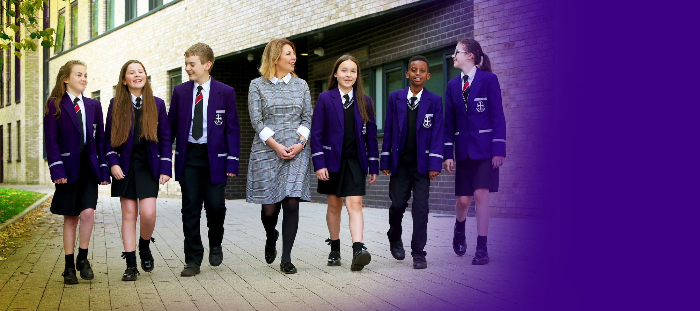





St Hilda’s CE High School
Croxteth Drive, Sefton Park, Liverpool L17 3AL
T: 0151 733 2709 E: info@st-hildas.co.uk I: www.st-hildas.co.uk

Mrs J Code
BA (Hons), NPQH, FCCT
Headteacher

WISDOM
HOPE
COMMUNITY
DIGNITY
EQUALITY

