January 2022

Dear Colleague

Thank you for your interest in the post of Class Teacher at Castle Hill School. In addition to your application, I would like you to write a brief outline (no more than 500 words) on the following statement:

‘What are the skills and attributes needed to become a teacher in a school like Castle Hill?’

A visit to the school is highly recommended. Tours of the school are arranged for Thursday 3rd February at 3.30pm and Thursday 10th February at 3.30pm, masks and vaccination evidence will be required for the visits.

All application forms should be returned directly to the school FAO: Recruitment or emailed to recruitment@castlehillschool.org.uk.

Good luck

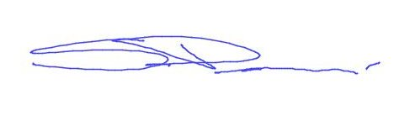

Steve Perren

Principal

