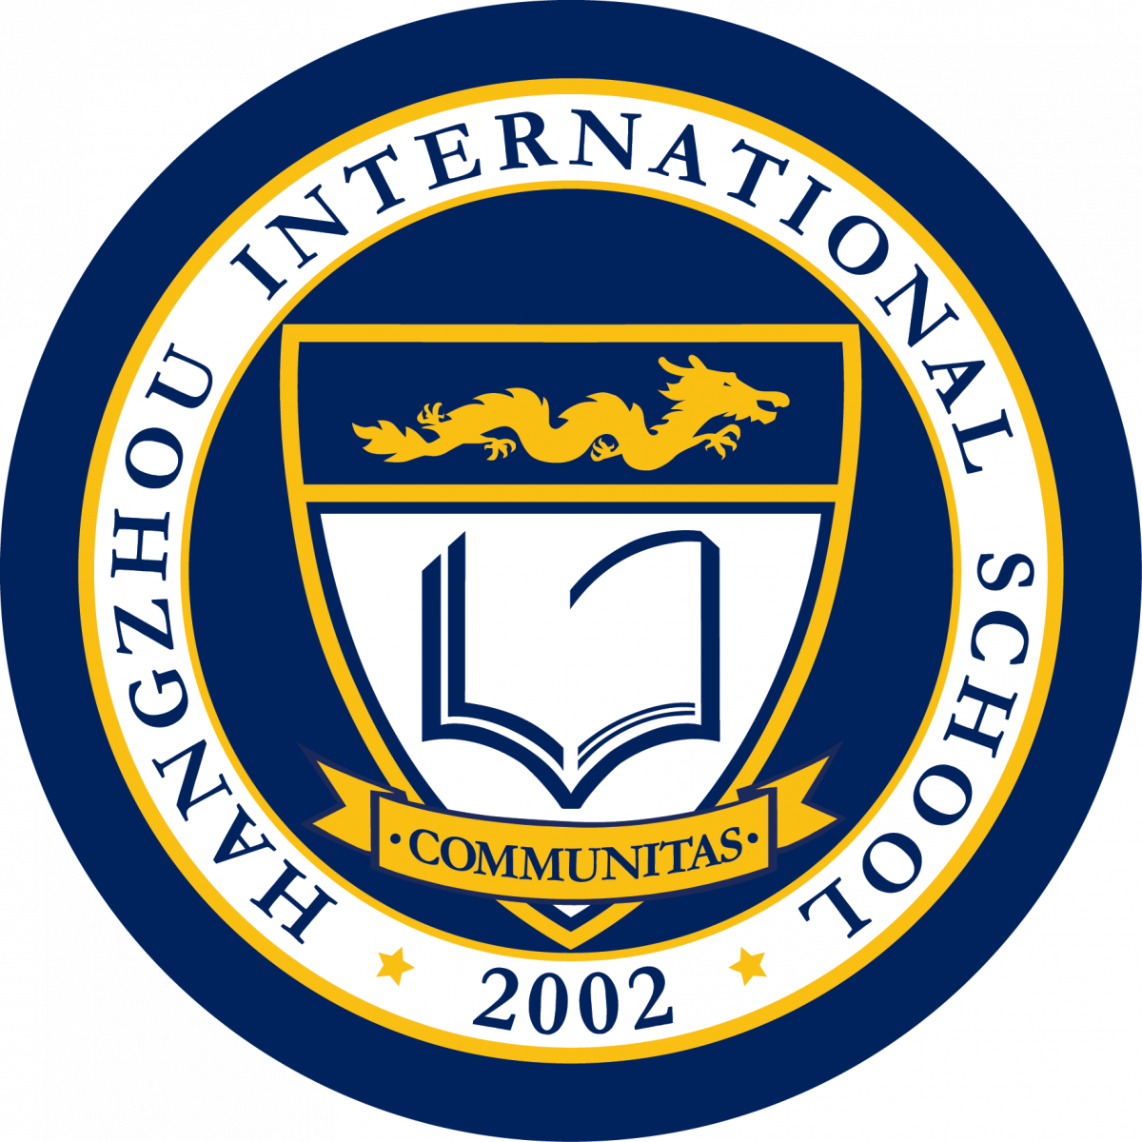
Hangzhou International School

Professional Realities at HIS

The HIS Mission
We provide international learners with opportunities
to pursue academic and personal excellence within a caring community.
There are several professional realities involved in working at HIS which may not be commonly found in other schools, and most notably not found in government-supported schools. The HIS professional learning community has high professional standards and staff surveys indicate a very high level of professional satisfaction.
We offer the following list of Professional Realities related to working at HIS. It is not comprehensive, but does highlight some key features. If you have any questions about anything on the list, please ask one of the school’s administrators for clarification.
- HIS generally cannot admit Chinese nationals and can only admit foreign students (with few exceptions). This is not school policy, but a consequence of Chinese law. As our mission is to serve only eligible students, and many expatriate families usually have short-term contracts of between six months and five years, we have a student turnover of around 20-25% per year. Total student enrollment as of September 2018 is just over 650 students.
- HIS is a highly dynamic school. This can mean that enrollments fluctuate each passing year, and construction and renovation projects are common meeting topics and physical realities. Flexibility and adaptability are key traits for our prospective faculty.
- Following sixteen years of operation, HIS has finally reached a point of program maturity, celebrating its first graduating class of 1 senior in 2005-06 school year and now sustaining at least two sections of each grade level and growing. Our impressive track record of success and achievement dating back to 2002 is a culmination of the significant commitment, perseverance, and hard work of our faculty and staff. As in any institution, we continually refine our programs, policies and procedures to remain successful within a highly competitive educational marketplace. Satisfied HIS teachers are those who are realistic and professionally mature enough to know that the pursuit of school improvement and the development of a great school is an ongoing, never ending task that requires energy and commitment from all.
- HIS is an IB World School accredited by the Western Association of Schools and Colleges (WASC) and delivers the IB PYP, MYP and DP programs. (HIS is currently a candidate school for PYP and DP, and has been authorized in DP since 2012)
- Hangzhou is a very dynamic and efficient city. Teachers have access to a broad range of cultural experiences of every sort and sports, activities, and events are plentiful. Quality of life and savings potential are very favorable. Hangzhou is viewed as a very picturesque and historic city, which is quickly becoming a more cosmopolitan, high-tech hub of China. HIS Teachers enjoy an easy fast train ride to enjoy different aspects of culture and history in neighboring cities.
- “Community” and “Collegiality” are highly valued by staff, students, and parents at HIS schools.
- Full commitment to the school as a community is expected. This includes reasonable attendance at student and parent events, in addition to directed attendance at certain whole-school events such as concerts. To be sure, HIS is a town-center for the Hangzhou international community.
- High standards of personal organization, personal presentation, and workplace presentation are expected. Most of our school community members are professionals themselves, and we maintain a dress code for teachers and administrators that reflects a relatively conservative approach. Students wear a uniform.

- Though a large portion of our students are native-English speakers, most students at HIS would not call English their first or best language. This means that you will have, in your classroom, many students with developing English skills at all times. We consider it to be our professional responsibility to find appropriate ways of enabling such students to access and be successful within the school’s curriculum. Both ESOL and non-ESOL students are capable of and should demonstrate high levels of achievement, both within our ESOL program and in the mainstream curriculum. Enabling them to achieve the best is harder work than teaching in a mono-cultural, monolingual context. It requires of teachers a significant amount of differentiation, something that we believe is a realistic expectation given our relatively small class sizes.
- As HIS is the only truly international school in Hangzhou, we do try to provide access to international families who have no reasonable option. We try to ensure students numbers in classrooms allow for personalized learning and strong relationships; however, we do not have absolute class size limits. We use the following targets for student-staff ratios:
- Nursery (EYI): 5:1 up to 16 students (current physical capacity is 14)
- Preschool (EYII): 6:1 up to 18 students (current physical capacity is 14)
- Prekindergarten: 18-20 students with one assistant
- Kindergarten: 20-22 students with one assistant
- Grades 1-12: 22-24 students (physical capacity of some classrooms may require smaller groups)
- Teachers must identify with and implement the HIS Curriculum. As we grow, it becomes more and more critical that we work effectively as grade level teams and departments. We also believe the curriculum allows teachers significant flexibility in choosing highly effective instructional strategies and permitting personal teaching style to shine through. The community places great value on the relationship that students are able to build with their teachers. This balance of teacher-generative scope and administrative protection of curriculum is well valued by our staff.
- Another reality of working in a progressive and dynamic school environment is that an open-door teaching style is expected. We aim to work and plan collaboratively, as well as communicate proactively with colleagues to effectively deliver the HIS curriculum to our students.
- Full participation in ongoing staff and curriculum development, grade level and departmental collaboration, in addition to teaching, preparing, assessing and reporting is a professional expectation of all faculty members.
- Time is set aside each week for Staff Development, Faculty meetings, or Grade Level/Departmental meetings. Attending these weekly sessions is a professional expectation.
- We report to parents formally through written, personalized progress reports, student portfolios, and student-led conferences. In addition to these formal reporting methods, teachers also report informally to parents on a frequent, on-going basis through emails, phone calls, classroom webpage and meetings. It is the school’s expectation that parent communications through email are responded to within a reasonable period of time, usually 24 hours.
- We expect all teachers to be computer literate, developing technology proficiencies and to be integrating technology seamlessly into their instructional practice.
- Contract hours are currently 7:30am to 3:30pm. In addition, teachers are expected to attend weekly faculty meetings as well as any other required meetings. Additionally, consistent contribution to the Extracurricular Program is expected, and grade level and departmental organization of teacher office hours is expected. All staff have assigned supervision responsibilities.
- The school must operate as a not-for-profit organization and is governed by a self-perpetuating Board of Directors. The Board governs the school and manages it through the Director of School. HIS only has tuition funds as revenue and is a completely independent entity, financially speaking. That said, the school is well-resourced and faculty budgetary conversations are more focused on value-added learning resources/initiatives.

