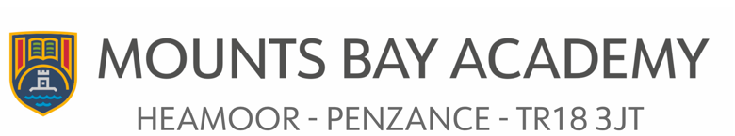

Role: Principal of Mounts Bay Academy
Salary: L28 – L33
Working weeks/hours: Full time (as per STPCD)
Contract type: Permanent
Closing date for applications: 9am on Monday 26th February 2024
Interview date: 12th and 13th March 2024
Start date: September 2024
Leading Edge Academies Partnership is a group of six distinct and unique schools located in beautiful coastal and island settings in Cornwall and the Isles of Scilly. We are fortunate to include a mix of primary and secondary schools, as well as an all-through school with boarding and off island bases. This diversity makes for a dynamic and varied perspective. We embrace the distinctiveness of each school and hold children at the heart of every decision we make.
All our schools share a vision, are values driven, like-minded, and passionate about empowering children, young people, and adults to achieve their personal best. Our schools strive for a curriculum which inspires and offers something for everyone; it offers breadth through wide ranging opportunities and prepares our pupils for their future. Digital technology is used to support teaching pedagogy, reduce teaching workload and to enhance accessibility for all pupils.
We are proud to have Mounts Bay Academy within our Trust. Mounts Bay Academy is a popular school in Penzance, West Cornwall with 1032 students aged 11-16 years. The school was last inspected in December 2021 with a ‘good’ judgement. The school prides itself on “seeing a world of opportunities, unchartered journeys and experiences yet to be lived”. It aspires to success for all, whatever this may look like, by nurturing the very best in each person, by identifying their strengths and talents and removing any barriers to learning. Talent is celebrated, curiosity is nurtured, and every individual is given the chance to shine. Young people flourish with a positive attitude to learning and life, ready to take on the challenges of our fast-changing world and to make a creative contribution to their community.
While we celebrate all of the successes and achievements at Mounts Bay Academy, as with all schools, there is still work to be done and we are looking for a highly motivated, inspirational, dynamic and ambitious individual to take this school to the next level.
In return we can offer:
• Excellent bespoke professional development
• Exceptionally well-resourced learning environment
• A friendly and caring whole academy community
• Employee benefits
• An employee assistance programme and other wellbeing initiatives
For further information, please contact Vedette Peaker, Director of People, on vpeaker@leadingedgeacademies.org or visit www.leadingedgeacademies.org
In line with our safeguarding practices, we only accept completed application forms. The successful candidate will be subject to reference checks with previous employers and an enhanced DBS disclosure check.

