
AMAZING SENIOR LEADERSHIP OPPORTUNITY:
ASSISTANT PRINCIPAL: PUPIL PREMIUM, EAL & EXTRA-CURRICULAR/ENRICHMENT PROVISION
Start: September 2022.
Closing date: 19th May, Midday.
There has never been a better time to join Lordswood Boys’ School. Following our recent Ofsted inspection and due to increased student numbers, Lordswood Boys’ School is now a firm school of choice. Read our inspection report by clicking here.
Leadership scale 11 - 15, (£54,091 - £59,581 per annum)
LBS Staff Welfare Plan included

We would welcome applications from current Subject Team Leaders, Heads of Department and Assistant Principal’s but especially from colleagues with an outstanding track record of student outcomes. Applications from English, Maths and Science specialists are most welcome. This role is not suitable for ECTs.

To help you gain experience in all aspects of School leadership the exact role and specific responsibilities of the Assistant Principal will be agreed annually and will change regularly.
The successful candidate work closely with the Principal and Vice Principals in areas of assessment, examinations and progress, driving high standards and expectations.
You should apply if:
- You are already an outstanding teacher with at least 3 years as a successful middle leader behind you.
- You are creative and innovative.
- You are optimistic, you enjoy working with young people and you always support your colleagues and school.
- You have very high standards.
- You can lead others, you can self-start and you are looking to work with and support a committed staff team.
- You have a track record of delivering outstanding outcomes and believe that every student deserves the highest quality learning experience.
These are reasons why you might want to join us:
- Lordswood Boys’ School was inspected by Ofsted on 15th & 16th February 2022 and was graded as a Good School. Read our inspection report by clicking here.
- The new school opened in March 2020. The environment is fully equipped for education in the 21st Century.
- You will play a key part in delivering the School Development Plan and your voice will be heard.
- LBS is about has achieved a fifth successive year of outstanding results.
- You will join an innovative and highly skilled leadership and management team.
- The school is expanding rapidly.
- We will be adding a bespoke Sport-only 6th Form from September 2022 and our new school has provision for this.
- All employees have access to our Westfield Cash Plan which covers expenses such as optical, dental, well-being, etc.
- All employees have access to the National College online CPDL service.
Other information
To apply, simply click the button or, if you need further information, interested candidates should contact Lee Williams, Principal, for an informal, friendly conversation about this opportunity.
0121-803 8143 or 07821-682824
We would also like to share the following:
Lordswood Boys’ School is part of the Central Academies Trust (CAT). CAT is a recently formed educational Trust with members and directors drawn from the highest achieving and highest profile schools in Coventry and Birmingham. Led by our Chief Executive, Dr. David Kershaw MBE, the Trust incorporates members and directors from industry and higher education amongst other fields. Committed to raising achievement in challenging schools and to securing the highest of high equity, we will work relentlessly to change young lives in the Midlands. Any professional that joins in with our mission will have opportunities to work across our schools in the coming years as we seek to develop and promote our own staff into outstanding school improvement experts or leaders of curriculum innovation and world class standards in education. We do not lack ambition.
See what the media say about us:
https://www.birminghammail.co.uk/news/midlands-news/birmingham-eton-astonishing-story-how-16202482
Lordswood Boy’s School is among the most improved schools in England.
OUR 2021 OUTCOMES: AMAZING

Headlines:
- English standard passes were 92%, 9 in 10.
- Maths standard passes were 92%, 9 in 10.
- English strong passes were 64%, 6 in 10.
- Maths strong passes were 79%, almost 8 in 10.
- Grade slip (grades achieved against target grades) in 2019 was +68…P8 was +0.42
- Grade slip in 2020 was +314.25…P8 was…+1.0?
- Grade slip in 2021 was +479.25…P8 was…+1.0?
- Grade slip per student +6.39, grade slip per student PP +7.05.
- Double Award Science standard passes were 62%, target 52%.
- Double Award Science strong passes were 33%, target 16%.
- Triple Science standard passes were 100%, target 100%.
- Triple Science strong passes were 100%, target 100%.

These outcomes are OUTSTANDING.

The school improvement project:

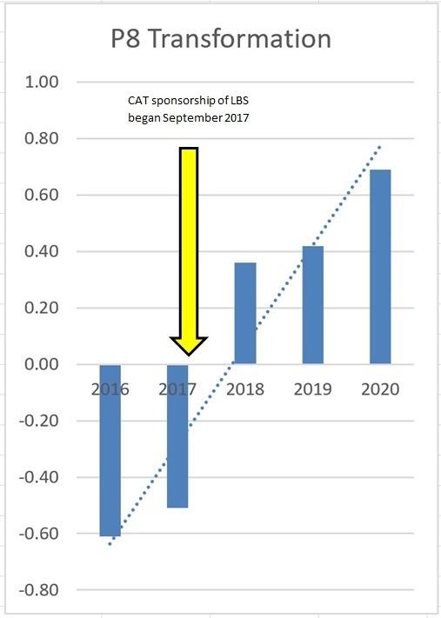

Lordswood Boys’ School is already one of Birmingham’s great educational success stories and we invite you to join us in our fabulous new, state-of-the-art building with our wonderful, engaging and highly intelligent and articulate young men.
For information and application forms:
E: l.williams@lordswoodboys.co.uk
T: 0121-464 2837
Candidates will be required to submit the names of two referees, one of which must be your most recent employer.
Candidates will be expected to inform us of their salary aspirations. The school is prepared to negotiate to secure the right colleague.

Visits available at the following dates and times:
Monday 16th May, 09.00 – 11.00
Tuesday 17th May, 11.00 – 13.00
Wednesday 18th May, 09.00 – 11.00
Please contact Michael Rennie, Director of Education, to arrange a visit.
Email: m.rennie@lordswoodboys.co.uk
Phone: 0121 – 803 8149 / 07518 - 908898

Closing date: 19th May, Midday.
Interviews will be held week beginning 23rd May 2022.
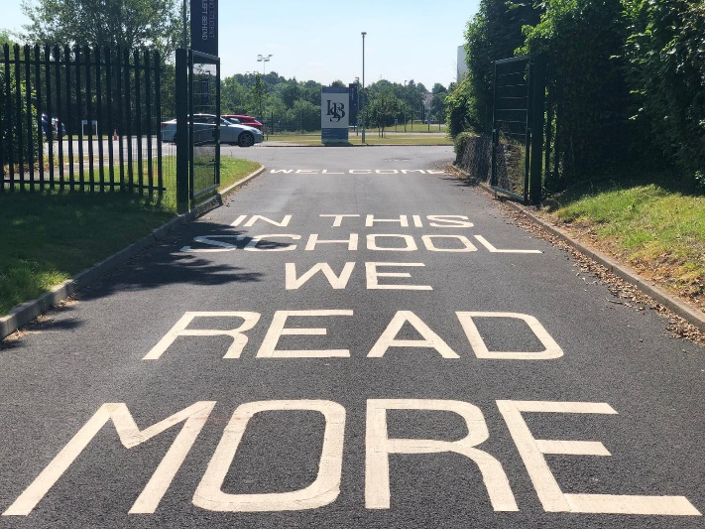


Post title: Assistant Principal
School: Lordswood Boys’ School
Pay range: L11-L15 (Leadership Pay Spine)
Line manager: Principal
Supervisory responsibilities: UPS/TLR holders, Teaching and Support Staff

General Responsibilities

The Assistant Head Teacher is to take a central role in assisting the Head Teacher, Deputy Head Teacher and the Trust to develop the school in accordance with the School Development Plan.
The functions and specific responsibilities are to carry out the duties of this post in line with the remit outlined in the current School Teachers’ Pay and Conditions Document including the conditions of employment for Assistant Principal’s.

Specific Responsibilities

The Assistant Principal will teach classes to model good practice, develop relationships, support training and development and ensure quality first teaching and secure the smooth running of the school. The Assistant Head Teacher will be a model professional and an excellent example to other teaching and support staff. They will positively encourage and support all members of staff. They will work in close partnership with the Head Teacher and Deputy Head Teacher in actively and demonstrably promoting enrichment, entitlement and achievement through building and implementing agreed school policies.
The Assistant Principal will take lead responsibility for ensuring the best possible curriculum offer, provision, well-being, progress and achievement for all students. They will work with the Head Teacher and Deputy Head Teacher to ensure that the school offers a high quality, exciting, engaging, well resourced, differentiated and well-matched curriculum for all students.

They will performance manage teaching and support staff including TLR leaders. This means playing a key driving role in being prepared to observe and to be observed.
In particular, the Assistant Principal will be required to:
Leadership and Management:
- Work in very close partnership with and support the Head Teacher and Deputy Head Teacher in the effective day to day management of the school and school community including recruiting and inducting staff, developing and implementing health and safety policies, leading assemblies and staff meetings, arranging cover and sharing the responsibility to cover for absent staff or staff on PPA / training, hosting and organising whole school events such as open days and parents evening, and responding to the views, needs and requests of the students, staff, parents, governors, visitors and the Trust.
- Work with the Head Teacher, Deputy Head Teacher, staff, governors and the Trust in the development, implementation and review of school improvement plans including regular monitoring and evaluation of standards and quality of provision, supporting school governance by attending meetings where appropriate and ensuring that all governors are able to play an active and informed part in school management and development.
- Work cooperatively with the Senior Leadership Team.
- Work with the whole staff to develop a strong learning environment that has at its centre high expectations of learning, work, performance, academic achievement and behaviour.
- Work with the Head Teacher and Deputy Head Teacher in the school’s achievement reviews and target setting processes by assisting with assessment procedures.
- Lead Teachers and team leaders to ensure that all teaching and learning and assessment policies and protocols are in place and up to date.
- Provide leadership in the development and management of all teaching and learning and in the creation and maintenance of high quality, stimulating, well-resourced and student friendly learning environments.
- Assist in the line management of classroom-based personnel to ensure the provision of high-quality interventions and support for children’s progress, achievement, well-being and good behaviour.
- Work with the Head Teacher and Deputy Head Teacher to provide CPD (continuous professional development) for classroom-based staff ensuring their needs are identified and met through quality training opportunities within available resources. To some cases to lead and in others to attend all meetings in relation to the School Development Plan.
- With the Head Teacher and Deputy Head Teacher, share responsibility for the induction and deployment of new staff, voluntary help, work experience students, trainee teachers/ students and parents/ carers working in classrooms and throughout the school ensuring all safeguarding requirements are met and that their work in school supports the learning and well-being of all children.
- Promote achievement and wellbeing and with the Head Teacher and Deputy Head Teacher to effectively manage the school resources to achieve the schools stated aims, meet its targets and sustain high achievement in line with the School Development Plan.
- Work with the leadership team in setting, nurturing, promoting and maintaining a very high standard of behaviour and mutual respect throughout the school ensuring that all staff play an active role in the pursuit of these standards.
- Assume responsibility for the management of the school in the absence of the Principal and the Vice Principal.

Teaching and learning
- Ensure that learning is at the centre of strategic planning and resource. Lead and support the teaching and learning of all students within the school through promoting models of excellent classroom practice coaching, mentoring and supported self-evaluation for teaching and learning staff.
- Assist in the design, development and implementation of systems for the collection of useful, timely, and accurate assessment data to track the progress of individual and groups of children in order to inform planning, evaluate performance, track progress and secure raised achievement across all key stages. This will include agreeing and articulating high expectations and setting stretching targets for the whole community.
- Monitor the effectiveness of teaching and learning through teachers’ planning, work sampling and scrutiny, lesson observations, supporting auditing and reporting outcomes, successful or otherwise and planning next steps and future actions. To monitor and support the effective marking of student work in line with the school marking policy.
- Assist with examination invigilation of internal, external and school assessment work as appropriate.
- Liaise with our partner schools in the Trust and local schools and other service providers and community resources to enrich and expand our provision and secure partnerships, collaborations, enrichment opportunities and expertise which bring benefits to all students and the school community. To play a key role in driving the Extra Curricular Activities programme and other aspects of enrichment within the School, including after school clubs and events, which may be held at weekends and occasional holiday dates.
- Take a strategic role in the development of new and emerging technologies to enhance and extend the learning experience of students.

Strengthening Community
- Promote and model good relationships with parents and carers, which are based on partnerships to support and improve pupils’ learning and achievement.
- Contribute to the development of the school as a community within the community; strengthening partnerships with families, neighbours, our local and wider community, other schools, services and the local authority.
- Contribute to the development of the education system by sharing effective practice, working in partnership with other schools and promoting innovation.
- Contribute to policies and practices which promote equality of opportunity and tackle prejudice and discrimination, support staff well-being and work-life balance and help to ensure we provide access to opportunities for growth, achievement and success for all adults and students in school.
Pupil Progress
1. To ensure that all students achieve well relative to their prior attainment and potential, making progress as good as or better than similar pupils nationally. Where this is not occurring, to ensure that concerns are addressed in consultation with the Deputy Headteacher and the Head of School.
2. To support Literacy and Attendance in school and drive the responsibilities of all teaching and support staff in accordance with school development plan, and to seek to create a strong corporate spirit within the school.
3. To understand the highest priority is the wellbeing and safeguarding of all the students at the School and that this is their first responsibility.
4. Work within the School's Health and Safety Policy to ensure a safe working environment for staff, students and visitors.
5. Adhere to School's policies and procedures as set out in the staff handbook or other documentation available to all staff.
6. A commitment to celebrating students' achievements, skills and talents, as well as an ability to tackle problems effectively.

Professional Characteristics - Specification
- Maintain high professional standards of attendance, punctuality, appearance, conduct.
- Inspires trust amongst colleagues, students and parents.
- Demonstrates a high degree of flexibility and innovation.
- Is very well organised.
- Ability to work effectively under pressure
- Excellent written and oral communication skills
- A good sense of humour
- A willingness to contribute to whole-school initiatives
- A commitment to extra-curricular activities and to the school's involvement in the wider community
- To promote the School's ethos, values and vision
- A commitment to networking and the sharing of best practice
- Excellent presentation skills, problem-solving skills and ICT skills
- A commitment to celebrating students’ achievements, skills, and talents

Professional Qualifications, Training and Characteristics
- Excellent subject knowledge and a first degree in a subject relevant to the teaching post
- A DfE recognised teaching qualification
- A detailed understanding of current educational initiatives applicable to the curriculum
- A commitment to the continuing professional development of oneself and others
- A very good attendance record
- A commitment to equal opportunities

