THOMAS BECKET CATHOLIC SCHOOL
DEPUTY HEADTEACHER CANDIDATE BROCHURE
A Catholic, Learning and Listening Community

#iambecket

CONTENTS
Welcome from the Headteacher | 3
About our Trust | 4
About our School | 5
Job Description | 8
Person Specification | 13
How to Apply | 16
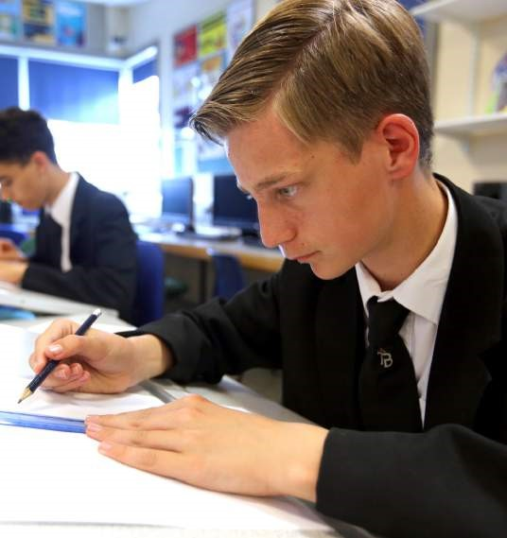

WELCOME FROM THE HEADTEACHER
Dear Applicant,
Thank you for your interest in the position of Deputy Headteacher at Thomas Becket Catholic School.
I firmly believe that there has never been a better time to join Thomas Becket. A bold statement, but one that is fitting for this leadership opportunity.
We are seeking a practising Roman Catholic Deputy Headteacher who is really inspired by our journey so far, is excited to support the Headteacher and the Senior Leadership Team to embrace the potential that this school has to offer.
With the support of our Trust, Thomas Becket has been on an incredible journey of school improvement over the last two years. Through investment in strong leadership, a relentless focus on teaching and learning and additional day-to-day support with financial and operational management, we have built the foundations for a bright and exciting future for this school.
This summer Thomas Becket celebrated some of its best ever GCSE results, with a Progress 8 score that places us amongst the top performing secondary schools in Northampton, and a significant increase in attainment. This is just one indicator of the transformation that has taken place here, but there is so much more to our story. At this school, you will find a community of teachers and support staff who genuinely care about every one of the students, and who are dedicated to delivering an exceptional all-round education for them.
This would be the ideal opportunity for an experienced teacher who has worked at a senior leadership level seeking their next exciting challenge in a growing and expanding Trust.
We believe that Thomas Becket has real potential to lead the way for Catholic education in Northamptonshire, and look forward to finding the right individual to help us achieve that.
I hope you are as inspired by the possibilities this position has to offer as we are and I am very happy to discuss any aspects of the role either by telephone or on a visit to the school.
Warm regards,
Mark McLaughlin

Headteacher
Thomas Becket Catholic School

ABOUT OUR TRUST

We are proud to be part of the St Thomas of Canterbury Catholic Academies Trust.
Within our Trust we work very closely with three Catholic primary schools in Northampton, sharing best practice and easing the transition between primary and secondary school for our students.
As part of the Trust, we have access to a wide range of additional benefits. This includes guidance on school improvement, governance and leadership as well as centralised operational support with areas such as HR and finance allowing school leaders to focus on delivering an exceptional Catholic education.
We are fortunate to benefit from our membership of the Northampton Diocesan Office for RE, Evangelisation, Catechesis and Schools (NORES) and also value working closely with other local Catholic Academy Trusts.

Type of School | Catholic Secondary Academy
Age Range of Pupils | 11 - 18
Gender of Pupils | Mixed
Number of Pupils | 753
Of which, in Sixth Form | 112

ABOUT OUR SCHOOL

Thomas Becket Catholic School joined the St Thomas of Canterbury Catholic Academies Trust in April 2016, and is the only Catholic Secondary School in Northamptonshire.
Based in the town of Northampton, the school has around 750 students aged 11 - 18, including a dedicated Sixth Form.

Our Values
Our Catholic faith is at the heart of the education we offer.
We believe it is not enough to love the children, but for them to know they are loved, and this is an ethos that underpins everything that we do.
Five core values bring together our commitment to our students, following the Gospel and inspiring the education that we deliver:
Faith, Justice, Compassion, Truth and Respect

Our Catholic Ethos
Our Catholic faith is central to the life of the family of schools which make up the St Thomas of Canterbury Catholic Academies Trust. Rooted in Gospel values, we recognise each member of our community as a child of God. With a focus on prayer, we are driven to strive for excellence. Through the example of Jesus Christ, we encourage each other to fulfil our potential.
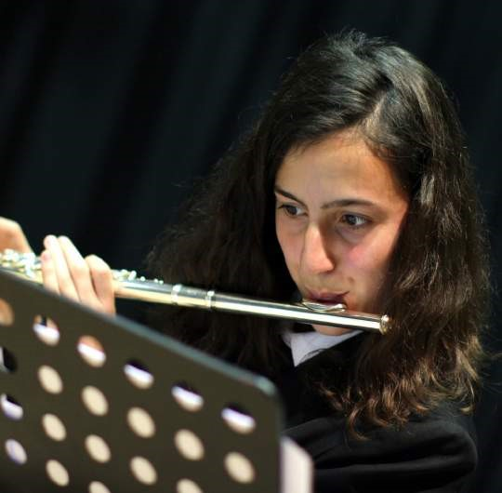

ABOUT OUR SCHOOL

Our Approach
At our school, we believe in offering an all-round education that combines a caring and loving ethos, with the highest possible ambition for our students to succeed. We want our children to become happy, confident and accomplished individuals, and believe we must deliver an education that opens up new and exciting opportunities for every one of them.
We deliver a traditional curriculum that is personalised for every child, with particular emphasis on those that are most in need. This includes a commitment to providing a broad range of academic and extra-curricular opportunities that encourage our students to develop their talents wherever they may lie.
Over the last two years, we have transformed the whole approach to the education delivered at Thomas Becket.
From leadership and management to behaviour and attendance, new structures, policies and interventions are now in place and are being embedded across the school. Quality first teaching, collaborative planning, streamlined assessments, regular observations and feedback are all key elements of our open and honest approach.
Identifying potential and developing our staff is important to us, and we have a strong emphasis on supporting our teachers and leaders to grow and flourish here. Weekly 90-minute CPD sessions, a supportive system of appraisals, coaching and mentoring opportunities are on offer for every member of our team.
Alongside our focus on school standards, we have also been developing our relationships within our community. Our local reputation is growing and we value working closely with our parents and local primary schools in order to provide the best possible opportunities for our students.
The improvements here have been rapid, and we are delighted to have had our expertise published within the Parliamentary Review.

ABOUT OUR SCHOOL

What Our Students Say Year 7
“I would like to be a teacher, because my teachers have been so kind and supportive. I want to be like that one day.”
“Our form tutors make sure we’re always ready for the day. We do lots of activities in form time that help us work together.”
“The older students are really friendly and ask us how we are settling in.”

Sixth Form
“There are some really good student-teacher bonds here. The teachers do genuinely care about you and want you to achieve. They are really easy to talk to and will give you help when you need it. That’s why I decided to stay here for Sixth Form - it feels like it’s where I belong.”
“The teachers encourage you to be yourself and let you express yourself. We know they really care.”
“The possibilities we’re given as Sixth Form students have been great.”

What Our Staff Say
“Quality first teaching, great relationships, hard-working staff and students have all led to incredible changes here.”
“There’s a warmth at this school, the building really comes to life with the people in it.”
“As a former student at Thomas Becket myself, the level of support for staff really stood out to me. It’s like a family here.”
“I’m thankful that I had the chance to become a middle-leader quite early on in my career. The senior team believed in me, and they really support and challenge you.”
“The CPD here helps you to reflect upon yourself as a teacher and a leader, sharing ideas with other staff across the school to see what’s working elsewhere.”
“The Catholic ethos is embodied in everything that we do. It is all about caring, and a belief that every one of our students can achieve.”

JOB DESCRIPTION AND PERSON SPECIFICATION

JOB DESCRIPTION AND PERSON SPECIFICATION

JOB DESCRIPTION

OVERVIEW
Job Title | Deputy Headteacher
Closing Date | 12 noon, Monday 18th March
Interview Date | Monday 25th March
Salary / Scale | L15 - 20
Purpose of the Position | To play a major role under the direction of the Headteacher in formulating the aims and objectives of the school, establishing the policies through which they shall be achieved, managing staff and resources to achieve the aims and objectives of the school and monitor progress towards their achievement.  The Deputy Headteacher will have delegated responsibilities which are both school-wide and of considerable weight. This will be in addition to carrying out the professional duties of a teacher other than a Headteacher. Depending on the skill set and subject matter expertise of the successful appointment, the duties of the role may be amended to reflect the post holder’s experience and academic interests.
Accountable to | The Head teacher of Thomas Becket Catholic School

MAIN DUTIES
- Core Purpose and Accountability
- To play a major role under the direction of the Headteacher in formulating the aims and objectives of the school, establishing the policies through which they shall be achieved, managing staff and resources to achieve the aims and objectives of the school and monitor progress towards their achievement.
- Undertake the professional duties of the Deputy Headteacher reasonably delegated to you by the Headteacher.
- Undertake the professional duties of the Headteacher, in the event of his absence from the school.
- In partnership with the Headteacher and the Senior Leadership Team, provide professional leadership and management of Teaching and Learning throughout the school.
- To provide professional leadership and management of School Development Plan priorities.

DESCRIPTION
2. Generic/Teachers
- You are to carry out the duties of a school teacher as set out in the current School Teacher’s Pay and Conditions Document. This includes any duties as may be reasonably directed by the Headteacher and the accountabilities expected of class teachers at Thomas Becket.
- To facilitate and encourage learning which enables students to achieve high standards, to share and support the corporate responsibility for the well-being, education and discipline of all children.
- All staff are expected to uphold the school’s principles and policies which underpin good practice and the raising of standards, and are expected to uphold and promote the school’s aims and values.
- All staff will be involved in working together, as part of a team, to develop areas of provision that impact positively on learning and teaching across the school.
- All staff are expected to actively undertake professional development through keeping abreast of the latest developments and thinking, coaching and mentoring, and self-evaluation and peer review.

3. Performance Management
- To undertake annual Performance Management, setting and agreeing targets linked to school development plan priorities with the Headteacher
4. Key Areas
IMPACT ON EDUCATIONAL PROGRESS BEYOND YOUR OWN ASSIGNED PUPILS:

Strategic direction/Shaping the future
- Support the Headteacher in:
- Ensuring the vision for the school is clearly articulated, shared, understood and acted upon effectively by all
- Demonstrating the vision and values of the school in everyday work and practice
- Motivating and working with others to create a shared culture and positive climate.
- Assist the Headteacher in the ongoing and annual review of standards of leadership, teaching and learning in specific areas of responsibility and across all areas of school provision.
- Develop and implement policies and practices for the subject/area(s) which reflects the school’s commitment to high achievement and is consistent with national and local strategies and policies.
- Promote high expectations for attainment.
- Establish short, medium and long term plans for the development and resourcing for the specific areas of responsibility.
- Monitor the progress made in achieving subject area plans and targets, and evaluate the effect on teaching and learning.
- Work with outside agencies and stakeholders to inform future action.

Leading Learning and Teaching, developing and enhancing the teaching practice of others:
- Work with the Headteacher and SLT to raise the quality of teaching and learning and pupil’s achievement, setting high expectations and monitoring and evaluating effectiveness of learning outcomes.
- Provide regular feedback for colleagues in a way which recognises good practice and supports their progress against professional and performance management objectives resulting in a tangible impact on students learning.
- Assist with the development of all staff to enhance performance.
- Undertake coaching and mentoring.
- Keep abreast of the latest developments in the area and disseminate effectively to other members of staff.
- Plan, delegate and evaluate work carried out by team(s) and individuals.
- Create, maintain and enhance effective relationships.
- Assist with the recruitment and selection of teaching and support staff.

Securing Accountability
- Work with the Headteacher to ensure the school’s accountability to a wide range of groups, particularly parents, carers, governors and the DfE; ensuring the pupils enjoy and benefit from a high quality education, for promoting collective responsibility within the whole school community
- Develop a school ethos which enables everyone to work collaboratively, share knowledge and understanding, celebrate success and accept responsibility for outcomes
- Work with the Governing Body (providing information, objective advice and support) to enable it to meet its responsibilities
- Reflect on personal contribution to school achievements and take account of feedback from others
- For your line managed subjects agree, monitor and evaluate pupil progress targets to make a measurable contribution to whole school targets.
- Engage all staff in the creation, consistent implementation and improvement in schemes of work and curriculum plans which encapsulates key school learning strategies
- Provide guidance on a choice of teaching and learning methods/strategies
- Coach and mentor
- Model and demonstrate
- Act as a consultant for other staff
- Exemplify good practice
- Undertake shared planning, team teacher etc
- Work with SLT to develop and implement systems for recording individual pupil’s progress
- Evaluate the quality of teaching and standards of achievement, setting targets for improvement.

Resource Management
- Work with the Headteacher and SLT to provide effective organisation and management of the school and seek ways to improve organisational structures and functions based on rigorous self-evaluation.
- Work with the Headteacher and SLT to ensure the school and the people and resources within it are organised and managed to provide an efficient, effective and safe learning environment.
- Monitor and control the use of resources and budget according to the school’s agreed financial procedures for areas of delegated responsibility.

Developing Self and Working with Others
- Work with the Headteacher to build a professional learning community which enables others to achieve.
- Support staff, within your team and within the whole school, in achieving high standards through effective continuing professional development.
- Be committed to your own continued professional development.
- Implement successful performance management processes with allocated team of staff.
- Treat people fairly, equitably and with dignity and respect to create and maintain a positive school culture.
- Build a collaborative learning culture within the school and actively engage with other schools to build effective learning communities.
- Acknowledge the responsibilities and celebrate the achievements of individuals and teams.
- Develop and maintain a culture of high expectations for self and others.
- Regularly review own practice, set personal targets and take responsibility for own professional development.

Strengthening Community
- Work with the Headteacher and SLT to engage with the internal and external school community to secure equity and entitlement.
- Work with the Headteacher and SLT to collaborate with other schools and organisations in order to share expertise and bring positive benefits to their own and other schools.
- Work with the Headteacher and SLT to work collaboratively at both strategic and operational levels with parents and carers and across multiple agencies for the well-being of all children.

JOB DESCRIPTION
5. Specific Duties for Deputy Headteacher
- To provide professional leadership and management of a key area of the School Development Plan as agreed, on an annual basis, with the Headteacher.
- To be responsible for behaviour policy & practice across the school.
- To take an active role in the Schools Leadership Team, contributed to the development of identified areas leading to high standards of teaching, effective use of resources and improved standards of learning and achievement for all children.
- To lead the Performance Management of a group of teachers.
- To identify and pursue leadership and management development opportunities (to be agreed and negotiated with the Headteacher who will give support throughout)

Other Specific Duties
Not all of the above duties will need to be performed all of the time and will vary according to the needs of the school at different points. The specific focus for the Deputy Head’s work programme will be negotiated and agreed at the beginning of the performance management cycles.
Staff will be expected to undertake any duty as specified by School Teachers’ Pay and Condition Documents not mentioned above.
Staff are expected to show professionalism at all times.

PERSON SPECIFICATION
1. TRAINING AND QUALIFICATIONS
 | Essential | Desirable
Qualified Teacher Status | √
Catholic Certificate of Religious Studies or equivalent |  | √
Degree | √
Post entry curriculum or management qualification |  | √
National Professional Qualification for Headship |  | √
Recent participation in range of relevant in-service training | √
Experience of providing successful INSET to colleague within current school | √

RSON SPECIFICATION

2. FAITH COMMITTMENT
 | Essential | Desirable
Practising Catholic | √
Evidence of participation in life of faith community | √

3. PERSONAL QUALITIES
 | Essential | Desirable
Willingness and ability to work at all levels from involvement in policy making to fine practical detailed applications | √
Loyalty, honesty and integrity | √
Flexibility | √
Pragmatic problem solver | √
Good time management skills | √
Perseverance | √
Experience of providing successful INSET to colleague within current school | √

4. PROFESSIONAL KNOWLEDGE AND UNDERSTANDING
Applicants should be able to present succinctly a clear and sound educational philosophy informed by Catholic ideals:
 | Essential | Desirable
Pupils’ educational development | √
School improvement strategies | √
Ability to plan strategically and manage change successfully | √
Effective monitoring and evaluation | √
Recognition of the value of teamwork within a school/Trust environment | √

5. PERSONAL SKILLS AND ABILITIES
Applicants should be able to clearly demonstrate that they have the necessary personal skills and abilities required for the post as detailed:
Ability to cope well with the demands and challenges of the post
Ability to promote a high standard of education, ensuring academic progress and good standards of behaviour
Effective communication skills
Ability to identify need, initiate development and deliver changes to a successful level and within agreed guidelines
Ability to promote successfully relationships with pupils, staff, parents, governors and other agencies
Ability to identity, gain commitment to and deliver management objectives
Competency in the use of Information Technology
Clear understanding of the National Curriculum, Assessment and examinations and of modern curricular
Pastoral care
An awareness and understanding of changes currently taking place within education and how they will affect the school
Clear views of the mechanisms for monitoring and evaluating the work of the school
Ability to support and challenge colleagues
6. CONFIDENTIAL REFERENCES AND OUTCOMES
Applicants must be able to positively provide the following information if successfully appointed:
At least 2 written professional references
Confirmation of professional and personal knowledge, skills and abilities detailed above
Positive and supportive faith reference from priest where applicant regularly worships
Positive recommendation from current employer
Satisfactory health and attendance record

PERSON SPECIFICATION

HOW TO APPLY

W TO APPLY

If you would like further information, or to arrange a school visit, please contact Jan Hayes, PA to Headteacher on: Tel: 01604 493211 or Email: HayesJ@ThomasBecket.org.uk
Application forms are available to download or Online Applications can be made via the school website: www.thomasbecket.org.uk
Completed applications are to be sent to Jo Brake-Oakes, Trust HR Manager at TrustHR@stccat.org.uk no later than 12 noon on Monday 18 March 2019.
All appointments will be subject to an enhanced DBS clearance in line with our Safer Recruitment Policy.
Thank you for your interest in our school.

