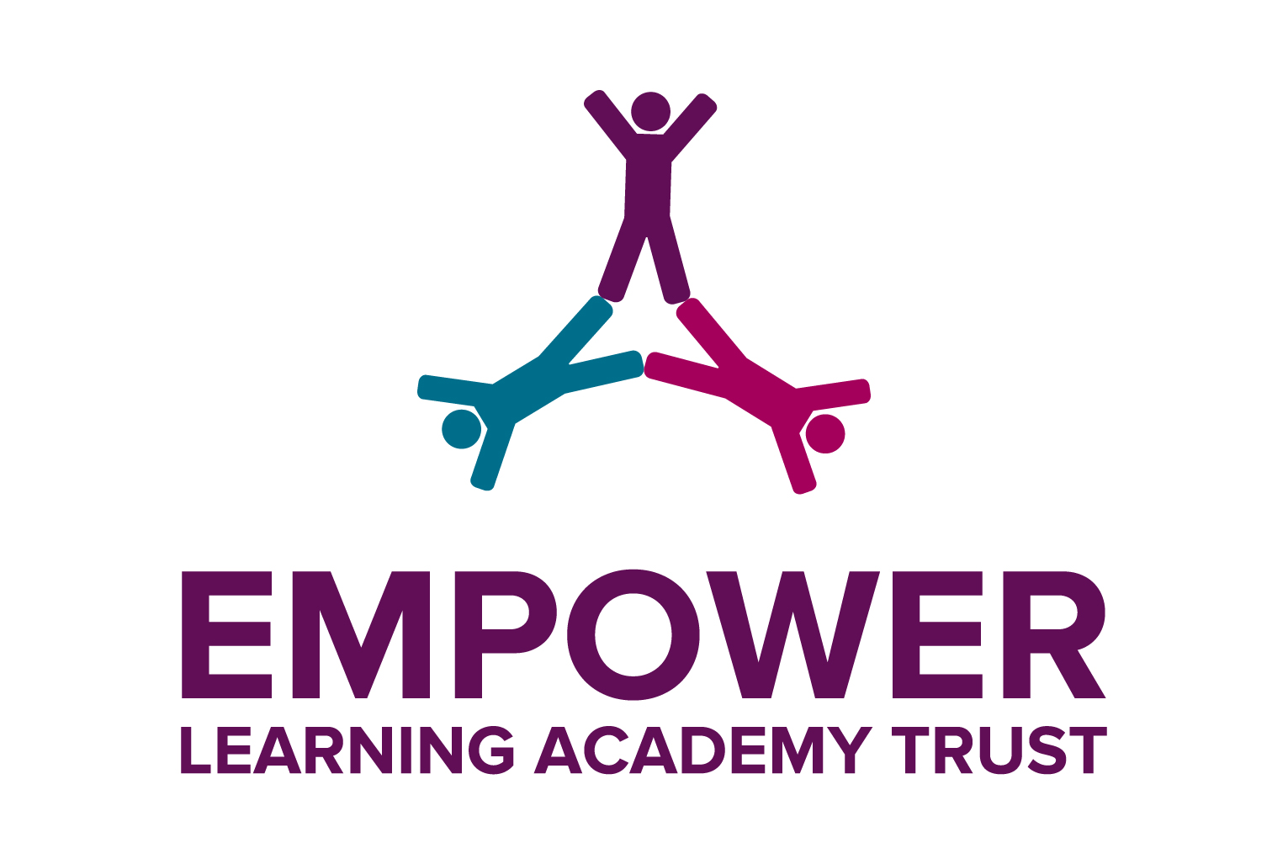

BOWER PARK ACADEMY

Principal: Stuart McLaughlin BA, MBA and FRSA

Information for the Post of:
Technology Technician

Closing Date for Applications:
6th October 2017 at 12pm

Interview will take place week commencing between 10th and 13th October 2017

Tier Room Supervisor

Thank you for your enquiry regarding the post of Technology Technician at Bower Park Academy.I hope the following information will prove useful in considering an application.

The Academy

The Bower Park Academy caters for pupils aged 11 to 16 from the London Borough of Havering and surrounding areas. It offers a broad and balanced education.

The Academy has recently joined a multi-academy trust (MAT), the Empower Learning Academy Trust, with Hall Mead School and The Brittons Academy. Hall Mead is outstanding and has teaching school status. The new MAT is using best practice development to support all staff in the Trust to improve the quality of provision. Furthermore, with its teaching school status, the Trust is benefitting from excellent CPD opportunities for all staff.

This is a very exciting time to be joining our learning community. Although the Academy was placed into a category of concern in December 2016, under new leadership and the support of ELAT, the Academy is on a trajectory of rapid improvement.

If you want to be part of a rapidly improving school and have the determination and desire to make a difference to the life chances of every student attending the Academy, we would welcome your application.

Our Vision for Raising Attainment

Our Shared Vision:

It is our aim to provide high quality learning for all students attending Bower Park Academy. This will be achieved by building a strong learning community and culture of learning consisting of students, staff, parents and the wider community. Underpinning this learning community will be high expectations and high aspirations. We expect students to be fully committed to their learning by trying hard at all times and coming to school prepared to learn to the best of their ability. Students will also be expected to aim high and not limit their aspirations. If they work hard and set themselves ambitious goals, they will achieve success at school.

Our moral purpose is to make a difference to the life chances of every student attending the Academy. Education has the power to transform lives and unlock potential. We believe that no matter what his or her starting point or personal circumstances, every student can achieve success at Bower Park Academy. Our aim is to ensure that every student is life ready when they leave the Academy by equipping them with the skills, attributes, values and qualifications necessary to lead highly successful adult lives. To achieve this goal, the Academy will ensure that all students:

- Achieve excellent examination results: Qualifications are a student’s passport to success. The better the qualifications, the more doors of opportunity will open to them.
- Become valued citizens: We want every student to develop the values and beliefs to enable them to become valued members of their community and make a positive contribution to our global society.
- Develop the skills and attributes for lifelong success: We want to ensure that every student is equipped with the skills and attributes that will not only mean that they can adapt to the rapidly changing world of work, but also have the mindset and drive to succeed in their adult life, no matter what they chosen career.

A crucial element of our vision is the high quality support and guidance all learners will receive. From September 2017, the Academy will be divided into four Houses and each House is further sub-divided into Learning Family or vertical aged tutor group. Through the House system we will provide a strong focus on each students learning and progress. All students will have Individual Learning Plans, which are reviewed regularly by the Learning Tutor. Consequently, the role of Learning Tutor is a vital part of the Academy’s ethos and this role.

Each subject belongs to a School of Learning which in turn is linked to a particular House led by an Assistant Principal. In effect, the teachers from each subject are the Learning Tutors in their related House. The House names have not yet been agreed, nor has the matching of subjects (Schools of Learning) to the Houses. An example of what this may look like is shown below:

- Moore House The School of Science & Sport
(Science and Physical Education)
- King House The School of Social Sciences
(Citizenship, History, Geography and RE)
- Edison House The School of Mathematics and Technology
(Mathematics, Technology and ICT)
- Rowling House The School of Communication
(English, MFL and Performing Arts)

The Post
This is an exciting opportunity for someone who is passionate about student’s education, the schools learning environment and the social and emotional welfare of individuals. The successful candidate will support teaching and learning within the technology department using their technical skills, knowledge and expertise and in addition, have specific health and safety knowledge. The successful candidate will work under the direction of Head of Department and play a key role in ensuring students are ready and supported in their learning.

Our aim is to be an Ofsted graded good school within two years and outstanding in five. We hope that you want to be a part of that transformational change.

Visits to the Academy are welcome. Please contact the Principal's PA, Mrs Debbie Grix (grixd@bowerpark.co.uk) to arrange a visit – you will be very welcome.

