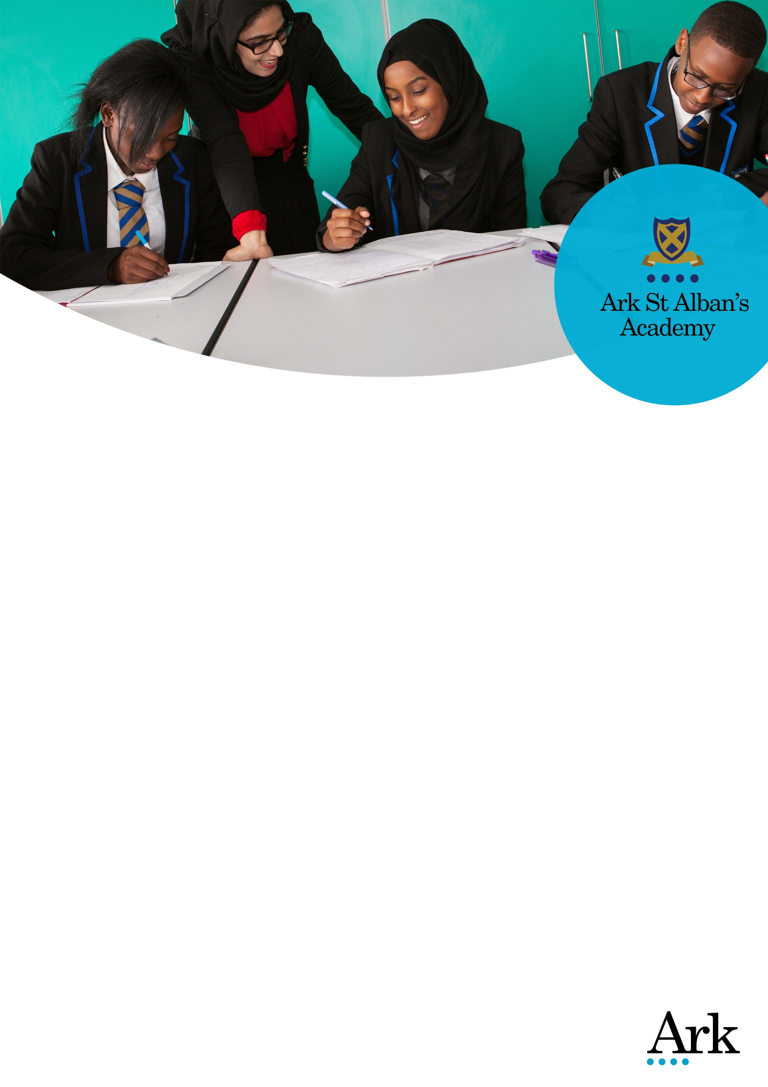

Vice Principal
Join a school where staff are given the freedom and support to innovate and collaborate
Start date: April 2018
Salary: L22 –L26 (£66,016 - £72,809)
Location: Highgate, Birmingham
Nearest train station/transport links: Birmingham New Street station
Deadline: 12pm on Monday 11th December 2017
Interviews: Interviews will be held between Wednesday 13th December and Friday 15th December 2017
Ofsted: Outstanding (2011)
Visits to our school are encouraged; to arrange, please call 0121 446 1300.
At Ark St Alban’s Academy we have high expectations of our students, exactly as if they were our own children. We expect them to go to university and succeed there and then lead fulfilling lives that make them happy and allow them to contribute back to the community.
We have much to be proud of and celebrate. But there is so much more to do and we refuse to stand still.
We are now recruiting an enthusiastic and talented teacher and leader, to join our senior leadership team as Vice Principal. This is an exciting opportunity to help lead a pioneering and high performing school through the fresh and exciting challenges that face us.
We believe that all children can - and will - achieve, we do everything we can to make sure that they reach their goal. We act with integrity and discipline to challenge all members of our learning community to make the most of their God given talents, maximising their contribution to society and making the world a better place for us all.
We want to hear from leaders who are driven by our unwavering commitment to deliver the best education for all young people. You’ll be clearly aligned with Ark’s ethos of growth mind set and you’ll have the highest aspirations and expectations of yourself and others and will be open and eager to learn. You’ll bring an infectious passion about teaching and its impact on learning and will do whatever it takes to ensure that learning stretches, inspires and challenges every pupil to fulfil their true potential.
Closing date: 12pm Monday 11th December 2018
To apply, please go on to our vacancy webpage: http://arkstalbans.org/vacancies.
Candidates who have been short listed for interview will be informed by the morning of Tuesday 12th December 2017.
Interviews will be held between Wednesday 13th December and Friday 15th December 2017
Ark is committed to safeguarding children; successful candidates will be subject to an enhanced Disclosure and Barring Service check.

Job Description: Vice Principal

Reports to: Principal
Start date: Easter 2018
Salary: L22 –L26 (£66,016 - £72,809)

The Role
The exact role and specific responsibilities of each Vice Principal will be agreed annually and will change regularly, to afford each member of the Senior Leadership Team the opportunity to gain experience in all aspects of school leadership.

The Vice Principal leads on such areas as curriculum development, staffing, timetabling, tracking and analysis of assessment data, behaviour management, external relations and community links, staff development, training and induction. As members of the senior leadership team, the Vice Principal will also be centrally involved in the overall leadership and management of the academy, helping to establish a school culture that is both nurturing and rigorous in order to achieve excellence.

Key Responsibilities
- To support the improvement of the academy through providing strategic leadership of key aspects of whole academy provision as directed by the Principal
- To support colleagues, including all other members of the Leadership Team, in their work for the development and improvement of the academy
- To support and contribute to the process of planning, implementing, evaluating and reviewing whole academy improvement
- Alongside the Principal, to ensure the safeguarding of all pupils, and that the safety and wellbeing of pupils and staff is promoted and maintained at all times.

Outcomes and Activities
Leadership and Management
- To share responsibility for the management of the academy and to contribute to the consultative and decision-making processes including the formulation of aims and objectives
- To fully support whole school policy decisions, contribute to their establishment and initiation and sustain their implementation and review
- To actively promote the academy and liaise with outside agencies as necessary, representing the Principal, the academy or Ark as appropriate
- To contribute to discussions and decisions at Senior Leadership Team meetings
- To offer information, advice and perspective to the governing body and to any legitimate external enquiry/evaluation
- To line manage other school leaders and subject areas
- To communicate and consult with staff, students, parents and members of the local community as necessary
- To manage staff and resources, ensuring that policies and procedures are adhered to
- In the absence of the Principal, to step-up and undertake the professional duties of the Principal as reasonably delegated.

School Ethos and Culture
- To maintain a presence around the school to ensure that the highest standards of behaviour and site-usage are upheld, to contribute to overview and review of student behaviour and to participate in the regular whole-school supervisory duties fulfilled on a scheduled basis by the Leadership Team
- To be active in issues of staff and student welfare and support
- To demonstrate a commitment to Equality of Opportunity for all members of the academy’s community.

Teaching and Learning
- To identify strategies for raising the attainment of students and to work towards these identified and agreed goals
- Support the training and development of teaching staff so as to improve the quality of teaching and raise the level of challenge in lessons
- Use regular assessments to monitor progress and set targets, and respond accordingly to the results of such monitoring
- Ensure that all pupils achieve at chronological age level or, if well below level, make significant and continuing progress towards achieving at level
- To model outstanding practice in terms of classroom teaching, preparation, marking and assessment.

Other
- Undertake, and when required, deliver or be part of the appraisal system and relevant training and professional development
- To undertake any other responsibilities as directed by the Principal.

Person Specification: Vice Principal

Qualification criteria
- Qualified to degree level and above
- Qualified to teach and work in the UK.

Experience
- Experience at Assistant Head or Deputy Head level (or equivalent)
- Experience of having worked successfully in at least one school in an urban, multi-cultural setting, teaching students from backgrounds of socio-economic disadvantage
- Experience of having led, or significantly contributed to, the success of a school through its leadership, ethos, teaching and learning and results
- Experience of having improved and sustained an effective behaviour management policy.

Leadership
- Able to work in close harmony with the Principal
- Effective management style that encourages participation, innovation and confidence
- Ability to lead, coach and motivate staff within a performance management framework, including professional development and effective management of underperformance
- Ability to develop the leadership skills of others
- Strong interpersonal, written and oral communication skills
- Takes personal responsibility for their own actions
- Resilience and motivation to lead the academy through day-to-day challenges while maintaining a clear strategic vision and direction
- Genuine passion and a belief in the potential of every student
- Commitment to the safeguarding and welfare of all students.

Vision and strategy
- Vision aligned with Ark’s high aspirations and high expectations of self and others
- Understands how to set high aspirations and effective strategies for the small school within the overall Academy. Including; delivery and prioritisation of small school leadership management that faces all aspects of curriculum, learning, administration, finance and communication
- Clear understanding of the strategies to establish consistently high standards of behaviour in an inner-city school and commitment to relentlessly instilling these strategies. Strong organisational skills and ability to delegate
- Use of data to inform and diagnose weaknesses that need addressing.

Leading learning
- Understands what outstanding teaching practice looks like, how to diagnose and implement effective strategies to raise learning standards.

Leading External Relationships
- Can skilfully manage and maintain effective working relationships with parents and other stakeholders.

Other
- Commitment to equality of opportunity and the safeguarding and welfare of all pupils
- Willingness to undertake training
- This post is subject to an enhanced DBS criminal record check.
Ark is committed to safeguarding and promoting the welfare of children and young people in our academies. In order to meet this responsibility, we follow a rigorous selection process. This process is outlined here, but can be provided in more detail if requested. All successful candidates will be subject to an enhanced Disclosure and Barring Service check.

