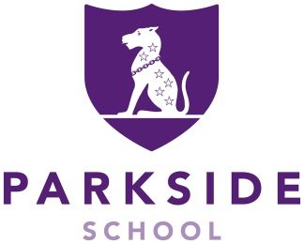
Parkside School

Nursery Practitioner

Interviews: TBC
Start Date: January 2024
Salary: Competitive
Location: Cobham, Surrey
Contract type: Permanent contract
Position: 8.15am to 3.15pm Monday to Friday during Term Time Only (with option to work at Holiday School during school holidays)

Parkside School is an independent Preparatory Boys School and co-ed Nursery, with a strong, nurturing and family ethos; set in beautiful grounds of 45 acres and only 40 minutes to London.

We are looking to appoint an outstanding individual with an NVQ3 qualification and experience of working in EYFS. The individual will need to be a motivated and empathetic practitioner providing a hands-on, fun, creative and innovative environment for the children, bringing enthusiasm to every interaction with those under their care.

This is an exciting opportunity to join a successful school and nursery dedicated to the highest standards of teaching, learning and care.

For further details of both the role and the school itself please review the Parkside website.

To be considered for the post please return your completed Application Form by the closing date as indicated on the advert to the HR Officer by email: hr@parkside-school.co.uk

SAFER RECRUITMENT STATEMENT: Parkside School is committed to safeguarding and promoting the welfare of children and young people and expects all staff and volunteers to share this commitment. Applicants must be willing to undergo child protection screening, including checks with past employers and the Disclosure and Barring Service.

IAPS boys’ day school
250 pupils aged 2 -13 years



September 2023

