August 2021

Dear applicant,

Thank you for expressing an interest in the post of Librarian at The Norwood School. This post is a permanent position and is advertised at scale point SO1 with an annual salary of £28,224 to £29,868 pro rata.

The successful applicant will play a pivotal role in supporting pupils’ literacy skills and developing their independent and personal learning skills. S/he will be a creative and imaginative individual who will make use of our performing and visual arts specialism to support learning, love of reading, like children and fit into the school’s philosophy that learning should be challenging and fun.

You will need to be someone who is full of innovative and creative ideas that will make our Library both exciting and a successful place to learn but also somewhere that showcases the excellent work that is done to promote learning skills and a lifelong love of reading.

S/he will need to have good IT skills, be a flexible and dynamic individual, outstanding interpersonal skills, patience and a real vision for the future of The Library within Norwood School and the local community.

If you believe that you have both the attributes and ideas to become an outstanding librarian then Norwood School would welcome your application.

Yours sincerely,

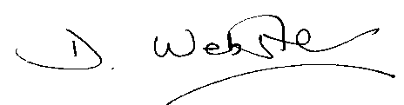

Denise Webster
Headteacher

