

Regional Director of Learning and Achievement – Bath Hub

Bath & Wells Multi Academy Trust, The Old Deanery, Wells
Salary: up to £70,000 per annum. This is currently under review.
Full time, Permanent

This is an exciting opportunity to work for an Academy Trust committed to high expectations and excellent provision for all learners.

As the Regional Director for Learning and Achievement you will have a responsibility for School Improvement for a allocated number of schools under the management and guidance of the Director of Learning and Achievement.
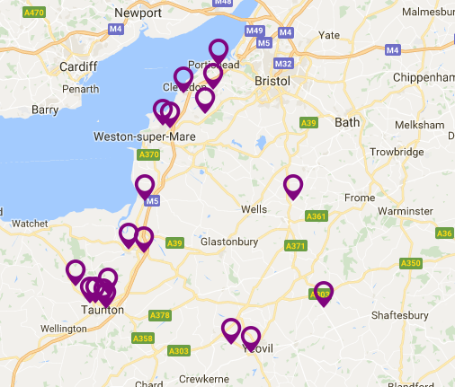
This opportunity has arisen due to the continued success of the Trust. We are currently home to 19 Primary Schools, and are increasingly sought after as a unique and distinctive option for schools within the Bath & Wells Diocese.
As an inspirational communicator, and innovative leader with strong educational background, you will provide strategic focus on attainment and progress ensuring our Schools have the highest quality support, challenge and intervention.
The successful applicant will lead and inspire others, they will build upon previous successes and address remaining challenges, making a real difference for our children.
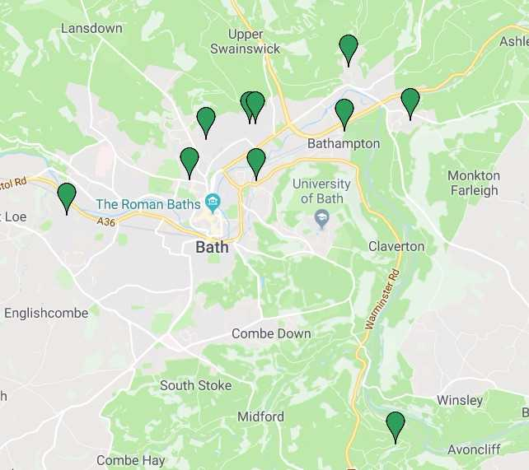
The successful candidate will have a responsibility for eleven schools initially within the Bath Hub and will provide overall effectiveness and an aspirational culture for all. You will be able to demonstrate a proven ability to lead and implement strategies for School Improvement and have excellent research, data analysis and reporting skills.

In return we can offer a competitive salary and benefits including; Access to the Teacher’s Pension Scheme with excellent training opportunities and CPD.
The Trust is committed to safeguarding and promoting the welfare of children and expects all staff to share this commitment. All posts are subject to satisfactory pre-employment checks.
Our current organisational structure of which you will be a part of is:

For full vacancy details and to apply please visit http://www.bwmat.org/vacancies/ For informal enquires please contact Teresa Wheeler teresa.wheeler@bwmat.org or on 07733 102704.

Closing date: 27th February 2018

The post holder will be required to regularly travel to schools within the Trust and will be allocated a given number of schools to oversee. It is anticipated that this particular post will have a focus on schools in the Bath area.

