Gosford Hill School

Design and Technology Faculty

The Curriculum

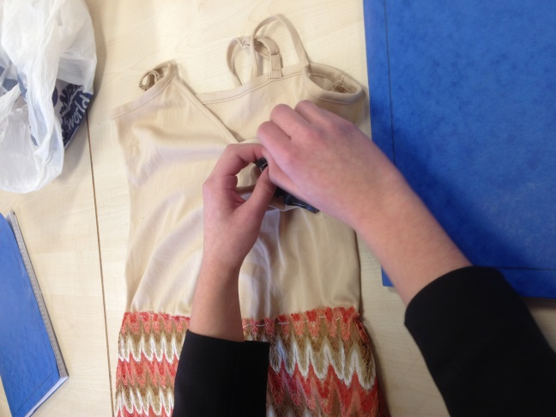
Students in Year 7 and 8 are taught in mixed ability groups and follow a rotation system. During Year 7, students study approximately 22 lessons of Food and Nutrition, Textiles and Resistant Materials. In Year 8, students complete two sets of shorter rotations of Food and Nutrition, Textiles, Resistant Materials, and taster lessons in Health and Social Care; which allows students to be fully prepared for their GCSE preference choices in March of Year 8. At Gosford Hill School we support the Design and Technology Associate by ensuring class sizes are kept within expectations ensuring a safe and bespoke working environment for students and staff.

GCSE syllabus is taught from Year 9 in mixed ability groups, following the AQA exam board qualifications. Students can choose from the following Design Technology areas: Food Preparation and Nutrition, Textiles or Resistant Materials. Within the faculty students also have the option of choosing to study BTEC First Level Two First Award Health and Social Care (GCSE equivalent), which also continues to be taught at post 16 study through BTEC Level 3 Diploma. This is a popular subject allowing a clear and consistent route for students wanting a career within the widespread multidisciplinary profession.

Design and Technology is widely taught through skill based learning and mini projects. This form of learning allows students to utilize and develop a wide range of practical skills and varied knowledge of materials and mediums. We actively seek to build on concepts taught in other areas of the school; such as extended writing, numeracy and key scientific principles.

The faculty is committed to ensuring that students are provided with the support and teaching needed to achieve their full potential. High expectations are set through challenging learning opportunities, and students are motivated to achieve through a caring, supportive approach. This is focused within the faculty through their learning and researching about the social, moral and cultural implications of design. We aim to ensure future students in our faculty understand sustainability and the environmental impacts of design globally.
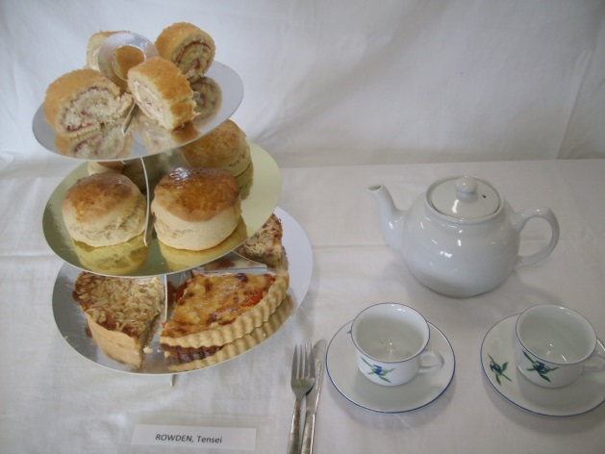
Extra-Curricular Provision

There are great opportunities for extra-curricular provision within the Design and Technology faculty. Design and technology based clubs and study support allow students to access a more personalised skills base, focusing and extending on knowledge of current activities within the school. Students can currently attends a Textiles club, and study support for all of the Design and Technology specialisms. Previously we have had the opportunity to offer a food club, and hope to reinstate this club after the Christmas break. Within the faculty, we have had guest speakers such as Oxfordshire Mind who completed a workshop with the KS5 Health and Social Care students. We have also had guest speakers such as a community nutritionist and ran a trip to visit an army base to view their catering facilities and practice. We also have close links with the in-house catering at school and an international hospitality business and plan to collaborate with these resources to stretch and challenge student’s understanding of Food Nutrition and Preparation, providing them with a real understanding of possible outcomes from studying the course.

Examination Results

Examination Results summer 2017
GCSE | No. of Students |  | %A*/A | %A*-C
AQA Food Technology | 23 |  | 13% | 69.6%
BTEC Level 2 Health & Social Care | 19 |  | 63.2% | 100%
GCSE AQA Resistant materials | 14 |  | 7.1% | 35.7%
A LEVEL | No. of Students | %A*-B |  | %A*-E
Diploma (* to two A levels) | 60% | 100% |  | 100%
* equivalent

Staffing, Resources and Accommodation

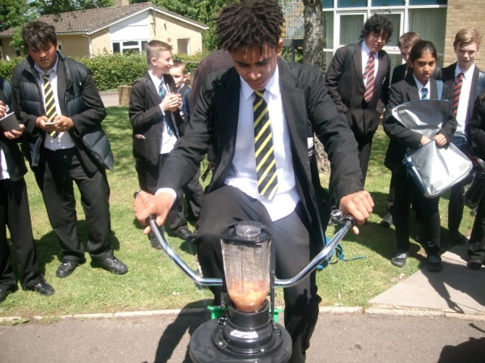
The Design and Technology Faculty currently have a specialist team of 5 subject teachers, covering all CGSE specialisms. Whenever possible, students are always taught by specialist teachers. We are a friendly, forward thinking team, that work together to achieve our goals as a faculty. We are supported by a full-time technician who covers all Design Technology areas.

The department consists of 2 fully functioning Resistant Materials workshops including; a 3D printer and laser cutter and forging equipment, a Textile room with 20+ sewing machines and a CAD/CAM embroidery machine, 2 Food practical rooms with 10 cookers in each, plus several rooms where Health and Social Care is taught.

Schemes of work are set out clearly across all key stages and we all share an open door and open resources policy, which helps ensure all of our staff are fully supported. All rooms are equipped with a projector, class sets of textbooks and a variety of teaching materials.

Informal visits to the school are welcome; please telephone to make an appointment to visit the facilities.

Gosford Hill School is an equal opportunities employer and is committed to safeguarding and promoting the welfare of children and young people. We expect all staff and volunteers to share this commitment. Due to this post having access to children and/or vulnerable adults, candidates will be required to undertake a Disclosure and Barring Service check. The possession of a criminal record will not necessarily prevent an applicant from obtaining this post, as all cases are judged individually according to the nature of the role and information provided.
Gosford Hill School operates a ‘No Smoking Policy’ for all new appointments. September 2016

