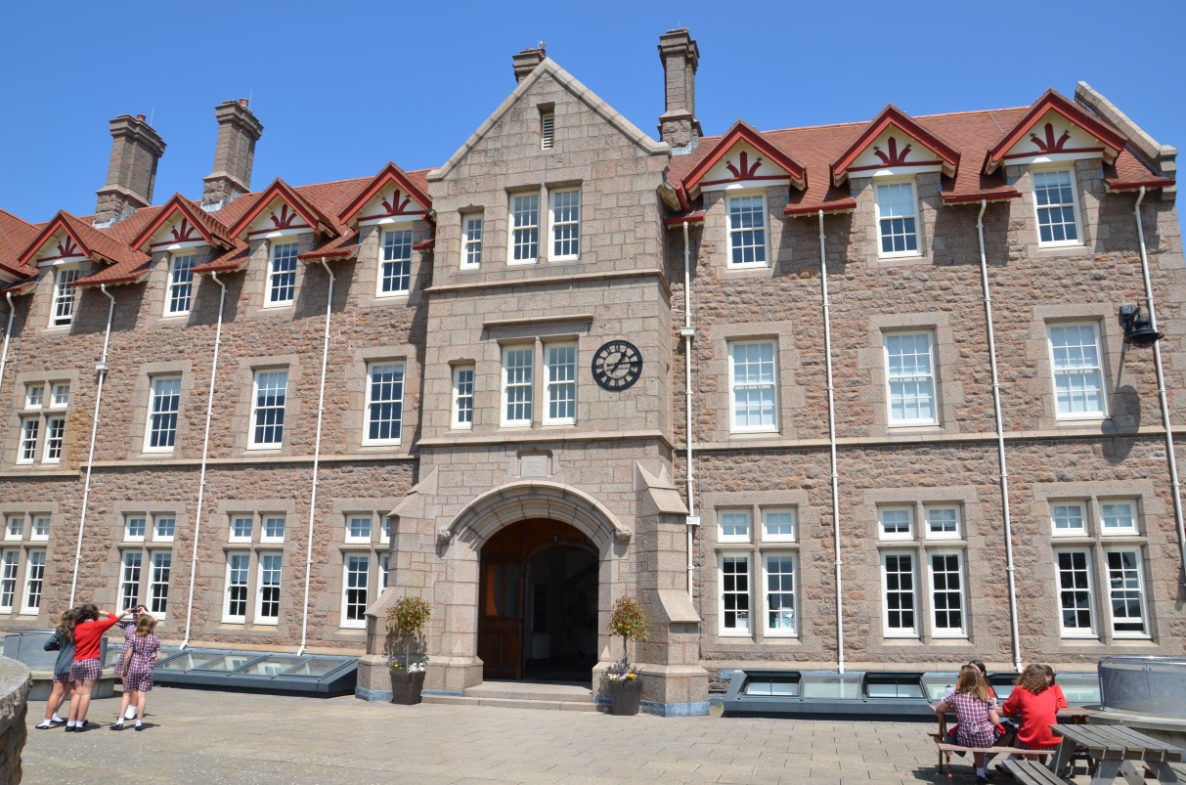


Co-ordinator of Computer Science

Required from September 2018

Thank you for your interest and welcome to our information booklet for the post of Co-ordinator of Computer Science at Jersey College for Girls. It is designed to give a flavour of life here at JCG, provide information to support your application and, with the College website, provide you with a snapshot of the myriad of varied activities that take place each day in College.
Founded in 1880, JCG has been at the forefront of girls' education in Jersey for over 125 years and has a well-deserved reputation for academic excellence and service to the island community.
Our students thrive on expert teaching, state of the art facilities and a vast range of extra-curricular, enrichment and expedition activities. They are enterprising, friendly and ambitious and they have wonderful purpose, energy and sense of service to others. Our staff care and are dedicated, creative and talented. Our exceptional academic results are a testimony to the personal and collective success of all at JCG. From here, our students go on to study at good universities, both in the United Kingdom and across the world.
Each day we strive to deliver the very best educational experience for our students. This experience should deliver outstanding academic achievement and, more importantly, nurture someone who is happy, well-mannered and able to find fulfilment in one’s service to others.
Inevitably, an information booklet and website can only partially reflect the reality of College life. I look forward to meeting short-listed candidates on Tuesday 6 March where interviews will take place at Jersey College for Girls. At interview, candidates will be given a tour of Jersey College for Girls, will meet our students and staff, and experience the warmth, vitality and ethos of intellectual curiosity that is JCG.
It is a privilege to lead this remarkable school and I would encourage you to apply for this vacancy.
Carl Howarth
Principal
Our Values

Aspire. Inquire. Excel. Belong.

Our Vision for member of staff at JCG
(This vision is not a statement of what is but what we as individuals strive to achieve. As such, the College strives to be the environment to facilitate and support this endeavour.)
Our staff recognise that they are one of their students' greatest influences and are passionate about what they do, drawing on the rich and fulfilling experiences they have in their lives beyond the classroom. They aspire to be the best they can be, are trusted and their professionalism is respected and valued by students, colleagues, parents and the wider community.
Our staff strive to pass on their passion for learning and inspire their students. They are focused on what is best for their students and endeavour to know and understand them.
Each of our staff contributes to a calm, collegiate, happy and purposeful organisation which cares for and invests in us as individuals and valued members of a team. Our staff care deeply for our students, encouraging them to achieve the vision JCG has for its students.
Our staff feel their career aspirations are known, valued and supported; that their professional learning is recognised, nurtured and tailored to them as an individual. Our staff engage with and participate in research and critical inquiry in order to refine their practice. Our staff feel empowered and encouraged to innovate, be creative, curious and to inquire, with space to re-design and re-think how we do things for our students, not only in their studies but in the wider aspects of their lives.
Our staff seek to excel as educators and in doing so, have a positive impact on our students, our colleagues and our community.
Our staff enjoy working in the exciting, vibrant JCG community, where colleagues and students possess a strong sense of belonging.

Our Ambition for each student

You will enjoy life to the full, value your friendships and achieve balance in your life. You will have a thirst for knowledge and already possess a broad understanding of the cultural, historical, geographical and scientific events and ideas which have fashioned your island and your world, and an eagerness to discover more. You will be a rigorous and imaginative thinker.

You will have a good range of hobbies and interests, including the Arts and sport, which you want to pursue. You will leave us with an excellent record of achievement for an academically-demanding course at university or employment which will lead to a stimulating career. You will have the ambition, motivation and staying power which will equip you to study independently and successfully at either. You will apply for internships, work experience and voluntary work in your holidays.

You will have grown as an individual who is happy, well-mannered and able to find fulfilment in your service to others. You will be thoughtful, open-minded and be able to lead. You will be conscious of the advantages you have enjoyed and of the opportunities and obligations such advantages should bring. You will want to have a positive impact on your community and the world.

You will have happy and lasting memories of your time at College and an admiration for those people who have nurtured and shaped your learning.

All our efforts and developments are dedicated to achieving this ambition.

JERSEY COLLEGE FOR GIRLS

JOB DESCRIPTION

Job Title: Co-ordinator of Computer Science
Responsible to: Head of Maths and Computer Science Faculty
Remuneration: MPS plus SA1
Time Allowance: .05

The aim of all posts at JCG is to sustain and improve the quality of learning of the students in the College. Teachers work with the Principal, Vice Principal, Assistant Head teachers and other Senior Staff to promote educational opportunities, equality of opportunity and a quality working environment for both staff and students.

Job Purpose

To provide high quality learning ensuring high levels of student success.

Principal Teaching Accountabilities

- Teach Computer Science across Key Stages 3 and 4 to achieve the highest academic standards and learning opportunities with the vision to develop the Key Stage 5 curriculum.
- Plan effectively to ensure that all individual student learning needs are met.
- Advise the Head of Faculty on issues relating to the learning and teaching of Computer Science and ensure effective resource management.
- Follow departmental policy for effective monitoring, marking and tracking of student progress and use assessment data to ensure all students have individual targets and are supported in all areas of their work.
- Ensure learning and teaching programmes take account of the latest developments in education and evaluate their impact upon teaching and learning, ensuring that appropriate use is made of ICT resources teaching.
- Attend and contribute to faculty and departmental meetings and take an appropriate share of the administrative duties of the department.
- Contribute to a full programme of extra-curricular opportunities.
- Undertake regular reviews of teaching practice and accompanying documentation as determined by the evaluation process of the school and faculty
- Contribute to parents’ meetings, the mentoring programme, staff teams, and reports and references for students as appropriate.
- Ensure all health and safety regulations are adhered to both on and off site.
- Be willing to undertake appropriate professional development and training as needed to keep at the leading edge of learning and teaching. e.g. subject developments and new qualifications or specifications.
- Undertake any other task as may be reasonably requested by the Principal.

PERSON SPECIFICATION

Person specification:

An ideal candidate for this post will have:

- A passion for and background in Computer Science and programming
- A related degree
- Strong interpersonal skills which display high levels of sensitivity, tact and diplomacy in dealing with difficult situations
- Good organisational and administrative skills
- An ability to take responsibility and a proactive approach to problem solving
- A keen interest in supporting student learning
- The ability to work collaboratively, to model good practice and maintain high levels of confidentiality
- Experience in actively supporting teaching staff and students in the completion of their work
- The ability to manage and motivate staff members to focus on what can be achieved
- The ability to work under pressure, prioritise and meet deadlines
- An ability to be able to demonstrate a strong understanding and commitment to the aims and ethos of the Maths and Computer Science Faculty at Jersey College for Girls

This job description is subject to review to ensure it meets the needs of the College.

Post holder _____________________________________ Date ______________

Principal ______________________________________ Date ______________

Appendix 1:

The Teacher’s Task

The DfE (Department for Education) and the representatives of the Teacher’s Unions (Jersey) have agreed the following statement of the Teacher’s Task in order to define more clearly the nature of teachers’ employment. It is their view that in this important work of educating Jersey’s children it is imperative that both teachers and Headteachers recognise the duty they owe to those children and the community. To this end the teacher is expected to maintain a professional commitment to their task and the Headteacher is pledged to a responsible and humane interpretation of this agreement.

The following provides a definition of the Teachers’ Task:

- Teach effectively to meet the needs of all pupils and to ensure discipline and safety within the school community.
- Plan, prepare, evaluate and modify as necessary personal teaching methods, work programmes and teaching materials in accordance with the DfE curricular policies and school schemes and standards.
- Mark and maintain records of pupils’ work in accordance with DfE and school policies.
- Promote the general progress and welfare of pupils in classes or groups or individually as part of the school’s pastoral and counselling arrangements.
- Assess and record pupils’ personal and social needs, development, progress and attainment.
- Provide or contribute to oral or written assessments and report on individual pupils and groups; consult and inform parents, co-operate with appropriate outside agencies in accordance with DfE and school policies.
- Contribute to and participate in corporate planning, self-evaluation, in-service training and professional development in assigned areas of the curriculum and pastoral arrangements; participate in related staff meetings and school events.
- Advise colleagues, co-operate with them on teaching programmes, methods, equipment and materials within assigned areas of the curriculum ensuring that appropriate administrative tasks are undertaken.
- Contribute and participate in the school’s pastoral, tutorial and guidance arrangements and undertake an appropriate share of the organisation and conduct of parental consultation and staff meetings.
- Contribute as required to the appointment, induction, professional development and assessment of junior colleagues, including new entrants to teaching.
- Accept an appropriate share of the administrative and organisational tasks within the school, including providing support for teachers, undertaking additional curriculum or pastoral responsibilities or holding senior posts.
- Ensure the safety and good order of pupils by carrying out an appropriate share of supervisions whenever pupils are authorised to be on school premises or elsewhere when the school is in session.
- Undertaking an appropriate share of all collective responsibilities including substitution for an absent colleague subject to guaranteed non-teaching time.
- Supervise support staff as required.
- Order and allocate appropriate equipment and materials in accordance with DfE and school policies and schemes.
- Co-operate as required with teachers in other schools and colleges on curricular, pastoral and administrative matters.

Computing at JCG
The aim of the Department is to inspire students to pursue a career in Computing, and to equip them to do this. Strong links have been developed between the Department and Jersey’s thriving Digital Sector. Students work with BBC Microbits, Raspberry Pi, and Robotics and have the opportunity to participate in coding projects internationally through the JCG -based International Women’s Academy.

The Computing Department is part of the Mathematics Faculty. There is one full time Computing teacher, one part time teacher and two technicians. There is a main PC lab well-equipped with work-stations and Smart board, and two Mac media rooms. There is a class-set of laptops, a Sixth Form study area equipped with PCs, and a Science computer area. A wireless network operates throughout the school. All students and staff have access to Office 365.

Computing is in a period of growth both in terms of student numbers and profile within the school. We are seeking a dynamic and resourceful leader with the vision to further drive the expansion of the subject.

The Curriculum

KS3
Years 7, 8 and 9: 1 hour a week

In Years 7, 8 and 9 students receive an hour of Computing each week. In Year 7, students are taught in Mathematics sets with a focus on a ‘linked but distinct’ connection between Mathematics and Computing. In Years 8 and 9 students are taught in teaching groups. Students at Key Stage 3 are taught Introductory Programming with Python, Excel Spreadsheets, Scratch applications, algorithms, and computer hardware giving them a broad grounding in computational thinking.

Students are encouraged to enter competitions and to participate in the local coding clubs. GCHQ Cyber First competition drew a large response.

KS4
Years 10 and 11: 3 lessons a week.

In Year 10 the students begin working on their two year GCSE course, studying the Edexcel 9-1 Computing course.

KS5

5 lessons a week

In the Sixth Form, alongside their A Levels, all students take elective courses and these may include coding, website building, or ICT development. It is expected that A Level Computing will be first offered from September 2018.

Why be a teacher at JCG?

The best testament about what it is like to be a teacher at JCG is the view of the teachers’ themselves.

The following quotes have been taken at random from the responses of individual staff to a question in a staff survey.

Question : What do you most like about your current job?

'I feel that there is a genuine desire to allow everyone to reach their full potential.'
'Inspiring students to succeed when they thought that they could not. Giving confidence and knowledge to students. Working with similarly motivated colleagues.'
'Opportunities to try something different, be creative. Teaching. Working in a great department. Excellent relationships with staff and students. Seeing students succeed. Running a department, making decisions.'
'The students I am privileged to teach and colleagues I am privileged to work alongside.'
'The students are endlessly engaging and their motivation to learn is exciting. My job offers constantly changing challenges and is certainly never dull! I feel supported by senior staff.'
'The fact that we all work together well as a team and we all support each other.'
'The potential of the students and their ability to embrace innovative teaching ideas and impress you everyday with their ideas and knowledge.'
'Working with the students and being part of what I see as a great team at JCG.'
'The supportive nature of my department and the lovely students who we teach.'
'The feeling that I'm making a positive difference in the classroom and in my wider responsibilities. I also like being part of a large and successful team.'
'Working with such talented and inspirational students.'
------------------------------------------------------------------------------------------------------------------------

Some comments from teachers ranging from those new to the College and those who have progressed their careers here:

Ed Palfreyman joined the College in the Summer Term 2016 and had this to say about JCG:

I arrived at JCG having taught at other schools across the UK and Jersey, both single-sex and co-educational. I have been impressed by the high levels of motivation in the girls’ approach to their learning. Amongst the staff there is a wide range of expertise and experience, but I can honestly say that I have never been part of such a supportive group of people. Expectations of staff and students are high, but there are structures and support in place to enable every member of the JCG community to reach their potential and to develop their studies and their careers, from tutors and counsellors to co-curricular and extension activities as well as professional development training.
I am also a parent of a Year 7 pupil and I have been delighted by the ease with which she has made the transition from Primary to Secondary school. This has been facilitated by a friendly and well-structured transition programme involving both staff and older pupils. The variety of extra-curricular activities on offer has been impressive and she has been made to feel very welcome in clubs from climbing to orchestra, hockey and JCGlee.

Simon Milner started in 2009
Teaching at JCG is every bit as rewarding as it is challenging. The students are highly motivated and endlessly engaging; members of staff are passionate, conscientious and supportive of their colleagues. I started at College as a Graduate Trainee teacher of English, and I was welcomed into the profession and given all of the help and guidance that is vital to making a successful start in teaching. Since then, I have had the pleasure of mentoring other trainee teachers, all of whom have flourished in the stimulating professional culture of the College.

JCG is an institution utterly committed to learning. Through rigorous academic study and a dizzying array of co-curricular opportunities, our students develop habits of collaborative inquiry, strategic thinking and cheerful perseverance. JCG students also learn to appreciate the privileges they enjoy and to adopt an ethically responsible perspective: through clubs like Fair
Trade and Amnesty International, students engage actively with social and political issues of global significance. The College is in the business of preparing young people for a life of learning that is only just beginning when they leave us to take their next, exciting steps.

As a teacher at JCG, you are also very much a learner. I have benefited enormously from the developmental opportunities afforded staff at the College. As well as helping me to nurture and sustain my love of the subject that I teach, JCG has allowed me to further my career by taking on responsibilities for areas of the curriculum, aspects of student journalism, and – more recently – for promoting and leading research driven learning. Life at JCG is fast-paced and demanding but the opportunity to thrive and grow alongside the College is one I would urge prospective applicants to seize.

Caroline David joined JCG in September 2015

“The move to the island for me was a straightforward process and the travel company were great! I was lucky enough to stay with friends for the first 3 months, to settle into the job and sort out all the essential registration tasks. I have made friends easily and I feel I have achieved a good work/life balance. Jersey is a great place to live, its near enough to visit the UK to see family, it has beautiful beaches and lots of lovely restaurants. For a small island there is lots going on and I have gained much more than just a great job from the move.

Being a teacher at JCG has renewed my love of teaching. The College allows me to implement innovative new programmes to affect students outcomes in a positive way.
We set high expectations here and are concerned with the success of every single student. It is such a privilege to work at JCG, the staff are talented, dedicated and supportive, the students are wonderful young people and the parents are committed and involved. I believe every day is a new opportunity to learn and my main goal is to prepare my students to be successful for the duration of their school years and beyond. JCG is now my second home where I feel welcome and appreciated. I am very happy that I took the plunge, it has been the most positive move I have made in my career and life so far.

Another member of staff said: I have cherished my time working at JCG. I haven’t been teaching long but I have had the opportunity of working in a range of schools and as soon as I walked into JCG on my first day and the doors were held open for me by the students, I knew I would love working here. I remember once the Principal reading out in assembly something that a past pupil had written and they described the school as making them feel safe. That is also true of how the school makes teachers feel. Everyday working at JCG is a surprise in that I don’t know what obscure and wonderful question I may get asked or what accomplishments will be read out in assembly but one thing that has remained constant is the feeling that every day I was coming to work in a wonderful school with wonderful people and that made me feel safe. I also feel that I have had that effect on the students too. I feel that my nurturing approach as a teacher has meant that the students do look up to me and do respect and trust me. For students to build up trust and respect with their teachers I think is an invaluable and integral part of enriching their education.

Information on Jersey College for Girls
www.jcg.je

Please take a look at our website where you should find all the information you need on the College. However, indicated below are some of the things you might want to access immediately.

On our website, please do look at our:

Vision for a student and member of staff at JCG - this outlines what our aspirations are for every student at the College and guides us in our day to day work with the students

Our A level and GCSE prospectuses outline our academic curriculum and are available to read here.

By clicking on ‘About us’ you will be able to follow links to:

College Prospectus - this will outline our Values of Aspire, Inquire, Excel and Belong which guide us in everything we do at the College.
Academic results - where you will find a summary and the details of our results.

By clicking on ‘School Life’ you will be able to follow links to:

Curriculum - information on the Faculties and all other aspects of the curriculum.
Extra-curricular - with downloads for the enrichment programme and extra-curricular activities.
Inquiring minds lecture series - outlining how we aim to extend the learning of the students beyond the taught curriculum.



How to Apply

Employment opportunities will give you access to documents outlining what you will need to know about working in Jersey. To see what it is really like to live on a beautiful island—click to watch the short Jersey Tourism 2014 TV Advert with our very own Alumni professional singer and song writer Nerina Pallot.

The post is available for September 2018. Salary is in accordance with the Jersey Scale of Salaries

Jersey College for Girls is a school that constantly strives to excel in every area of school life and if you would like to be a part of our team please apply through the States of Jersey by going to the www.gov.je website.

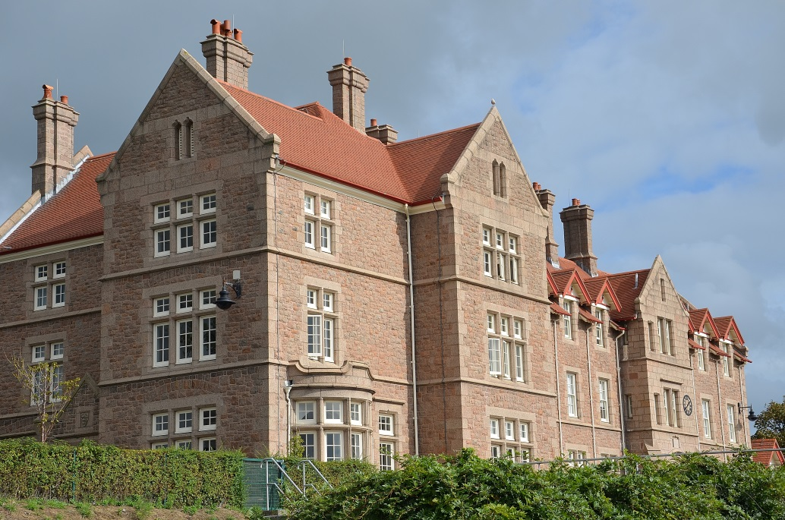

If you would like to speak with someone about this opportunity please do get in touch with Mr Andrew McGarva, Assistant Headteacher, at a.mcgarva@jcg.sch.je or on 01534 516215.

Applications are due by 18th February 2018 and interviews will take place on Tuesday 6th March 2018.

Thank you for your interest in this position.



