
Application Pack
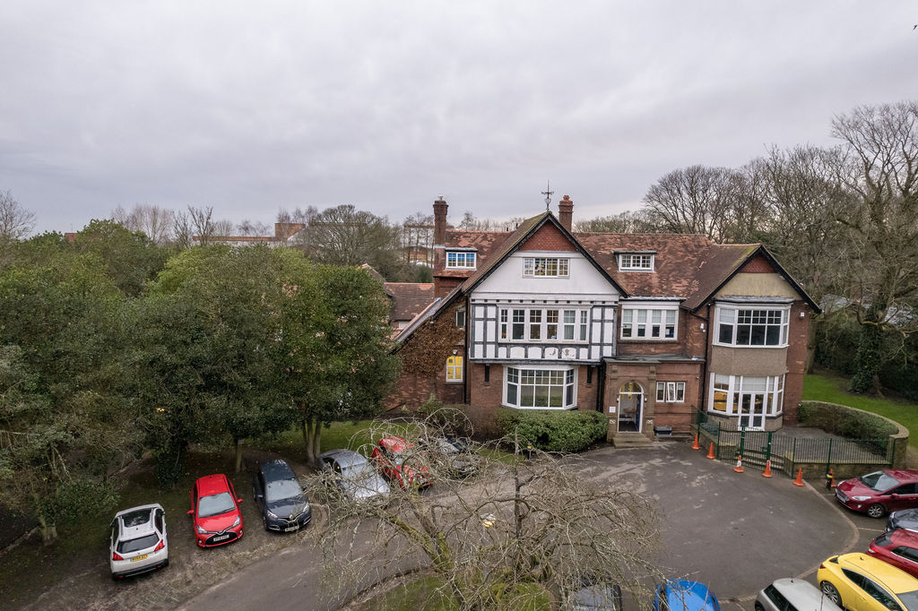

Data and Timetable Officer

Contents

Page 3 – Letter of welcome from the Headteacher
Page 5 - Context of the School
Page 6 – Advert
Page 7 – Job description for Data and Timetable Officer
Page 9 – Person Specification
Page 10 – Application details

Welcome Letter from the Headteacher

Dear Applicant,

Thank you for your interest in the position of Data and Timetable Officer at The Acorns School.
The Acorns School is a short stay Pupil Referral Unit for 11-16 year old pupils who have either been; permanently excluded, or who need respite in the form of interventions. We are located in Ormskirk and cater for pupils from the surrounding locality and also further afield.
We believe in a child centred approach and “learning to achieve” is part of our caring ethos and culture.
We aim to support our young people to learn to make steps to improve and enjoy achieving success.
Together we strive to provide a caring, structured learning environment in which all pupils can develop academically, socially and emotionally and in which pupils and staff feel safe, secure and valued.
We offer an enriching, educational environment for pupils who have experienced difficulties in school. In our school pupils are accepted, valued and feel safe. We assess pastoral and learning needs and plan for progress. We give time to pupils. This is so they can reflect on and reassess their difficulties, build self-esteem and develop meaningful relationships.
The Acorns provides a broad and balanced curriculum designed to capture pupils’ interests and prepare them for life. We aim to improve each pupil’s academic performance, ability to learn and social and emotional skills so that pupils are able to return to school, further education or enter the world of work.
We work productively and collaborate with parents, carers, other schools, training organisations and other appropriate agencies for the good of all pupils.
We want our young people to ‘learn to achieve’.

We are seeking a well-qualified, enthusiastic and committed Data and Timetable Officer to be part of our team.

We are committed to safeguarding and promoting the welfare of children and expect all staff to share this commitment. The successful applicant will be subject to an enhanced DBS check.

We look forward to hearing from you.

Yours Sincerely,

Mrs J Hodson
Headteacher

Context of the School

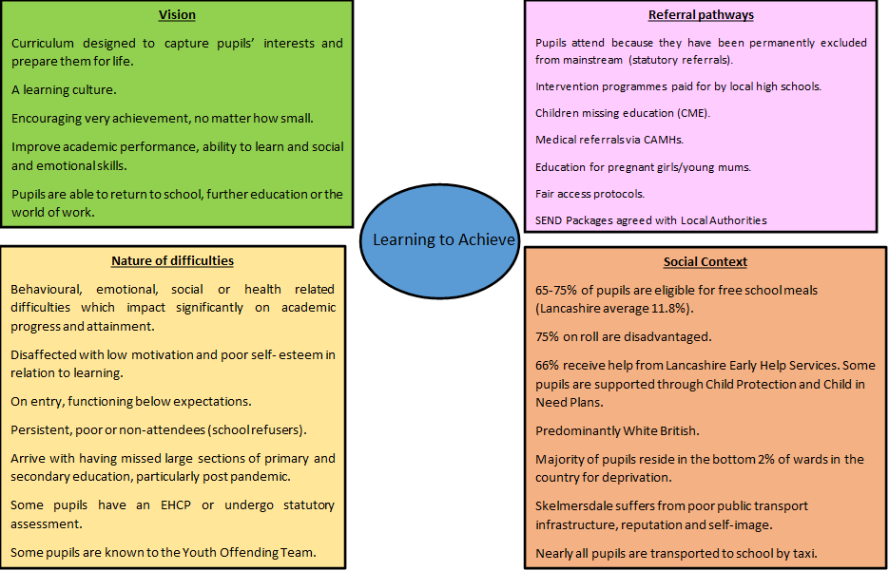

Advertisement

Data and Information Officer permanent Term Time only plus 2 weeks – one of which must be the week of the summer GCSE exam results (37 hrs per week)
Grade 7
£24677 - £28370 (Pro Rata)
£27,852 - £32,020 (Full Time Equivalent)
Data and Information Officer.
Applications are welcome from colleagues able to offer the following skills/ experience:
The Acorns School has an exciting opportunity for a dedicated and enthusiastic person to co-ordinate the data and Management Information Systems (SIMS), taking a leading role in planning, development, design and monitoring of these within the school. The role involves being part of the school business team, reporting to the School Business Manager.
The school is situated in pleasant surroundings and employs 28 staff. It serves the West Lancashire district and occasionally pupils from outside that area. The school is commissioned by the local authority to provide an education for the following categories: pupils attend the school as a result of permanent exclusion or for medical needs on the advice of a hospital Consultant or CAMHS professional. The school is commissioned by local mainstream secondary schools to support pupils who may be at risk of exclusion or who are having difficulties in school for a variety of reasons. Acorns also takes young people on roll who are unable to access a mainstream school for other reasons and this usually includes being new to the area, returning from home education and pupils in year 11 unable to find a school place. Throughout the year, the pupil roll increases and groups are subject to change.
The ideal applicant would need to be a positive, flexible and resilient individual who easily adapts to change and is a good team player always willing to support colleagues and share expertise. Applications are particularly welcome from candidates who have experience of working in a similar environment. However, if you believe you have the right skills and mind-set please do not hesitate to apply indicating how your strengths can assist the school in moving forward. CPD is given the highest priority and new staff are mentored by established colleagues.
It is strongly advised that you visit the school as you will be able to see its clear strengths and facilities. Please contact Debbie Williams School Business Manager to arrange to visit.
Email: d.williams@westlancspcss.lancs.sch.uk T: 01695575486
Closing date: 29th September 2023 Shortlisting: W/C 2nd October 2023 Interviews: TBC

Job Description – Data and Timetable Officer

Please note that under the Criminal Justice and court Services Act 2000 it is an offence for an individual who has been disqualified from working with children to knowingly apply for, offer to do, or accept or do any work in a regulated position. An individual is disqualified from working with children if he/she is included on certain lists held by the Criminal Records Bureau, or has been disqualified from working with children as part of a sentence.

Post title: Data and Timetable Officer
Directorate: CYP Schools |  |  |  |  | Location | The Acorns School, Ormskirk
Establishment or team: |  | School Business Office |  |  |  | Post number:
Grade: | Grade 7 |  | Staff  responsibility: | Yes |  | Essential Car user: | No
Scope of Work – appropriate for this post:
- Responsible for all aspects of the day-to-day management of management information systems (SIMS and Class Charts), including inputting, analysing and reporting of data
- To assist with the preparation of reports using a wide range of data sources, including the analysis of pupil achievement data to inform SLT.
- To assist with recording and reporting of attendance data.
- Produce staff and pupil timetables for the beginning of each academic year and then update as required throughout the year.

Accountabilities/Responsibilities – appropriate for this post:

Administrative/Teacher/Pupil Support
- Ensure timely circulation of timetables to staff and pupils and respond to related enquiries through the year.
- Manage the school’s management information systems, troubleshooting any issues when required.
- Provide data to school partners when required, including census and redetermination data.
- Provide appropriate staff training and guidance in the use of the school’s management information systems.
- Support SLT with appropriate data-related tasks when required.
- Provide analysis of examination results for staff and governors at all levels
- Any other duties commensurate with the role.

General Duties
- To work within school policies and procedures.
- To contribute to the provision of an effective environment for learning.
- To support the promotion of positive relationships with parents and outside agencies.
- To attend skill training and participate in personal/performance development as required.
- To take care for their own and other people's health and safety.
- To be aware of the confidential nature of issues.
Additional Information:

Prepared by: | Joanne Hodson | Date: | 24.4.23

PERSON SPECIFICATION FORM
Job Title: Data and Timetable Officer |  |  | Grade: 5
Directorate for Children and Young People |  |  | Post Number:
Establishment/Team: The Acorns School

Requirements  (on the basis of the Job Description) |  | Essential (E)  Or  Desirable (D) |  | To be identified by: Application Form (AF),  Interview (I),  Test (T),  Other (specify)
Qualifications
Educated to Grade C/4 or above (or equivalent in English and Maths |  | E |  | AF
Willingness and ability to obtain and/or enhance qualifications and training for development in the post |  | E |  | AF
Experience
Previous experience of working with and interpreting data |  | E |  | AF/I/R
Awareness of data protection legislation |  | E |  | AF/I/R
Successful experience of working in a school environment |  | D |  | AF/R
Working knowledge of SIMs and/or Class Charts |  | D |  | AF/I/R
Knowledge/skills/abilities
Establish successful relationships at all levels and have good communication skills both verbal and written |  | E |  | AF/I/R
Ability to work within a team |  | E |  | AF/I/R
Ability to efficiently manage and prioritise workloads |  | E |  | I
High attention to detail with accountability for accuracy |  | E |  | I
Well organised, proactive and able to thrive under pressure. |  | E |  | AF/I
Other (include special requirements)  1. Commitment to Equality & Diversity  2. Commitment to Health & Safety |  | E |  | I
Prepared by: | The Headteacher | Date: |  | 25.4.23
Note: We will always consider references before confirming an offer in writing.

Application Details

 |  |  |  | 
 | Private and Confidential | Application No. |  |  | Job Ref No.

Lancashire County Council as an equal opportunity employer intends that no job applicant or employee will receive less favourable treatment because of his or her sex, marital status, race, colour, nationality, national origins, ethnic origins, faith, sexual orientation or disability, nor be disadvantaged in any unjustifiable way by any other condition.

Please read the accompanying note ‘How to complete the Application Form’ before completing this form
1 |  | Application for the post of Data and Timetable Officer
 |  | Section/Location/School/Establishment |  | The Acorns School 43 Ruff Lane, Ormskirk |  |  | Grade
 |  | To be returned by

2 |  | Title |  |  |  |  |  | Forename |  |  |  |  |  |  |  |  |  |  |  |  |  |  | Surname
 |  | Previous name(s)
 |  | Home Address
 |  |  |  |  |  |  |  |  |  |  |  |  |  |  |  |  |  |  |  |  |  |  |  |  |  |  |  |  | Postcode
 |  | Telephone Number(s)  Please indicate a preferred method of contact. |  |  |  |  |  |  |  | Home |  |  |  | Preferred |  |  |  |  |  |  | Mobile |  |  | Preferred |  | Work |  |  |  | Preferred
 |  |  | May we contact you at work? |  |  |  |  |  |  |  |  |  |  |  |  |  |  | Yes |  |  |  |  |  |  |  |  | No
 |  |  | Email address
 |  |  |  |  | If you supply an email address you are agreeing to receive all further correspondence regarding your application via email.
 |  | National Insurance number

3 |  | Present post/job title
 |  | Name and address of present employer
 |  | Date appointed |  |  |  | Salary/grade |  |  |  | Notice period
Previous employment and voluntary experience
(Please give exact dates and indicate the reasons for any gaps in employment records)
 | Employer |  |  |  | From |  | To |  | Post/job title (please indicate if in local government and give the grade) |  |  | Reason for leaving
DO NOT TYPE BELOW THIS LINE - FOR ANY FURTHER INFORMATION PLEASE ATTACH A SEPARATE SHEET.

4 | Education (details of Secondary Schools, Colleges, Universities and Professional Education)
 | Schools/Colleges/Universities and Professional Education  (including start and end dates) | *Qualifications obtained  (including Awarding Body, grades and dates)

*Certificates for qualifications shown as essential will be checked at interview
5 | Current course of study (if any) and the date you expect to complete it

6 | Details of any other specialised training or qualifications not covered in previous sections (e.g. short courses, on-the-job training, etc.)
 | Membership of professional bodies
You must be registered with the HCPC to practise as a Social Worker
Health and Care Professions Council (HCPCC) registration number
HCPC Registration date

7 | Experience or achievements

Give a concise account of relevant experience, current duties, or achievements in support of this application, or the relevant competencies identified in the Person Specification. Please include all those related to the list of essential experiences, skills etc. for the post set out in the Person Specification.
Also include any appropriate voluntary and other interests (membership of relevant societies etc.)
Please use an additional sheet if necessary.
DO NOT TYPE BELOW THIS LINE - FOR ANY FURTHER INFORMATION PLEASE ATTACH A SEPARATE SHEET

8 | Disclosure of Criminal Background (please refer to enclosed advisory notes)
 | Do you have any convictions, cautions, reprimands or final warnings that are not "protected" as defined by the Rehabilitation of Offenders Act 1974 (Exceptions) Order 1975 (as amended in 2013).? |  | Yes | No |  |  | (Click as appropriate)
 | If you answer yes, please detail offence(s) including date(s) and sentence(s) where relevant, in a sealed envelope, marked confidential and take along to interview if successful.
You may be entitled to answer 'no' to this question even if you have been convicted of a criminal offence in the past, however certain types of employment which involves contact with children and / or vulnerable adults are excluded under Rehabilitation of Offenders Act 1974 (Exceptions) Order 1975 (as amended in 2013). It is therefore suggested that you take appropriate advice if you are in any doubt as to the correct answer to give.

Please note the amendments to the Exceptions Order 1975 (2013) provide that certain spent convictions and cautions are 'protected' and are not subject to disclosure to employers , and cannot be taken into account.
Guidance and criteria on the filtering of these cautions and convictions can be found on the Disclosure and Barring Service web site.
If this post involves working with children or vulnerable adults
I certify that I am not included on the Children’s Barred List or Adults’ Barred List maintained by the Independent Safeguarding Authority, that I have not been disqualified from working with children or vulnerable adults and I am not subject to any sanctions imposed by a regulated body or subject to any ongoing investigation into any matter which may bring into question my suitability for the post applied for.
 | Signed: |  |  |  | Date:

9 | Do you hold a current full driving licence for a car  (or other relevant vehicle)? (Click as appropriate) | Yes | No | Not required for post

10 | Do you consider yourself to have a disability, or to be a deaf person?  For a definition, see our advice note ‘How to complete the application form’. | Yes | No (Click as appropriate)

11 | With your agreement, the County Council will provide your contact details to Trade Unions for recruitment purposes, so that they can contact you with information about membership. Shared details will include name, address, job title and location. If you don’t agree to your information being passed on to Trade Unions, please tick the box

12 | Canvassing directly or indirectly will disqualify candidates. State whether you are related to or have a close relationship with any existing employee or employer (including councillors and governors)

13 | By submitting this application form, I certify that the information contained in this application form is accurate and true. I give my explicit consent to the processing, transfer and disclosure of all information submitted by me during the recruitment process and throughout any subsequent periods of employment for pre-employment checks, equal opportunities monitoring, payroll operations and training and absence records.  I understand that by deliberately giving false or incomplete answers I will be disqualified from consideration for this post or, if I am appointed, may be liable to summary dismissal with possible referral to the police.
 | Signed: |  | Date:

Details of Referees
Please give the name, address and occupation of two referees and state their relationship to you (e.g. employer/ supervisor/tutor). Where appropriate, one referee should be your current or most recent employer. Please refer to the guidelines for advice on appropriate referees.
The Authority reserves the right to seek any further references deemed appropriate.
1 |  |  |  |  |  |  | 2
Postcode |  |  |  | Telephone No. |  |  | Postcode |  |  |  | Telephone No.
Email address |  |  |  |  |  |  | Email address
Relationship |  |  |  |  |  |  | Relationship

When completed this form should be sent to the recruitment manager.

Please note that, in the interests of economy, we will not acknowledge receipt of your application. If you have not been contacted within 28 days of the closing date, you should assume your application has not been successful. You may telephone Ask HR if you wish to check on the progress of your application, quoting the job reference number.

Recruitment Monitoring in Employment
MONITORING JOB APPLICANT’S FORM
All applicants for jobs must complete this monitoring form to enable us to fulfil responsibilities placed upon us under legislation in relation to the monitoring of applicants by racial group and to assist us in the elimination of unlawful discrimination, the promotion of equality of opportunity and good race relations between people of different racial groups.
Please return this form with your completed application form to the address given in the advertisement or with the job details.

This information will be treated as strictly confidential and will only be used for monitoring purposes. Details will not be available to members of the Selection Panel.

Details of the job you have applied for
Directorate/DSO: |  |  | Job title
Job Ref: |  |  | Grade:
(if known)

1.Name (in block capitals) |  |  | 5.Please check the box which best describes your ethnic/cultural/racial origin |  |  | 6.Do you consider yourself to have a disability or to be a deaf person?  (Please see the definition of disability in the advice note ‘How to complete the application form’.) |  | yes  no
 |  |  | (O) | White British |  |  |  | yes  no
 |  |  | (9) | White Irish |  |  |  | yes  no
 |  |  | (H) | Any other White background |  |  |  | yes  no
 |  |  |  | (please type in) |  |  |  | yes  no
2. I am:  (Please check the appropriate box) |  |  |  |  |  | 7. How did you find out about this job?  (Please check the appropriate box)
 |  |  | (J) | Mixed White and Black Caribbean
 |  |  | (K) | Mixed White and Black African
MALE | FEMALE |  | (L) | Mixed White and Asian |  | Internal circular | Job centre
 |  |  | (M) | Any other Mixed background
 |  |  |  | (please type in)
 |  |  | (4) | Asian or Asian British Indian
3. I consider my marital status to be  Please note: If you are widowed or divorced and you live alone, please check ‘single’. |  |  | (5) | Asian or Asian British Pakistani
 |  |  | (6) | Asian or Asian British Bangladeshi
 |  |  | (8) | Any other Asian or Asian British background
 |  |  |  | (please type in) |  | Newspaper/journal  (please say which) | Internet  (please say which site)  or other source…
Single | Married |  |  |  |  | Newspaper/journal  (please say which)
 |  |  | (1) | Black or Black British Caribbean
 |  |  | (2) | Black or Black British African
 |  |  | (N) | Any other Black or Black British background
4.Date of Birth |  |  |  | (please type in)
 |  |  | (7) | Chinese
 |  |  | (A) | Any other ethnic group |  | Thank you for your assistance.  Your co-operation will help  promote equality of opportunity
 |  |  |  | (please type in)

DATA PROTECTION
The information you supply about yourself as part of the application procedure is handled according to the requirements specified in data protection legislation. This includes the Data Protection Act 1998 and the General Data Protection Regulation.

Information you supply as part of the application process will be used for recruitment purposes and, if you are successful, for subsequent employment purposes. If you are unsuccessful, your application is retained for a maximum of 12 months from the closing date and then confidentially destroyed. Equal Opportunities information is anonymised and then used for statistical monitoring purposes.

The Lancashire County Council contact for data protection matters is:

The Data Protection Officer
PO Box 100, County Hall, Preston, PR1 8XJ

NB: Please do not return your completed application form to this address.

FINAL CHECKLIST
Please ensure that you have:

- Filled in all relevant parts of the form
- Signed and dated the form
- Correctly addressed the return envelope as directed on page 7
- Completed the monitoring form (this is essential if your application is to be
considered)
- Read and understood the Data Protection Act and the General Data Protection
Regulations Statement details above
- Correctly responded to the question on criminal convictions.

APPLYING FOR A JOB WITH LANCASHIRE COUNTY COUNCIL

IMPORTANT ADVICE ON COMPLETING THIS APPLICATION

Your application form plays an important part in your selection. Your completed form is the only basis for considering your initial suitability for the post. Please ensure you address all the essential requirements listed in the specifications. The following advice should help you to complete the application form as effectively as possible.

SOME POINTS TO BEAR IN MIND BEFORE YOU START

- Look carefully at the job description and application form. Ask yourself why you are interested in the job. Don’t copy the same application for a series of jobs.

- Read the Employee Specification carefully. This outlines the type and range of skills/experience etc that we would like the candidate to possess or have the potential to develop.

- Try to complete the form in a concise, well organised and positive way.

- Please use the application form provided, continuing on a separate sheet if necessary. Please do not send standard details of your own, i.e. in the form of a curriculum vitae, unless specified in the advertisement.

- Please remember to complete the Monitoring Job Applicants Form on page 9, as this is essential for the County Council to determine whether its Equal Opportunities Policy is working with regard to employment.

Please note that we are only able to employ nationals of European Economic Area (EEA) countries, citizens of Switzerland and those legally entitled to work in the UK. Lancashire County Council does not hold a sponsorship licence and is unable to employ non-EEA nationals under tiers 2 or 5 of the points-based system. If you submit an application form and are shortlisted for interview, you will be required to produce documentary evidence of your right to work in the UK.

The Disability Discrimination Act 1995 defines a disabled person as:
(Relevant to question 10 on page 7 and question 6 of the Monitoring Job Applicants Form on page 9) ‘A person with a physical (including sensory) or mental impairment which has a substantial and long term adverse effect on their ability to carry out normal day to day activities.’ Or someone who has had such a disability but is now recovered. Or someone with a severe disfigurement.

APPLICATION FORM

The following headings correspond to some of the appropriate sections in the application form:
Post applied for: | The full job title should be completed and the relevant School shown.
Name and Address: | Make sure that your full name (including any previous names), address and telephone number (if you are on the telephone) are legibly written.
Present Appointment and Previous Employment | Starting with your first post, ending with your present post, list all the employers you have worked for, provide job titles and the period you worked for them. This information may be used to assess whether you meet the experience requirement for the vacancy. Check that the dates are correct and in order. Please also provide an explanation for any gaps in employment.
Education and Professional Qualifications: | Give a list of formal and informal qualifications. Information may be necessary here to assess whether you meet the required qualifications for the vacancy. Ensure that nothing important has been omitted. Please include the name of the awarding body, the grade and the date the qualification was obtained.

