

Published: 19 November 2021

Application deadline: 9.00 am 4 December 2021

Candidate brief

Sports Fellow

(from September 2022)

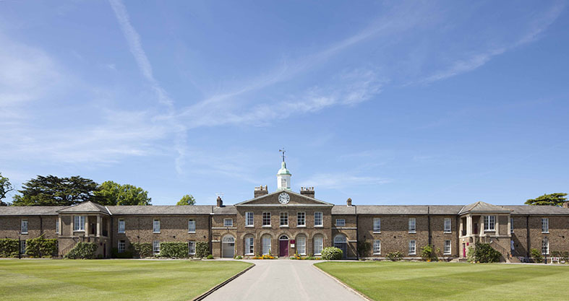



Life at Haileybury

Haileybury is an outstanding British independent

co-educational boarding school. We offer modern boarding and day provision for eight hundred boys and girls aged 11–18. Established in 1862, we are situated on a glorious, historic 500-acre campus in Hertfordshire, just 20 miles north of London and 35 miles south of Cambridge.

Ours is a happy, purposeful and tight-knit community where more than 90% of the teaching staff live in College accommodation, either on campus or within walking distance of our beautiful site. This helps create a unique atmosphere in which to work.

We focus on creating a warm, nurturing environment which is particularly evident in the Lower School, a “school within a school” for Years 7 and 8, which includes its own Boarding House, Highfield. Boarders and day pupils join one of 12 houses when they enter the main school (Years 9 to13). This creates strong “family” groups of about 55 pupils per House.

An appreciation of the wider life of a seven-day-a-week boarding school is a prerequisite for a successful career at Haileybury, along with a willingness to immerse oneself in the boarding and co-curricular programme. The three aspects to every full-time teaching role are: teaching, tutoring in a Boarding House and involvement in co-curricular activities. Teaching staff are also expected to attend Chapel services.

* The School provides a welcoming, vibrant community whether you are a young, single NQT or a more established professional with or without a family.
* The School puts great emphasis on excellent CPD and career development opportunities with regular internal training, and opportunities to pursue further training outside of the School.
* There is also the opportunity for great music making for musicians of all abilities and opportunities to be included in concerts.
* There is a vibrant sporting community with opportunities to join staff sports teams and use our world class facilities.
* Members of the teaching staff are part of a wider Haileybury family which comprises our sister schools in Kazakhstan, our alumni and Haileybury Turnford, a local state maintained academy sponsored by Haileybury.
* There is easy access to all the academic, cultural, social, sporting and retail facilities on offer in London and Cambridge.





Curriculum and results

At Haileybury, we encourage academic excellence and promote intellectual curiosity. A combination of a robust, creative curriculum, inspirational teaching and an atmosphere in which the progress of every pupil is important, ensures that the learning at Haileybury is of the very highest quality.

We are an academically selective school, providing a wide range of (I)GCSEs and in the Sixth Form a choice of A Level or the International Baccalaureate (IB) Diploma. Our all-round pastoral care extends to pupils and staff alike and is underpinned by our open, embracing Christian ethos that welcomes equally those of faith and no faith. This nurturing environment, together with extensive co-curricular activities, creates confident individuals, with leadership, team and social skills. We deliver what many schools only promise – a truly holistic education in which our pupils are prepared for university and life beyond as global citizens.

Haileybury combines excellent scholarship with forward-looking teaching. In pupils and teachers alike, our aim is to nurture a love of learning and a desire to explore new ideas. In so doing we prepare pupils to develop academically and to achieve at their highest level. Their endeavours are supported by outstanding facilities, study resources and enrichment opportunities.

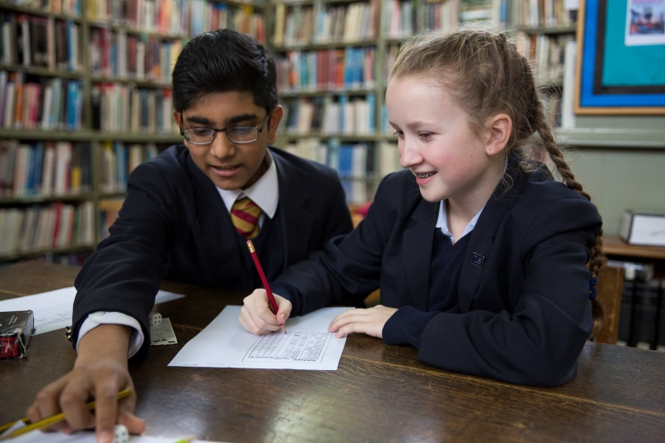



Sport at Haileybury

Sport is integral to life at Haileybury and we encourage sporting excellence on both an individual and team level. At the same time we strongly foster a “sport for all” mentality throughout the school and all our pupils participate within our sporting curriculum.

The week has three primary sporting slots with Tuesday, Thursday and Saturday afternoons being devoted to sport throughout the year for the Main School. The Lower School has sport on a Wednesday afternoon and a Saturday morning. In and around this, there are lunchtime sessions, afternoon sessions and further training takes place on most evenings too.

Haileybury has a history of producing players who go on to perform at an elite level with a number of Old Haileyburians playing for England currently (Lizzie Bird, Jamie George, Nick Isiekwe and Sam Billings) and others at a professional level: Nick Page at Loughborough Students and GB development squad hockey, Vicky Hewett at Surbiton HC, Tom Billings world #1 rackets and Zara Everitt & Isabel Stibbs at London Pulse Netball.

We currently have 66 representative players in the school across cricket, netball, hockey, rugby, lacrosse, football, many of whom are nurtured through the Haileybury High Performance Programme as well as through the regular sports coaching programme.

**Staffing**

We have directors of the focus areas: S&C, rugby, cricket, hockey and netball. In addition to these roles, all the teaching staff are obliged to be part of the coaching structure. Our teaching staff includes high calibre sports people in their own right and are a huge asset to the programme.

**Sports Schedule**

Boys will typically play rugby, hockey, football and cricket through the seasons of the year and the girls’ hockey, netball, lacrosse, cricket.

**Results**

The focus sports are extremely strong with girls’ hockey being a leading force in schools’ hockey where we were national champions in March 2020 so too the boys’ rugby, where we finished top 5 in the country in 2019. Lacrosse, cricket and netball are following the same trajectory with U13 girls winning the national netball title in Summer 2021.

**Facilities**

We thus have the best range of facilities in the East of England, with acres of rugby and football pitches, 5 cricket squares, two astros, a large sports complex, rackets and squash courts, 8 netball courts and an indoor tennis centre, all on a beautiful campus a short hop from London.

For the latest up to date information on Haileybury Sport, please visit:

[www.haileyburysport.com](http://www.haileyburysport.com)



The role

Haileybury wishes to appoint a number of Sports Fellows. The primary responsibility of the post holders will be to support the delivery of the sports and co-curriculum programmes. This will suit a new graduate with an interest in entering the teaching or coaching profession or someone who is looking for a year’s professional experience before following a career outside education.

**Personal characteristics:**

The successful applicant(s) will:

* Have a university degree in any subject (or equivalent).
* Have a passion for and a high ability in at least one of our focus sports: netball, hockey, cricket, rugby, S&C.
* Be available for coaching throughout the working week (Monday to Saturday, sometimes Sunday).
* Demonstrate a willingness to learn and to adapt when faced with challenges.
* Have effective communication skills, selecting and using appropriate media to communicate.
* Show professionalism, loyalty and integrity in all school matters.
* Have a willingness to work beyond the contracted hours when the occasion demands.
* Have an ability to manage their own time effectively and be organised in their working habits.
* Act as a role-model to pupils through personal presentation and professional conduct.

**Responsibilities:**

Working under the Deputy Head (Co-Curricular) and the Director of Sport towards delivering the sporting curriculum in the Main School and the Lower School, the successful applicant(s) will:

* Plan and lead sports and co-curricular sessions for the pupils at every age group, including running training sessions, organising clubs and attending inter-school fixtures.
* Nurture individuals who show particular talent in the sport by guiding them towards (and preparing them for) representative trials.
* Encourage and support pupils for whom sport is not their main priority.
* Assist with sports administration, S&C loading and video analysis.
* Assist with and attend school trips.
* Assist in hosting of opposition pupils, staff and parents on match days.

Any wider role within the school can be tailored for the successful candidate(s) in terms of the broader co-curriculum. Opportunities to be involved in the boarding and other elements of school life may also be possible.





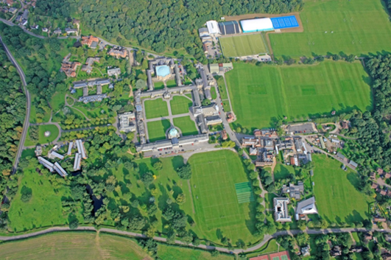



Benefits package

* The salary will be £16,200 (pro-rata) on a fixed term 10 month contract with School accommodation and all meals provided for free during term time.
* Fixed term contract: 22 August 2022 to 2 July 2023.
* The Common Room is welcoming and you will have access to free tea and coffee throughout the working day. The school also has a resident doctor and full-time Health Centre as well as a resident Church of England Chaplain.
* The School is in a fabulous location, surrounded by Hertfordshire countryside but travelling from Haileybury is very straightforward:
  + Central London is 35 minutes away by train (via Broxbourne station).
  + Cambridge is 50 minutes away by car.
  + London Stansted Airport is just 30 minutes away by car.
  + London Heathrow Airport is 50 minutes away by car.
  + London Luton Airport is just 40 minutes away by car
  + Key routes north and east/west, the A1 and M25 are 20 minutes away by car.

Equal Opportunities

Haileybury is an equal opportunities employer and is committed to a policy of treating all our employees and job applicants equally. It is our policy to take all reasonable steps to employ and promote employees on the basis of their abilities and qualifications without regard to age, disability, sex, gender reassignment, pregnancy, maternity, marital or civil partnership status, race (which includes colour, nationality and ethnic or national origins), sexual orientation, trade union membership, religion or belief.

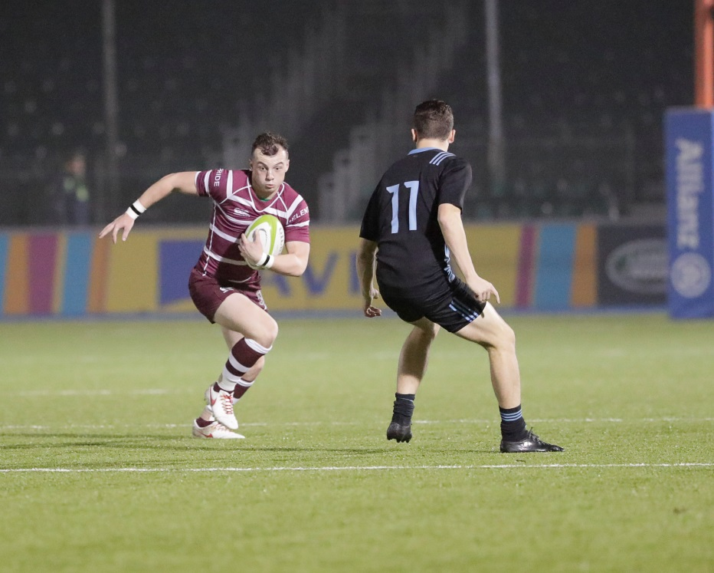



The vacancy

**Working hours:** This is a role requiring a commitment to work some evenings and weekends during term time, and also some periods of time in formal school holidays such as co-curricular trips, for example. The boarding aspect of the College also requires commitment from staff covering pastoral and co-curricular activities during the evenings and at the weekends.

**Probationary period:** The appointment is subject to the receipt of satisfactory references, the successful outcome of a Disclosure and Barring Service Enhanced Disclosure and completion of a one term probationary period.

**Applications** should be made on the staff application form and include a covering letter & CV, outlining the reasons why you are interested in the role and any additional information you would like to add. Please address to: [HR@haileybury.com](mailto:HR@haileybury.com)

**Closing date and selection process:**

Completed applications must be received by 9 am Saturday 4 December. Interviews will take place at the College’s discretion on receipt of applications.

**Documents required at interview:** All safeguarding checks must be completed prior to the employee starting work at Haileybury. Therefore, in order to facilitate this process all candidates are required to bring the following documents to the interview:

* valid passport
* UK driving licence (both parts if applicable)
* UK birth or marriage certificate
* two documents as proof of address e.g. a utility bill and a bank statement
* proof of your National Insurance Number e.g. National Insurance Card or a previous P45 or P60

In addition to the above, please bring to the interview all proof of relevant qualifications and courses undertaken. Originals only will be accepted, do not bring photocopies.

**Disclosures:**

We will appoint, train, develop and promote on the basis of merit and ability alone. It is a stipulation of the Governors and a statutory requirement that members of staff appointed to Haileybury should be shown not to have any criminal record which might prevent them accepting a post at the School. Accordingly, Haileybury requires permission from all members of staff to make an appropriate investigation. Offers of employment are subject to a satisfactory outcome of this enquiry.

**Safeguarding & Child Protection:**

All applicants must be willing to undergo child protection screening, including, but not limited to, reference checks with previous employers, prohibition checks and a criminal record check via the Applicants Disclosure and Barring Service (including Barred List Check). All offers of employment are conditional upon the satisfactory outcome of child protection screening checks.

**Overseas applicants:** Applications are welcomed from applicants not currently resident in the UK and these applicants may at the School’s discretion be interviewed by Skype.

If you have any questions regarding the interview process please contact Angus Head (Deputy Head Co-Curricular) via Miss Georgie Barber in the first instance on 01992 706 200 or email g.barber@haileybury.com.



Travelling to Haileybury

Haileybury is located in rural Hertfordshire between Hertford and Hoddesdon about 20 miles north of central London

Air travel: London Heathrow (50 minutes by car), London Stansted (30 minutes by car) and London Luton (40 minutes by car) airports are within easy reach of Haileybury. London Gatwick Airport (75 minutes by car) is only slightly further away. All are served by rail links to central London.

By rail: There are two main line railway stations close to Haileybury. Hertford North to London (Moorgate or King’s Cross) is a 40-minute journey. Broxbourne to London (Liverpool Street) is 35 minutes. Hertford North is a five minute car ride from Haileybury and Broxbourne is 10 minutes away.

By road: Haileybury is conveniently located close to the A10 and easily accessible via the M25, A1(M), M11 and A414.

• From the South East: Leave the M25 at junction 25 to join the A10 north (Cambridge), exiting the A10 at Hoddesdon.

• From the South West: Leave the M25 at junction 21a to join the A405, then the A414 to Hatfield and on to Hertford. The B1197 leads to Hertford Heath village.

• From the North: Leave the A1(M) at junction 4 for the A414 to Hertford, or leave the M1 at junction 7 (St Albans) for the A414 to Hertford.

• From the East :Via the M11 leave at junction 7 (Harlow) for the A414 to Hertford.

