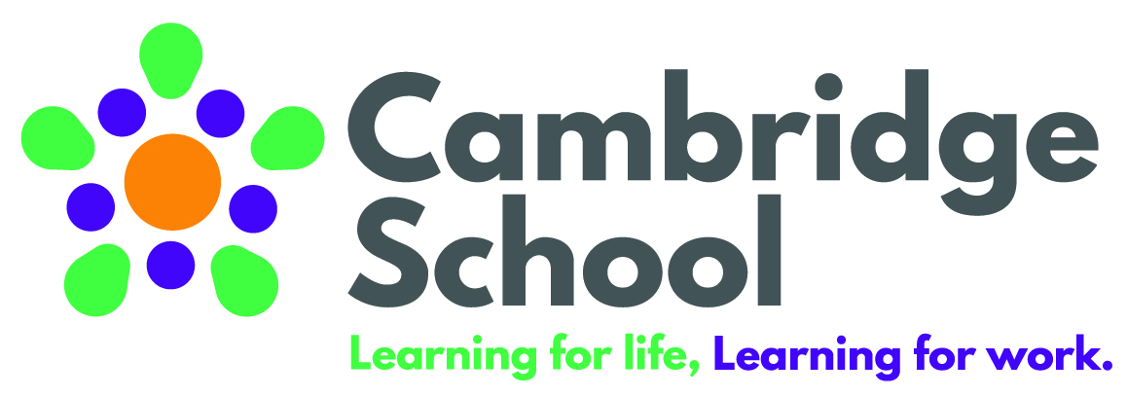
SEMH Class Teacher required – September 2019
Contract: full time, fixed contract – for 1 year in the first instance (subject to probationary period)
Cambridge School is a vibrant and multicultural secondary special needs school in the London Borough of Hammersmith and Fulham serving a diverse student community including learners with ASD and SEMH.
We are committed to becoming an outstanding provider for our students and we welcome applications from dynamic, determined and resilient individuals.
You will bring with you a strong knowledge in how to differentiate for a wide range of learning needs and have great strategies for promoting positive behaviour for learning in the classroom. You will be passionate about finding imaginative and creative ways to engage the pupils in learning. Most of all, you will have a sense of humour, you’ll want to have fun in the classroom and will want to look for opportunities to take the learning outside of the classroom and into the community and wider locality around London.
We offer our staff free access to a gym and swimming pool as well as a rich wellbeing programme including yoga, massage and cycle to work loans. The school invests heavily in professional coaching, mentoring and training.
If you are interested in joining us and would like to visit the school before submitting your application, please contact the School Business Manager, via email.

Cambridge School is fully committed to safeguarding and promoting the welfare of children and young people and expects all staff to share this commitment.

References and an enhanced DBS disclosure will be requested for the successful candidate in accordance with Safeguarding Children and Safer Recruitment in Education legislation.

Closing date: Friday 12th July 2019
Interviews: TBC
Start Date: September 2019
For an application pack please go to our website http://www.cambridge.lbhf.sch.uk/
Or contact the School Business Manager on r.moore@cambridge.lbhf.sch.uk
020 8735 0980
Cambridge School, 61 Bryony Road, London W12 0SP

