January 2018

Dear Applicant

Deputy Principal at Weydon School

As the new Principal of Weydon I am excited about making my first very important appointment for the school. I am passionate that the team will have the drive, energy and forward thinking approach to get the school in the top 5% of schools in the country. If you feel excited by this challenge then please read on!

Thank you for your interest in the post of Deputy Principal at Weydon School. Weydon is an 11-16 mixed comprehensive with around 1600 students. Our students are at the heart of all that we do. We are a caring school that thrives due to outstanding relationships that exist between the staff and students. Students are well behaved, have a positive attitude and enjoy coming to school. We believe that all our students have the potential for excellence and work towards this by having very high expectations of students and staff by continually raising aspirations.

In 2017 85% of students achieved 5 or more A*-C/4 grades or better, including English and Maths, and 32% of students achieved a grade A*-A/grade 7-9. We were also pleased with the positive progress 8 score of +0.17 but we are predicting higher for the 2018 results. We aim to be placed in the top 5% of schools nationally and we are driving this ambition through the schools big six –

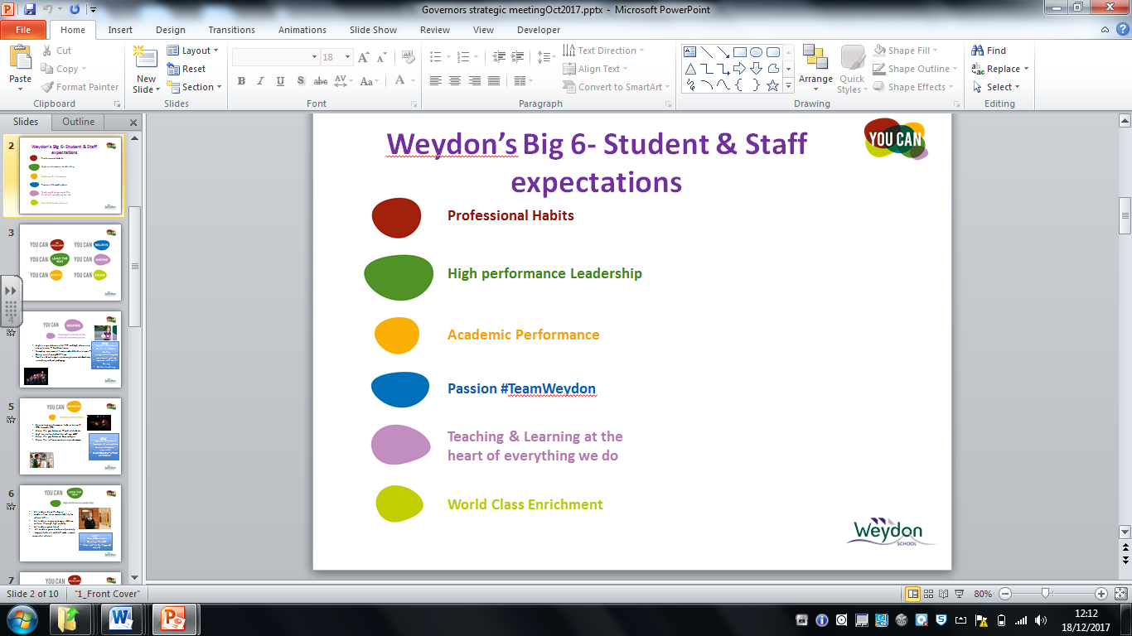

Before deciding to apply, please see our application pack. We have included a person specification and job description and also our staff prospectus. Our website also provides a great source of information about our wonderful school and can be accessed by the following address www.weydonschool.surrey.sch.uk

If you are interested in having a look around Weydon prior to applying there will be an opportunity for candidates to visit on Tuesday 16th January from 9.00-10.45am and Thursday 18th January from 9.00-10.45am. I and other members of the leadership team will be available to answer questions. Please contact my PA, Kathy Lockett by email on klockett@weydonschool.surrey.sch.uk or by phone 01252 725052 if you would like to book a place.

The vacancy for Deputy Principal post has arisen due to a restructuring of our excellent leadership team in light of WMAT partnership and promotion of Stuart Maginnis and myself to Principal of Heath End School and Weydon School respectively. Once the appointment is made the leadership team will consist of Principal, two Deputy Principals and six Assistant Principals. All leadership responsibilities are reviewed annually but the position being advertised is for an outstanding Deputy Principal in charge of Standards & Assessment. Weydon academy is an energetic place to work and as the lead school in WMAT has many opportunities for the right candidate to grow and seek further career promotion. It is forward thinking and innovative and an exciting place to work.

I hope that having browsed our website and reviewed the information provided you will be interested in applying. Completed application forms should be emailed to our HR manager by 10.00am on Monday 22nd January. Interviews will be held on Tuesday 30th and Wednesday 31st February 2018. Along with your application form you should include a letter of application, on no more than two sides of A4 (12 point font), outlining:

- What are your passions in leadership and what skills and expertise you would bring to the role
- A concise example of an initiative you have led in your current role with clear reference to the impact it has had
- What makes outstanding leadership and how you meet the wider person specification.

I would also like to have an opportunity to meet all shortlisted candidates in their own schools during the week beginning Monday 22nd January. The aim is to do a learning walk with you and possibly meet someone you line manage? I appreciate this is quite unconventional but it is very important to Weydon that we recruit the very best candidates for our school.

This is an incredibly exciting time to join Weydon as we begin as a new leadership team within our collaborative MAT. I look forward to receiving your applications.

Please note that due to limited resources we will only contact applicants who have been shortlisted for interview. If you do not hear from us within two weeks of the closing date you should assume that your application has been unsuccessful on this occasion.

Application forms may either be sent by post to the Principal at the school or be emailed to cstapleton@weydonschool.surrey.sch.uk.

Should you have any queries relating to this post please do not hesitate to telephone me on 01252 725052.

Yours sincerely
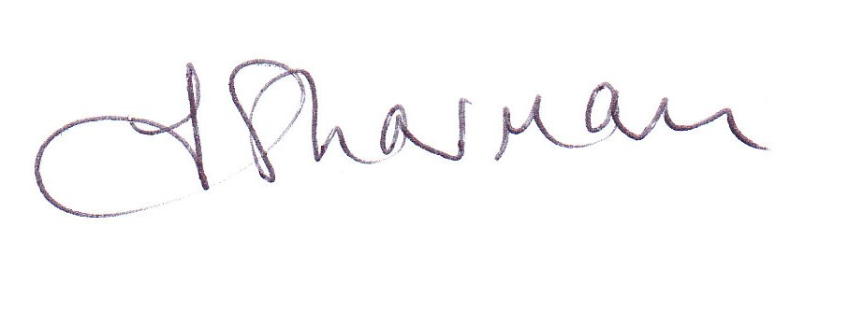
Jackie Sharman
Principal

