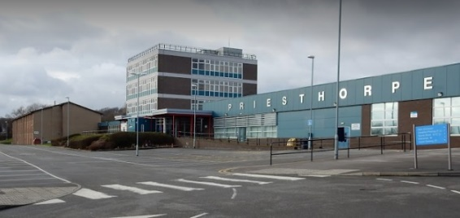
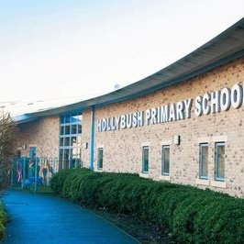
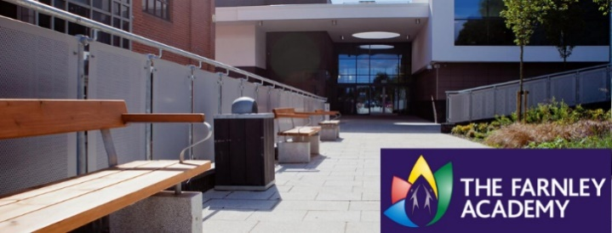
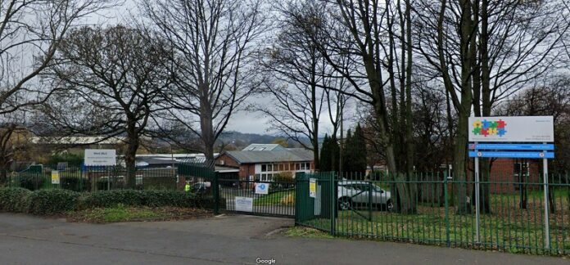
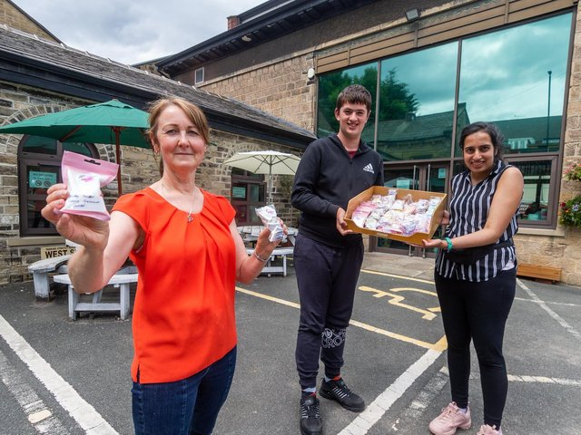
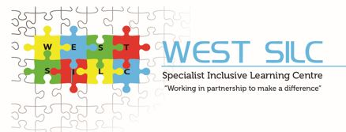
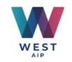
Primary Partnership based at Hollybush Primary School, Bramley
Approx. 12 pupils
Personalised inclusion
Post 16 – MLD/SLD - The Powerhouse, Springfield Mills, Farsley including Studio and Hub as well as The Foundry at Sunnybank Mills, Farsley
Approx. 50 pupils
Secondary Partnership based at Priesthorpe Coop Academy
Approx. 30 pupils
High levels of inclusion
All aged Partnership based at
The Farnley Academy
Approx. 40 pupils
Complex and Multiple Learning Needs (CMLN/PMLD) – complex physical and medical needs
Milestone site
Approx. 130 pupils
CCA—Complex Communication and Autism
Semi-formal
SEMH—Social Emotional and Mental Health
West 11 - 12 students at risk of permanent exclusion from West High Schools - key stage 3
West 14 - Up to 30 students at risk of permanent exclusion from West High Schools - key stage 4

