DULWICH COLLEGE YANGON
NEW TEACHER INFORMATION

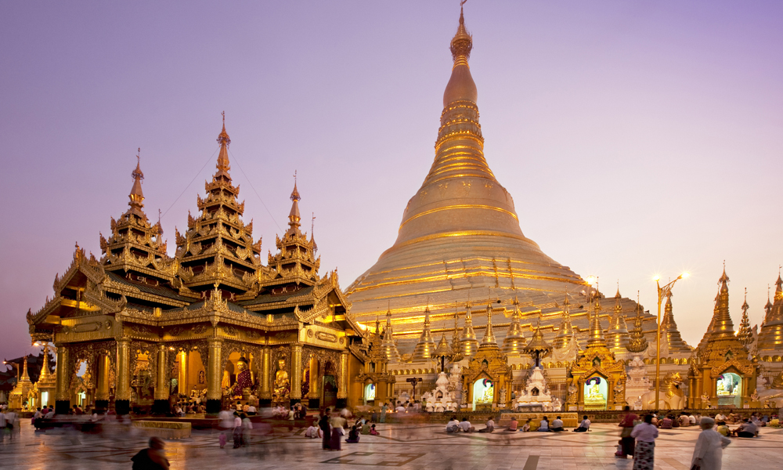

CONTENTS

1. Letter from the Headmaster 3
2. About Yangon 4
3. Moving to Yangon 5
3. Induction at Dulwich College Yangon 7
4. Flight Allowance Information 7
5. Other Important Information 9
Salary Payment
Personal Income Tax
Local Currency
Transport
Police Checks
Visas
Medical Insurance and Healthcare
Communication
Life in Yangon
Personal Safety
Cultural Sensitivities
Language

Dear Colleagues,
Welcome to Dulwich College Yangon. I am delighted that you will be joining the DCY team in August.
We are a school with two campuses, and although this provides us all with some exciting challenges, it also presents us with opportunities to experience something truly unique. You have the opportunity to join a truly gifted team of inspirational educators and administrators.
Our purpose is very simple; to give our children the very best education possible and to create a learning environment that will be the best in Myanmar.
I have absolutely no doubt that we have the right people in place to achieve this.
Moving to a new school and a new country is never easy, but we have many people who are very experienced internationally and all are here to ensure the transition will be as smooth as possible. Whether it be the HR team or your colleagues-to-be, we are here to support you and assist you in any way we can.
You have all been chosen for possessing a ‘can do’ attitude, a sense of humour, and the willingness to inspire, so a great time awaits you here in Yangon!
Warmest regards,
Daryl Orchard
Headmaster, Dulwich College Yangon

ABOUT YANGON
Yangon, Myanmar
Yangon, formerly known as Rangoon, has a population of over 5 million and whilst no longer the capital of Myanmar it continues to be the largest city and commercial capital of the nation. The city sits on the confluence of the Yangon and Bago rivers, 30kms from the Andaman Sea coast, and enjoys a tropical monsoon climate.
Yangon boasts a rich history and offers unique sites including the Shwedagon Pagoda, Inya Lake and the highest number of colonial period fin-de-siècle buildings in SE Asia. Yangon International Airport is connected by direct flights to the major cities across Southeast Asia as well as connections to Europe via the Arabian Gulf.
History and Culture
Described as the ‘garden city of the East’ at the turn of the 20th Century, Yangon has played a central role in the colonial and contemporary history of Myanmar. Designed by the British, the city grew to become one of the leading cities in Southeast Asia by the Second World War. Since then, due to isolationist policies, the city’s infrastructure has declined. After the first opening-up of the country in 1990s the city has seen renewed investment, a trend that continues today as new apartments, office blocks and amenities are built to cater for the demands of an increasing population, and the arrival of expatriate workers and their families.
Yangon provides an excellent taste of Myanmar culture, with museums, galleries and restaurants providing insights and flavours of this ethnically diverse nation. Whilst the infrastructure occasionally struggles to keep up with the pace of development, Yangon retains its charm as it seeks to rediscover its prominent role in the region.
Daily life in Yangon
The official language of the country is Myanma, with a great variety of ethnic dialects also spoken throughout the country. English is frequently seen throughout Yangon, in street signs, maps and directions. The older generation often has a good understanding of English, and the younger generation is learning fast. Whilst English is not necessarily widely spoken, you are able to make yourself understood without many difficulties.
The colonial quarter of downtown Yangon provides a ‘living museum’ of colonial architecture and bustling street life. The ethnic and religious diversity of the country is most apparent downtown, where Catholic cathedrals stand alongside synagogues, Hindu temples, mosques and Baptist churches, all under the glimmering gaze of the Shwedagon Pagoda, the holiest Buddhist shrine in Myanmar.
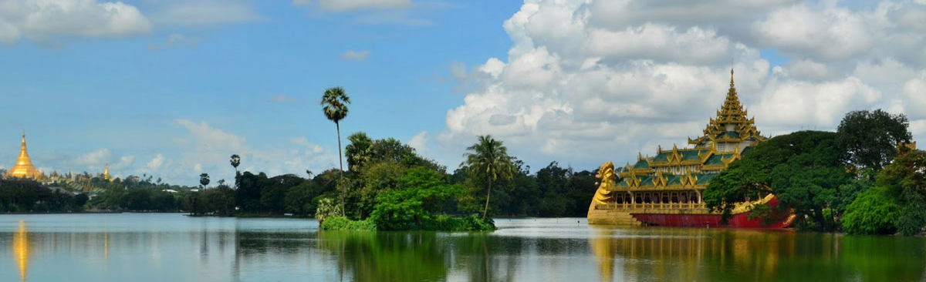

MOVING TO YANGON
Frequently Asked Questions
Which shipping company should I use?
The College does not recommend any specific company. We would only advise that you should use a reputable company and that you get quotes from several companies to ensure that the rate you pay is competitive. Unless carrying your personal items with you on the plane, it is not recommended to arrange your own shipments, as customs regulations are very difficult to navigate, and you may incur unnecessary import duties.
Can I use the College address on my shipping documentation?
When arranging your shipping you can use either school address (Dulwich College Yangon, Pun Hlaing campus, Golf Estate Avenue, Hlaing Tharyar Township, Yangon 11401, Myanmar or Star City campus, Kyaik Khauk Pagoda Road, Thanlyin Township, Yangon 11291, Myanmar). Please liaise with your shipping company about the timing of your shipment to ensure that they are not delivered to the College in advance of your arrival in Yangon, as we do not have the space available to safely store and secure these personal items. Once you arrive in Myanmar we will assist you with ensuring these personal items are safely transferred to your home address. We recommend you to arrange your shipment arrival after you have landed to Myanmar not only saving the storage cost but also it is one of the custom documentation requirements includes your visa and entry stamp.
Should I ship by air or by sea?
Shipments by air are more expensive, but will arrive quickly. Shipments by sea will be more affordable, but you can expect to wait a lot longer for your belongings. We would recommend you discuss your needs with a variety of shipping companies and get quotes for your requirements, and possibly use a mixture of the two. Be prepared to be without your shipment for several weeks, even with careful timing, as customs clearance times are unpredictable.
What should I ship and what can I get easily in Yangon?
Semi-furnished accommodation with basic home comforts, white goods and a welcome pack will be provided by the College. However, additional electrical goods, soft furnishings and items such as bedding and towels will not be included. These items will all be readily available in Yangon, but in limited styles, supplied by local shops rather than high street stores that you may be familiar to you elsewhere. New and second-hand furniture can be found at reasonable prices. Small electrical appliances, such as toasters and kettles, can be found here quite cheaply. If you have children you may wish to ship as many of their toys and games as possible to assist with their settling in. You may wish to consider buying glassware, crockery and other breakable items when you arrive so as not to risk fragile items in a shipment.
Clothing and shoes in larger sizes will be hard to find in Yangon, and children’s shoes from brands such as Clarks may be up to twice the price you would pay in the UK. If you are taking prescription medicines it is advisable that you bring enough to finish the course; likewise toiletries/medicines that you like to use may not be available locally. If you have a specific query about the availability of certain things in Yangon, please get in touch and we will be able to advise you.
What documentation should I bring with me?
Please ensure that you have with you on arrival in Yangon the original documents of your education certificates, criminal record checks and marriage certificate (where relevant). It is very important that you have these with you as the HR Department must verify all original documents as part of our safeguarding practices, and to comply with local laws. It is recommended that you keep these in your hand carry luggage.
Are there bans on bringing in any items that I should know about?
To ensure your shipment is not delayed, or items confiscated, it is advisable to consult with the shipping company you use about any items which cannot be brought into Myanmar.
What else can I claim from the Relocation/Shipping Allowance?
On submission of valid receipts, we will reimburse you for the following relocation costs incurred (up to the limit of your allowance):
- Freight / storage / excess baggage costs to move your personal effects into Yangon
Please be aware that you may be charged additional custom charges as all goods are inspected at customs on arrival in Yangon.
Please note that you are not able to claim for consumables such as food items or cleaning products. Any unused amounts of the allowance are nor refundable.

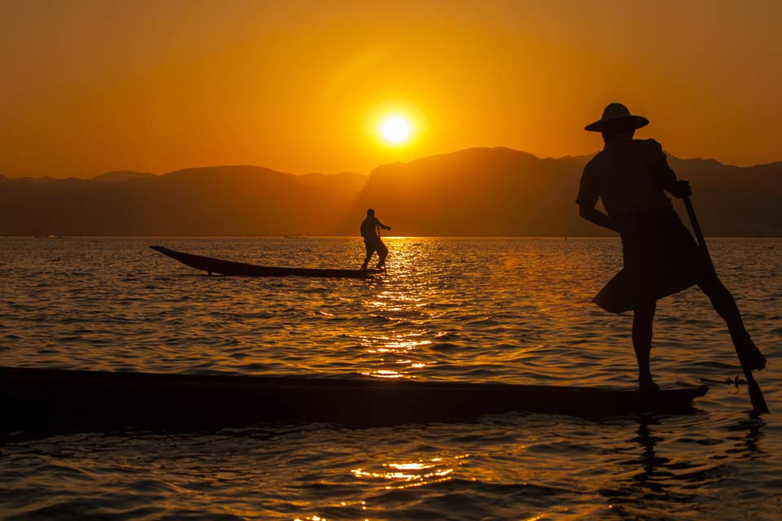
INDUCTION AT DULWICH COLLEGE YANGON
We would strongly recommend that you arrive in Yangon between Friday 7 and Sunday 9 August 2020. It is our aim for all new teachers to be met by a DCY representative on arrival at Yangon International Airport. If you have not already done so please email your flight arrival details to Thinzar (DCY HR Manager) thinzar.nyein@dulwich-yangon.com.mm as soon as they are booked (further information on flights can be found below), this will allow us to schedule your pick-up.
Details for the Induction will be stated in the induction schedule which formally commences 10 August 2020; it is expected that you attend induction and are able to focus on all the information which will be given to you during this time.
Please be mindful that the first few days in Yangon will be very busy, and that each teacher has different requirements and preferences. We will try very hard to meet the individual needs of all. There is also plenty of time built in to settle into your classrooms.
FLIGHT ALLOWANCE INFORMATION
Does the College pay for my initial flight to Yangon?
You will need to book flights yourself, arriving on or before Sunday 9th August, and you will be able to claim the cost back through expenses on submission of original receipts and boarding passes. The amount of the flights will be deducted from your annual flight allowance and paid to you in your salary at the end of either August or September, depending upon the submittal date. During induction you will be supported by the Finance and HR Teams in learning how to complete and submit the forms.

What if I want to fly in to Yangon from a country other than my home base?
For your first flight/s in to Yangon in your first year, the incoming flight should be from your point of domicile (as indicated in your contract). Your home base is determined by your passport. If you hold two passports you will need to nominate which one you wish to be linked to your contract. Please inform HR if your incoming flight is not from your point of domicile.
What if I do not use all my flight allowance?
Any unused allowance will be paid to you with your salary in July 2021 at the end of the academic year. Please note it will be taxable.
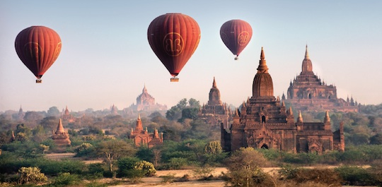
OTHER IMPORTANT INFORMATION
SALARY PAYMENT
Your salary will be paid net of tax on the last working day of each month. You will be required to nominate the proportion you want paid in Yangon (local currency) and offshore. Monies should reach your offshore account within 2-5 working days depending on your nominated country and bank. Your first salary payment will be made at the end of August – we will assist you in opening a local bank account soon after your arrival in Yangon.
Please note that any offshore payments from Myanmar to your nominated country will attract bank charges, these are standard overseas transfer costs and are not covered by DCY.
PERSONAL INCOME TAX
Salary payments are subject to Myanmar Personal Income Tax. As the Myanmar tax year runs from October to September, and your contract commences in August, the exact amount of tax levied may differ in August and September as your tax will be based on two months’ salary. From October 2020, the percentage will increase to reflect a full years’ salary.

LOCAL CURRENCY
You will receive a salary advance in local currency (Myanmar Kyat), on request, when you arrive in Yangon and this will be the equivalent of $250 US Dollars. Whilst in country, many shops and restaurants will only accept Myanmar Kyat. Until as recently as 2014 there were very few ATMs in Myanmar due to economic sanctions. However they are now commonplace and will generally accept cards with Visa and MasterCard logos to access overseas accounts (be prepared to try a few different machines!).
Please be aware that you will not be able to source Kyat outside of Myanmar, therefore we recommended that you bring US Dollars with you, and use your Visa / MasterCard as a backup. Although the Myanmar government has recently told the banks to accept more than just the most pristine of foreign currency, dollar bills that are not perfect are likely to be rejected, or at best, exchanged at a lower rate. Therefore make sure you ask for NEW DOLLAR BILLS at the foreign exchange counter (no marks, folds or tears).
In Yangon you should only use banks to exchange Dollars into Kyat - do not exchange money on the streets as you will receive a poor exchange rate and possibly even forged notes.
TRANSPORT
There will be group transport arranged for the induction period. Taxis are plentiful, cheap, but very basic. You will need to request the air-con to be turned on. We recommend that you use Grab or Oway taxi’s as the cost is confirmed prior to starting your journey. Very few of the local taxi’s are metered so you need to agree a price beforehand as they may charge a lot more than the basic fare.
Make sure that you have smaller notes, as the drivers will often say that they cannot change a 10,000 kyat note. Generally, the drivers will be courteous, friendly, but will rarely have any English so ensure that you have the destination written down if you are unable to say it in Myanmar. Public transport is an adventure to be experienced, especially the local trains, but is not practical for everyday use.

POLICE CHECK
As part of the Dulwich Collage Yangon Safeguarding policy, all College staff are required to provide up-to-date criminal record check certificates or documents.

The requirements are as follows:

- British passport holders residing in the UK
You need a DBS check. You must also provide a criminal record check document from the country where you are registered as a teacher (if this is outside the UK), and from all countries where you have resided in the last 10 years.

- British passport holders not residing in the UK
You need a ICPC check. You must also provide a criminal record check document from the country where you are registered as a teacher (if this is outside the UK), from your current country of residence and from all other countries where you have resided in the last 10 years.

- Non-British passport holders currently residing in the UK
You need a DBS check, and a police check from your home country. You must also provide a criminal record check document from the country where you are registered as a teacher (if this is not the country of your passport), and from all countries where you have resided in the last 10 years.

- Non-British passport holders residing in a country other than their home country
You need a police check from your home country. You must also provide a criminal record check document from the country where you are registered as a teacher (if this is not the country of your passport), from your current country of residence and from all countries where you have resided in the last 10 years.

Your current HR department should be able to assist you with this.

British passport holders, or non-British passport holders currently residing in the UK, are required to undergo a new UK criminal record check through the Disclosure and Barring Service (DBS) prior to taking up your new position within the Group.

To arrange such a check, please contact our colleague Christopher Parsons at Dulwich College in London who will guide you through the process: e-mail parsonsca@dulwich.org.uk or tel. +44 (0)20 8299 9304.

VISAS
All new staff need to apply for a “Business – B type” visa (70 days) with single/multiple entry to Yangon. Once in Myanmar the College HR Department will support your visa renewal process. This may involve a trip to either Bangkok or Kuala Lumpur.
Please ensure you have adequate space in passport. For visa renewal you will require at least 4 pages in your first year in Myanmar. We recommend at least 8 blank pages, which will allow for additional travel during this time. DCY does not grant time off for passport renewal or fund any associated costs.
MEDICAL INSURANCE AND HEALTH CARE
New teachers and their dependents will be covered by the College BUPA private medical insurance scheme from 1 August 2019. Insurance premiums paid on behalf of teachers are treated as a benefit in kind and taxed as such. Details of the scheme will be presented during induction, including a list of benefits and an outline of the claims process. Medical facilities are limited in Yangon, the following medical facilities are popular with expats:
Pun Hlaing International Hospital
Hotline 09778787852
Expat Liaison Officer (Pont Pont) 0943025888

Parami Children’s Hospital
Samitivej International
Emergency: 0931911541 / 0931911542

International SOS Clinic
Tel: +95 1 657 922

Whilst there are no medical requirements for entry into Myanmar, we would recommend that you have up to date vaccinations for Tetanus, Hepatitis A and Typhoid.

COMMUNICATION
The school will provide all new teachers coming from overseas with a SIM card and enough credit to make 1 or 2 short calls back home after you have arrived. After that, our staff can help you choose from a variety of different mobile phone packages (which are all relatively inexpensive). All will most likely be on a ‘pay as you go’ basis. It is rare for houses or apartments to have landlines. The speed of the internet is improving all of the time, but can often be slow. However, Wi-Fi is now widespread throughout the city, although likely to be expensive in comparison to the cheap standard of living in the country. Post is unreliable, so it is best to avoid anything being sent to Yangon, and if so ensure that it is registered and sent to the school address.

LIFE IN YANGON
Space does not allow a full description of the activities available in the city, including sight-seeing, shopping, eating out and leisure activities. Satellite TV is not cheap, but will provide you with a basic package of overseas channels such as CNN, BBC News, Fox Movies, HBO etc. It is particularly well served if you enjoy watching European football! There are now a good range of English newspapers, magazines, guides and media sites that will keep you informed about the best places to eat, shop and enjoy yourself. Some of the most popular are;

Yangon Golden Guide: shopping/health/education/travel & tourism/useful telephone numbers
Know It Myanmore: shopping/food/sports/gyms/night clubs/restaurants/art galleries
Frontier Myanmar: Myanmar economic/future development projects
Indepth Myanmar Magazine: streets of Yangon/culture/stories/food & restaurants
Mizzima Weekly: Myanmar news & Insight
Enjoy it Myanmar: food/restaurants/culture

Facebook – join Yangon Connection group

PERSONAL SAFETY
Yangon is still a remarkably safe place to be in terms of personal safety. It is safe to walk the streets at all times, although sensible precautions should be taken at night as you would in any city. House and car crimes are not common, but it also makes sense to lock your doors and windows at night, and not to leave valuable items in the car. If you find yourself in any difficulties, Myanmar people are always willing to help, subject to language barriers.

Caution should be exercised during the rainy season when the streets flood, owing to unseen potholes and any broken electricity lines if there has been a large storm. Snakes are present in the green field areas around our schools and elsewhere. However, exercise caution if walking in long grass. Mosquitos are plentiful in the rainy season, so ensure that you have your spray and lotion at hand, although they are no worse than in most other Asian cities.

CULTURAL SENSITIVITIES
The majority religion of Myanmar is Buddhism and this pervades all aspects of everyday life. We will provide a cultural awareness orientation as part of induction week. One easy tip to remember is that the head is sacred and the feet are seen as unclean. So no ruffling someone’s head and avoid showing the soles of your feet or pointing with your toes. The Myanmar people are a wonderfully hospitable people and will forgive visitors if they make a cultural faux pas. Nevertheless, a lack of patience or raising your voice and appearing angry is frowned upon and not so readily accepted as in the West.

LANGUAGE
As with living in any foreign country, the ability to speak a few phrases of Myanmar will always induce a smile and sense of interest from the locals, so it is worth giving it a try. If you want to learn more, language schools or private tutors are quite cheap. A recommended text (with MP3 down loads) is John Okell’s ‘Burmese: An Introduction to the Spoken Language’. However, you would need to bring this from overseas and some of the content is very dated.

