TEACHER OF GEOGRAPHY
JOB DESCRIPTION

We seek an experienced teacher or NQT to join the Geography team. This role would suit a teacher looking to develop their pedagogy and career in a supportive environment. Equally we have excellent NQT provision and would welcome new teachers who are starting their career in teaching. The goal of our department is to enthuse and foster a love of Geography within our students whilst also striving to achieve exceptional outcomes for all abilities.

Your role within the department would be to become an integral part of our close-knit team as we believe in working collaboratively and supporting each other. We wish to appoint someone who is passionate about Geography and cares about providing an excellent education for our students. New ideas are always welcome and valued, creativity and the willingness to take risks with new teaching strategies are a must.

The ability to embrace new challenges and an openness to constructive feedback and advice are essential. We regularly run field trips, both local and abroad. As a new member of the team we would welcome new ideas for trips and would support you in making these a reality. We believe in education outside of the classroom and inspiration through experience.
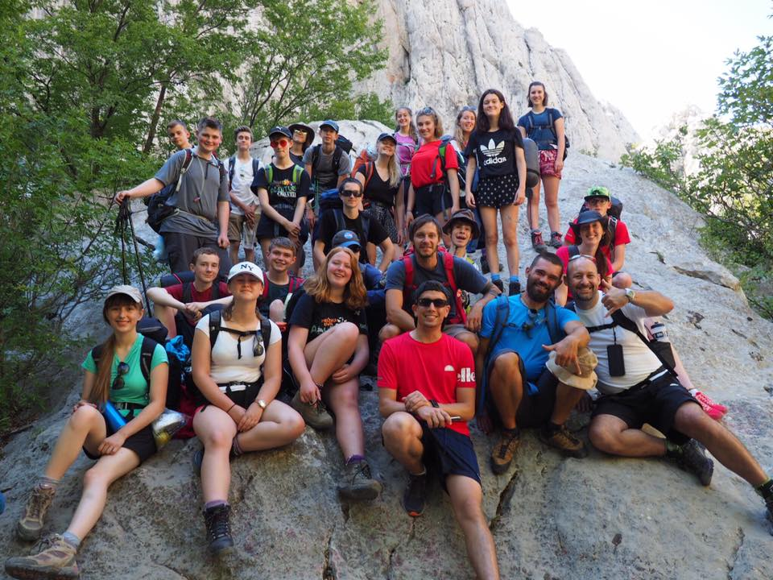
We look forward to welcoming the successful candidate and helping you gain new experiences as well as develop into an outstanding teacher. Most of all, we are looking for someone who embraces new experiences and loves Geography as much as we all do.

