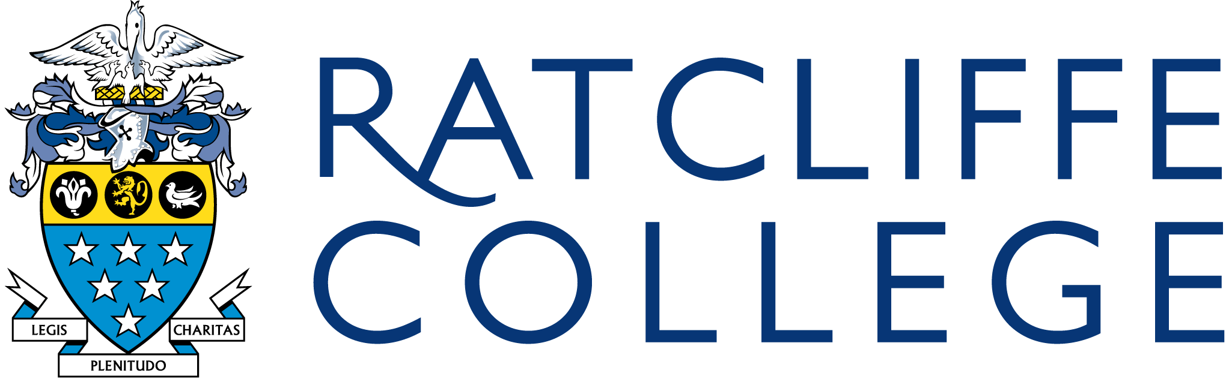

Welcome to Ratcliffe College
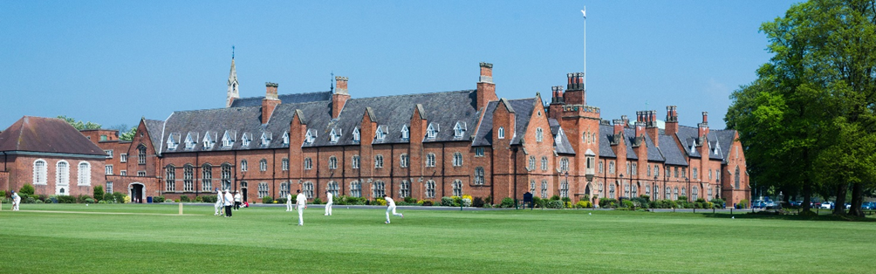

I am delighted that you have taken an interest in applying for the part time Teacher of Religious Studies post and I hope that this pack will offer you an insight into this exciting position and our wonderful school community.

Ratcliffe College is regarded as one of the leading Roman Catholic boarding schools in Britain. Founded in 1847, we are situated in 200 acres of beautiful grounds in the East Midlands, within easy access to the M1 Motorway and East Midlands Airport. There are 900 students in the School, aged 3-18. We are a family-orientated community, committed to the transformation of young minds, hearts, bodies and souls, in pursuit of all-round excellence and we encourage big ideas. The College was judged as ‘Excellent’ in its recent ISI inspection (May 2022).

We would be delighted to welcome you to visit us to see Ratcliffe for yourself. Whilst instilling within the students the values to which we hold firm of confidence, courtesy, compassion and courage, we prepare them to be professional young people in whatever field of work they choose to pursue in later life.

The commitment we show to our students extends to our 360 staff. We are committed to ensuring that all staff are thoroughly supported in terms of their professional development and wellbeing.


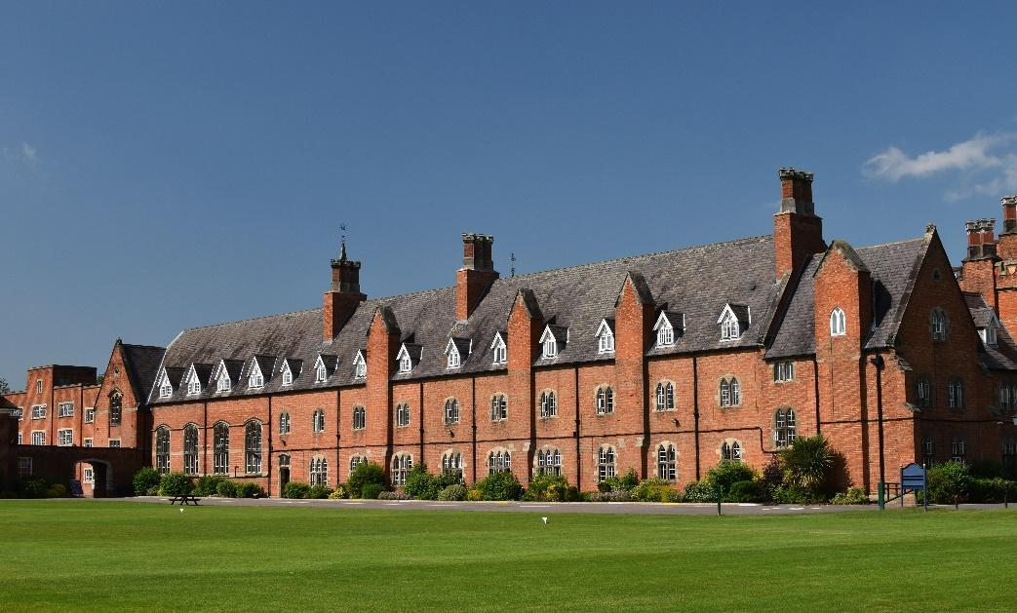
Best Wishes

Jonathan Reddin
Headmaster
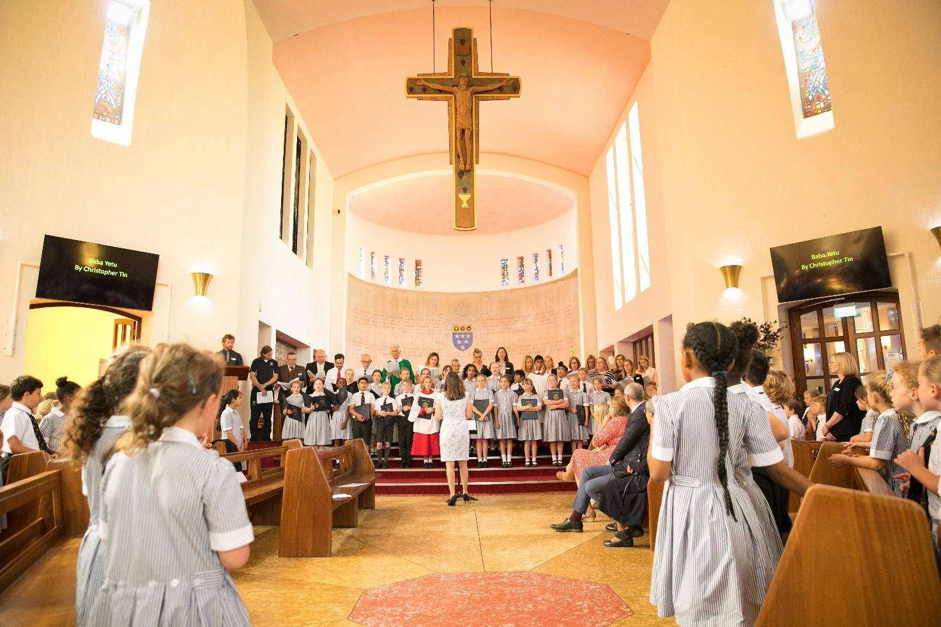

Full time or Part-time Teacher of Religious Studies

Required for Summer or September 2024

Background Information

We wish to appoint a Full time or Part time (0.5 - 0.7 FTE) enthusiastic and well-qualified Religious Studies teacher who is a practising Catholic, to join our very successful Religious Studies Department. The ability to teach Religious Studies at Key Stage 3 and GCSE is essential. For the right candidate, there will be the possibility of A Level (Ethics, Philosophy or Theology) teaching in the future. ECT applications would be warmly welcomed.
Ratcliffe College is a co-educational, day and boarding school with 900 students aged between 3 and 18 years. The majority of students are of above average ability. Each year, most of them obtain 9 or more GCSE passes at Grade C or above, and a large number of sixth formers proceed to Higher Education. In Religious Studies, examination results at GCSE are excellent.
The Religious Studies Department consists of four full-time and three part-time teachers, working in parallel with the Chaplaincy team, made up of a full-time residential Lay Chaplain, Miss Frances Daw and Fr President, Fr Philip Sainter. The department is housed in its own suite of four rooms. The department is well stocked in terms of learning resources and has a generous budget allocation.
The department is friendly, professional and committed to a collaborative approach to curriculum development. Its work underpins the overall Catholic aims of the College.

Classes in Year 7 and 8 are taught in mixed ability groups. The Department follows schemes of work which follow the requirements of the Bishops’ Conference set out in the 2022 Curriculum Directory. From September 2023, we will be followed the new Year 7 Scheme of Work, prescribed in the new
Religious Education Curriculum Directory. There are detailed schemes of work and methods of assessment and these are regularly reviewed to ensure that all staff contribute to a coherent and supportive programme of study.
At GCSE, all students follow the Eduqas (Route B) course. There are three main areas of study:
- Foundational Roman Catholic Theology
- Applied Roman Catholic Theology
- Judaism

Students start the GCSE course in Year 9 and are taught in sets across half the year group.

At A Level, the Department has established a reputation for excellence with a 100% pass rate. Students follow the OCR A Level Religious Studies course. There are three main areas of study:
- Religion (Christian Theology)
- Philosophy
- Ethics

Additionally, there is a Core Sixth Form programme, providing opportunities for religious and ethical debates as well as involvement in fundraising initiatives.
While the department concentrates on the academic side of Religious Education, opportunities exist for working with the Chaplaincy team in the spiritual development of the students in such areas as the liturgy, assemblies, charity funding and religious retreats, to name but a few.
Ratcliffe College is a Catholic School and all staff are expected to support its aims and ethos. Teachers are required to attend school assemblies and when they occur, school Masses (for example, start and end of term Masses; Holy Days and other feasts. There will be an expectation for the successful candidate to contribute to duties and co-curricular activities within the School.

Person Specification
 | Essential | Highly Desirable
Faith | Practising Catholic
Qualifications | Good honours graduate in Religious Studies / Theology (or a very closely related subject)  Teaching qualification (PGCE or equivalent)
Skills | Ability to teach GCSE Religious Studies
Skills | Excellent classroom management skills
Skills | Excellent interpersonal and communication skills
Skills | Ability to command respect of children
Skills | Ability to prioritise
Skills | Knowledge, understanding and competence in ICT
Skills |  | Ability to teach Religious Studies (Ethics, Philosophy, OR Christianity) to A Level.
Skills | Good organisational skills
Knowledge & Experience | A record of successful teaching or teaching practice | Experience of contributing to the writing of schemes of work
Knowledge & Experience | Understanding of current good practice in teaching and learning | Evidence of continuing relevant professional development
Knowledge & Experience | Good organisational skills
Personal Qualities | Commitment to the ethos and aims of the school
Personal Qualities | Passion, initiative and enthusiasm
Personal Qualities | Hard-working, honest and reliable
Personal Qualities | Ability to maintain appropriate and supportive relationships with children and staff
Personal Qualities | Positive attitude to use of authority and maintaining good behaviour standards
Personal Qualities | A willingness to be involved in the pastoral care of pupils
Personal Qualities | Ability and willingness to contribute to, and support, the school’s extra-curricular programme
Personal Qualities | Ability to work as a team including willingness to take part in assemblies, retreats and/or trips organised by the Religious Studies department.
Personal Qualities |  | Good sense of humour
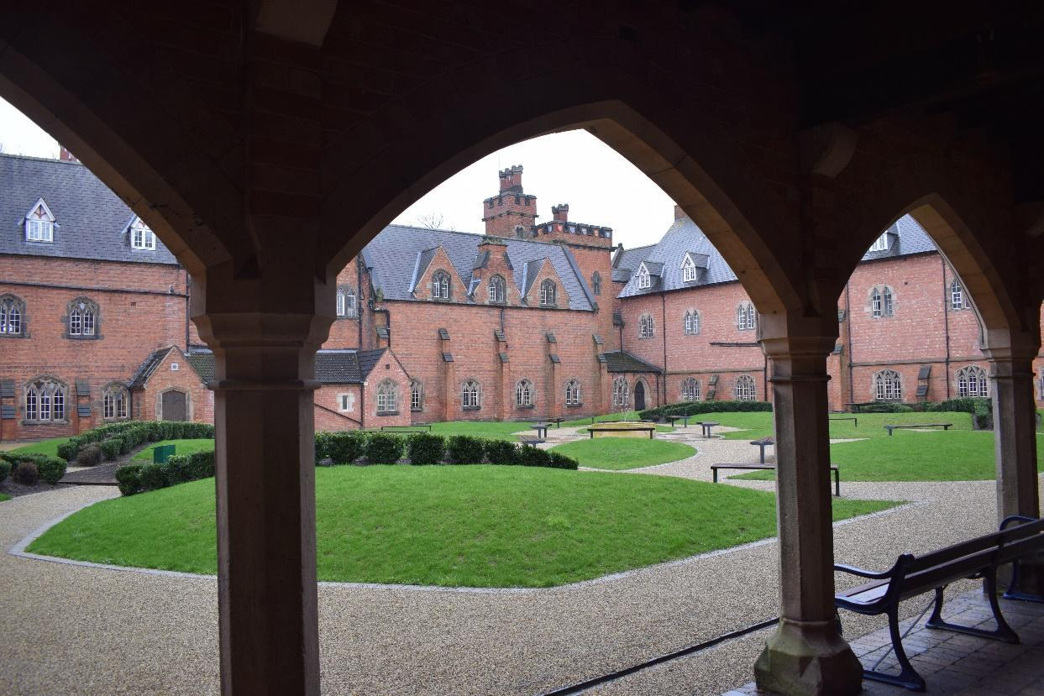
Teaching Staff Terms
Professional development is taken seriously at Ratcliffe and members of staff are encouraged to prepare themselves for promotion at Ratcliffe and elsewhere. A full induction programme, which meets statutory requirements, is available for Early Career Teachers.
Salary: Ratcliffe Pay Scale plus Ratcliffe Allowance. The Ratcliffe Allowance is on a sliding scale presently ranging from £943 to £9,851, depending on the experience of the teacher (these values are reviewed annually). Children of staff who are eligible for the School receive staff discounts on fees currently set at 50% of the day fees (this benefit may be subject to means-testing in the future). Subsidised lunches and coffee are available. Furthermore, the School participates in the Teachers’ Pension Scheme. Please note from April 2024, employer contributions into the TPS will be capped at 23.68%. An alternative defined contribution scheme is also offered, full details are available. Sports facilities, including a fitness suite, pool and specialist running track are available to staff.
Please follow the link below to the on-line application form:
https://www.ratcliffecollege.com/about/vacancies/
Should you wish to speak with the Head of Religious Studies ahead of applying, please contact Mr Nick Walsh by email: NWalsh@ratcliffecollege.com
The closing date for receipt of applications is 9.00am on Thursday, 11 January 2024
The College reserves the right to interview ahead of the closing date and so early application is strongly encouraged.
Before Governors confirm a permanent appointment, a satisfactory report of general health will be required of the selected candidate. Ratcliffe College is committed to safeguarding and promoting the welfare of children and applicants must be willing to undergo child protection screening appropriate to the post, including checks with past employers and the DBS.
For further information about Ratcliffe College please see our Website: www.ratcliffecollege.com

