
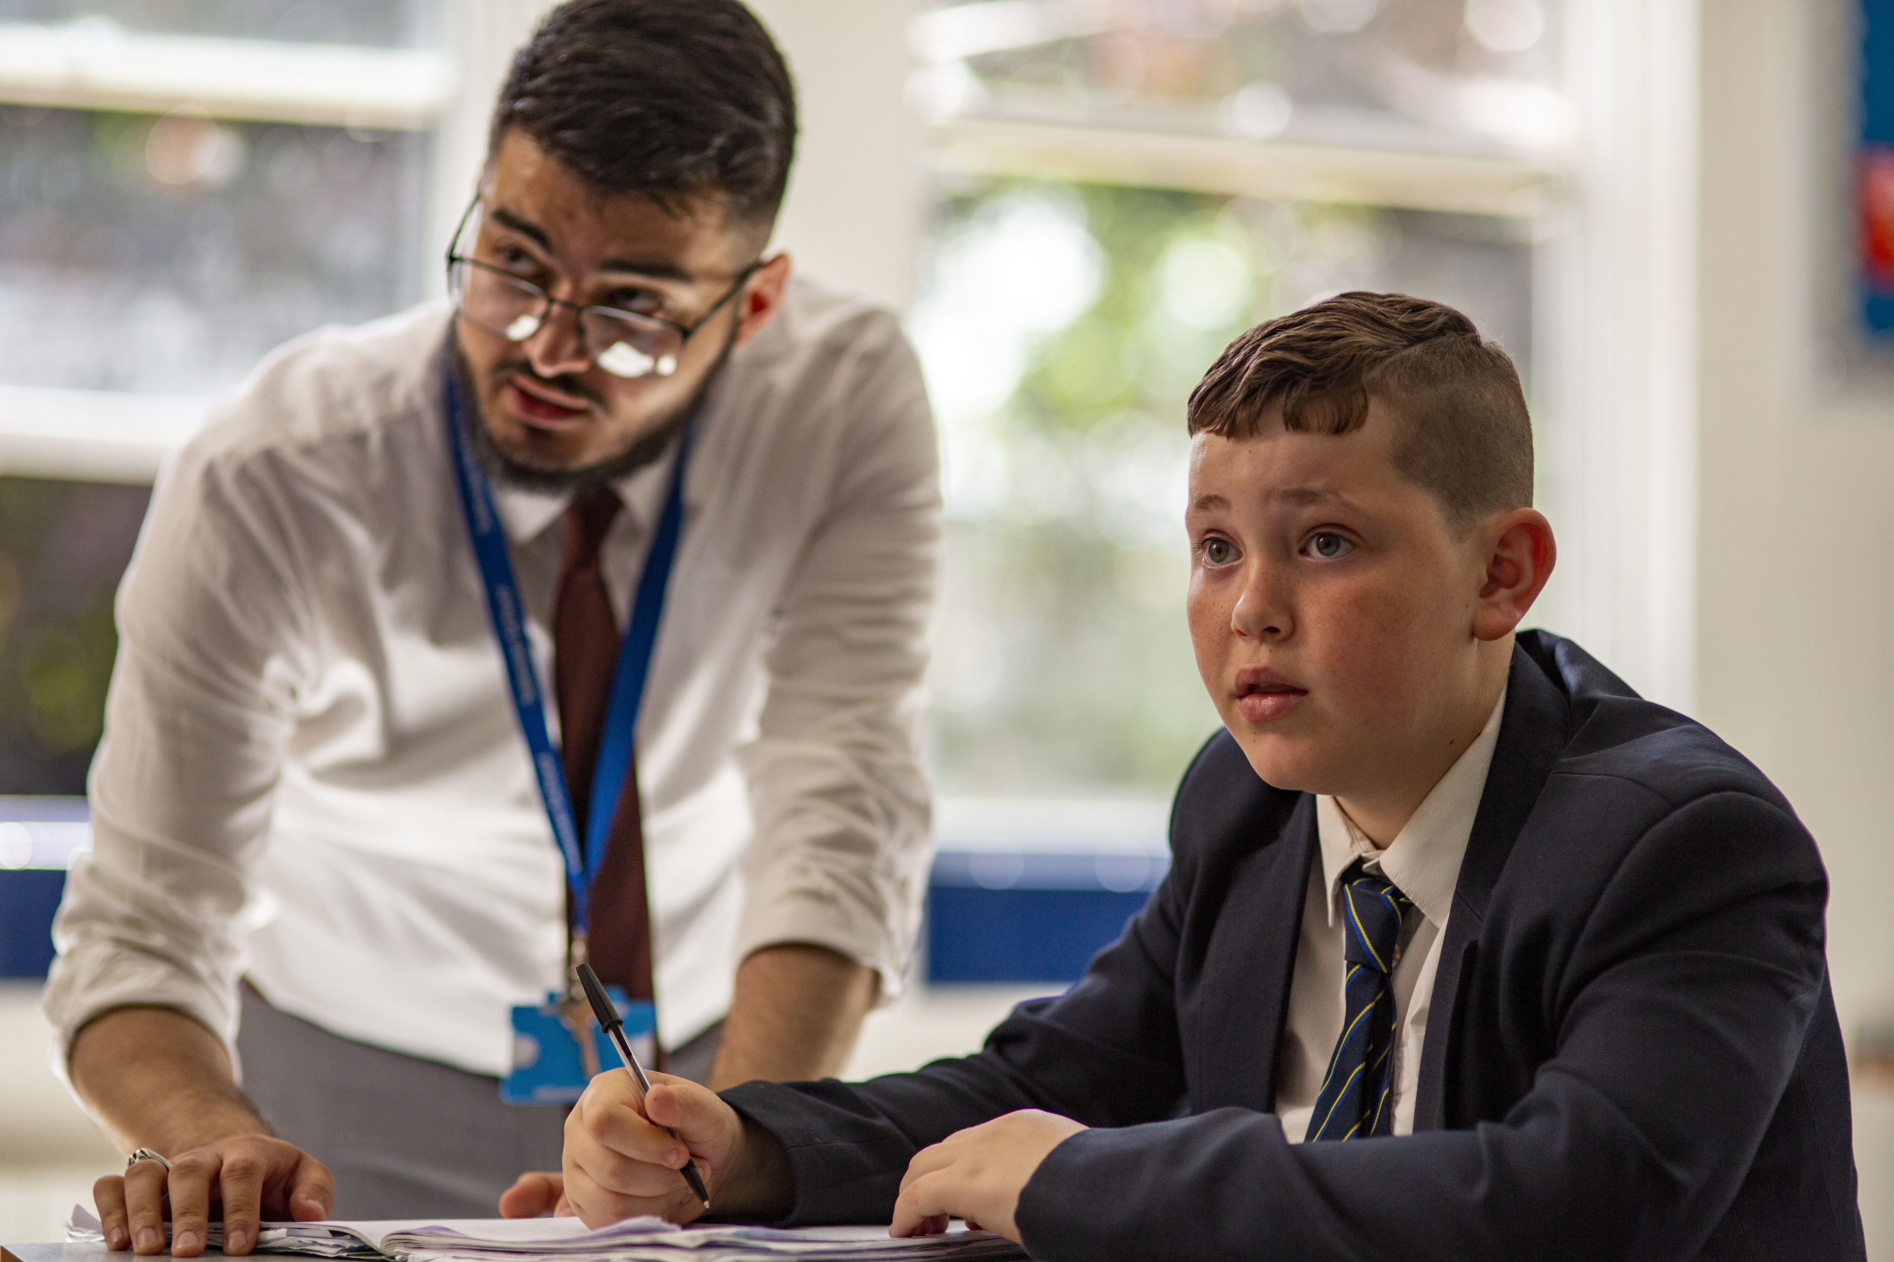
2nd IN COMPUTING

Starting your Salesian journey
Salesian
Enlightening minds, uplifting hearts
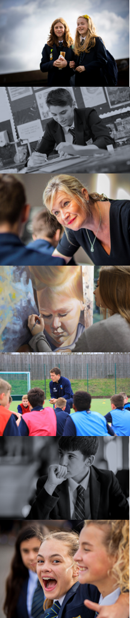
2nd in Computing Appointment
With the possibility of whole school responsibility

To commence: 1st September 2023
Salary: Main Scale / Upper Pay Spine (TLR1) – negotiable for the right person
Closing date for applications: 17th April 2023

Interview Date: 20th April 2023
Salesian School is seeking to appoint an exceptional individual to lead and teach in the Computing Department with the possibility of taking on responsibility of whole school IT Strategy and eLearning for the right candidate. This is a key role within the school and suitable for an ambitious candidate looking for more responsibility and a step towards senior leadership. If you are energetic, enthusiastic and love teaching children then we’d be delighted to hear from you. We are always happy to meet potential applicants prior to interview; please don’t hesitate to contact us (pcarr@salesian.surrey.sch.uk) if you would like any further information or to visit the school.
Paul Gower
Headteacher
pgower@salesian.surrey.sch.uk

The Computer Science Department at Salesian
Due to the expansion of the current curriculum and the appointment of our new Head of Department, we are looking to appoint a 2nd in Computing to support in the delivery of the Computing curriculum.
The department is currently made up of five teachers. We have five IT suites across the school and college sites. The latest version of MS Office and the complete Adobe CC form the basis of our mainstream software along with additional specialised applications. All software and hardware is maintained by our excellent IT support team.

In Key stage 3, students study Computing and attend two lessons per fortnight throughout the year. The curriculum is 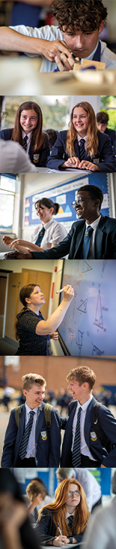designed to enable students to transfer into either an IT or Computer Science course at Key Stage 4. We focus on use of mainstream software packages and excellent pedagogy to develop pupils’ computational thinking, programming and the creative use of IT applications skills.
At Key Stage 4 we offer the OCR Cambridge Nationals in Creative iMedia for our IT option and OCR Computer Science. We usually have one to two classes opting for each subject in each year group and have enjoyed some excellent results in recent years.
At Key Stage 5 we offer OCR Cambridge Technicals in IT which allows pupils the unique opportunity to develop comprehensive digital literacy skills in software such as Blender. There is also an A Level Computer Science and are looking to launch the new T Level in Digital Production Design and Development next year.

A desirable candidate will be someone with the skills and experience to teach Computing across all Key Stages and able to support, track and record the attainment of pupils at KS4 and KS5 respectively. The right candidate will be keen to develop their leadership skills and have a high levels of self-motivation; as well as an ability to plan strategically ahead of time to ensure the ongoing academic success of our pupils.

We achieved strong results. At Key Stage 4 in 2022 with nearly 50% of students achieved 9-7 in Computer Science and 100% A*-C at A level. We are certainly not complacent, there is still a lot to do and we are excited about appointing the right person to move the department onto new challenges.

We are determined to make the Computing Department at Salesian the best in Surrey, if not the country! We look forward to meeting you and discussing your ideas to help us in achieving this end. Please do visit us and come and look around.

Oliver Hamshar
Assistant Headteacher, senior line manager for Computing
ohamshar@salesian.surrey.sch.uk
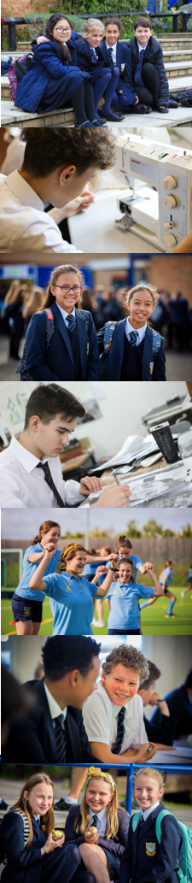


Salesian School is committed to safeguarding and promoting the welfare of children. Enhanced DBS checks will be sought prior to appointment
Appointments at Salesian

Information for Candidates
Thank you for your interest in the positions currently being advertised at Salesian School. I would like to take this opportunity to share some thoughts with you.
Salesian is a co-educational 11-18 Catholic comprehensive school and part of the Xavier Catholic Education Trust. The school ethos is based on the work of Don Bosco, a Salesian priest. Community and great relations are central to our work. As a consequence, both students and staff are happy, positive and enjoy their time at school.
Standards at the school are outstanding and students achieve exceptionally well. In last year’s GCSE examinations 54% of all grades were 9-7 with our provisional Progress 8 at +0.8. At A level 41% of all grades were A*-A and 77% A*-B.
The school has over 1800 students and is situated on two sites approximately one mile apart, near to the centre of Chertsey. The main school is situated at Guildford Road and our Sixth Form College has 350 students on its own site at Highfield Road.
A great deal of emphasis is placed on co-curricular life at Salesian and outside the formal curriculum there are numerous opportunities for students to take part in a wide range of activities - drama, sport, music, exchanges, away days, Duke of Edinburgh, retreats and trips.
We work hard to ensure that staff and students are well looked after but we also set exceedingly high expectations of everyone at the school and underperformance is always challenged. When you get the balance right between challenge and support you get great teaching, when you have great teaching the school becomes heavily-oversubscribed and when this is the case parents believe in what you are trying to do and support you in doing it. All of this results in us having the privilege of working with children who are, on the whole, an absolute delight!
We are graded as Outstanding, are a ‘World Class School’ and as part of the Xavier Catholic Education Trust are a Teaching School Hub. We were obviously delighted with this recognition and are all very proud of our achievements which are a great tribute to the staff and students who have worked so hard to enable us to reach this point.
Regardless of all this, we don’t think we’ve got it cracked; the challenge now is to keep improving on what we do. Are you the person to help us continue on this journey?
Candidates are welcome to contact the school to find out more information about specific departments or pay us a visit. We take recruitment very seriously and want to do all we can to find the best staff for our students.
The ideal candidates will be energetic, enthusiastic, ambitious and excellent practitioners. We would expect at least two years’ hard work and good service. In exchange we will prepare you for the next step in your career.
I believe Salesian is a fantastic place to work and I am excited about the prospect of appointing colleagues with whom we can work closely in order to drive the school forward. There are great opportunities here for the right candidates to provide a high quality service for our community and make a real difference to children’s futures. I very much look forward to meeting you.

Paul Gower
Headteacher

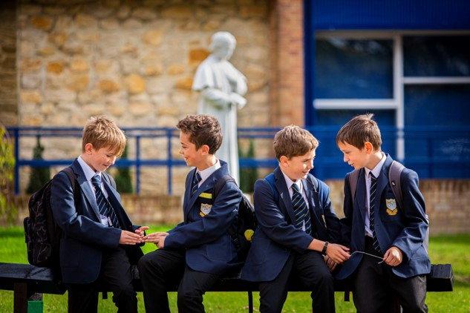


Job Profile: 2nd in Computing
Salary: Main Scale or Upper Pay Spine
Responsible to: Head of Department
Person Specification
- Commitment to supporting the distinctive nature of a Catholic school
- Qualified Teacher status
- Recent and relevant professional development
- Willingness to further develop professional skill
- Ability to enthuse, inspire and develop students under the Catholic ethos
- Ability to challenge, motivate and empower students
- Ability to recognise the needs of students and raise standards
- Ability to manage resources efficiently
- Commitment to promoting the educational principles of St. John Bosco
- Genuine enjoyment of working with young people
- Commitment to inclusion for all
- Commitment to excellence in terms of teaching and learning
- Knowledge and understanding of recent developments in learning and teaching
- Excellent grasp of new technology and its potential to support learning
- Excellent communication, interpersonal and organisational skills
- Commitment to working as a team player
- Ability to be an effective Form Tutor
- Commitment to supporting and promoting the extra-curricular life of the school
- Boundless enthusiasm and a positive outlook
- Capacity to work very hard under pressure
- Personal integrity and the drive to do what is best for the students
- Sense of humour
- Commitment to ensuring that Salesian becomes the best school in the country

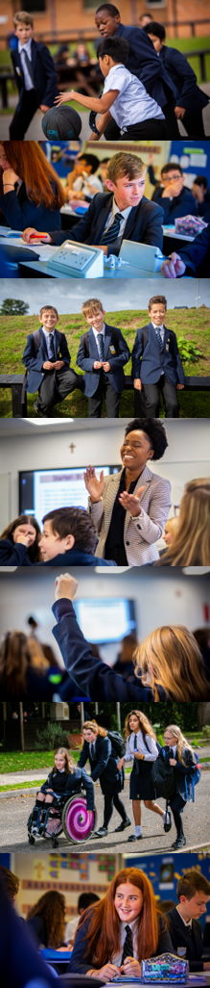
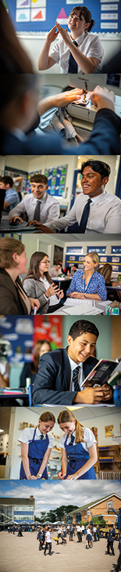Responsibilities
In short, love the children and teach great lessons but see below for the detailed version:
The responsibilities outlined in this job description are in addition to those covered by the latest School Teachers' Pay and Conditions Document.
Professional Values & Practice
Teachers should:
- Have high expectations and commit to raising the students’ educational achievement
- Be committed to safeguarding and promoting the welfare of students
- Seek and use opportunities to work collaboratively with colleagues to raise standards by sharing effective practice
- Liaise effectively with parents or carers on students’ progress and achievements
- Show a commitment to professional development by identifying areas in which they need to improve their professional knowledge, understanding and practice in order to teach more effectively in their current post, and, with support, take steps to address these needs
- Attend staff, departmental and other meetings as required
- Participate in the arrangements for performance management within the school
- Undertake a due share of duties according to the published rota
- Be aware of the School Health and Safety Policy
Teaching
Teachers should:
- Have a secure knowledge and understanding of the subjects they are trained to teach
- Set challenging teaching and learning objectives which are relevant to all students in their classes
- Plan effectively to meet the needs of students in their classes
- Plan effectively for special educational needs in consultation with the Head of Learning Support
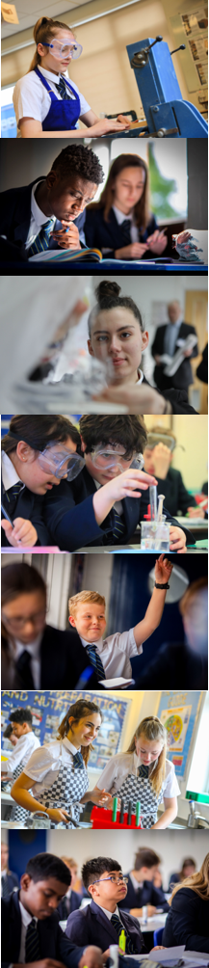
- 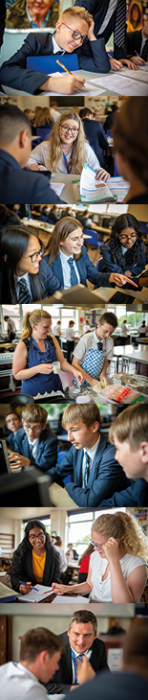Work effectively as part of a team and liaise with, deploy, and guide the work of other adults who support students’ learning
- Use a variety of teaching methods and styles appropriate to the range of ability of the students being taught
- Ensure a standard of behaviour that enables students to learn
- Undertake the teaching of those classes assigned under the school timetable
- Plan and prepare lessons in accordance with the Schemes of Work of the department
Monitoring and Assessment
- Make appropriate use of a range of monitoring and assessment strategies to evaluate students' progress towards planned learning objectives, and use this information to improve their own planning and teaching
- Mark and assess students' work on a regular basis in accordance with the school's marking and assessment policy
- Set and mark homework in accordance with school policy and departmental guidelines
- Record and report on student development, progress and attainment as required
Form Tutor
- Take the register each morning session and lead the daily act of worship
- Provide support and guidance to students and monitor performance in accordance with the schools policies
- Monitor students’ attendance and conduct and liaise with appropriate staff
- Liaise with parents and carers regarding issues as they arise
- Complete student reports in accordance with the school policy on Assessment, Recording and Reporting
Extra-curricular
- Make an effective and consistent contribution to the extra-curricular life of the school
Other
- Carry out any other duties at the direction of the Headteacher or as laid out in Salesian School documentation

