

Head of English
Bury C of E High School

Head of English
Bury C of E High School

T1 – T9 (£28,000 - £43,685)
Plus, TLR 1c (£10,712)
1.0 FTE
Permanent Contract
The main purpose of this role is:

- To provide professional leadership and management for the subject
- To be a role model to members of the department, demonstrating excellent teaching and learning in their own practice and providing innovative curriculum thinking to drive the curriculum forward in all linked subjects
To raise standards across the subject in Teaching and Learning and Curriculum leading to better outcomes for all.
Closing date: 9am 27th September 2023
Interview: 12th October 2023


Welcome to The Bishop Fraser Trust
From Mrs Tania Lewyckyi, Chief Executive Officer

The Bishop Fraser Trust is Multi Academy Trust which was set up on the 1st December 2017.
Our family of schools are as follows;
- St James’s Church of England High School (11-16)
- Canon Slade School (11-18)
- Bolton St Catherine’s Academy (3-16)
- Bury Church of England High School (11-16)
- St Catherine’s Church of England Primary (Horwich) (3-11)
The Trust’s vision is based on our strongly held Christian values: “To allow all children to experience ‘Life in all it’s fullness’, no matter what their starting point.” We offer a high quality, inclusive and distinctive education within a caring and nurturing environment based on our Christian values, recognising the uniqueness of each child.
Our schools are situated in Bolton and Bury. We are an outward facing Trust and constantly look to learn and collaborate with others. We also have an excellent provision via our Train Teach Lead Partnership (TTLP), which offers excellent CPD and school to school support. Our links with Manchester Diocese, GMLP and the Bolton Learning Partnership continues to be strong.
We are now developing our primary sector and hope to welcome at least two more primary schools over the next 12 months
We became a Trust to secure the special nature of our individual schools as we do not think that

one size fits all. We also wanted to secure our ethos and distinctiveness, enabling us to work together and to become the Trust of choice for local families and staff. Our employees are very important to us as we rise or fall by the professionalism and dedication of our staff.
It is an absolute privilege to have the opportunity to make a difference in the lives of our young people. From 2 to 18 years old, we have the potential to enhance life chances in all of our schools and improve the local communities at the same time. Our focus is on more than exams; it is about the development and wellbeing of the whole child, allowing them to effectively thrive in this fast-moving world in which we live. If this is the first time you have heard about us, we hope you are inspired and feel that you could thrive within our positive and aspiring Trust.

Tania Lewyckyj
Chief Executive Officer

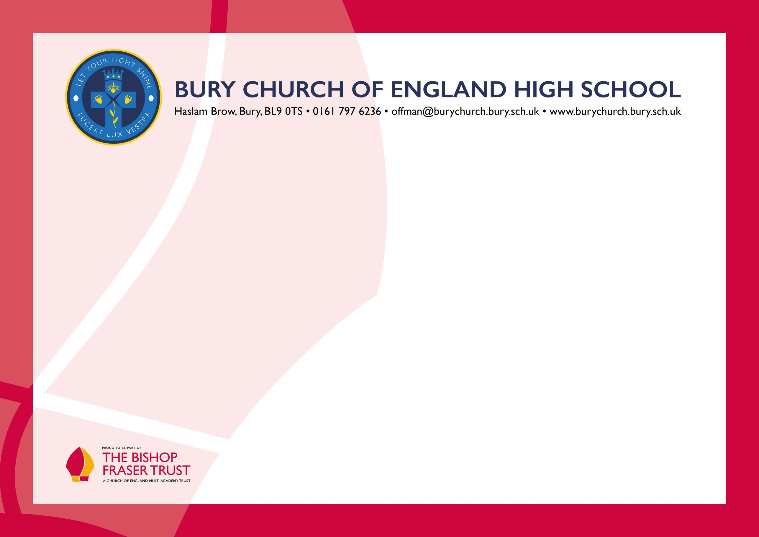
The Governors seek to appoint a well-qualified, innovative and committed individual who will support the values, aims and ethos of the school and work hard with us to help realise our vision.
We are forward thinking with high aspirations for all. We are not complacent and constantly aim to improve all aspects of our work.
You will find further information about the school on our website. We hope you will find the details informative and of interest to you. If there is anything else you would like to know, please do not hesitate to contact me and also, if you wish, we can arrange a tour of the school prior to you submitting an application.
Completed applications can be returned via the school's TES portal on our school website or emailed to recruitment@thebishopfrasertrust.co.uk You should only submit your application one way. Please do not send your application to any other email address.
If you have not been contacted within ten days of the closing date, please assume your application has been unsuccessful. Whatever the outcome, we thank you for your interest.


Dear Applicant,
Thank you for your interest in Bury Church of England High School. I hope the information provided here gives you what you require at this stage as you consider whether or not to apply for the post.
We are creating a true centre of excellence where every child and member of staff is valued and encouraged to "let their light shine".
We are a school with a rich history which has served Bury for more than 250 years and which remains at the heart of the community.
We are proud of the school's good practice and high standards of achievement. Like any school we also have our challenges, but through our collective efforts, Governors, staff, parents and community partners are committed to improving the effectiveness of the school yet further. Our aim is to provide a high-quality educational experience for our pupils as we help to prepare them for adulthood and lifelong learning.
If you can work collaboratively, are emotionally intelligent and resilient, then Bury Church of England High School is a good place to be. We were judged as 'Good' (February 2020) by Ofsted and Outstanding in our SIAMs Inspection (March 2017).

Welcome to Bury Church of England High School
from Mr Simon Braithwaite, Headteacher
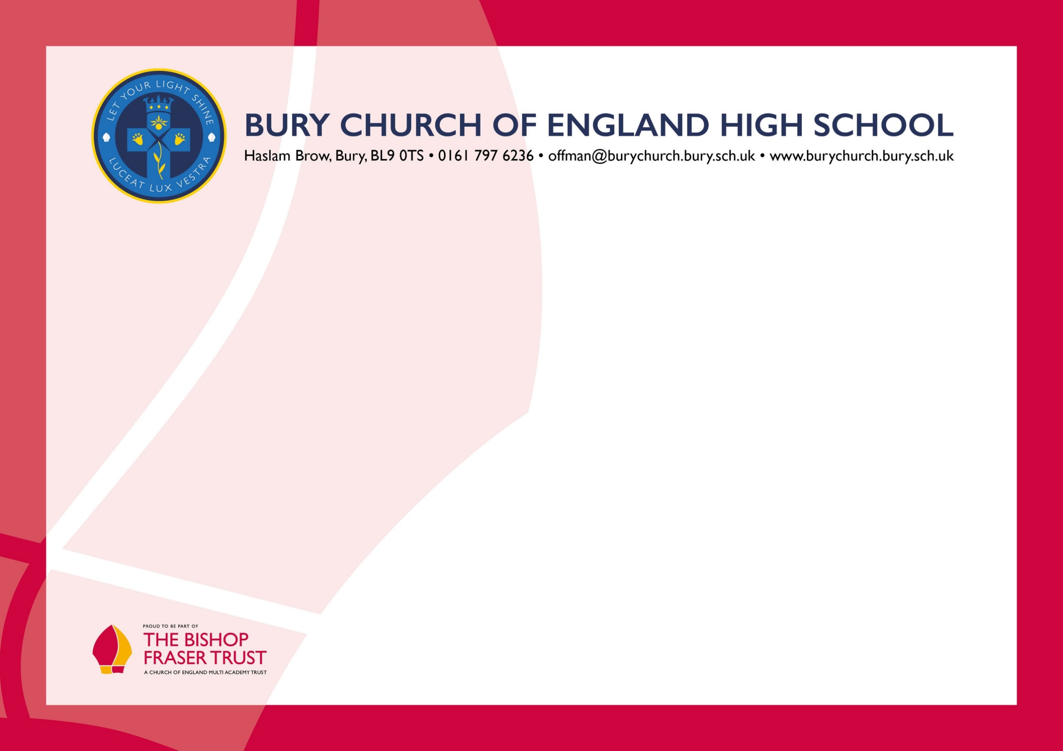

About our school

Our Christian faith is fundamental to what we do in a church school, yet we do not often stop to think how that faith directly impacts on the way we ‘do school’. The school motto of “Luceat Lux Vestra” (Let your light shine) is central to what we are about as a learning community.

Our ‘Believe, Achieve, Inspire’ approach is all about putting the teaching of Jesus into practice. Jesus explained that the reason He had come was so that people “may have life in all its fullness” To embrace life to the full, young people need to believe in themselves, in God’s goodness and purpose for them, and that they can make a positive difference in this world. To enjoy that fullness of life, they need to achieve the best qualifications of which they are capable, the life skills to engage with the wider world with confidence and a sense of being at peace with God and themselves. To experience the breadth of that fullness they need to inspire others by their gifts and abilities, with their vision and passion and to join them in the adventure of life. In short, we are called to enable them to ‘Let their light shine before people that people may see their good work and give glory to their Father in heaven’.

Living and Working in Bolton & Bury

 Bolton and Bury are great places to work!

Affordable cost of living: compared to some of the bigger cities in the UK, the cost of living in Bolton and Bury is relatively affordable.

Convenient transportation: Bolton and Bury have transportation links, with easy access to the M60, M61 and M62 motorways and regular train services into Manchester City Centre. Bury has an excellent tram link to Manchester central and two major train stations.

Beautiful green spaces: Bolton and Bury have a range of beautiful parks and green spaces, such as Heaton Park, Jumbles Country Park and Rivington and Moses Gate

Country Park. These offer an opportunity to escape from the hustle and bustle of daily life, and enjoy nature walks, picnics, or outdoor activities. The local moorland is exceptional.
Cultural attractions: Both towns have a rich industrial heritage and have a number of museums, galleries and historical landmarks that showcase this. These include the Bolton Steam Museum, Bury Transport Museum, and the East Lancashire Railway, which is a popular tourist attraction. Bolton has an excellent theatre, The Octagon. Manchester offers a huge array of culture and arts programmes.
There is a plethora of eating places, country pubs and activities. Bolton runs the UK Iron Man competitions in July and there is the Food Festival in August.
Academic institutions: Bolton and Bury are home to a number of Universities, Colleges and other academic institutions, such as the University of Bolton, and Bolton and Bury Colleges. There are great links with our Universities in the area such as Manchester University and MMU.



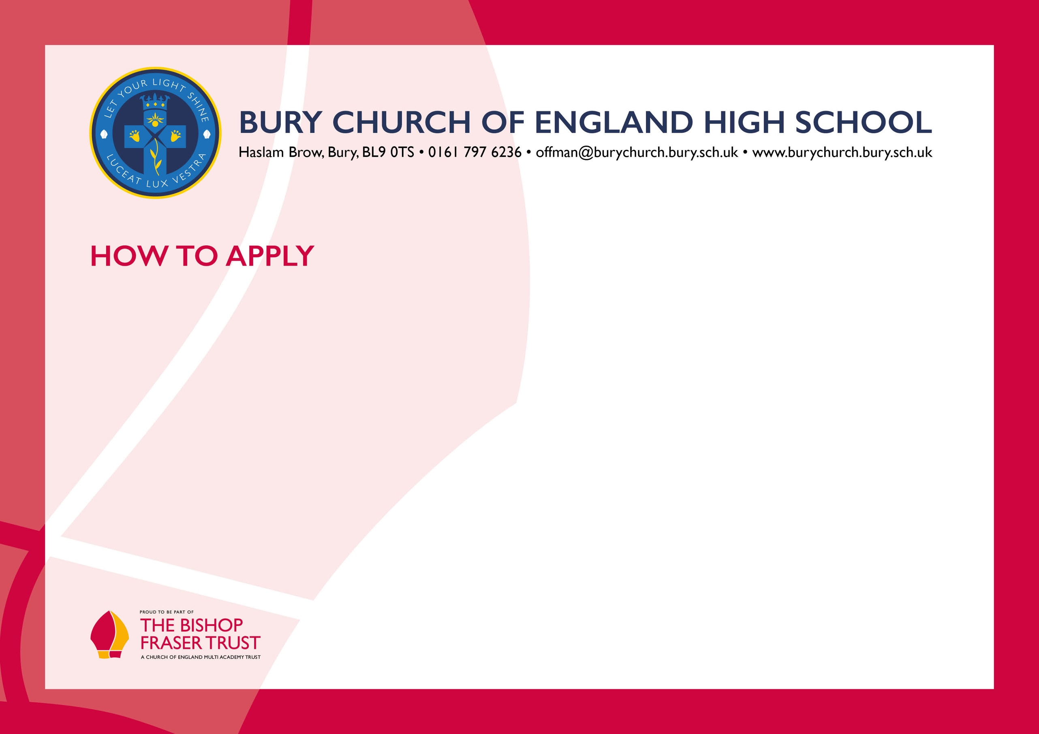
We will not be able to consider late applications.

In accordance with the General Data Protection Regulations, the details provided in the application form will be used for selection and interview procedures, and for employment records if your application is successful. Our recruitment privacy notice with further details is available both on our school website.
Successful candidates will be asked to provide, prior to taking up the appointment, documentary evidence (including National Insurance number) showing their entitlement to work in the UK. We will also carry out reference checks, an enhanced DBS and declaration of health check.

We hope that you have enjoyed reading about The Bishop Fraser Trust and our school and that you will feel able to apply for this post.

To apply, please complete the application form attached and email this to recruitment@thebishopfrasertrust.co.uk

Please do not send CV’s or open references as part of your application as these will not be considered.
It is important that you provide a complete employment history from when you left full time education. If the application form is not fully completed or has unexplained gaps in your employment history, your application will not be considered. Copies of your qualifications will be required at the interview stage; please do not send these with your application.
Please also include within the body of your application form a statement of no more than two sides of A4 to explain why you want to work at our school, why you are the best candidate for this post and what you would contribute to our Trust and school, with examples from your recent work if possible. We are keen to learn about your impact and your educational philosophy.

