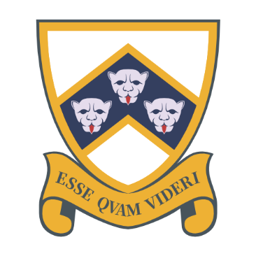
JOB DESCRIPTION
Job title: Art and design technician
Responsible to: Senior technician
Responsible for: n/a
Hours: 29.60 hours a week, 39 weeks per annum (term-time)
Salary: Col2 (£23,605 to £24,505) Pro-rated to £16,028 to £16,639
Main purpose
Provision of technical support for art & design lessons. Co-ordinating the practical resources and facilities required and providing assistance and advice in the practical needs of lessons. This will include liaising with teaching and support staff. As a member of the technician team, assistance may also be required to support other curriculum areas i.e. Computer Science

Qualities
An organised, practical and pro-active team player who has the ability to work with all members of the school community. To be flexible and positive towards changes in day-to-day working arrangements and priorities which are liable to change at short notice.
It is the expectation that all members of staff will:
- Be committed to the safeguarding and promotion of the welfare of children and young people
- Comply with the policies and procedures relating to child protection, health and safety, finance, security, confidentiality and data protection, equal opportunities, and report all concerns to an appropriate person
- Take appropriate action to identify, evaluate and minimise any risks to health, safety and security in the school working environment
- Contribute to the overall ethos/work/aims of the school
- Establish constructive relationships and communication with all staff and other agencies/professionals
- Recognise own strengths and areas of expertise and use these to advise and support others
- Participate in training and other learning activities and performance development as required

Main Duties and responsibilities:
- Technical support for lessons, including:
- Liaising with teaching staff and ensuring appropriate arrangements are in place for the effective support of lessons
- Provision, removal and cleaning of fully working equipment for lessons
- Providing technical advice and assistance to teachers and students, including assisting with practical lessons where appropriate
- Maintenance checks of all equipment
- Ensure all equipment and resources are stored correctly
- Preparation and setting up of equipment and resources. Clearing away and cleaning of equipment.
- Attending department meetings as appropriate
- Make suggestions for alternative approaches, resources and equipment
- Completion of risk assessments for own area of responsibility
- Work with teachers to reorganise resource requests if they are not available
- Ordering / procuring resources
- Running the kiln

- Liaise with teaching staff to ensure that all teaching and associated support activities are in accordance with the relevant Health and Safety legislation, including:
- All necessary risk assessments, COSHH assessments etc are in place, are available to staff, are complied with, and are reviewed and updated as necessary
- Regularly consult and implement the relevant up to date guidance
- The safe disposal of materials
- Ensure the correct PPE is utilised where necessary

- General maintenance of stores and preparation area, including:
- Care and maintenance of stores, drainage systems etc.
- Reporting required repairs as appropriate
- Stocktaking

- Other duties:
- Provide technical support to extraordinary events such as outreach and F1 project
- Liaise with local, regional and national organisations to ensure best practise
- Provide support to local partnership schools through advice around practises
- Running or participating in extra-curricular clubs in the area of art, design and technology

This document outlines the current duties required and the level of responsibility. It is not a comprehensive or exclusive list and duties may be varied from time to time which do not change the general character of the job or the level of responsibility entailed.

Person Specification:
Attribute | Essential | Desirable
Education and training | - 5 GCSEs including English, Maths, grade C or above (or equivalent) | - Workshop familiarity
Experience | - Knowledge of Health and Safety legislation including COSHH regulations  - Knowledge of safe working practises in relation to the handling and usage of hazardous equipment and tools | - Previous work in secondary education setting  - Visual arts  - Manual handling  - Experience in one of the areas of metalwork, photography, photoshop
Other skills and qualities | - Excellent interpersonal skills with ability to engage with variety of stakeholders  - Able to foster effective working relationships within a team  - Good organisational skills  - Pro-active and self-motivated  - Flexible and adaptable  - Able to work under pressure in a busy environment  - Ability to work effectively both alone and in a team  - Ability to communicate and relate effectively with all students, staff, parents & external agencies  - Good IT skills  - Deal appropriately with confidential and sensitive information | - Genuine interest in art / design  - Willingness to engage with the wider life of the school, such as supporting the 11+ exams and extra-curricular trips

