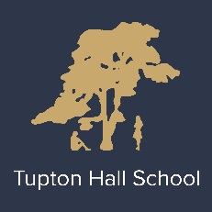
THS PE Faculty Mission

Aspire | To be the best we can be.  Excite and invigorate all stakeholders in PE with inspirational teaching, traditional and new learning activities, regularly share our success stories and develop the growth mind set
Learn | Staff and students prepared to develop and learn about themselves, clear on their strengths and what can make us all better and plan to do it.  Share what works and be prepared to change what could be better
Achieve | Provide a sound programme of study linked to all key stages to allow for clear progression  Use data productively and measure impact via sound review mechanisms  Target those in need-support them  Be proud of our desire to look to make progress, however small but regularly…

The Contribution of PE to the Whole School Curriculum at THS

Develop physical competence.
Promote physical development.
Teach pupils, through experience, to know about and value the benefits of exercise in relation to physical, mental and social health.
Develop self-esteem through the development of physical confidence.
Help pupils to cope with both success and failure in the context of co-operative and competitive physical activities.
Provide experience of activities which should lead pupils to lifelong participation.
Develop resilience
Develop problem solving skills
Development of interpersonal skills.
Forge links between school and the community and across cultures in order to further develop of social, moral, spiritual and cultural awareness
Foster a sense of personal pride in THS

