Assistant Principal / Head of English **
Salary Range:
Assistant Principal – L9 – L13
Head of English – UPS & TLR1b

** Head of English with a fully supported career pathway to successfully progress to the role of Assistant Principal within minimum one year, maximum two years.

Assistant Principal responsible for English. This role will require the successful candidate to lead in other areas of Academy improvement in addition to English.

St Aidan’s CE Academy is an Academy with a strong shared ethos of ‘success grows success when you are destined for greatness’.

We are entering a very exciting phase as an Academy on our journey to outstanding. We are looking for an inspirational and ambitious leader with the highest personal and academic standards to lead the English Department. A unique individual who is an outstanding practitioner, with unwavering high aspirations and can evidence achieving the best outcomes for all pupils. We are excited to welcome a leader with a passion for English, an embedded love for Teaching and Learning, boundless energy and drive. A special someone who has the vision and capacity to develop and embed a culture of attainment and to lead the department to ensure all pupils consistently receive the very best Teaching and Learning.

The ideal candidate will:
- Develop and embed the strategic direction and development of the English department
- Drive forward the quality of Teaching and Learning in the English department
- Lead and manage staff in the English department
- Have performance management responsibilities in the English department

What we can offer you:
- A strong family ethos
- Very supportive and incredible staff team
- Career progression
- Outstanding relevant CPD
- Leadership opportunities
- We are an outward facing Academy
- Research opportunities
- Incredible pupils

Our central belief is that exceptional schools / Academies recruit and retain exceptional teachers and leaders. You will be joining an ambitious, energetic and supportive team of staff. You will be working with outstanding colleagues who are incredibly passionate about their subject specialism and pedagogy and who show extraordinary commitment and dedication to our pupils in their care; as well as being hugely supportive of each other.

Should you wish to visit the school, please contact Alex Simpson, PA to the Principal, on 01325 373778 to arrange a date/time.

Further details and an application form are available from Alex Simpson, Tel: 01325 373778 or Email: A.Simpson@staidansacademy.org.uk or alternatively downloaded from our website: www.staidansacademy.co.uk.

Applications must be returned to Alex Simpson via email.
Closing Date: Monday 12 April, 12 noon
Interview: TBC

The Academy is committed to safeguarding and promoting the welfare of children and expects all staff to share this commitment. The post is subject to a successful DBS clearance and pre-employment checks will be undertaken before an appointment is confirmed.

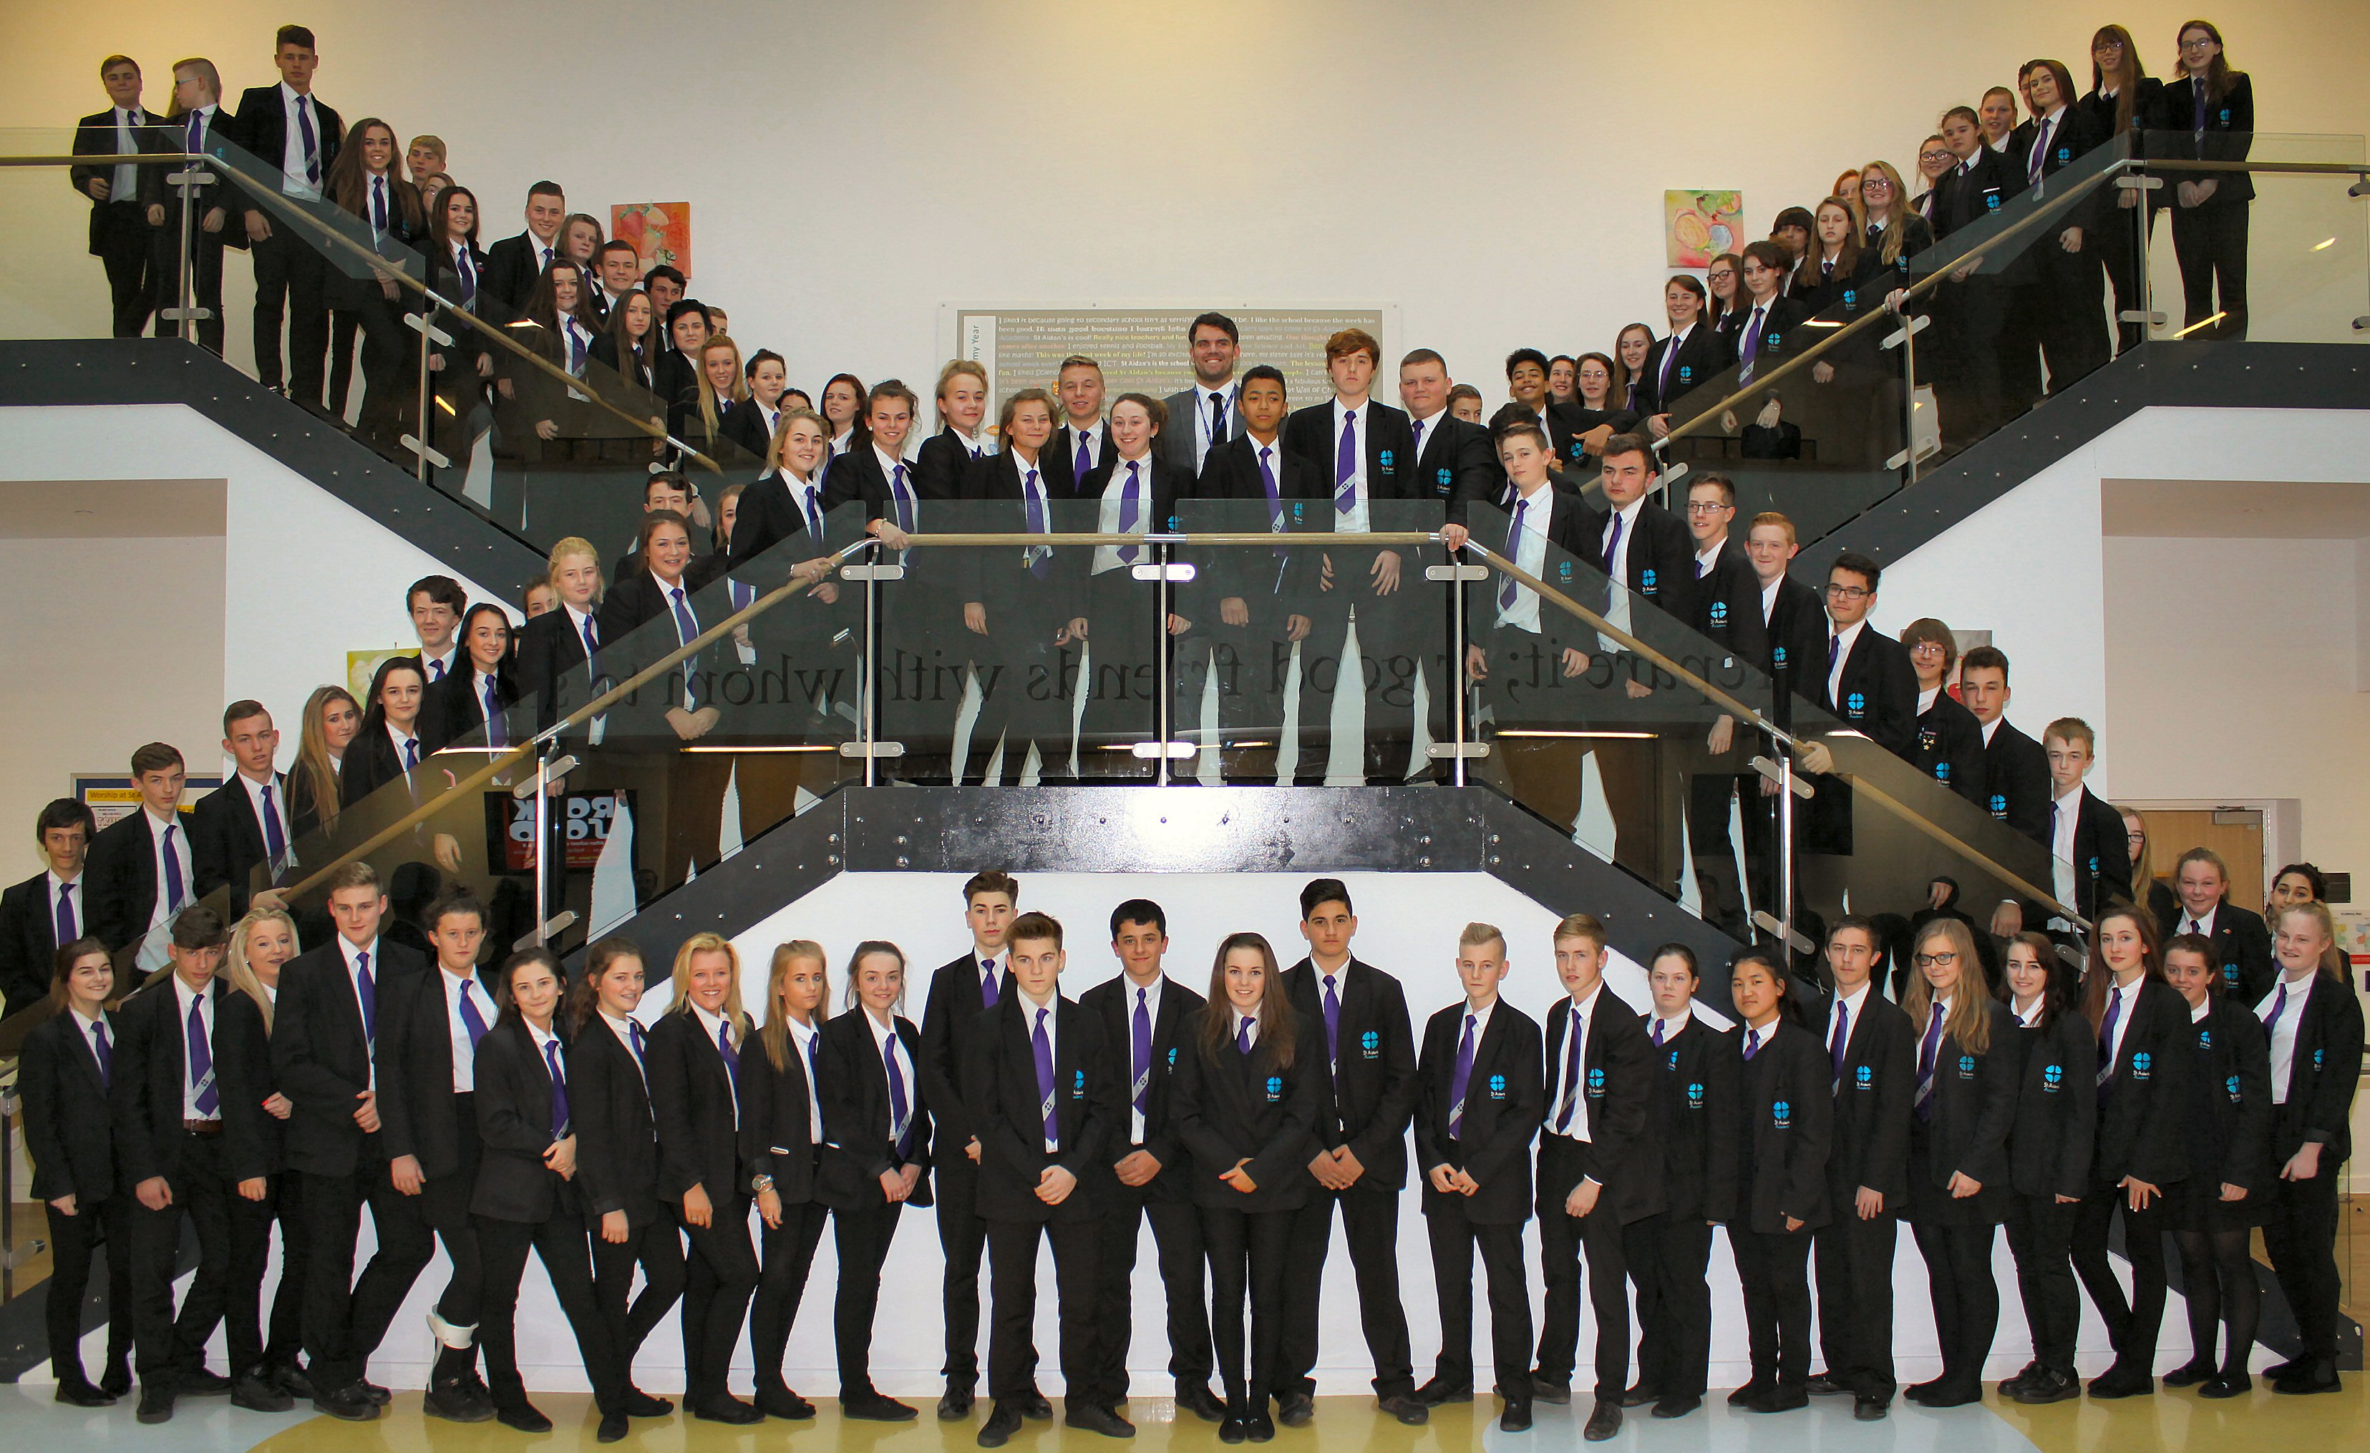 | St Aidan’s Church of England Academy  Hundens Lane, Darlington  DL1 1LL  Phone: (01325) 373770  Principal: Mrs N Gibbon

