CANDIDATE PACK

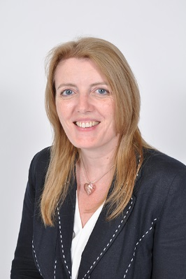
Dear Candidate,

Thank you for expressing an interest in becoming the Year 6 Teacher for Holland House School, and a member of our dynamic and progressive team.

This presents an incredibly exciting opportunity to become part of something special. Holland House is a small, family orientated school, based in Edgware in London which provides a unique balance between tradition and the best of modern teaching practice. We believe in a vigorous curriculum that holds high its academic standards while allowing pupils the opportunity to explore creative endeavours and our teachers have a passion for the delivery of excellence in education.

We give Staff the chance to be creative, collaborative, and by bringing teaching alive to develop the skills, passions and innate attributes of all the children.

Helen Stanton-Tonner,
Headmistress

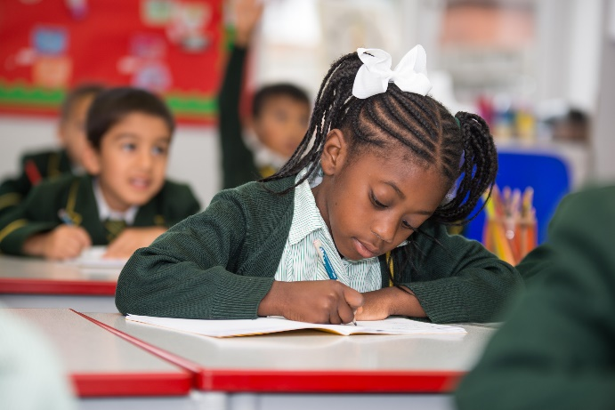

Contents – the aim of this pack is to give you sufficient background information to support your application.

1. Message from the Headmistress

2. School History

3. Ours values and beliefs

4. School Organisation

5. Important Features of the
School

6. The local area

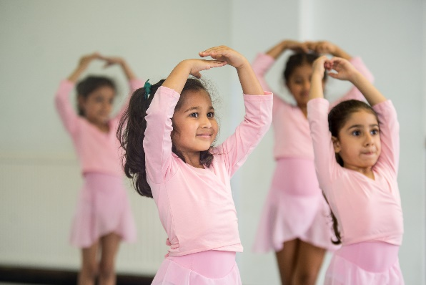
School History.
The school was founded in 1937 as an independent co-educational day school for pupils aged 4 – 11 years. The School moved to its present site in 1941. In 1974 it became a charitable educational trust with a board of Governors now consisting of 8 members. There are now approximately 150 pupils attending Holland House School.

Our Values and Beliefs
Holland House is an academically selective school that provides a high-quality learning environment which aims to provide an opportunity for every child to reach their potential. We recognise each child to be unique with individual needs and talents. We support pupils’ development in a stimulating and creative academic environment. Pupils are well prepared for their next school and for their future lives in a fast moving and challenging world.

Holland House School Aims:
- Providing a school where children are happy, secure and productive
- Providing an education with breadth and strong academic foundations through which pupils’ flourish
- Providing an education underpinned by strong relationships between teachers, pupils and parents
- Imparting the best of traditional values as a central theme running through a Holland House education
- Fostering robust relationships with leading secondary schools
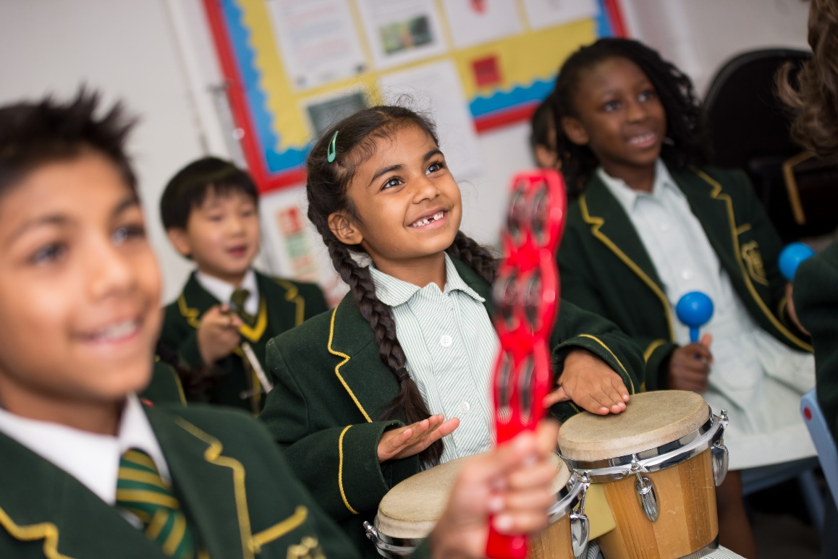
- Rewarding achievement in whatever field
- Our aim is to provide a school where children are happy and productive. We believe that education can be fun, and that enjoyment of school life does not preclude high academic achievement

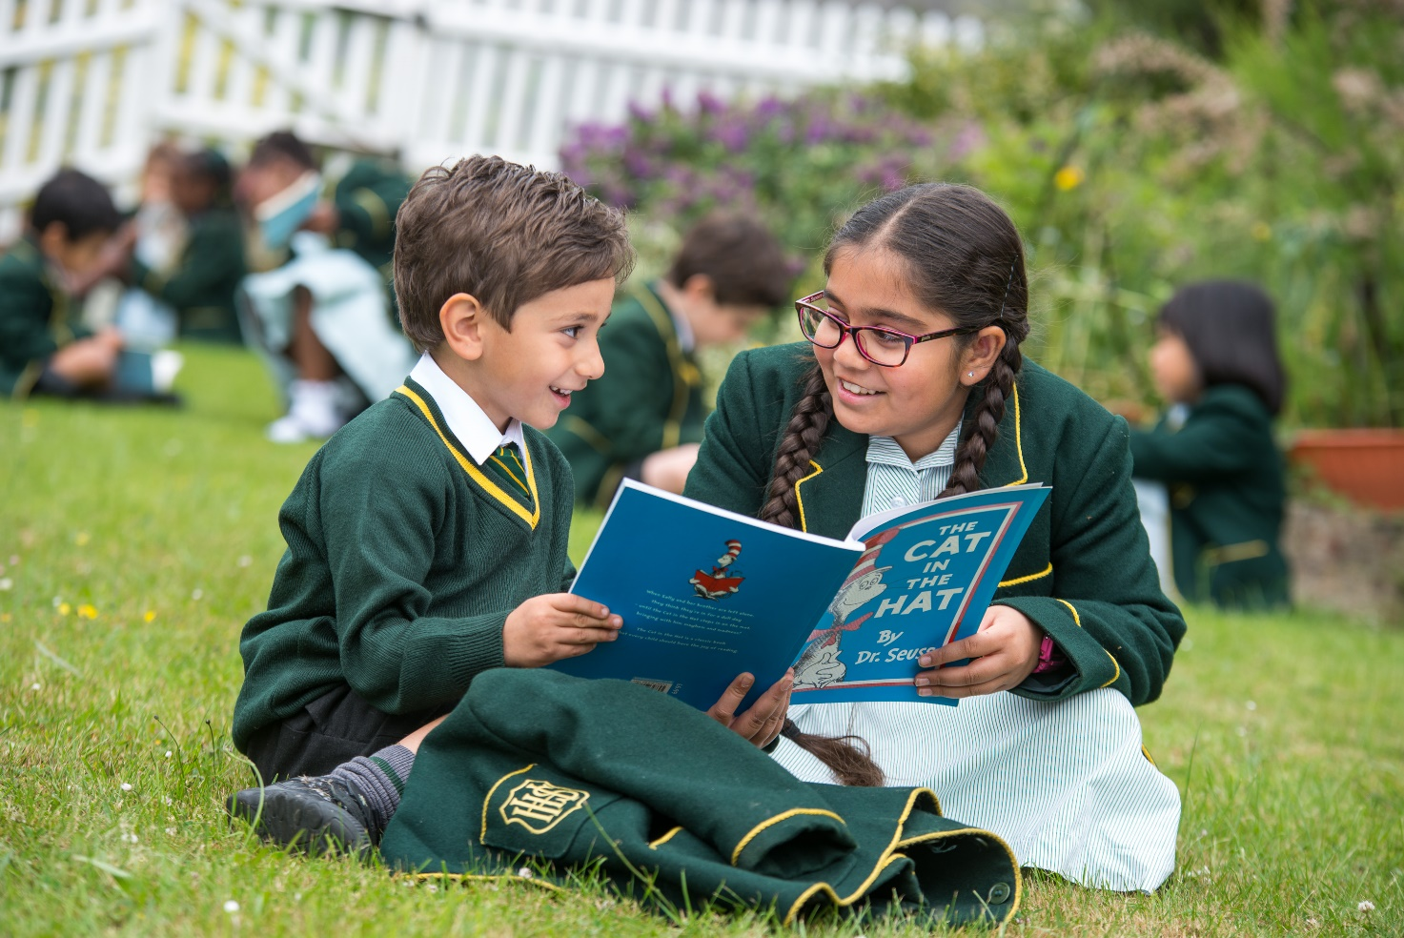We believe that confidence and self-esteem, even in the young child, follow intellectual development be it academic or moral.

All children are strongly motivated by the staff to give of their best in the belief that every child has something important to offer. Achievement, in whatever field, is rewarded.

Each child is helped to discover and do what is right, to continually develop all the qualities of good character, including productiveness, honesty and justice to all.

Holland House School seeks to identify the most that each child can do and then make it possible for each child to achieve the most.

School Organisation
Holland House School is one form entry school from Reception to Year Six. Pupils are assessed on entry at 4+, which is our main intake as pupils tend to remain until 11 years old where they sit a variety of exams for top London independent and state schools. The school is split into two departments, the Pre-Prep (Reception, Year 1 and Year 2) and the Prep School (Year 3, Year 4, Year 5 and Year 6).
The Senior Leadership Team (SLT) consists of the Headmistress, Deputy Head Academic, Deputy Head Pastoral, The Designated Safeguarding Lead and the School Bursar. The school is a charitable trust with a Board of Governors who meet regularly and are active within the school.

Important Features of the School - All all our teachers teach excellent and innovative lessons consistently and are able to coach others to do the same. Successful candidates will be excited at working collaboratively and in support of such an excellent team that aims to deliver rich learning experiences and develops different pedagogies. We believe that the combined power of flexible teaching styles, adaptable learning spaces and specialist teacher input to meet different curriculum needs is a potent way to improve learning.

English Language is at the heart of everything we do, with pupils having the chance to develop their comprehension and composition skills every day. All teachers are expected to develop reading, writing and speaking skills in lessons.
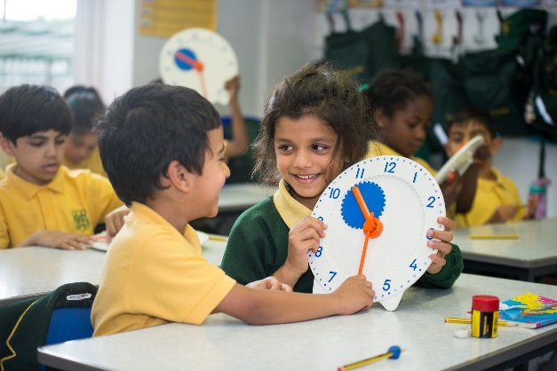

Mathematical Skills are emphasised from the Reception Years upwards. A strong focus on learning number bonds and multiplication and division facts provides a strong foundation for pupils’ development. We aim to teach ahead of National Curriculum expectations and the focus on independent school exams takes our curriculum beyond national age expectations.

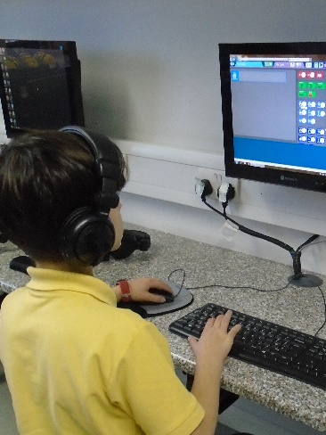
Integration of New Technology is becoming a central aspect of the pupil’s learning experience. Pupils are constantly challenged and stretched to achieve their potential. All staff are expected, with training, to develop this practice further.

Throughout the school we take pride in a broad curriculum. French is introduced as the curriculum modern foreign language in the Reception Year and Music, Art, PE, Computing and Dance are taught by specialist teachers. Preparation of children for 11+ Entrance or academic scholarship entry to a range of senior schools is the aim of our own schemes of work.

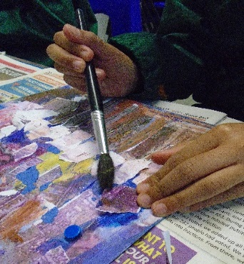

Class Sizes are small and with a maximum of 22 pupils. Keeping class sizes small allows us to further stretch those who have been identified as academically capable and to support those who are progressing more slowly.

The Local Area
Holland House is a thriving school, nestled in the North West London town of Edgware in the London borough of Barnet. The nearest Underground station is Edgware Station on the Northern Line and the M1 & M25 are easily accessible and a short drive away.

Next Steps
The closing date for applications is 12.00 midday on Monday 27th January.
Successful candidates will be notified by Wednesday 29th January of their interview date and time. Interviews will take place on either Monday 3rd or Tuesday 4th February.
All candidates will be expected to teach an English and a Maths lesson to a Year 5 or Year 6 class as part of the interview process.

