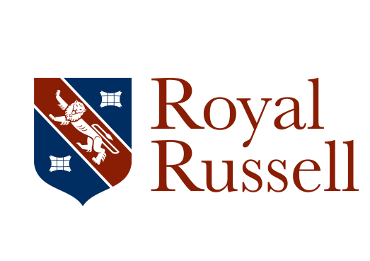

Hockey Coach

Royal Russell School is offering a fantastic opportunity for a coach to join us for the beginning of September 2019.

We would like to hear from Hockey coaches who are passionate at delivering high quality sessions and are interested in supporting teams and individuals.

Our exceptional onsite facilities include,6 full size grass football pitches, a new Olympic standard floodlit hockey pitch, 2 further new floodlit all-weather games areas for Netball and Tennis. We also have a large well equipped sports hall, a gymnasium and a 25m indoor swimming pool.
The school has a growing, yet thriving Hockey programme which has developed exponentially over the past 4 years and is continuing to do so following the development of our exceptional astro turf and MUGA space. With further exciting projects in the near future and a nationally successful reputation, sport at Royal Russell offers exceptional opportunities for all our pupils.
Royal Russell will support you in your professional development provided within the school and external courses where appropriate.

The Role:

During the day you will be actively coaching on the astro turf in afternoon sessions and after school you will take part in the Hockey co-curricular programme.

You will be required to support our Saturday and midweek fixtures programme.

We Offer:

Along with the fantastic opportunity to join a top team of colleagues at Royal Russell we offer;
• On the job training, work experience and a qualification
• All meals provided free in term time
• We will endeavour to support your professional development through specific coaching qualifications in areas agreed by the school and successful candidate.
Use of the Swimming Pool, Strength and Conditioning facility.

Job description
Job title: Hockey Coach
Reports to: Head of Hockey and ultimately Director of Sport

Responsible for: No posts

Working Time: Weekly hours agreed at the beginning of each academic year, plus any hours agreed for fixtures at weekends

Purpose of Job:
To deliver high quality Hockey coaching to pupils in the specific field required by the School in line with the scheme of work or Long Term Athlete Development Model.

Main Responsibilities:
- To ensure you are punctual for each coaching session and have set them up in advance, utilising the pupil’s changing time so that each session is ready to be delivered once pupils are fully prepared.
- To check that areas are suitable for each sports activity in accordance with good health and safety practice as specified in the RR Sports Handbook.
- To ensure that pupils undertake suitable warm-up activities before commencing each session and also complete cool down activities in an appropriate sport specific manner to avoid injuries.
- To deliver up-to-date coaching in the specified sport as directed by Head of Sport or Games which is in line with the frame work set out by the National Governing Body of the sport so that pupils receive a high quality experience and strive to excel in that sport.
- To set high expectations and standards of behaviour by pupils towards each other that encourages effective team-working.
- To promote a competitive spirit within the specified team with mutual support for each other regardless of individual abilities and outcomes.
- To provide feedback on pupil performance if required, including contributing to reports on athletes to facilitate improvement in their performance and/or contribute to their development.

General Responsibilities:
- Ensures the safety and well-being of children and young people at the School by adhering to and complying with the School’s Safeguarding and Child Protection Policy and Procedure at all times.
- Displays correct staff identification at all times whilst on site.
- Attends training and staff INSET sessions organised by the School to provide a consistent approach across the entire School staff population.
- Adheres at all times to Health & Safety legislation, and all departmental policies and procedures, to ensure the safety of you and colleagues as well as pupils, staff and visitors.
- Carries out any other reasonable duties as requested by the Headmaster or members of the Senior Management Team.

This job description contains an outline of the typical functions of the job and is not an exhaustive or comprehensive list of all possible job responsibilities, tasks, and duties. The job holder’s actual responsibilities, tasks, and duties might differ from those outlined in the job description, and other duties commensurate with this level of responsibility may be either permanently or temporarily assigned as part of the job.

Person Specification – (Hockey Coach)
The person specification focuses on the range of criteria required to undertake the role effectively. Candidates will be assessed from their Application Form and personal statement (A), interview (I) and by a Lesson Observation (L) as appropriate.
Essential | Desirable | Measured by /evidence
Education and Qualifications
GCSE in Maths and English at Grade C / Level 4 or above, or equivalent |  | A
A commitment to continuing professional development |  | A/I
 | Educated to A Level or equivalent | A
 | Minibus licence or willingness to undertake the relevant training | A/I
 | First Aid Qualification or willingness to undertake the relevant training | A/I
Level 2 Coaching qualification minimum (or working towards) |  | A/I
 | Relevant officiating qualifications or willingness to undertake the relevant training | A/I
Skills / Knowledge / Experience
 | Experience in teaching/coaching children in sports activities | A/I/L
 | Plays at least one sport competitively at County standard or equivalent | A/I
Essential | Desirable | Measured by /evidence
Proficient in the use of Microsoft Office 365 and the associated software packages |  | A/I
 | Proficient in the use of tablet technology | A/I
Ability to work with accuracy, with good attention to detail |  | A/I
Ability to work collaboratively in a team |  | A/I
Excellent organisational skills |  | A/I/L
Personal competencies and qualities
Ability to communicate succinctly, effectively and attractively both orally and in writing, using appropriate language |  | A/I/L
Friendly and approachable with a can-do mind-set |  | A/I/L
High degree of personal motivation, initiative, energy, creativity and drive |  | A/I
Ability to build effective working relationships with pupils, parents and staff |  | A/I/L
Able to take ownership of a task and see it through to completion |  | A/I/L
Willing and flexible to assist with peaks in workloads including assistance with co-curricular activities |  | A/I
Enthusiastic and committed to promoting high standards of sporting performance |  | A/I/L

