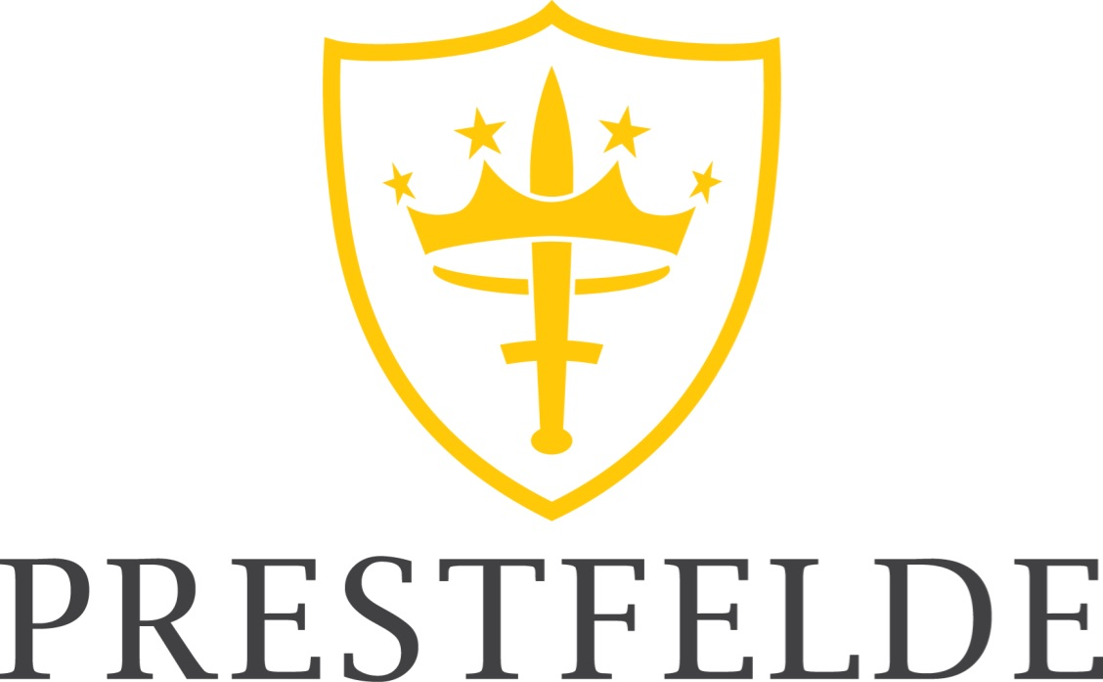

WELLBEING ASSISTANT

We are a thriving Co-educational Preparatory School in Shrewsbury, Shropshire with over 300 Pupils, aged 3-13 years. The School is situated on a beautiful 30-acre estate and offers flexi boarding supporting our independence and enrichment programs.

We are currently seeking to recruit a Wellbeing Assistant to join our outstanding team, here at Prestfelde School. This is a full-time position working term-time only (35 weeks), Monday to Friday from 8am to 5pm.

The role will assist the Pastoral Support Officer by supporting pupils with any behavioural, attendance, welfare or other issues impacting on learning and development. The purpose of this role is to ensure that all pupils are carefully and sensitively supported with their general wellbeing from learning through to social and emotional development by providing support and guidance for each individual child’s needs.

This is an exciting opportunity to be part of a friendly and successful independent school being an integral part of Prestfelde’s daily operation.

To apply for this position, please visit our website https://www.prestfelde.co.uk/staff-vacancies to obtain an application form together with further details about the role.

Please note that we do not accept CV’s. Please send completed application forms to the HR Assistant, Mrs Charlotte Davies at cdavies@prestfelde.co.uk.

Closing Date: Friday, 15 January 2021
Interview Date: Friday, 29 January 2021

Early applications are strongly encouraged. The School reserves the right to conclude the recruitment process before the closing date should the ideal candidate be identified.

Prestfelde School is committed to safeguarding and promoting the welfare of children. Applicants must be willing to undergo child protection screening appropriate to the post, including checks with past employers and an enhanced DBS check.

