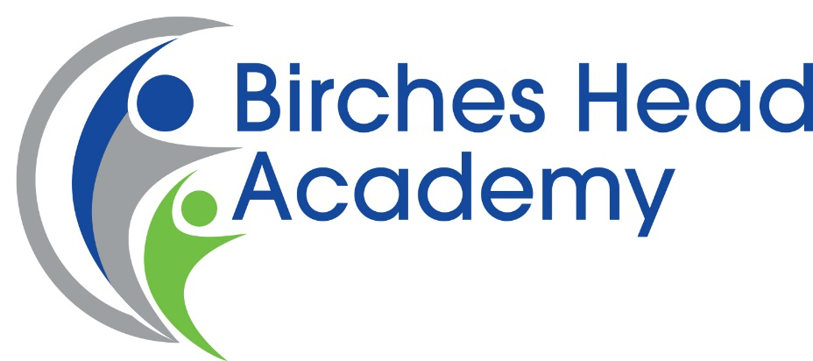

Recruitment Pack
Teacher of Art and or Design & Technology
Full Time or Part-time Considered
MPS1 – UPS3

Closing Date: Monday 22nd May at 9am
Interviews: Wednesday 22nd May

In the interests of economy, we regret that we are unable to acknowledge all applications. If you have not received an invitation to attend an interview by Friday Tuesday 21st May please accept this as an indication that you have been unsuccessful on this occasion.

A Message from the Headteacher

Dear Applicant,

Thank you for downloading this application pack and for your interest in becoming an Art and/ or Design & Technology Teacher for Birches Head Academy, in Stoke-on-Trent.

This is an exciting time at Birches Head Academy as the academy has made dramatic improvements and seen a complete culture change in recent years resulting in growing numbers of children applying for places.
The Academy works in partnership with a number of schools both locally and nationally. We also work closely with many of our local Secondary schools as well as our primary feeder schools and colleges to ensure all students have the very best opportunities and outcomes.
The Academy has excellent facilities and has undergone extensive building work under Building Schools for the Future.
I have very high aspirations for the young people at Birches Head Academy. I want the very best for them. I want them to ‘Aspire to be More’. If you feel you can make a contribution to this important enterprise and help our children to be the best that they can be, then I look forward to receiving your application.
If you would like to discuss this vacancy or visit the school please contact Mrs J Bracegirdle , Head’s PA and Office Manager by email jbracegirdle@bircheshead.org.uk

Yours faithfully

Ms K Dixon
Headteacher

Our Academy Vision
We seek to build a community where our students have the social, intellectual and cultural capital to have:
- Unlimited ideas and dreams
- A vision of what they want to achieve in life and how to achieve it
- A strong sense of duty and of service to others
- Care and compassion for each other
- Choice filled lives and be good people
Above all else, we want our students to experience fullness of life, where the sort of person that they become is of paramount importance. This is articulated in our motto “Aspire to be More”
We want to be the best school in the city and one of the best in the country, so that all our pupils have the best education and pupils to model positive behaviours based on mutual respect and social integrity. Our community has a consistent culture of high expectations so that everyone can achieve their full potential. By doing this we will instil into our pupils a desire and the means to be the best and make a positive difference in our world.
The Art and Technology Department
The department consists of the two closely related subjects of Art & Design and Design & Technology. The overriding aim of the department is to equip students with the necessary skills & tools to be able to express themselves creatively. We have the highest expectations of our students and hope to instil in them a high level of aspiration and determination coupled with an enjoyment of Art, Design and Technology. There are three large specialist art classrooms, two specialist technology classrooms plus a workshop, food room and a kiln room. There are desktop computers, Mac computers and laptops within the department which have Photoshop and 2D design for use by the students. In addition, the department also has a set of digital cameras, a Boxford laser cutter and facilities / equipment for ceramics, textiles, engineering, photography and printmaking.
The department is keen to promote a caring environment where all students and staff feel happy and safe to work. Health and safety is regarded as being of paramount importance and the teaching and learning of this continues each year.
The Context
The City of Stoke-on-Trent is in the West Midlands and has a population, of 249,000, which is predominately white British but with a significant minority ethnic community. Ambitious plans are underway to transform and renew the City through major investment in health, housing, economic development, and education. The ‘Potteries’ as Stoke-on-Trent is affectionately called is renowned for its world class ceramics industry and industrial heritage. The Midlands power house is driving economic growth and renewed prosperity.

The City boasts a strong cultural tradition with its ceramics heritage and Performing Arts tradition.

With a 10% increase in the number of children, education is of critical importance to the future prosperity of the City, and the BSF programme has established excellent facilities for our young people.

Our Academy Values
As a student of Birches Head:
• I will have self-belief and the social skills to continue to succeed in an ever-changing world
• I will take pride in my efforts and have the confidence to celebrate my successes
- I will embrace challenges and opportunities; I will make a positive contribution with honesty and integrity

Staff of Birches Head will:
• Inspire you to grow in confidence, resilience, self-respect and with a sense of responsibility
• Foster a sense of pride in you and celebrate your successes
• Expand your horizons, challenge you to reach your full potential and realise your aspirations

Job Description
Birches Head Academy wishes to appoint a well qualified Teacher of Art and/ or Design and Technology to support the work of the Academy. Birches Head Academy is committed to safeguarding and promoting the welfare of children and young people and expects all staff and volunteers to share this commitment.

This post is subject to an Enhanced DBS Identity Check under the rehabilitation of Offenders Act (1974).

Candidates called for interview will be required to provide photographic proof of identity, proof of address and original qualification documents.

Teacher Job Description
PURPOSE OF POST
- To maintain and/or raise standards of student attainment and achievement within their taught classes and other learning activities and to monitor and support student progress.
- To be accountable for student progress and development within their taught classes.
- To develop and enhance their own teaching practice to achieve high standards.
- To ensure a high quality delivery of an appropriately broad, balanced, relevant and differentiated curriculum for all students studying in their classes, in accordance with the aims of the Academy and the curricular policies.
- To effectively manage and deploy support staff, financial and physical resources to support the designated curriculum portfolio.
- To monitor and support the overall progress and development of students as an academic progress tutor.
- Responsibility for the provision of a full learning experience and support for students within subject area, liaising with the Principal, Senior Leadership Team, Head of Faculty and other Subject Leaders, Achievement Leaders, SENDCO, and relevant staff with Academy responsibilities, relevant support staff, LA representatives, link governor, external agencies and parents/carers.

DUTIES
Key Roles
- Through effective teaching secure successful outcomes for learners such that they enjoy and achieve when compared to indicators used by the Academy and external bodies.
- Use challenging targets to raise standards for all learners and eliminate low attainment among particular groups and individuals.
- Support the drive to develop, implement, review and improve teaching and learning to ensure that each student thrives, exhibits outstanding learning behaviours and achieves positive progression.

High Standards of Teaching and Learning

Teachers are accountable for the setting of targets for improvement and delivering effective teaching and learning that secures high standards of students’ achievements. The following identify aspects and prompts that will enable teachers to carry out their role:

- Role model
- Implementation of national strategy (e.g. Pedagogy/methodology)
- Self-evaluation
- Ambience/climate for learning
- High expectations
- Learning styles and thinking skills
- Use of data analysis
- Marking and assessment
- Reporting
- Planning, schemes of work
- Meet the needs of all students (including management of behaviour and its impact on learning)
- Intervention strategies (e.g. booster classes, use of National Strategy resources)
- Educational enhancement (e.g. trips/visits)

Student Outcomes
- Key Stage 3
- Key Stage 4
- Behavioural standards
- Extra-curricular activities
- Examinations/ accreditations
- Attendance and punctuality

Duties as an Academic Tutor
- Maintain discipline and acceptable standards of conduct.
- Establish a positive rapport with students to develop their social and academic potential and be a main source of reference for students.
- Mark the Tutor Group register, ensuring absences and lateness are accounted for and appropriate actions taken to ensure high attendance and punctuality.
- Compile reports, profiles and references on students as required.
- Monitor students’ home study, the teaching of tutor group periods, escorting the tutor group to assemblies and attending tutor meetings called by the Team Leader.
- Track students’ academic progress and maintain close contact with parents and other agencies.

Other professional requirements

- Establish and maintain effective working relationships within the team and also other colleagues and clients/ partners of the Academy.
- Be responsible for own professional development and proactive in their own performance management.
- Participate as required in meetings with colleagues in respect of their post, duties and responsibilities.
- Any other duties and responsibilities within the range of the salary grade.

General

- The duties and responsibilities of the post will be subject to those detailed in the Academy contract issued to all teachers.
- This Job Description does not define in detail all the duties/responsibilities of the post. It will be reviewed at least once a year as part of the performance management process and may be subject to modification or amendment after consultation and agreement with the post holder
- Staffs’ individual priorities for each academic year will be identified through team plans. It is the responsibility of each individual member of staff to meet the agreed targets within the context of the Academy’s improvement plan.
- Team priorities for each academic year will be identified through the Academy’s improvement plan. It is the responsibility of the Head of Faculty to ensure team plans are implemented, monitored and reviewed and for individual team members to meet the targets set.

Person Specification

DEPARTMENT: ART and Design technology
APPOINTMENT OF: TEACHER AND ACADEMIC TUTOR

MINIMUM ESSENTIAL REQUIREMENTS | MEASURED BY:  A)APPLICATION  B)TEST/EXERCISE  C) INTERVIEW
QUALIFICATIONS/TRAINING  It is essential that the post holder has:  - Qualified Teacher Status.  - Graduate status.  - A balanced programme of relevant courses undertaken. | A
EXPERIENCE/KNOWLEDGE:  It is essential that the post holder has:  - Training and experience across the secondary phase in specialised subject area.  - Experience of successful management of change.  - Proven effectiveness as a teacher.  - Experience in the practical application of learning. | A & C
SKILLS AND ABILITIES:  It is essential that the post holder has:  - Ability to support teaching across the Academy.  - Ability in understanding of good assessment and its implications for planning and teaching.  - Evidence of successfully implementing strategies for raising standards.  - Knowledge of assessment across vocational and G.C.S. E. Specialist subject(s).  - Ability to communicate effectively both orally and in writing. | C
It is desirable that the post holder is/has :  - A self-starter with vision and imagination.  - Ability to take risks.  - Strong awareness of Health and Safety issues. | A & C
ADDITIONAL FACTORS:  It is essential that the post holder has:  - Ability to lead and motivate staff and students.  - High expectations personally for students and staff.  - Commitment to equal opportunities policies.  - Good organisational skills.  - Ability to work to agreed targets and deadlines.  - Ability to work under pressure and be flexible.  - Integrity, loyalty, sensitivity and a good sense of humour.  - A willingness to undertake appropriate training.  - Awareness and sensitivity with regard to equal opportunities and race equality.  - An ability to fulfil all spoken aspects of the role with confidence through the medium of English. | C

How to Apply
If you decide to apply for this post please complete an application form: curriculum vitae alone will not be accepted. Your formal letter of application (supporting statement) should be no longer than 2 sides of A4 and should address:

- Why the post attracts you
- How your experiences and achievements match the job and person specification

Please return your completed application to: jbracegirdle@bircheshead.org.uk (Office Manager)

Please note, it is the policy of Birches Head Academy to contact shortlisted candidates only.

Key Dates

Closing Date: 17th May at 9am
Interviews: 22nd May

Academy Location

Birches Head Academy:
Birches Head Road
Stoke on Trent
ST2 8DD
01782233595
Email: info@bircheshead.org.uk

Additional Information

Ofsted Reports: www.ofsted.gov.uk

Information about Stoke City council: www.stoke.gov.uk

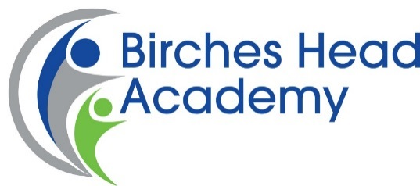
Reference Consent

The School/Academy obtains references as part of the pre-employment process. As part of the reference details relating to your employment, our standard form asks for your absence record e.g. number of days and number of occasions in the last two years, details of any disciplinary records you might have on file and information on your conduct and performance.

Upon receipt of this data it would be reviewed by the appointing manager and HR will hold this information on your personal file for the duration of your employment, it would then be destroyed in line with current requirements.

In line with the new General Data Protection Regulation and Data Protection Act 2018, we require your consent to request this information from your referees.

In order to consent to the School/Academy requesting the information outlined above please sign and date the below to confirm that you are happy for us to proceed on this basis.

Name: …………………………………………....

Signature: …………………………………………….

Date: ……………………………………………..

Once completed, please return this form to:-
Office Manager

