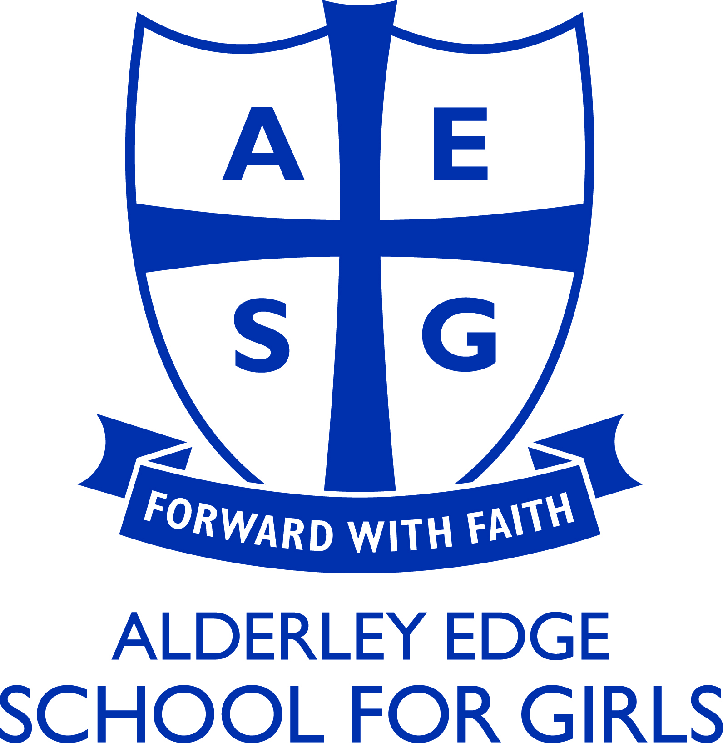

Psychology Department

The Department currently consists of the Head of Department, delivering a 2 year A level programme at Key Stage 5 with 11 hours of teaching per fortnight in both Year 1 and Year 2 of sixth form. The successful applicant will be expected to teach Psychology to A level using the AQA specification. Students currently take the Relationships, Stress and Forensic Psychology options within Year 2. The department works closely with the other subjects in school to ensure a cross-curricular approach to Psychology.

Whilst there is no specification demand for coursework, the students complete both primary and secondary research regularly and there is a teaching emphasis on application of the subject within the wider context. Students are encouraged to work independently and with initiative. They are also taught to develop discursive skills and skills of analysis and evaluation beyond the confines of the set specification.

At A level, Psychology is a popular option, usually comprising two classes in Years 12 and 13. The department and students consistently out-perform other similar centres in results, both in the grades achieved and in the average percentages for each examination paper. Students are set the highest of expectation both academically and socially.

