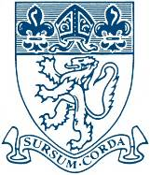
The Piggott School

Person Specification

Advice and Guidance Mentor

Professional Attributes: | Essential | Desirable
Excellent communication and interpersonal skills, be positive and approachable

Good literacy, numeracy and computer skills
Ability to work within a team working environment and also able to work independently

Confidentiality at all times
Practical First Aid experience
Educated to degree level
Experience of working in business environments

Personal Attributes: | Essential | Desirable
Be able to support and promote the values of the school and the mission statement ‘to be a school which inspires and encourages the highest achievement and attainment’
Have effective organisational and time management skills
Have the ability to prioritise, plan, monitor and evaluate
Have genuine respect for all members of our school community
Have enthusiasm for being involved in the life of a busy school
Be aware of safeguarding children issues and good practice in E-Safety
Calm under pressure, adaptable and energetic
A sense of responsibility

A sense of humour
Flexibility and use of initiative

