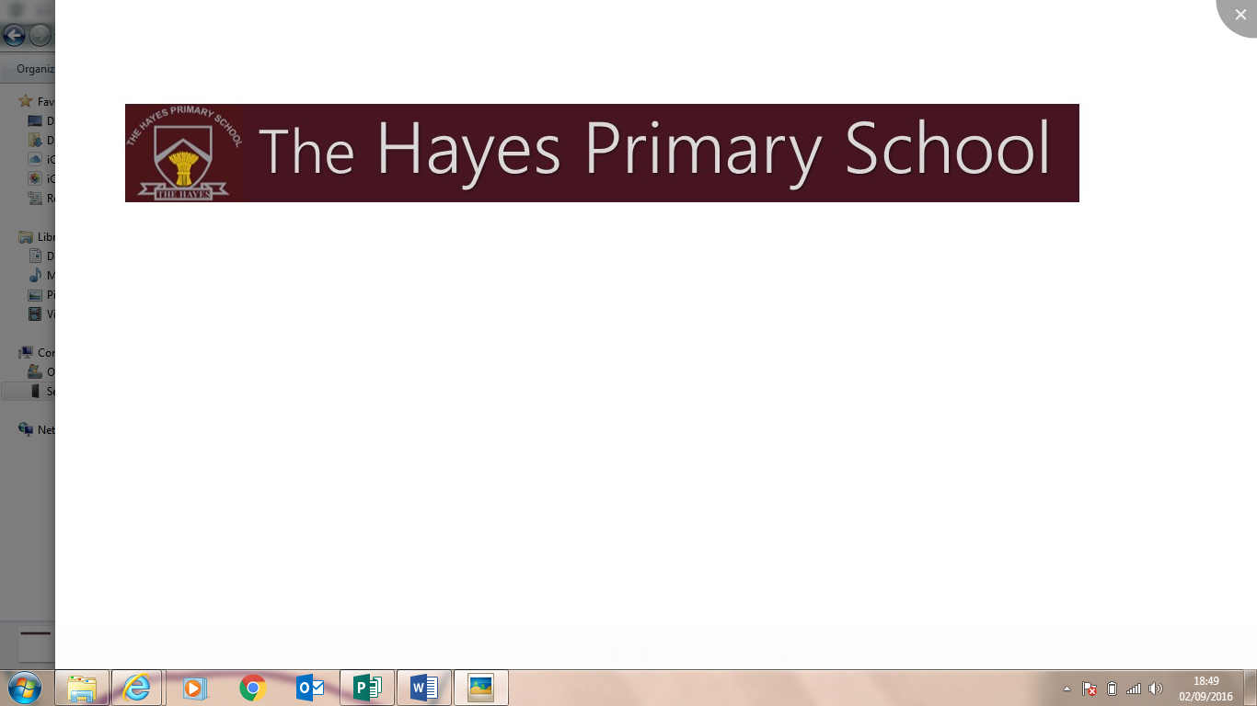

Hayes Lane, Kenley  
Surrey CR8 5JN  
T: 020 8660 4863  
F: 020 8660 4870  
**Head Teacher:** Claire Slade BA Hons QTS (Mus), NPQH  
Email: [head@hayesprimary.croydon.sch.uk](mailto:head@hayesprimary.croydon.sch.uk)  
**Deputy Head Teacher:** Laura Olley BA Ed QTS Hons, NPQH  
Email: [deputy@hayesprimary.croydon.sch.uk](mailto:deputy@hayesprimary.croydon.sch.uk)  
**Office:** [sec@hayesprimary.croydon.sch.uk](mailto:sec@hayesprimary.croydon.sch.uk)  
**Website:** [www.thehayesprimaryschool.co.uk](http://www.thehayesprimaryschool.co.uk)

June 2017

Position: Class Teacher   
Closing date for applications: Friday 23rd June 2017

Dear Applicant,

Thank you for your interest in the post of Class Teacher at The Hayes Primary School. I hope the person specification and job description will be of interest to you and look forward to receiving your completed application.

The Hayes Primary School is larger than average-sized primary school. We have 60 children in each year group, with a capacity of 420 pupils. Our school is situated in Kenley and we have a large school field, large hall and swimming pool. We have a strong tradition in sport and the Arts.

Our motto is ‘Be The Best We Can Be’ - and this is what we ask of all our children and staff. We are seeking talented and committed people: go-getters and team players. This is a unique opportunity to join the valued team in our successful school and to be a significant part of improving the life chances of our wonderful children. We look forward to meeting you!

Applications close on Friday 23rd June and interviews will be held for those shortlisted, week beginning Monday 26th June. Visits to our wonderful school are warmly welcomed and can be arranged by contacting Mrs. Rosalind Redman (School Business Manager) on 020 8660 4863.

I would like to thank you for expressing an interest in the post and look forward to showing you around our very special school.

Yours sincerely



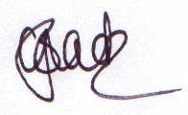

Miss Claire Slade  
Head Teacher