A message from the Principal

I would like to thank you for considering working for our wonderful school.
I have been fortunate enough to work as a Principal for the last 16 years in
good schools and having recently joined NCBIS I feel privileged for the
opportunity to lead such an amazing school.

NCBIS is a friendly community where we all support each other and work
passionately to bring out the best in everyone.

NCBIS was established in 1978 by a group of parents,
most of whom were connected with the World Health Organisation (WHO). The school has operated since that time as a “not-for-profit organisation” under the auspices of the Heliopolis Society for the Cultural and Social Care of English Speaking Foreigners (‘The Society’) and is managed through a Board of Directors elected from amongst the parent community.

Our school, which caters for children aged 3-18, has a student population of 700 and is made up of over 60 nationalities. Local Egyptian nationals and Egyptian dual nationals represent approximately 35% of our enrolment while 65% of our students are full expatriates.

NCBIS strives to bring out the best in everyone. We make learning fun, challenging and relevant in an environment that is welcoming, safe and stimulating. We provide a holistic education based on the types of learning we feel is important for students in the 21st century; international mindedness, the attributes and attitudes of the IB Learner Profile, and a highly meta-cognitive approach to teaching and learning form the foundation of our instructional programmes.

We use the High Performance Learning philosophy and framework in our school. This means that we believe that all the students can be high performers, and we teach with these expectations in mind. Using the research-based High Performance Learning approach helps us to systematically build the cognitive competencies that lead a young person to thrive in school and later life. We embed the HPL philosophy throughout our school. We never tell our students they cannot achieve; it is just they are not doing it yet but with practice and perseverance it will happen.

Our primary school is comprised of two streams: International and Dutch. Both streams follow the follow an inquiry-based curriculum, based on a bespoke course of study that prepares students to be active participants in a lifelong journey of learning. Both streams teach their respective national curriculum for English / Dutch and Mathematics. Students from both streams come together regularly for learning activities, assemblies, events and trips.

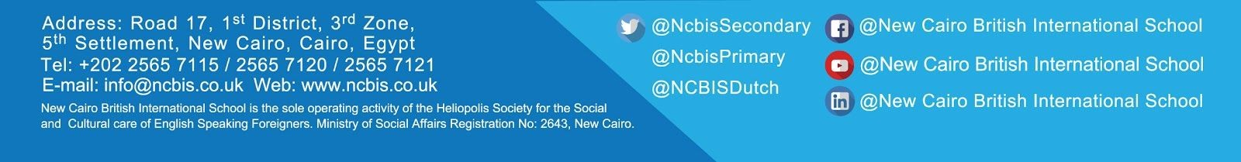
In our secondary school, our Key Stage 3 (Year 7 – 9) students work with the British National Curriculum as its framework whilst also integrating learning ideas that promote independent learning and strong research skills. In Year 10 and 11 we offer a combination of GCSE and IGCSE programmes and examinations, while we offer the IB Diploma Programme as our pre-university qualification. Our students are very successful in achieving extremely good results.

Alongside our academic programme we educate the whole child in preparation for the future. We, therefore, include after school clubs, opportunities for creative, action and service programmes, International Award and Junior International Award opportunities as well as our Challenge and educational trips. Our students are future-ready!

We pride ourselves on the excellent teachers we have, both in terms of their academic excellence as well as their professional relationships with the children. Most of our academic staff come from the United Kingdom, or The Netherlands in the case of our Dutch Stream. All our teachers are qualified and have at least 3 years of experience before joining us. We also have some staff members coming from Australia, Canada, USA, Germany, Spain, South Africa and France. We have a strong team of learning support staff and EAL teachers the school; all classrooms in the primary school have a dedicated teaching assistant.

Our school is evaluated and accredited by COBIS, BSME, CIS, IBO and the Dutch Ministry of Education. These regular inspections and evaluations from independent organisations quality assure the standard of our teaching and learning, as well as the care we provide. Our last ISI inspection report (October 2019) graded the students’ academic development as good and the students’ personal development as excellent.

I am pleased that our school is very fortunate to have a very active ‘Parent Teacher Group’. The PTG also welcomes new families, offers shopping and cultural visits, and is involved in a multitude of other social events to benefit the community. They are a very important part of our school as they bring a wonderful community feel to NCBIS.

NCBIS is a school where we bring out the best in everyone; come and join our community. I look forward to welcoming you to our school.

Trudie Masterson
Principal

