Secondary School Maths teacher person specification | Essential | Desirable | Demonstrated through
Qualifications
Educated to degree level | ✓ |  | Application form
Recognised teaching qualification e.g. B.Ed, PGCE | ✓
Qualified teacher status | ✓
Experience
3 years teaching experience | ✓ |  | Application form
Experience of working with children with special needs |  | ✓
Professional Knowledge and Understanding
Knowledge of National Curriculum for England, GCSE/IGCSE , IBDP or A level | ✓ |  | Application form & interview
Knowledge of IB Maths (To act as EE supervisor) |  | ✓ | Application form & interview
Understanding the relationship between planning, assessment, monitoring and target setting to maintain high levels of achievement and behaviour for all children | ✓ |  | Interview
Professional Skills
Able to demonstrate the effective use of ICT to enhance learning and teaching | ✓ |  | Interview
Ability to teach Google Apps for Education, Microsoft Office (Including Access) amongst others | ✓ |  | Interview
Able to plan and work collaboratively with colleagues | ✓ |  | Interview
Able to communicate sensitively with parents | ✓ |  | Interview
Good communication skills both orally and in writing | ✓ |  | Application letter & interview
Willingness to share expertise, skills and knowledge and ability to encourage others to follow suit | ✓ |  | Interview
Personal Attributes
Commitment to excellence | ✓ |  | Application letter & interview
Ability to enthuse and motivate others | ✓ |  | Interview
Commitment to professional development | ✓ |  | Application form
Ability to cope with frustration | ✓ |  | Interview
Proactive | ✓ |  | Interview
Ability to embrace change | ✓ |  | Interview

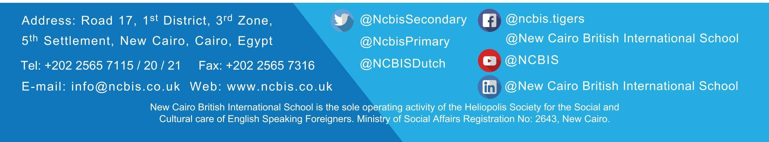

Created: January 2021
Review date: August 2021

