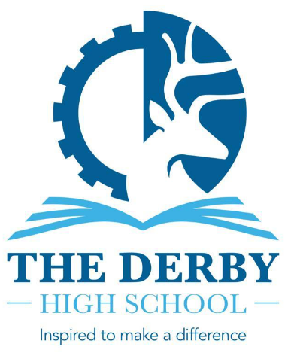
THE DERBY HIGH SCHOOL
SCIENCE AND ARTS COLLEGE
RADCLIFFE ROAD
BURY
BL9 9NH

Tel: 0161 764 1819 Fax: 0161 764 9365
Email: derby@bury.gov.uk

Headteacher: Ms C H Hubert
11-16 mixed comprehensive NOR approx. 950

Required for: January 2025

Assistant SENDCO

The Derby High School is the highest performing school in Bury, Greater Manchester and has sustained this position for a number of years. We are seeking to appoint a full-time, permanent Assistant SENDCO for January 2025. This role is a great opportunity for an aspiring SENDCO to take on leadership responsibility in our SEND Department. The ideal candidate should be committed to raising student progress and standards and ambitious in their desire for all pupils to achieve.

You will be working alongside a dedicated, hardworking and forward-thinking team where you will be supported to develop your practice. You will undertake a programme of SEND CPD and have the opportunity to work in and develop the use of our newly developed INCLUDE area, designed to support excellent care and intervention for students with additional needs.

The Derby High School is an over-subscribed 11-16 Co-Educational School situated in the heart of the town. Year on year our students make exceptional progress and our current Progress 8 measure stands at +0.4. We are an inclusive school serving a diverse student population who are a joy to teach. The leadership of the school at every level is a key strength and this was recognised by Ofsted in our most recent full inspection. We boast a talented staff who are proud to belong to the school and are committed to delivering the highest standards. All who visit The Derby High School are impressed by the warm and welcoming environment that we work in.

We believe that The Derby High School is a great place to work. This post offers you the opportunity to work in/with:

- A successful school with a strong will and determination to continue to improve
- A school that has high expectations of all who work here
- A school that places teaching and learning at the heart of school improvement
- A school that is striving to be at the forefront of inclusive education
- A school that is driven by strong values, invests in its staff and students and has a high regard for their welfare
- A supportive and cooperative teaching staff who are committed to their roles
- A school that works effectively with all stakeholders
- A caring school where you can make a real difference to the lives of young people
- A school that values your well-being

We will encourage you to be bold and creative and provide professional development that will support you in your future career plans.

In line with our commitment to safeguarding and promoting the welfare of our students, appointment will be subject to a full DBS check and references. To apply for this post, please download and complete the application form and provide a letter of application and email to Mrs Silgram-Clynes at ssilgram-clynes@thederbyhighschool.co.uk

The Derby High School is committed to safeguarding and promoting the welfare of students. Any applicants will be subject to full employment checks, including DBS checks.

CLOSING DATE: 8th October 2024 at 9.00 am

Completed electronic applications can be emailed to Silgram-Clynes at ssilgram-clynes@thederbyhighschool.co.uk

Posted applications should be sent FAO Mrs Silgram-Clynes at the school address.

