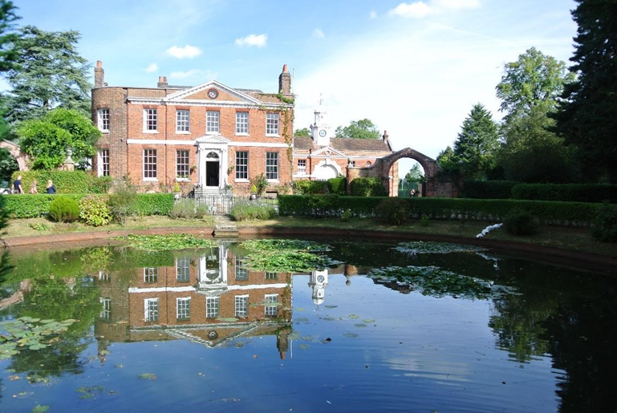

Teacher of Geography
Part-time or full-time
The ability to teach another subject is advantageous but is not essential.

September 2021

March 2021
About Mount House School
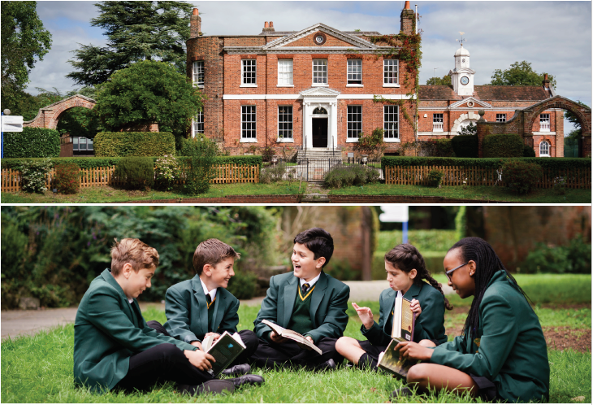
Co-educational excellence, where everyone is known, cherished and challenged.
Mount House is a small school with a highly nurturing environment in Barnet, North London. With a maximum of sixty students in each year group, it gives every student a chance to participate and shine in a whole range of academic and co-curricular areas.
In September 2020 our new Head Sarah Richardson joined Mount House and from her previous role as Deputy Head of the Perse School in Cambridge. As well as making enhancements to the academic curriculum and co-curricular programmes, Mrs Richardson is soon due to announce exciting plans for the development of the school site including some elements of which we hope will be ready for the start of the academic year in September 2021.
The Mount House school building is a stunning Georgian house set in a green and leafy corner of London opposite Hadley Common. Offering a countryside feel whilst still being close to train and tube stations is a really beneficial aspect of the school’s location. The rare combination of being a small school in an idyllic location close to central London allows our students to gain confidence whilst realising all the incredible opportunities the city has to offer.
Education has been the main purpose of this beautiful building and its grounds since 1940 when Mount House became the Architectural Association School during the war and subsequently St Martha’s Catholic Girls School. In 2018 the transition to co-education was implemented and Mount House School was established. From September 2022 Mount House will be fully co-educational.

Mount House teachers are truly 3 dimensional with a focus on the whole child: academic, extra-curricular and pastoral. We encourage students to work hard, and to develop their intellectual and creative curiosity. We encourage students to ask for help and to be kind in all their interactions with others. We also place great emphasis on the ‘all-round’ education of our students, and the creative arts, music and sport all play an important part role in school life. Pastoral care is truly exceptional at Mount House, and central in delivering that care are tutors working with small groups of students, enhanced by a supportive and enjoyably competitive House system in which all students participate.
A ‘small is beautiful’ ethos is the magic ingredient at Mount House, where every student is well known and supported to reach their true potential and where among the staff there is a close community feel and a supportive, collegiate atmosphere.

Our Values. At Mount House we A S P I R E to be:

Adaptable: prepared for life and in our future careers.

Supportive: a community with a strong sense of belonging in a safe, caring, inclusive and happy environment, in which everyone feels valued.

Principled: the importance of being a responsible citizen, developing an awareness of, and contributing to, both the local and broader community.

Inquisitive: developing a high degree of intellectual curiosity, beyond subject knowledge and high academic achievement, fostering a life-long love of learning.

Resilient: developing a growth mindset, being capable of taking knocks with a can-do attitude.

Excellent: aiming for excellence and to make the best even better.

Mount House Characteristics
- A SMALL CO-EDUCATIONAL day school. Mount House is committed to maintaining small class sizes.

- Strong ACADEMIC PERFORMANCE. All the teachers at Mount House are experienced, highly qualified professionals with a strong track record of success. Mount House has produced excellent, and rapidly improving, public examination results in recent years.

- A school to MAXIMISE POTENTIAL. At Mount House every child is motivated, enthused and supported to maximise their highest academic potential.

- A school that is serious about ART, DRAMA, MUSIC & SPORT. Art, drama and music promote individuality, personality, self-confidence, self-discipline and team work.

- A school that fosters INDIVIDUALITY AND SELF-CONFIDENCE. At Mount House we recognise that each student is unique and our aim is to encourage and develop this individuality, whilst nurturing any talents and building upon them.

- A school that prepares students for the WORLD OF WORK. A Mount House education extends beyond the confines of the classroom. Our ‘skills for the future’ programme begin as students join us in Form 1 and continues until they leave us.

- A school with OUTSTANDING PASTORAL CARE. Mount House caters for those of all faiths and none. Its environment fosters mutual respect and tolerance. Mount House instils a sense of right and wrong and promotes excellent behaviour in all areas of school life.

Job Title: | Teacher of Geography
Reports to: | Head of Humanities
Starting Salary: | Competitive dependant on qualifications and experience
Hours: | 08.15 – 17.15
We are seeking to appoint a dynamic and inspirational individual to teach geography in our rapidly expanding school. This post would suit an NQT.

Geography is a popular subject at Mount House and is taught to all students in Years 7, 8 and 9. For GCSE we teach the AQA course, but currently have no A Level geographers; we hope that as the School grows we will be able to offer the A Level.

Closing date for applications: Monday 12th April at 9 am
Interviews to take place: the week beginning 19th April, or sooner

We would like you to have:
- Qualified Teacher Status
- A track record of outstanding classroom practices
- Excellent interpersonal skills to facilitate effective communication with a range of stakeholders
- Strong organisational skills
- The ability to work with and interpret data reporting systems
- Clear understanding of the impact of effective study skills and intervention programmes on student outcomes at all key stages
- An innovative and flexible approach
- The ability to show initiative, to multi-task and develop existing skills
- Evidence of continued professional development and learning
We can offer:
- A dynamic working environment with excellent professional development opportunities
- A positive working environment within an extremely well-resourced school
- Small class sizes and strong community links

Main duties and responsibilities:
Teaching and learning

- To define the knowledge, skills, techniques and concepts to be developed and taught in a way that ensures progression and continuity throughout the curriculum.
- To ensure the appropriate levels of challenge across the curriculum to meet the needs of all levels of student ability.
- To promote teaching and learning styles which stimulate student interest and involvement in learning.
- To establish appropriately high expectations by setting down clear guidelines for establishing good standards of behaviour and achievement within the curriculum area, including the careful presentation of work and the promotion of literacy throughout the school.
- To establish procedures for the monitoring and recording of progress, which include the active participation of students, and involve the passing on of records from year to year.

Efficient and effective deployment of resources

- To foster and support the co-curricular programme in the interests of the school community.
- To promote high levels of literacy across the school in line with the literacy policy and focus for the year

Communication and liaison
- To ensure effective dialogue with parents in accordance with school policies.
- To attend parent/ teacher consultation evenings and to arrange appropriate cover (including information on students progress) for absent staff.

Attributes | Essential Criteria | Desirable Criteria
Knowledge and skills | - Knowledge of current curriculum development in their subject  - Knowledge of a wide range of pedagogic approaches to cater for different learning styles and ensure that all students are engaged  - Sound understanding of personalising the educational experience for students  - Excellent interpersonal and communication skills (including written, oral and presentation)  - Able to work with others to achieve common goals  - Able to provide clear direction and to inspire, motivate and enthuse others  - Effective behaviour management  - Excellent organisational skills  - Preparedness to challenge under performance | - Evidence of professional development relevant to the role  - To be able to effectively interpret, analyse and use data
Experience and skills | - Experience as a classroom teacher in a secondary setting  - An excellent classroom practitioner  - Understands how and believes they can improve student outcomes  - Excellent understanding of assessment processes and how to use these to support planning and raise student achievement  - Ability to lead own professional development  - Confident user of new technology as a management tool | Ability to lead an extracurricular activity
Personal attributes | - Have a positive approach to education  - Energy, enthusiasm and perseverance  - Reliability and integrity  - Good interpersonal skills  - Able to perform well under pressure  - Clear vision and educational philosophy  - Positive commitment to individual personal development  - Capacity to work hard, under pressure, to meet deadlines  - A good record of attendance during the last three years  - Adaptable and amenable with respect to working practices  - Ability to work independently and be a team player
Equality | Candidates must demonstrate understanding of, and acceptance and commitment to, the principles underlying equal opportunities

Pension:
Subject to meeting the qualifying conditions all Teaching Staff are automatically enrolled in our work place pension scheme, currently provided by Scottish Widows. Mount House matches the employee contribution up to a maximum of 7.5% of your salary.

School fee remission:
Staff fee remission is granted in accordance with the provision at the time of commencing employment at Mount House School

Meals:
In term time Staff are provided with lunch in the School Dining Room.

Pre-Employment Vetting Checks:
It is a condition of employment at Mount House School that every applicant who accepts the offer of a job will be subject to criminal background checks through the DBS and will be required to provide documentary evidence to confirm their identity and right to work in the UK. The checks will be carried out at the School’s expense. References will be taken up, including those from previous employers.

Safeguarding Children:
The post-holder’s responsibility for promoting and safe-guarding the welfare of children and young persons for whom he/she is responsible or with whom he/she comes into contact will be to adhere to and ensure compliance with the Safeguarding Policy Statement at all times. If, in the course of carrying out the duties of the post the post holder becomes aware of any actual or potential risks to the safety or welfare of children in the school he/she must report any concerns to the Head and / or DSL.

