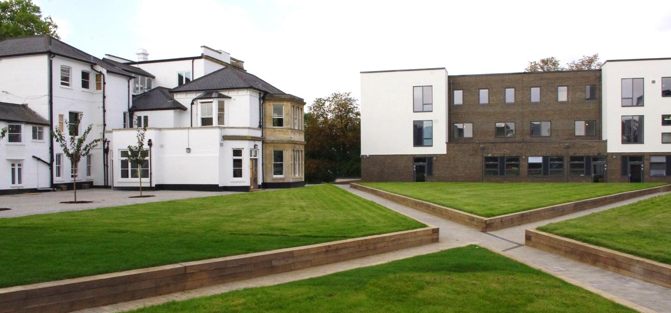
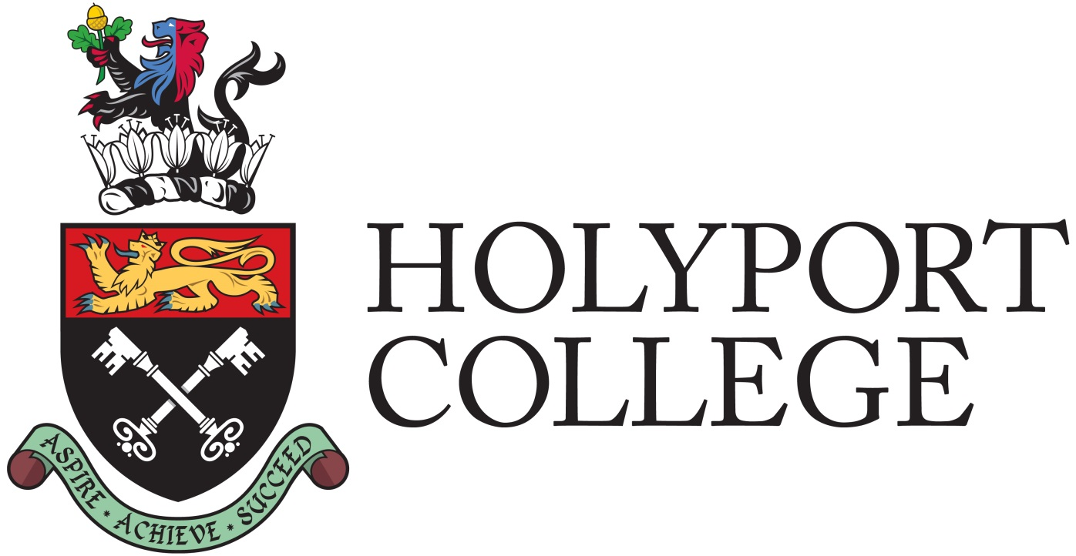
CANDIDATE INFORMATION PACK

Holyport College is a co-educational state day and boarding school for pupils aged 11 – 19 years, providing an outstanding, all-round education.

Letter from the Head Master

Welcome to one of the most unique and exciting opportunities in education today.

Opened in September 2014, we have got off to an excellent start and are one of the most over-subscribed schools in the Royal Borough of Windsor and Maidenhead. Our Sixth Form opened in September 2017 and we are excited that so many of our current students have decided to stay with us and lots of them also decided to study Geography.

In May 2017, we had our first inspection from Ofsted. Rated as ‘Outstanding’ in every category, here is a flavour of what inspectors saw during their visit:

- The school is a harmonious community where all groups coexist and cooperate together particularly well. Pupils are thoughtful, respectful and friendly. They are exceptionally proud to be a part of this new school. Behaviour is impeccable.
- Pupils are encouraged to develop as confident, articulate young people with an enthusiasm for learning and life

Our students are happy, well-motivated and are already making rapid progress in their learning. We expect them to give of their best in all that they do and we haven’t been disappointed. If you want to work with well-mannered young people who want to succeed, Holyport College is the place to be.

Our Geography department is thriving – the subject is very popular at both GCSE and A level. We have already had two Geography trips to Iceland. Who knows where we might end up going next?

Our staff are central to us achieving our aim of inspiring and motivating each of our students to aim higher and achieve more than they ever thought possible. You will be part of a well-supported team of professionals in an exciting, progressive and ambitious educational environment. We are especially interested in someone who is excited about teaching Geography at A Level.

We are honoured to have as our partner Eton College. Eton’s fine traditions, its educational expertise and exceptional pastoral care help us to create a school where students aspire, achieve and succeed. And yet we are forging our own path and identity to become one of the country’s best schools.

Our website will help you to get to know us more. However, if you have any questions, please do not hesitate to get in touch – headmaster@holyportcollege.org.uk


Walter Boyle
Head Master
JOB DESCRIPTION – Teacher of Geography

REPORTS TO: Head of Humanities
START DATE: September 2018 (or sooner if available)
SALARY: MPS/UPS including London fringe (equivalent)

THE POST

Holyport College seeks an ambitious and effective graduate teacher to teach Geography. We are especially interested in someone who has experience of or an interest in teaching Geography at Advanced Level. This post will give you the opportunity to work with extremely well-motivated young people who are ambitious and capable.

THE ROLE
To teach Geography in a fun and engaging manner, ensuring students make progress and enjoy the subject.

THE DEPARTMENT
At key stage 3 students have 2 lessons of Geography a week. At GCSE they have 3 lessons per week. All students must take either History or Geography at GCSE, with many choosing to take both. Geography has proven to be a popular subject in the Sixth Form.
Fieldwork is incorporated within the curriculum wherever possible. At GCSE students are taken on 2 days of fieldwork, currently a river investigation at Amersham FSC and a human investigation in the town of Reading. At A level the plan is to take students on a 4/5 day residential field course.

KEY RESPONSIBILITIES
- To plan, resource and deliver lessons and sequences of lessons to the highest standard that ensure real learning takes place and pupils make excellent progress
- To provide a nurturing classroom that helps pupils to develop as learners
- To help to promote good behaviour across the College

TEACHING AND LEARNING
- To teach engaging and effective lessons that motivate, inspire and transform pupil attainment
- With direction from the Head of Humanities, assist in the creation and development of challenging and innovative schemes of work which are inspiring for learners and teachers alike
- Use regular, measurable and significant assessments to monitor progress and set targets and respond accordingly to the results of such monitoring
- Participate in preparing pupils for external examinations
- Maintain regular and productive communication with parents, to report on progress, sanctions and rewards and all other communications
- Develop an exciting and motivating co-curricular and enrichment offer
- Direct and supervise support staff assigned to lessons
- Adhere to the College’s behaviour management policy, ensuring the health and well-being of pupils is maintained at all times
COLLEGE CULTURE
- Support the College’s values and ethos by contributing to the development and implementation of policies, practices and procedures
- Help create a strong College community, characterised by consistent, orderly behaviour and caring, respectful relationships
- Help develop a culture and ethos that is committed to achievement
- Support and work in collaboration with colleagues and other professionals in and beyond the school, covering lessons and providing other support as required

OTHER
- Carry out the role of a form tutor
- Undertake other various responsibilities under the reasonable direction of the SLT or Head Master

PERSON SPECIFICATION – GEOGRAPHY TEACHER
QUALIFICATION CRITERIA
- Qualified to degree level
- Experience of teaching in the state or independent sectors (includes teaching practice), preferably to A Level
- Right to work in the UK
SKILLS AND ATTRIBUTES
- Effective team worker
- High expectations for accountability and consistency
- High aspirations and expectations of self and others
- A belief in the potential of every student
- Motivation to continually improve standards and achieve excellence
- Commitment to the safeguarding and welfare of all students
TEACHING AND LEARNING
- Excellent classroom teacher with the ability to reflect on lessons and continually improve their own practice
- Effective and systematic behaviour management, with clear boundaries, sanctions, praise and rewards
- Thinks strategically about classroom practice and tailoring lessons to students’ needs
- Understands and interprets complex student data to drive lesson planning and student attainment
- Commitment to regular and on-going professional development and training to establish outstanding classroom practice
APPLICATION INFORMATION
DISCLOSURE AND BARRING SERVICES
All applicants must be prepared to undergo screening to confirm their suitability to work with children and young people.
EQUAL OPPORTUNITIES
Holyport College welcomes applications from all sectors of the community.
INTERVIEWS
Shortlisted candidates will be interviewed by a panel of senior staff. They will also be asked to teach at least part of a lesson.
APPLICATIONS
Applications should be returned by e-mail to careers@holyportcollege.org.uk . The closing date for applications is Noon on Wednesday 31st January, 2018. Interviews will be held the week beginning 5th February 2018.
Applications must contain the following:
- A fully completed Application Form;
- A fully completed Recruitment Monitoring Form;
Applicants may also provide Curriculum Vitae to supplement information given in the Application Form.
In compliance with the Department for Education’s safer recruitment guidance, the College will contact referees if you have been shortlisted for interview.
Holyport College reserves the right to check the accuracy of statements made as part of an application process. Those submitting an application are deemed to have given consent to such checks being made.

All staff take part in the College’s performance management process and must abide by the Code of Conduct for Staff and Volunteers at Holyport College.

