
Assistant Student Support Officer

Start date: 1/9/25
Contract type: Fixed Term Contract

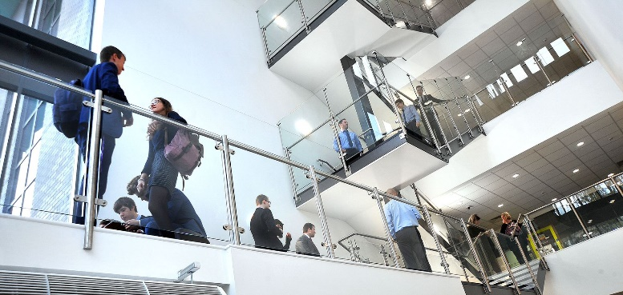
Required from 1st September 2025 to support our students at South Devon University Technical College (SDUTC is part of Education South West).
The South Devon UTC is looking for an Assistant Support Officer who will work as part of our dedicated pastoral inclusion team meeting the welfare needs of our students. As part of the you will have responsibility for day to day welfare needs of students.

We are keen to recruit like-minded people who go above and beyond for the sake of our students to ensure that they fulfil their potential.

This is an exciting opportunity to join our team which has a strong sense of purpose and enjoys variety and challenge.
What we can offer you:
- The opportunity to work in a small specialist college where all staff are viewed as part of the family.
- Somewhere where leaders look after you as well as encourage you to pursue your aspirations and goals.
- A college where the learning experience focused on technical and employability skills for young people is the centre of everything that we do.
- A college with a healthy view of work life balance
If you are interested in any of these positions please email your completed application to: Julie.scagell@southdevonutc.org.uk by 27/6/25 at 12.00 with interviews likely to take place on
1/7/25 12.00—16.00.
ESW is committed to safeguarding and protecting the welfare of children, and applicants must be willing to undergo child protection screening appropriate to the post, including checks with past employers and an enhanced disclosure via the Disclosure and Barring Service.

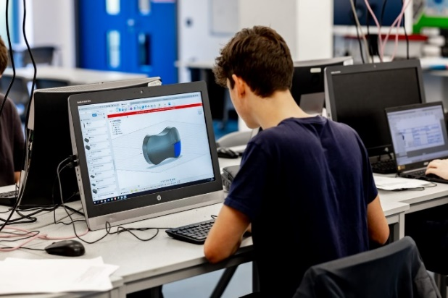

South Devon UTC
Job Description

Post Title: Assistant Student Support Officer
Responsible to: Key Stage 4 Lead
Scale: C6
Actual salary approx=£18’962
Hours: 32.5 hrs a week (8.30am – 3.30pm) / 38 weeks a year-Mon--Fri

Purpose of the Post: Working with the Key Stage 4 Lead, Student Support Officer, Designated Safeguarding Lead, Operational SENDCO, Attendance Officer and Headteacher to take the lead within the college to address the needs of pupils who need particular help to overcome barriers to learning focusing specifically on student attendance and behaviour.

General Responsibilities:
- To work closely with the Designated Safeguarding Lead, Student Support Officer and Operational SENDCO to ensure both are aware of any issues/concerns about a particular student so they can be supported in all areas.
- To observe confidentiality in all aspects of work.
- To participate in the supervision process and/or appraisal process.
- To demonstrate a willingness to undertake training development and learning opportunities to improve skills.
- Comply with and support others to observe Health and Safety procedures and processes.
- To work within the college’s policy and procedures in respect of equal opportunity, anti-discriminatory and anti-oppressive practices.
- To accept that this job description may be periodically subject to review.
- To undertake any other duties and/or times of work as may be reasonably required of you, commensurate with your grade or general level of responsibility within the college or based in any other establishment.

Team Membership: Inclusion Team

Key Responsibilities:

Pastoral support:

- To support the Student Support Officer in managing inclusion support for students at Key Stage 4 and at times KS5.
- To Lead the Mental Health Ambassadors across the college
- Establish productive working relationships with students, acting as a role model.
- To work with identified students (cause for concern), to follow and implement the hierarchy of support outlined in the behaviour policy and stages to exclusion.
- Hold all appropriate meetings and complete and share all supporting paperwork for students as they move through different levels of the Inclusion Protocol.
- Work with other members of the Inclusion team to develop, implement and monitor various support plans for individual students.
- Manage and supervise pupils excluded from and/or otherwise working to modified timetable.
- Provide advice to pupils relating to their social, health, hygiene and emotional development needs.
- Undertake comprehensive assessments of pupils to determine those in need of particular help.
- Work closely with the SEND department to identify any students with SEND and to support their needs.
- Arrange and develop 1:1 mentoring with pupils and provide support for pupils individually or in small groups and act as a key worker
- To work closely with the Attendance Officer/KS4 Lead to immediately identify any attendance concerns and enact follow up actions through the green protocol. There will be a designated period each day to do this.
- Work closely with students and parents to reduce any barriers that cause attendance issues: such as uniform issues
- Work closely with tutors and staff to support student’s attendance and behaviour.
- Take a lead role in managing the effective transfer of pupils across phases and support the reintegration of those who have been absent.
- Challenge and motivate pupils, promote and reinforce self-esteem.
- Establish constructive relationships with carers/parents, exchanging information, facilitating their support for their child’s attendance, access and learning and supporting home to college and community links.
- To work closely with the Inclusion Lead/SENDco and to make appropriate referrals to external agencies.
- To be part of the college safeguarding team.
- To be part on the college duty team i.e. attend lessons when called to pick up specific issues or students.
- To be part of the break time duty team.
- Be part of the first aid team.
- Make home visits when necessary.
- Manage the Reset Room and provide timely reports of its effectiveness.

Supporting the UTC:

- To foster links between home and college.
- To participate in relevant professional development as deemed appropriate.
- To understand and apply the college policies on learning and behaviour, and the statutory guidelines relating to disability discrimination and special educational needs.
- To maintain confidentiality and sensitivity to the students’ needs but have regard to the safeguarding procedures of the college.
- To carry out duties as directed by the Headteacher, Student Support Officer, SENDCO or Designated Safeguarding Lead.
- To remain aware and work within all relevant college working practices, policies and procedures;
- To attend staff meetings and college-based INSET as required;
- The role is based at South Devon UTC, but you may be required to work in any Trust college within the local area as directed, where the operational need requires it
- To be responsible for your own continuing self-development, undertaking training as appropriate.
Expectations
- As appropriate, to the postholder’s duties must be carried out in compliance with the following:
- Trust Equality Scheme
- Information Security Policies
- Financial Regulations
- Health and Safety at Work Act (1974) (and subsequent Health and Safety legislation)
- To work flexibly as required
- To maintain confidentiality of the Trust’s affairs
- Participate, support and comply with Trust arrangements for responding to emergencies and/or business interruptions
- To work at all times within Code of Conduct of the Safeguarding Policy
- These duties and responsibilities should be regarded as neither exclusive nor exhaustive as the postholder may be required to undertake other reasonably determined duties and responsibilities, commensurate with the grading of the post, without changing the general character of the post

South Devon UTC
Assistant Student Support Officer
Person Specification
ATTRIBUTES | ESSENTIAL | DESIRABLE | HOW IDENTIFIED
Relevant Experience | Experience of working with children with special educational needs and EHCP’s in a college setting.  Maintaining accurate records  Experience of motivating students to learn and be sociable.  Planning and prioritising tasks and work under the pressure of a busy inclusive environment | Experience of college information management systems e.g. Progresso | Application form  Interview  References
Education & Training | Attainment of GCSE qualifications (or equivalent) including Maths and English (educated to Level 2 standard). | Level 3 qualifications or equivalent (e.g. A Levels)  C or above in GCSE English | Application form  Education Certificates
Special Knowledge & Skills | Knowledge and understanding of the different social, cultural and physical needs of students  Have an interest in how students learn and behave  Really care about students, particularly those who find learning and managing their behaviour difficult.  Communicate effectively and appropriately with students with different abilities. | Knowledge of issues relevant to special educational needs and child development including the SEN code of practice | Application form / references / Interview
Any Additional Factors | Able to prioritise between different demands and to work to deadlines  Discreet and confidential  Be productive and show initiative  Computer literate  Willing to learn and take on new ideas and developments  Compassionate and sensitive approach to children and their needs  Displays an awareness, understanding and commitment to the protection and safeguarding of children and young people. |  | Interview


The successful candidate will meet the following person specification. Please note that the listed criteria will form the basis of the selection process.

How to apply


Application deadline
Completed applications must be received by 27.6.25
Please submit your application to Julie Scagell Julie.scagell@southdevonutc.org.uk

Completing your application
Candidates are asked to complete all the standard information required on the application form, and to submit a supporting statement outlining your suitability for the role.

The Governors are committed to safeguarding and promoting the welfare of children and applicants must be willing to undergo child protection screening appropriate to the post, including checks with past employers and an enhanced disclosure via the Disclosure and Barring Service.

It is the Governors’ Policy to ask to see original certificates for all qualifications of A Level or equivalent, and above, at interview.

Discussion and visits
Informal discussions with the Headteacher are welcomed, as well as visits to the college. Please arrange a suitable time with Julie Scagell Julie.scagell@southdevonutc.org.uk Telephone: 01626 240201

References
Candidates are advised that online checks will be made as part of the shortlisting process. References will be taken up immediately after shortlisting. Candidates are asked to ensure that their referees are informed of the need to respond within the timescale set. In all cases, at least one professional reference is required.

The post will be offered subject to satisfactory completion of pre-employment checks.

Welcome to South Devon UTC

At 14-16 (Key Stage 4) we provide a core education in GCSEs English, Maths and Double Science as well a specialist technical route in either in Engineering, Health Sciences or Digital Technology (from September 2022). In the Sixth Form (Key Stage 5) students can continue the same three pathways following courses up to an equivalent of 3 A Levels.
The primary focus of our UTC is to provide students with an educational experience which prepares them for employment in either engineering, health or the world of digital technology. These three industries provide huge employment opportunities for young people when they leave college or university. A UTC education is built upon the principles of employability and the skills required to be successful at work.
What makes our education pathways different is that our curriculum is built to work in partnership with employers. A range of industrial and university partners provide experiences for students which stretch beyond the college setting.
South Devon UTC opened in 2015 as an engineering centre with specialist equipment which enriches and enhances the educational experience for students. Since March 2021 the UTC has become part of Education South West, a large multi academy trust stretching across South Devon. This new partnership has resulted in significant investment to develop facilities and provide new pathways in Health Sciences.

Our Vision
Developing a new generation of Engineers, Health Scientists and Digital Technology leaders who will transform the world we live in.

Our Mission
To present to the workforce resilient students who are competent, technically capable and innovative contributors to a just and tolerant society.

A Unique Learning Experience

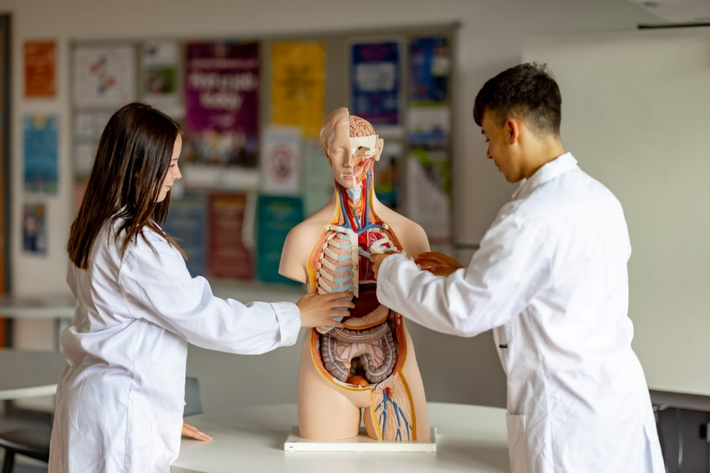
South Devon UTC will provide excellent standards of academic and technical education and a high quality, inspirational and unique learning experience.

Successful Progression
Students will have an opportunity to gain the qualifications, skills and experience needed to progress successfully to university, higher level apprenticeship or employment.

An Exciting Alternative
South Devon UTC promises to offer an exciting alternative, providing a bright future for young people, employers locally, nationally and internationally.

Education South West (ESW)
Thank you for your interest in Education South West - we are always on the lookout for exceptional talent to join us and contribute to our team of creative education professionals.

At Education South West we believe that education makes children’s lives better. We believe that every child has the right to achieve all that they are capable of and more, regardless of their background or raw ability.

Across all our colleges our staff aim to provide an educational experience which is outstanding; our colleges all believe strongly in the power of and broad and balanced curriculum. Sport, art, technology drama and music play a key role in all our colleges.

We encourage innovation, creativity, and individuality. By sharing this individuality and creativity we believe that colleges and communities become stronger through unity and collaboration.

We are caring and compassionate. Every individual in our colleges matters and we believe strongly that children and staff should enjoy their time at college, and work. A positive can-do attitude to their work and study is necessary. The happier and more stimulated a person is the more motivated they are to improve.

We believe in developing a positive attitude to learning and to life, in having clear goals and in providing a supportive environment to help the realisation of these.

We support and challenge our college leaders and the staff in our colleges to be the best they can, leading effective teams at every level, growing future leaders, and working together to provide an exciting education for all.

We welcome and support aspirational and ambitious teachers and classroom support staff, dedicated to supporting children through their time at college.

We offer excellent opportunities and professional development through in-college CPD, our Research College status, through our teaching colleges and through our links with the wider education community. We are ambitious for our children and our employees and always looking to support, challenge and develop talent, whatever stage you are in your career.

When recruiting staff to work with children we place immense importance on:

- people who go the extra mile.
- a commitment to professional development and a desire to continue learning, via research, private study and in learning from others.
- a desire to ensure that everything that is done within colleges is the best it can be.
- a firm commitment to the philosophy that we work in education to improve young people’s lives and improve society; we serve our communities and the wider populace.
- the ability to develop positive relationships with pupils, students, and parents.
- good interpersonal and communication skills when liaising with stakeholders.
- a good sense of humour.
- a commitment to working in partnership with others and sharing selflessly best practice within and outside of ESW.

Your journey with ESW starts here and we look forward to meeting you in the future.

Special Educational Needs Team

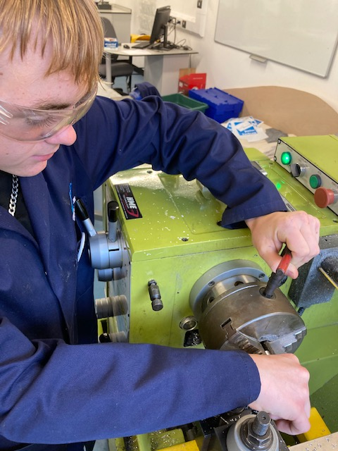
South Devon UTC is a small but growing specialist technical college. We deliver a core curriculum of English, Maths, Science, PE and PSHE alongside specialist qualifications in Engineering and Health Care Sciences.

You will be liaising with SENDCO, Head of College, Class teachers, and other support staff, which may include outside agencies, e.g. Speech and Language Therapists and Educational Psychologists.

THE POST
The Learning Support Mentor’s (LSM) main role is to provide support to students who have Special Educational Needs, specifically those with an Educational Health Care Plan. The LSM will ensure that the students can integrate as fully as possible in the activities generally undertaken by the other students in the class and make progress.
Duties will include running specific programmes and activities to assist the students’ individual learning and social needs. The LSM will be responsible for implementing the targets and strategies outlined in the EHC Plan in liaison with the class teachers and the SENDCo.
The small team based at the UTC are supportive and friendly team with full subject expertise provided by the partnership with Coombeshead Academy.

THE COLLEGE’S FACILITIES
The South Devon UTC is situated in Newton Abbott. It was a brand-new specialist facility which opened in 2015. It has specialist facilities in Engineering, Health Care Sciences and IT. All of the curriculum is delivered in modern well-equipped classrooms.

STAFF AND STUDENTS OF THE College
All staff are considered leaders within the college and given the opportunity to participate in the decision-making process through regular team, pastoral and staff meetings – and whole college events. UTC teachers are expected to link with their specialist teams at Coombeshead Academy.

Relationships between staff and students here are excellent. We see evidence of this in the time which staff devote to giving students individual help outside of classes and the time and energy they commit to trips. Our students are well motivated and responsible, and we receive many plaudits when they are active on visits.

CONTINUING PROFESSIONAL DEVELOPMENT
We are very clear in our belief that the staff are our best resource and invest a lot of time and resources in continuous professional development. We place a great deal of importance in supporting trainee teachers and NQTs. All our NQTs have an individual curriculum team-based mentor as well as mentoring from the Professional Development Leader. We do our absolute best to offer all our staff a continuous training programme as their career enters various stages from NQT through to preparation for middle and senior leadership, and then on eventually to headship. Our policy is to train our own staff who can then lead others.



