Bishop Ramsey CE School

Teacher of Science

The Science Faculty

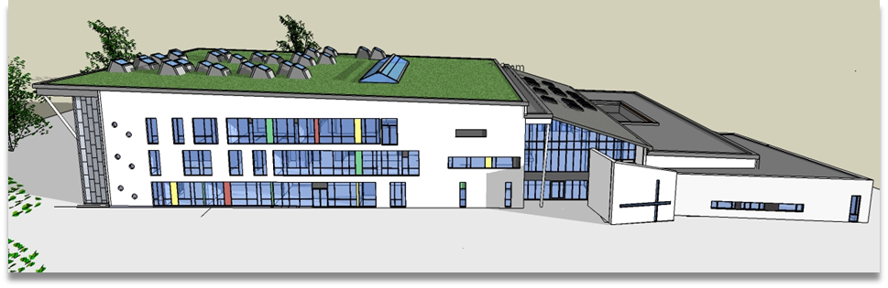

Vision
The Science Faculty vision is to ‘help students to exceed their potential as scientists’. We have an enthusiastic and dedicated team of subject specialists in Biology, Chemistry and Physics and work collaboratively to offer students an engaging and challenging curriculum. We have recently developed a new KS3 curriculum, with a focus on ‘putting the fun back into science’, ensuring that students carry out practical activities in most KS3 lessons.
Accommodation
The Science Faculty is well resourced and staffed. We have 11 fully equipped labs, each with interactive whiteboards or plasma screens and two large prep rooms.
Staffing
The department is staffed by a team of fourteen specialist science teachers and four technicians.

Mrs N Jeffries | Head of Science Faculty |  | Dr N McGeady | Teacher of Science
Vacancy | Deputy Head of Science (KS3) |  | Mrs M Davies | Teacher of Science
Dr T Jackson | Head of Physics |  | Ms M Molfeta | Teacher of Science
Mr A Murphy | Head of Biology |  | Mrs A Vishnoi | Teacher of Science
Mrs S Ngochi | Head of Chemistry |  | Mrs R Burnam-Richards | Teacher of Science
Miss S Nelson | STEM Co-ordinator and Teacher of Science |  | Mrs D Vyas | Senior Science Technician
Mr M Doran | Teacher of Science |  | Ms M Bashova | Technician
Mr N Khan | Teacher of Science |  | Ms K Imiolczyk | Technician
 |  |  | Miss T Chapaneri | Technician

Courses
KS3 is taught across Years 7 and 8, where students study Biology, Chemistry or Physics topics as well as completing mini investigations each term. Students are taught in mixed ability groups at KS3 and class sizes are kept below 28 students. Students in Year 7 also study STEM, which is taught by members of the Science Faculty as well as teachers from other faculties
From Year 9, approximately two thirds of students study GCSE Combined Science, with the remaining students opting to study GCSE Triple Science. There are 3 Triple Science groups and 5 Combined Science groups in Years 9, 10 and 11. Students are taught in setted groups at KS4 and follow the AQA syllabus. Results at GCSE are well above national average, with approximately 75% of students achieving at least a grade 4. The results for Triple Science are excellent, with 99%+ of students achieving a grade 4+ and approximately 45%+ of students achieving a grade 7 or above in 2018.
There are 3 to 4 A Level groups in Year 12 and 13 in Biology, Chemistry and Physics so the department is able to offer teaching in the Sixth Form to a large number of teachers in the department. Biology students study the specifications set by the Edexcel Board, Chemistry students study specifications set by the OCR Board and Physics students study the specifications set by the AQA Board. The results at A level are excellent; in 2018, more than 60% of students studying A Level Biology, Chemistry and Physics achieved a grade B or above (approximately 70 students).
Extra Curricular activities
We also provide extra-curricular opportunities, including a Science Club, a STEM Club, Science Week competitions for KS3, KS4 and KS5 students, several trips (including an A Level physics trip to CERN) and taster sessions for primary school children from local schools.

