
(ASD
Teaching Assistant (Level 3)
ASD Designated/Exceptional Provision)

Information for Applicants












Letter from the headteacher

June 2025

Dear applicant,

I am delighted that you are looking to apply for a job here at Birchwood Community High School. I feel very lucky to be the headteacher at this vibrant school. BCHS is an amazing place to work, with a unique sense of spirit and community – it is warm and welcoming, people-focused and totally dedicated to the community that we serve.

Our staff are passionate about education and believe that all young people should be inspired to be the very best that they can be. Our vision and values articulate the things that we put importance on and also encapsulate the school’s spirit: we are a team. The staff know this, our parents/carers know this and, most importantly, our students know this. Our vision at BCHS is to have students who understand the power of aspiration, knowledge and kindness.

We believe in the power of knowledge and the importance of a challenging, word-rich curriculum for all. That said, we are not all about the academic, we actively teach social responsibility and direct students in acts of kindness within the school setting but also in our wider community. We view it as our duty to ensure they leave us with high aspirations, secure knowledge and a kind heart.

We pride ourselves on the core ethos of our school being underpinned by the strongest foundations of discipline, respect, tolerance and compassion – we ensure our students are equipped with a strong moral compass. We offer a very strong extra-curricular programme with every member of staff offering a provision, it is an aspect of our school community that we are very proud of, and rightly so.

We know that our students are excellent people, and they thrive in a culture of achievement and success; we have high expectations, encouraging them to be aspirational in their learning and to enjoy all aspects of school life. Academic standards at BCHS are good for all students irrespective of their starting point. However, we know that we are all capable of even more. We continue to strive to improve levels of student achievement and move towards being recognised as outstanding in all areas.

It is essential that we appoint the right person to this role, and it is important that their values and views align with what we are trying to achieve as well as our philosophy on staff wellbeing and development. I would recommend that your read my personal blog (https://leadership-life.co.uk), our school blog (https://www.birchwoodhigh.org/nexilis/) and our Professional Growth handbook to really give you a more comprehensive insight into how these views and values translate into our day to day processes and habits.

Our website and this application summary can only give you a flavour of who we are, but I hope that it will inspire you to apply for the Teacher Assistant (Level 3) vacancy. If you have any questions or need any further information about this fantastic opportunity, please do not hesitate to contact the us on joinus@birchwoodhigh.org

Vacancy details:

Salary Scale
NJC Grade 5 £24,992 - £28,624 FTE. (Actual pay is £18,883-£20,796)

Contract
Permanent, 31.25 hours per week, Term time only, plus 5 INSET days.

Method of Application
The preferred method of application is electronically via email. All applications must be made using the school’s application form. Applications will be shortlisted for interview and the HR Manager will contact those selected regarding the time and venue. Applicants who have not been contacted within two weeks of the closing date can assume that on this occasion their application was unsuccessful.

Closing Date
Applications received after the closing time of 9am on Thursday 24th June 2025 will not be considered.

Interview Dates
TBC

Safeguarding
All staff who teach, train or work regularly with children aged up to 18 and vulnerable adults are required to comply fully with legislation and Birchwood Community High School policies and practices to ensure learners are safeguarded and protected.

Please feel welcome to come and have a visit before applying, but be assured that whether you visit or not, it will not affect the short-listing process. If you would like to have a look round, please email our HR Manager, Tina Wiegand (twiegand@birchwoodhigh.org) to arrange.

Thank you for considering our truly amazing school as the next chapter in your career, and hopefully I will be reading your application soon.

Yours sincerely,



Emma Mills
Headteacher



‘There is a ‘buzz’ of energy in classes, reflecting pupil’s positive attitudes to their learning.’


Our Vision

Team Birchwood believe in the power of aspiration, knowledge and kindness. We know that we achieve our best when we work together.

Our Ethos

High aspirations, high expectations and high achievement rely upon a positive working environment based upon respect. For us, respect means consistent positive regard for everyone in our learning community. A strong moral purpose enables students in our school to grow into independent, responsible young adults who can access a happy and healthy future.

At Birchwood we strive to ensure that every lesson counts, for every child, every day. We expect teachers to deliver engaging lessons that ensure students acquire powerful knowledge and develop both essential and desirable skills. For this to happen, behaviour must enable every teacher to teach and every child to learn. We expect students to come ready each day to challenge themselves to be the very best they can be. We have a wide variety of extra-curricular activities to help children develop all their skills and talents and there are many opportunities to develop their leadership skills throughout
their school life.

Our Mission

We are 100% committed to our students. We seek to sustain a community that is rooted in respect and the belief that every student can succeed. We endeavour to equip our young people with the qualities, qualifications and values that will enable them to lead fulfilling lives and become responsible citizens. We want the children in our care to leave us with high aspirations, secure knowledge and a kind heart.

We maintain high standards of ethics and behaviour; one of the ways this is by embracing the British Values: democracy; the rule of law; individual liberty and mutual respect; and tolerance of those with different faiths and beliefs.

Our Aims

We wish for our students to be:

- safe, happy and cared for in a secure and supportive environment.
- supported and challenged to do their best through excellent teaching, a broad and balanced curriculum and a wide variety of experiences.
- recognised, celebrated and rewarded for all their achievements that they develop confidence and independence.
- developed emotionally, intellectually and morally so that they are able to be successful in the rapidly changing, multicultural society in which we live.
- successful, whether through academic qualifications or a more vocational route, so they can move on to the next stage in their life.

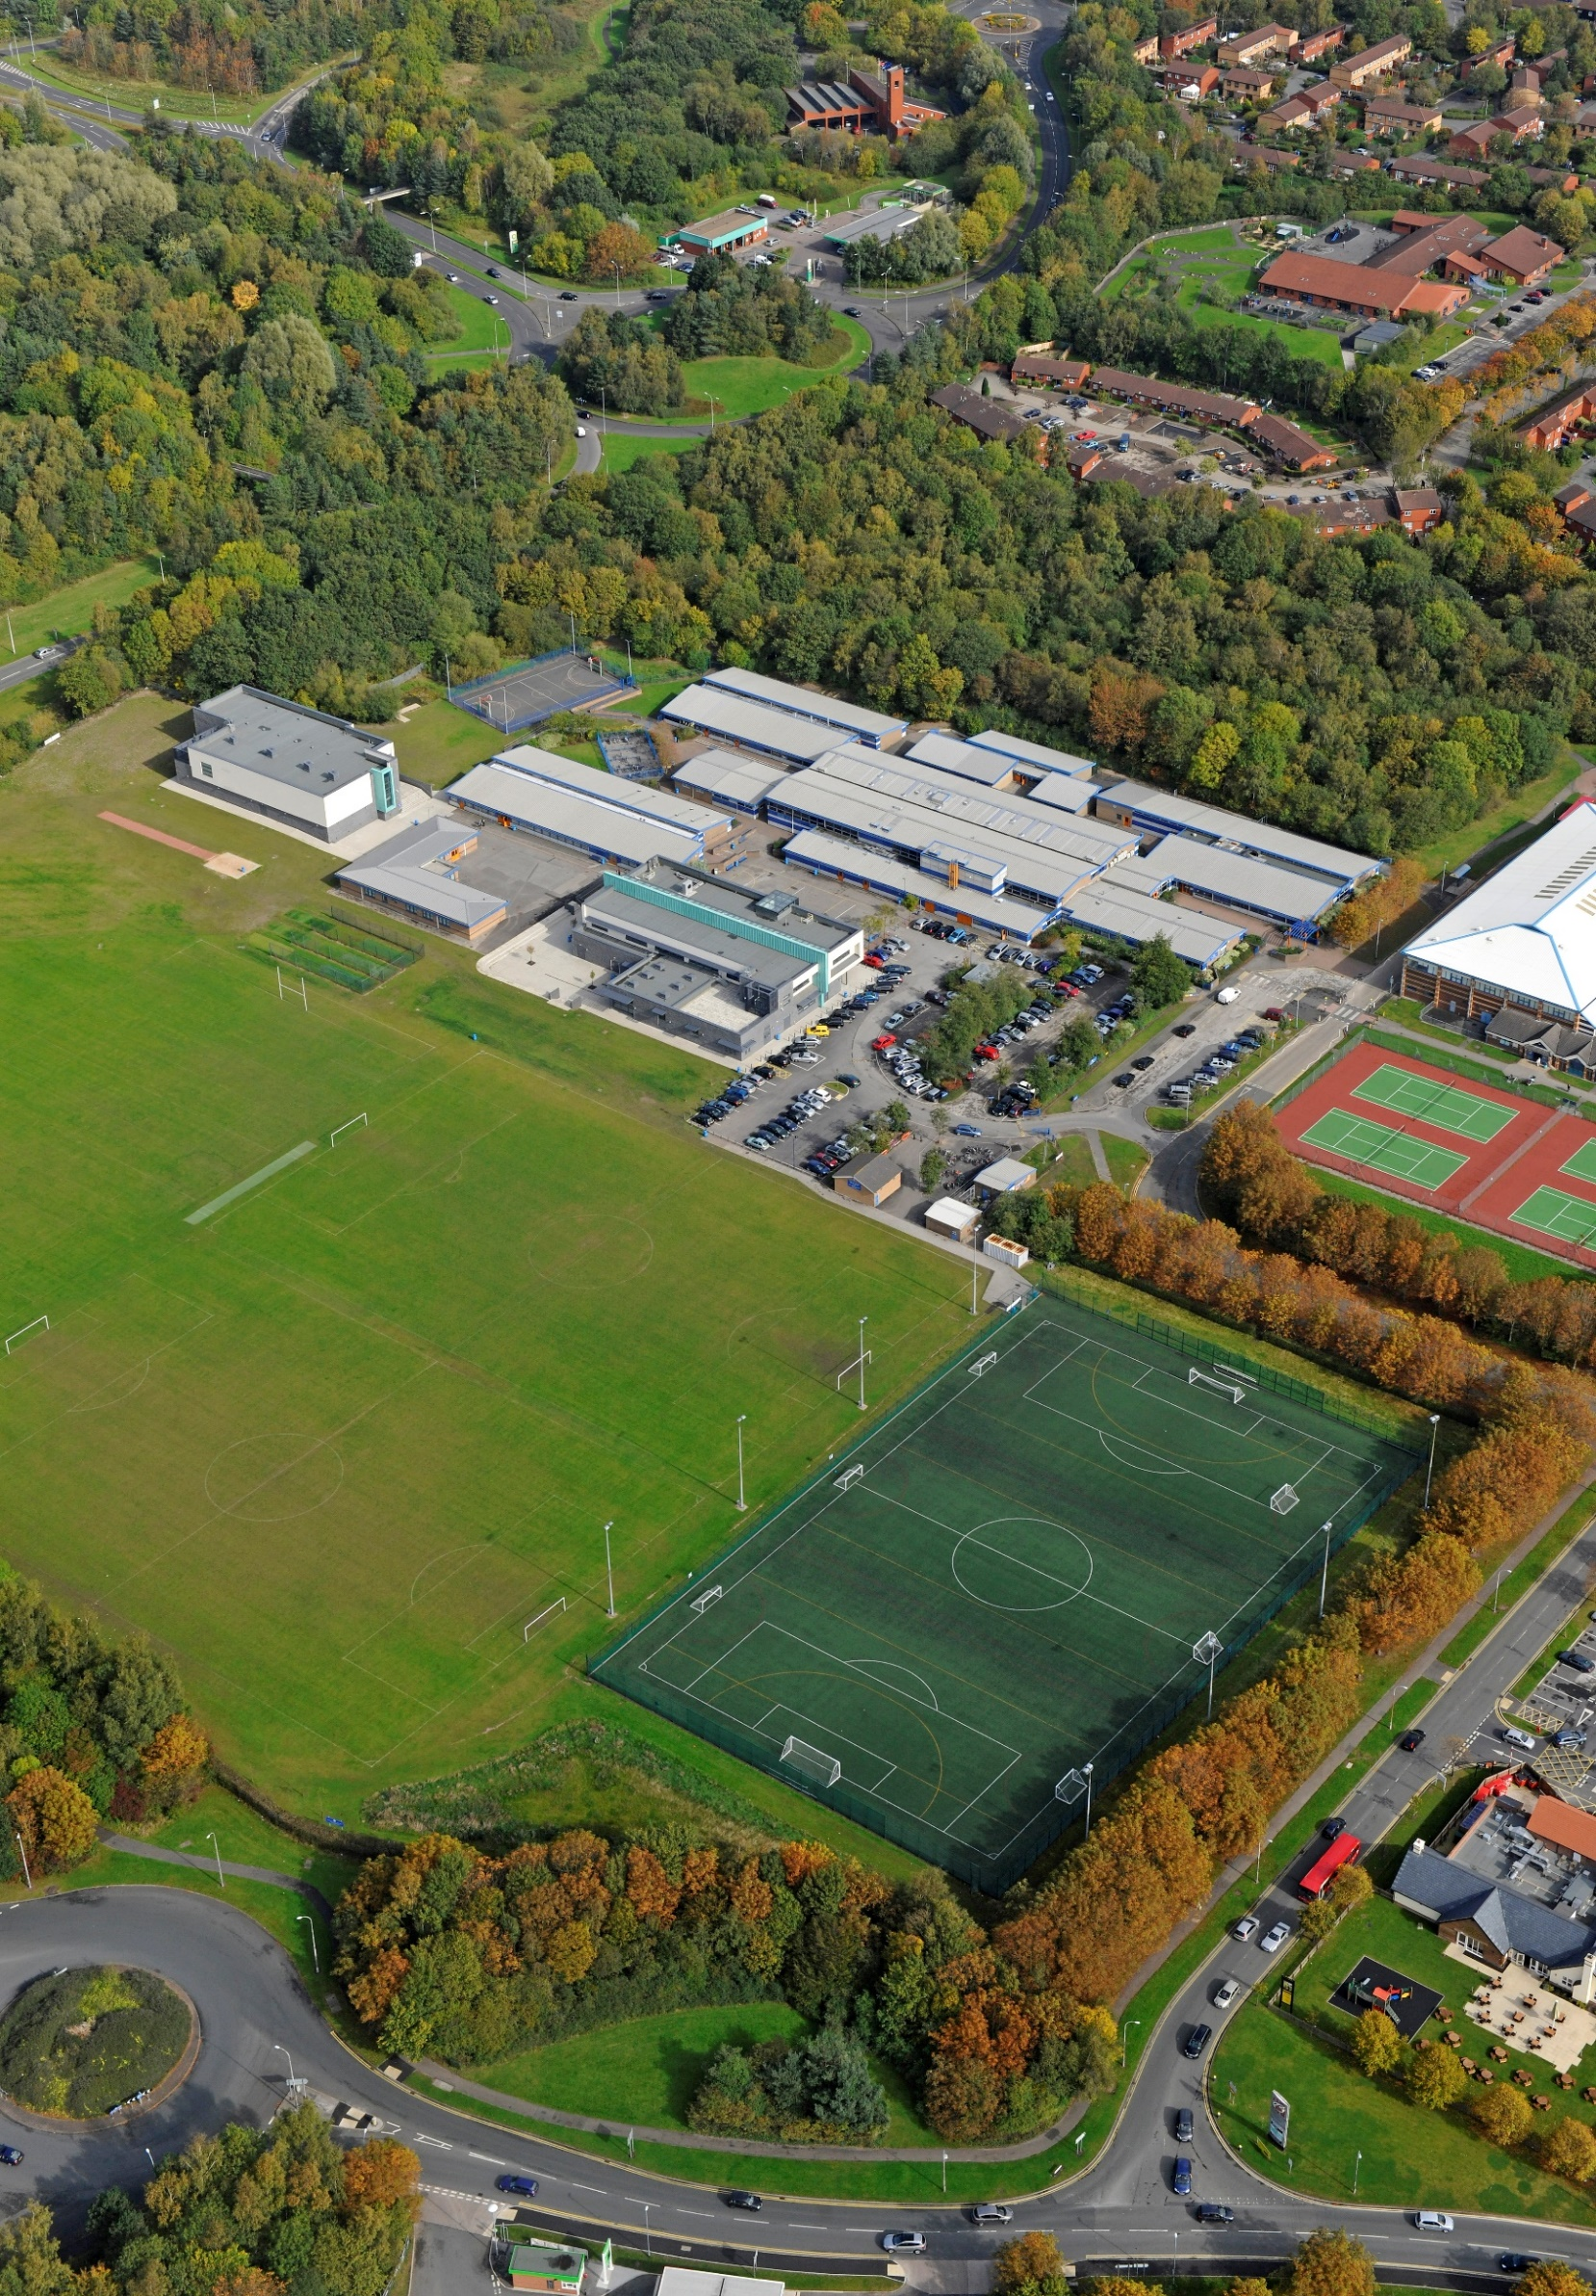

School Profile

JOB DESCRIPTION
- The school joined One Community Trust on 1st September 2023.
- The school is of an average size with 894 currently on roll.
- The most recent OFSTED inspection (December 2024) judged the school to be Good in all areas.
- The percentage of students on the Pupil Premium register is 39%, which is above the national average.
- The proportion of students with SEND (ECHP) is in-line with the national average.
- Most students are of white British heritage.
- Students arrive at the school with outcomes broadly in line with national averages.

POST TITLE: | TEACHING ASSISTANT LEVEL 3 (ASD Designated/Exceptional Provision)
SCHOOL: | Birchwood Community High School
GRADE/SCP: | NJC Grade 5 £24,992 - £28,624 FTE. (Actual pay is £18,883-£20,796)
TERM: | FIXED TERM (until 31st August 2026 in the first instance) – 31.25 hours per week, term time only, plus 5 days
REPORTS TO: | Deputy Headteacher

MAIN PURPOSE

To work with and supervise individuals and groups of children under the direction/instruction of teaching and/or senior staff, inclusive of specific individual learning needs, enabling access to learning for all pupils and assistance and support in classroom management and behaviour techniques and providing specialist support in a specific curriculum/resource area.

JOB PROFILE

SUPPORT FOR THE PUPIL
- Establish good working relationships with pupils, acting as a role model and setting
high expectations.
- Be aware of and respond appropriately to individual pupil needs ensuring effective interaction.
- Provide consistent support to all pupils, responding appropriately to individual pupil needs.
- Assist with the development and implementation of Individual Education Plans.
- Promote inclusion and acceptance of all pupils.
- Encourage pupils to interact with others and engage in activities led by the teacher.
- Promote self-esteem and independence, employing strategies to recognise and reward achievement within established school procedure.
- Provide feedback to pupils in relation to progress and achievement under the guidance and direction of the teacher.
- Use specialist (curricular/learning) skills/training/experience to support pupils e.g. interventions.

SUPPORT FOR THE TEACHER
- Provide clerical/administration support (e.g. photocopying, filing etc).
- Assist with appropriate displays
- Establish and maintain an appropriate learning environment under the supervision of the teacher.
- Contribute to lesson planning, evaluating and adjusting lessons/work plans as appropriate.
- Monitor and evaluate pupils' responses to learning activities through observation and planned recording of achievement against predetermined learning objectives.
- Provide objective and accurate feedback and reports as required, to the teacher on pupil achievement, progress and other matters, ensuring the availability of appropriate evidence.
- Be responsible for keeping and updating records in agreed format with the teacher, contributing to reviews of systems/records as requested.
- Administer, invigilate and assess routine assessments and accurately record achievement/progress.
- Promote positive values, attitudes and good pupil behaviour, dealing promptly with conflict and incidents and encouraging pupils to take responsibility for their own behaviour in line with established school policy.
- Liaise sensitively and effectively with parents/carers as agreed with the teacher within role/responsibility and participate in feedback sessions/meetings with parents under teacher's supervision.
- Adapt the planning of mainstream teachers to enable children with ASD to access the learning alongside peers where appropriate.
- Support mainstream practitioners to meet the needs of children with ASD, using specialist strategies and approaches as required.

SUPPORT FOR THE CURRICULUM
- Support the delivery of agreed learning activities/learning programmes, adjusting activities according to pupil individual needs.
- Support the delivery of literacy/numeracy programmes, effectively utilising all alternative learning opportunities to support extended development.
- Support the use of ICT in learning activities and develop pupils' competence and independence in its use.
- Assist pupils to access learning activities through specialist support eg., curriculum/SEND specialism.
- Determine the need for, prepare and maintain general and specialist equipment and resources.

SUPPORT FOR THE SCHOOL
- Be aware of and comply with school policies and procedures relating to child protection, health, safety and security, confidentiality and data protection. Report all concerns to the appropriate person (as named in the policy concerned).
- Be aware of, and support, differences and ensure all pupils have equal access to opportunities to learn and develop.
- Contribute to the school ethos, aims and development/improvement plan.
- Establish constructive relationships and communicate with other agencies/professionals, in liaison with the teacher, to support achievement and progress of pupils.
- Attend and participate in regular meetings as appropriate.
- Participate in training and other learning activities as required.
- Establish own best practice and use to support others.
- Assist with the supervision of pupils out of directed lesson time, including before and after school if appropriate and within working hours.
- Assist in the supervision, training and development of classroom support staff.
- Assist with the planning of opportunities for pupils to learn in out-of-school contexts, according to school policies and procedures and within working hours.
- Accompany teaching staff and pupils on visits, trips and out of school activities as required.
The post holder may reasonably be expected to undertake other duties commensurate with the level of responsibility that may be allocated from time to time.

PERSON SPECIFICATION

Level 3 Teaching Assistant Person Specification

Skills | Essential |  | Desirable
Ability to work effectively within a team environment, understanding classroom roles and responsibilities | ✓
Ability to build and maintain effective working relationships with all pupils and colleagues | ✓
Ability to promote a positive ethos and role model positive attributes | ✓
With guidance as required from the teacher/staff lead demonstrate the ability to work with children at all levels regardless of specific individual need. | ✓
Ability to work in a way that promotes the safety and wellbeing of children and young people. | ✓
Ability to adapt own approach in accordance with pupil needs | ✓
Ability to continually develop and extend own working practices | ✓
Excellent personal numeracy and literacy skills | ✓
Knowledge & Understanding |  | Essential | Desirable
Good understanding of national curriculum and other learning programmes (within specified age range/subject area) e.g. knowledge of core subject areas etc. |  | ✓
Understanding of principles of child development and independent learning. |  | ✓
Minimum 2 years’ experience of working with children in an educational setting (within specified age range/subject area). |  | ✓
Working knowledge of relevant policies/codes of practice/legislation |  | ✓
Understanding of statutory frameworks relating to teaching & learning |  | ✓
Understanding of inclusion, especially within a school setting |  | ✓
Experience of resources preparation to support learning programmes |  | ✓
Effective use of ICT to support learning |  | ✓
Understanding of other basic technology – laptop, ipad, photocopier, etc. |  |  | ✓

NOTE TO APPLICANTS: Whilst all points on the specification are important, those marked ‘E’ are the key requirements. You should pay particular attention to these points and provide evidence of meeting them. Failure to do so may mean that you will not be invited to interview.


