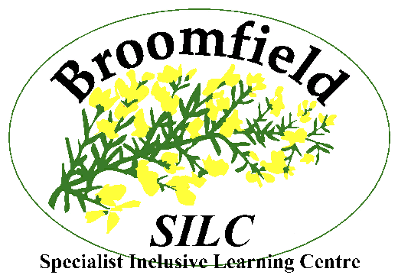
Broomfield South SILC
‘Investing in Individuals, Transforming Lives’
Broom Place, Belle Isle, Leeds LS10 3JP
TEACHER VACANCY – Formal Teaching and Learning Group
Salary Scale: MPS/UPS + SEN 1
Contract: Full Time
Contract Type: Permanent
Start Date: 1st September 2023
Job Advertised: Monday 24th April 2023
Closing Date: Thursday 18th May 2023 at 12 noon.
Interviews: Thursday 25th May 2023
Please contact Ruth Hall at the school if you would like to talk further about the position ruth.hall@broomfieldschool.org.uk
The vacancy is suitable for experienced teachers and ECTs.
Please be aware we do not accept applications direct from agencies and also CVs.
The Governors of this caring and successful school wish to appoint an enthusiastic, motivational and outstanding teacher to join our dedicated team at this exciting time in the life of the school. We are looking for a teacher who want to make a real difference to the lives of our pupils to inspire a desire for learning, to maintain our high standards and make a significant impact on the life chances of our pupils.
The role will be based within our Formal Teaching and Learning Group, which follows the National Curriculum using personalised approaches incorporating EHCP outcomes. Pupils in the formal TLG, undertake external accreditations for example Pearson Entry Level English and Maths.
Applications from mainstream colleagues are warmly welcomed and experience of teaching pupils with special needs and Autism Spectrum Condition across the age range is an advantage. Please state any subject specialism and experience of delivering accreditation pathways.
The successful candidate will excel in meeting the diverse needs of our pupils. You will be supported within your class by a team of Learning Support Assistants and by a Middle and Senior Leadership Team who have a secure understanding of the rewards and challenges of teaching in our school. Our staff are passionate about developing the learning and life chances and opportunities of our pupils and young people.
Our young people (2-19) have a wide range of special educational needs, including Autistic Spectrum Condition.
We offer an inclusive setting operating on the main Broomfield site and two mainstream partnership sites:
- Windmill Primary School
- Rodillian Academy
This enables us to meet a wide variety of pupils’ needs and provide support and advice to the community.
Staff can be expected to work on any of the three sites if required.
The successful candidates will have;
- Experience and skills of teaching pupils with a wide range of Special Educational Needs including ASC
- The ability to offer a range of inspirational teaching, learning, assessment and behaviour management strategies to ensure learning is engaging and inclusive
- High expectations, commitment and enthusiasm for both the personal and educational development of all pupils
- Excellent communication, organisation and interpersonal skills
- An ability to work collaboratively with parents, carers, multi- professionals and outside agencies
- The ability to work effectively within a team
- A passion for education and willingness to support staff in enabling all our pupils to reach their potential
- A commitment to making contributions to the life of the school
- A commitment to the provision of a high quality education for all
- Experience of teaching both English and Maths
- Experience of delivering accreditations

In addition the following personal qualities;

- Positive and creative attitude
- Resilience
- Enthusiasm and the ability to motivate and inspire others
- Able to use initiative
- Willingness to reflect and share effective practice with others

In return we can offer:
- Friendly, enthusiastic and highly motivated pupils and young people
- The support of our strong, caring and committed staff team
- A comprehensive CPD programme with a commitment to developing your skills and career progression

We promote diversity and want a workforce which reflects the population of Leeds. Applications are welcome from all, irrespective of sex, sexuality, race, religion, marital status, age, or disability.
Safeguarding Recruitment Statement
The school is committed to safeguarding and promoting the welfare of children and expect all staff and volunteers to share this commitment. Appointments will be subject to an enhanced DBS disclosure.
Access
The Broomfield main site and our partnership sites have disabled access facilities, including a lift.

For further details and recruitment pack please contact Broomfield South SILC by email broomfield@broomfieldschool.org.uk visit our website; www.broomfieldschool.org.uk
or by telephoning Ruth Hall on 0113 2771603

Please note that Broomfield South SILC operates No Smoking policy

Reg Charity no; 1143948

