Barking Abbey School  A Specialist Sports and Humanities College  Sandringham Road  Barking Essex IG11 9AG  Headteacher: Jo Tupman | 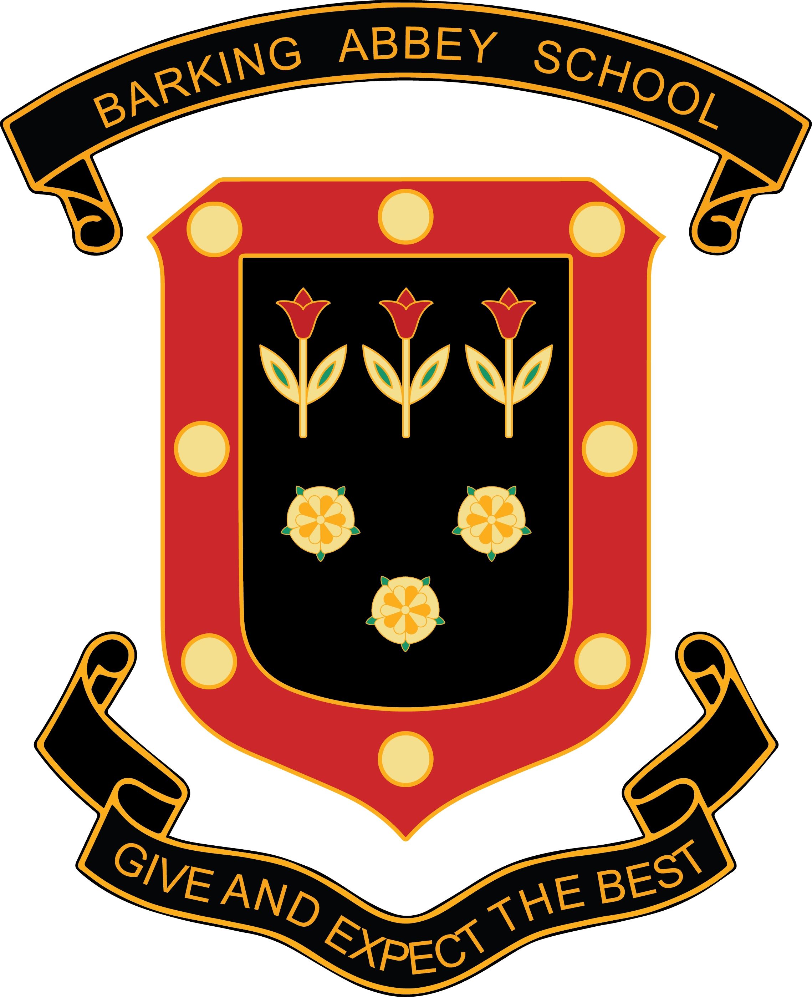
Librarian
Permanent
Term Time only
35 hours per week
Start Date: 3rd September 2019
Salary Scale 4 SP 7 - 10 £22,377- £23,607 per annum pro rata
Actual Annual Salary: £18,185 - £19,184 per annum

Ref: 0222

We are seeking to appoint a highly skilled, dynamic and energetic individual committed to ensuring that all students read for pleasure and aspire to achieve high academic standards.

Our library is a vibrant and popular learning space but the successful candidate will be able to further develop this environment as the campus prepares to welcome both Key Stage 3 and 4 students by September 2021 at our Sandringham Campus.

The successful applicant needs to be flexible, a good team player, able to take responsibility and have a keen eye for detail. With excellent communication skills, you will be able to liaise effectively with students to ensure that the library runs smoothly at all times during the school day.

If this is you, then come and join ‘Team BA’. We are a welcoming team that strives to provide an inclusive and supportive environment for our students and staff. The staff at Barking Abbey are a passionate and dedicated team of professionals who value our long, successful history whilst being excited about our future.

This is an excellent opportunity to play a key role in the development of the school as it continues its journey from Good to Outstanding.

Barking Abbey is a heavily over-subscribed split-site secondary school in the London Borough of Barking and Dagenham, and has a well-deserved reputation for its friendly and supportive atmosphere and its excellent academic achievements.

Interested applicants should download the core staff application form, found on-line at www.barkingabbeyschool.co.uk and email completed application forms to jobs@barkingabbeyschool.co.uk

Only fully completed application forms will be accepted, CV applications will not be considered.

Closing Date: 9am Monday 5th August 2019
Interviews: Thursday 15th August 2019

Barking Abbey is committed to safeguarding and promoting the welfare of children and is an Equal Opportunities Employer.

This post is exempt from the Rehabilitation of Offenders Act 1974 and a comprehensive screening process, including Disclosure check, will be undertaken on all successful applicants.

