Job Description
Head of IT Systems (Full time/Permanent)

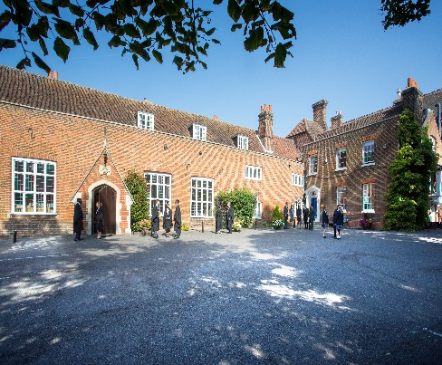

Introduction

Chigwell School is seeking to appoint an experienced Head of IT Systems to lead our innovative ICT Team. The post holder will manage the delivery of the School’s information systems including a strategic overview of the direction of ICT systems in line with the School’s priorities and needs. ICT underpins today’s modern lifestyle and the School places ICT at the core of its learning community. The successful candidate should have proven professional experience and knowledge of the IT’s industry best practice and processes. This is a permanent, full-time position reporting to the Deputy Head (Staff and Systems) and the Bursar.

Background
Founded in 1629 by Samuel Harsnett, the son of a Colchester baker who went on to become Archbishop of York, Chigwell School stands on it original site with the original school building still in use. However, whilst Chigwell of today is conscious of its long-standing history, it is a forward-looking, ambitious, co-educational independent school of 930 pupils aged four to eighteen. It enjoys excellent facilities, a dedicated staff, bright and hardworking pupils, and a site of 100 acres.

Chigwell School is located in the picturesque village of Chigwell just over ten miles from central London and on the Central Line. The extensive, beautiful grounds are close to the edge of Epping Forest and it is rare for a school to have so much space and yet be so close to the centre of the Capital. Most pupils are day pupils but in the Sixth Form, there is a small community of international boarders, roughly thirty from sixteen countries, and these live in four small boarding houses.

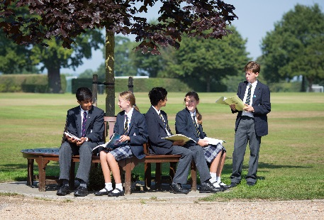

As well as being an academic school, Chigwell has the reputation for providing a rich and full education, with plenty of opportunities for all pupils who are enthusiastic, co-operative and able. Chigwell is a caring and friendly school, with a close sense of community, not least between colleagues. As the Good Schools Guide reports: Academically, pupils are put through their paces but it all seems to be done in such a civilised and pleasant manner that you are more likely to hear pupils talk about opportunities and prospects than pressure and stress. “Anyone who wants to do well here, will do well” said one student, and I can’t think of a nicer place to succeed.”

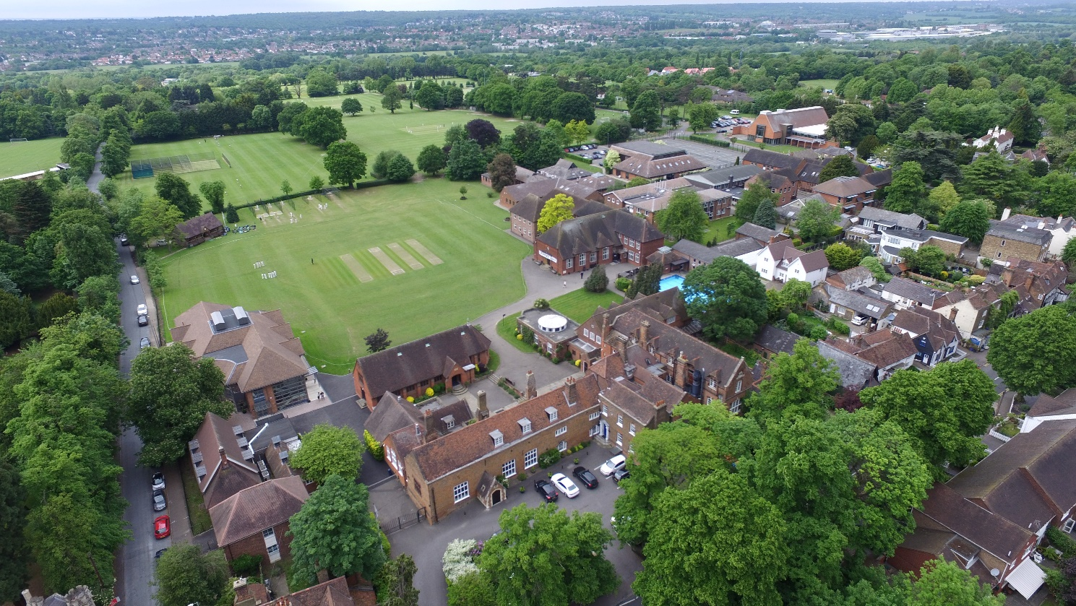

The School Development Programme

Over recent years, the School’s facilities have been extensively developed in order to enhance the educational experience that pupils receive. The development programme has included the following additions:

- 2008 Wilson Building teaching block
- 2008 Floodlit AstroTurf pitch
- 2009 Junior School library extension
- 2010 Complete redevelopment of catering facilities
- 2010 Sixth Form coffee shop
- 2010 Harsnett’s and Church House converted into boys’ boarding houses
- 2012 The Old Chigwellian Club and land was incorporated into the school estate
- 2013 Pre Prep School built and opened
- 2013 Two new science labs created
- 2014 Drama Centre balcony extended to provide additional music and drama rehearsal space
- 2016 The Risham Sarao Sixth Form Centre was completed

Currently the extension of the Dining Hall is underway and in the future the plan is to:

- Renovate the Chapel
- Develop the Sports Centre
- Expand our music facilities
- Further expand our provision of bursaries

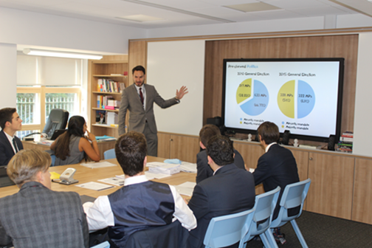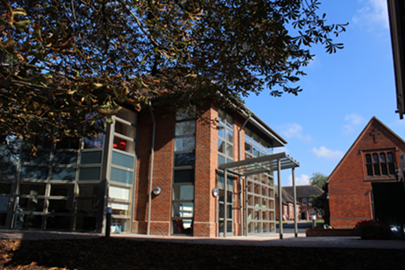

The School

Some pupils join in Reception and there are two classes in each of the three Pre Prep year groups. A small number of other children join the Junior School at 7+ (Year 3) and there are two or three classes in each of the KS2 year groups. At 11+ (Year 7), there is a further entry with four classes making up Years 7 to 11. Again, there is a small entry into the Sixth Form. Entry at each stage is selective and although there are three main sections to the School (Pre Prep, Junior School and Senior School) these sections work closely together and there is a common ethos running throughout.

There are over a hundred teachers and together with the support staff, there is a friendly, mutually-supportive atmosphere. All teaching staff contribute to the extra-curricular programme.

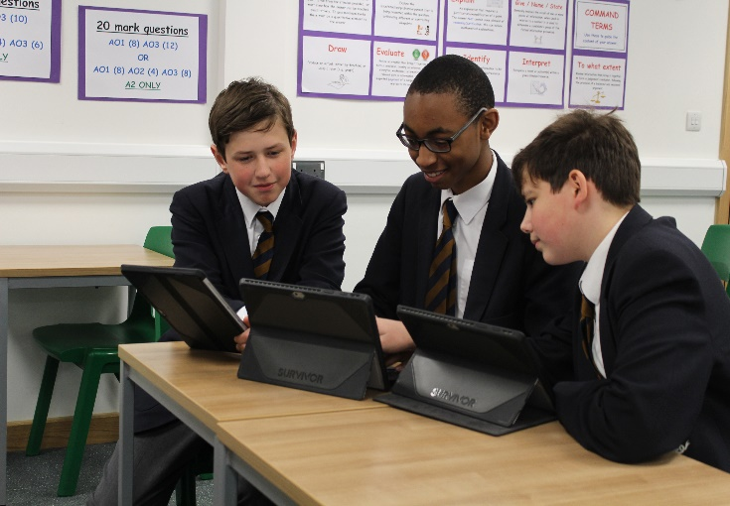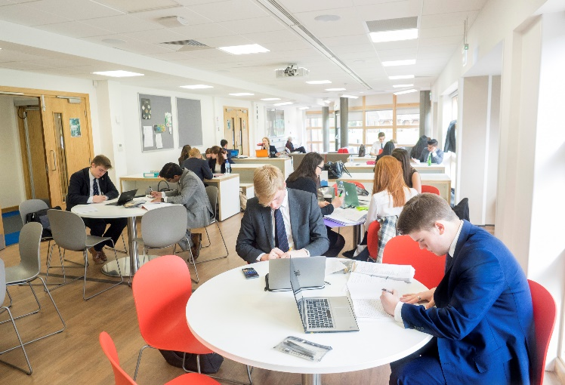

The role

The Head of IT Systems will manage the delivery and protection of the School’s information systems, including management of the ICT staff and communication with senior management. This will include a strategic overview of the direction of ICT systems in line with the School’s educational priorities and both teaching and administrative staff ICT needs. The Head of IT Systems reports to the Bursar and the Deputy Head (Staff & Systems)

Key responsibilities:

IT Strategy
Define and implement an IT strategy for the School aligned to the educational and business objectives. This strategy will then be turned into an operational roadmap ready for implementation.

Maintain an Operational Roadmap with Key Milestones and Budgeted Costs
Creating an IT strategy is the basis for creating an operational document or Roadmap along with timings, resources and budgeted costs. This document will serve as the basis for implementing the initiatives and projects that have been identified.

Define an IT Framework
Define and update a framework to support the delivery of a robust IT support service. This would include processes for starters, leavers, security groups, new hardware requests, new software requests and change management.

Management of IT Staffing
Ensure that an effective, well-trained IT staff team is able to support the variety of IT systems and data needs of the School and is able to train and support teaching and administrative staff in their work.

Advice on Data Protection Requirements
Support the School’s Data Protection Controller in ensuring that data is held securely and that staff are aware of their legal responsibilities for protecting the privacy of personal data.

Input to SMT and Governors’ Meetings (as required)
Attendance at specific SMT and management meetings is necessary to ensure that the IT strategic goals are aligned to the School’s needs and to educate and update Executive and Management teams on IT issues. This could include updates or discussions around specific projects such as business continuity or data protection requirements.

Management of 3rd Party Vendors and Suppliers
Management of 3rd party IT suppliers is required to ensure effective and secure delivery and support of services that are well integrated with the School’s systems.

Selection of Software Applications and Planning of Systems Integration
Provide direction, guidance and support on the selection and integration of software applications required by all School departments.

Disaster Recovery and Business Continuity Planning
Work with key departmental heads to create a Business Continuity and Disaster Recovery plan. This will involve understanding the School’s information recovery requirements along with the priorities of IT system uptime and availability.
This job description is subject to regular reviews to meet the changing needs of the School.

The Applicant:

The key skills and knowledge that we are looking for are:

- Good organisational and time management skills.
- Excellent IT technical background.
- Excellent verbal/written communication skills
- Ability to manage IT staff
- Strategic approach to systems and information management
- Knowledge of school systems
- Detailed understanding of Microsoft technologies and services
- Ability to plan and manage budget/financial responsibilities

Remuneration

Competitive and commensurate with experience.

Other benefits of working at Chigwell School include:

- A competitive salary  - Access to the School Pension Scheme  - Free lunch and refreshments during term time  - Childcare Vouchers  - Personal Accident Cover  - Employee Assistance Support Programme  - Free on site parking and cycle racks  - Use of School Library | - Medical Centre on site  - Free use of School’s sports facilities outside of the School day  - Commitment to professional development  - A vibrant and supportive community of highly motivated students and staff  - A beautiful working environment- 100 acres site beautifully landscaped with a number of listed buildings

Further details can be found on the School website (www.chigwell-school.org).

Application is by a form which can be completed online or downloaded from our website (select Vacancies) and submitted to the Headmaster’s PA: hmpa@chigwell-school.org

Closing date: Friday 12th January 2018. Early applications are welcome.

Chigwell is committed to safeguarding and promoting the welfare of children and young people and expects all staff and volunteers to share this commitment. Applicants must be willing to undergo child protection screening including checks with past employers, prohibition orders and enhanced DBS.

