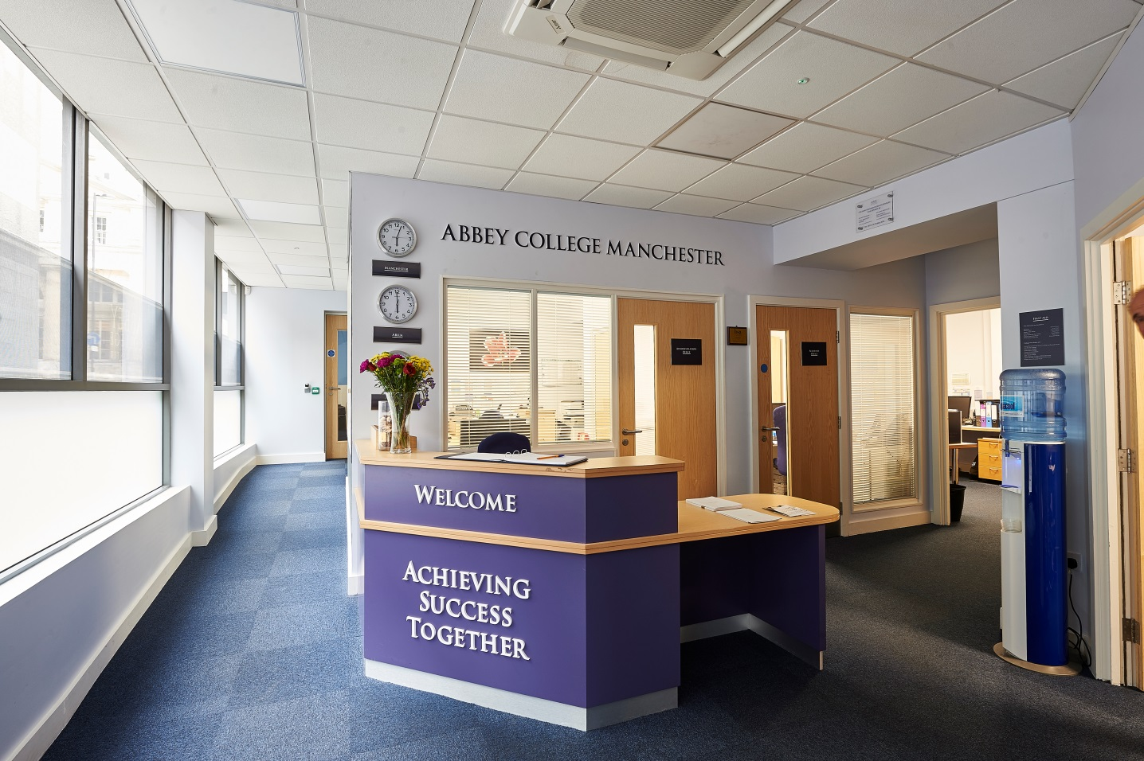

Information Pack:

Resident Houseparent

March 2021

About Abbey College Manchester

Abbey College Manchester was founded in 1990 and over the past thirty years has become one of the leading providers of independent sixth form education in Greater
Manchester. There are approximately 200 students in the college. Within this around 40% are from the Manchester area with the remainder coming from up to forty different countries across Europe; Africa; Asia and the Americas.

We aim to:

• guide our students to achieve academic success and fulfil their aspirations
• respect and value each student providing a friendly, safe, supportive environment where students are happy and grow in confidence
• show a sensitive understanding of the challenges facing young people in the 21st Century by
empowering students to make informed decisions and have the determination to achieve their goals
• prepare our students for university, their future careers and to make a positive contribution to the community.

We are a dynamic, exciting college, situated in the heart of Manchester providing high quality, flexible A Level, International Foundation, Combined Studies and GCSE programmes. We have recently introduced two unique programmes to complement our offering; these being the Combined Studies Programme and the Academic Studies with Football Training or Basketball Training Programme. Our modern building provides an environment conducive to study and in our small classes each student can develop their individual aptitudes aided by a strong system of tutorial guidance.

Teaching and learning is rigorous whilst being creative and responsive to individual need. Our enrichment activities include sport, voluntary work, charity events and many other opportunities led by the students and staff. We encourage students to raise their own expectations
and standards to the highest possible level. Staff, students and families get to know each other well and enjoy working together.

At Abbey College Manchester we offer a unique alternative to the traditional school whilst maintaining a strong academic ethos. Everyone contributes, everyone is appreciated; our committed teachers love their subjects and seek to inspire their students, in their turn, to love learning and value the acquisition of knowledge.

Boarding Accommodation

Abbey College Manchester has approximately 100 students living in our boarding accommodation. About 40 students reside with our homestay families and 60 live in our Senior Boarding House (Clydesdale House) which is a 10-minute walk from the main college building. Only students aged 16+ reside in this boarding house. The post holder would be taking responsibility for the students at Clydesdale House as described in the job description in conjunction with the Head of Senior Boarding and Boarding Staff teams. The students live in clusters on two floors at Clydesdale house which are accessed only by ACM students and boarding staff. This is an exciting new residential role to move the college forward in developing a modern boarding offering that bridges the gap between sixth form and university. With a diverse range of students and nationalities, the role presents challenges and opportunities to innovate and develop the college offering. To that end, current and extensive experience of working in a boarding school(s) is desirable.

Description of the post

The role is an important, supportive one, which requires flexibility and good communication with the Head of Senior Boarding and other boarding staff. The post holder must always behave in a responsible and appropriate manner for a person charged with the welfare and safety of students, and act as a role model. This is a residential role. Rent-free accommodation is provided within Clydesdale House, with all council tax, utilities and meals during term time included. The first responsibility of the Houseparent is to maintain the highest standards of Safeguarding and Child Protection for the students in Clydesdale House and promote student welfare as the core purpose of their role.

Clydesdale House Resident Houseparent
- Full time role
- Reports to the Head of Senior Boarding
- Works directly with the College Nurse, SENDCo, Heads of House, Assistant Heads of House, Director of Accommodation

Key responsibilities
- Establish friendly, supportive relationships with students whilst maintaining authority
- Encourage students to always behave appropriately as civilised members of a boarding community, where differences are celebrated and respected by all
- Supervise and, as appropriate, direct and support boarding students in their work outside lessons
- Take responsibility for nighttime supervision as agreed with the Head of Senior Boarding
- Help organise and share in activities in the evenings/weekends and accompany trips and visits where appropriate
- Develop he community and ethos of Clydesdale House in line with the college ethos
- Spearhead the organisation of events and extra study time at Clydesdale in the evenings
- Support and develop good study routine habits with senior boarders at Clydesdale by supporting post college study sessions
- Be the overnight Fire Officer for Abbey College Students in Clydesdale House
- Mentoring students in the Senior Boarding House
- Ensure students are following a healthy lifestyle and are encouraged to eat College meals in the evening
- Prepare morning breakfast and encourage students to eat that and to collect their packed lunches
- Be available to students for discussion and report any concerns to the appropriate person(s)
- Keep clear written records, following college policies and procedures, relating to student welfare
- Attend boarding meetings with the Head of Senior Boarding and other boarding staff as appropriate
- Participate in training/professional development, as appropriate
- Be familiar with National Minimum Standards for Boarding Schools and other relevant documentation regarding the welfare and safety of boarders including, but not limited to latest legislation covering all safeguarding and child protection matters. Ensure all NMS and safeguarding is implemented.
- Be in residence 24 hours before the start of and at the end of each term (on a rota)
- As this is a new role it is anticipated that the job description will develop with the role

Note: This job description is indicative of the duties and responsibilities of the post but does not form part of any contract of employment. All jobs within the college evolve over time and their features vary from year to year.

Hours of work

This is a residential post and as such, you will be required to work both days and nights, weekdays and weekends.

The expected pattern is a rota of four days and four nights followed by three days (and nights) off dependent on need. The cross over day will be a Saturday when both house parents will be working so that activities can be facilitated. Boarding remains open during the three half terms and the Easter week. The three weeks at Christmas and two months in the summer are holidays for boarding staff who can remain in the residential accommodation should they so wish. You will have a total of three extra “occasional days” (24-hour periods) to take during the year, by agreement with the Head of Senior Boarding. The college calendar will be provided for clarity.

Under the Working Time Regulations 1998 (as amended), you are not permitted to work in excess of a 48 hour week (averaged over a reference period of 17 weeks) unless you sign to the effect that you are prepared to do so. By applying for this role and signing the contract, you agree that this limit does not apply in your case. You agree that you may terminate this agreement by giving one term’s written notice.

Key qualities
- To be able to follow the ethos of Abbey College Manchester Boarding that is in line with the college’s philosophy
- Team player who can adapt to the college ethos and innovate whilst working within the existing and developing structures
- Extensive current experience of working in a boarding school
- Experience of working with students 16-19+ age group
- Ability to help students across the ability range develop good study habits
- Experience of working with second language speakers and international students
- Ability to innovate and develop ideas appropriate to the setting
- Ability to work with young people and make a good relationship
- Ability to manage possible conflict
- High levels of organisation
- Honesty and integrity
- Be suitable to work with young people (DBS clearance)

About the Alpha Plus Group

The Alpha Plus Group is the parent company of Abbey College Manchester and nineteen other schools. It was founded in 1931 under the name Davies, Laing and Dick. The schools and colleges within the group have developed a longstanding reputation for delivering premium quality education.

In all its educational establishments, the Alpha Plus Group aims to provide a supportive and controlled environment in which children and young people are encouraged to pursue high academic and personal goals as happy and secure individuals. The Group expects that all its staff will be alert to the needs of its pupils and students - including their need for safety and protection - and will always put the interests of children and young people first.

Each school and college retains its own identity, with the Heads and Principals afforded significant management authority, but with the benefits of financial security, camaraderie and opportunities for sharing best practice by belonging to one of the country's leading educational groups.

The selection processes

Job title: Resident Houseparent

Activity | Date
Deadline for receipt of applications | 16th April 2021
Shortlisting of candidates | w/c 19th April
Interview dates | w/c 26th April
Start date | 1st September 2021

Applications will only be accepted from candidates completing the Abbey College Manchester Application Form and Equal Opportunities Monitoring Form.

Safeguarding Statement
Candidates should be aware that all posts in the college involve responsibility for safeguarding children. The Abbey College Manchester Safeguarding Statement is as follows: “We recognise our moral and statutory responsibility to safeguard and promote the welfare of all students. We endeavour to provide a safe and welcoming environment where children and young people are respected and valued. We are alert to the signs of abuse and neglect and follow our procedures to ensure that children and young people receive effective support, protection and justice”.

Rehabilitation of Offenders Act, 1974
This post is exempt from the Rehabilitation of Offenders Act 1974 and therefore all convictions, cautions and bind-overs, including those regarded as ‘spent’ must be declared. Please provide full details in a sealed envelope marked ‘Confidential’. The letter will be opened after shortlisting, prior to interview.

References
These will be taken up after interview. As part of this your referees will be asked about your suitability to work with children and whether they know of any disciplinary offences relating to children or young persons (whether the disciplinary sanction is current or time expired) and whether you have been the subject of any child protection allegations or concerns and if so the outcome of any enquiry or disciplinary procedure.

Interview
If you are invited to attend an interview this will be conducted in person and will include questioning on your suitability to work with children. All candidates must bring original documents confirming any educational and professional qualifications that are necessary or relevant for the post (e.g. the original or certified copy of certificates, diplomas, etc.). All candidates invited to interview must also bring their passport or photo ID and proof of the right to work in the UK (if applicable).

Terms and conditions

Remuneration
- £19,000 plus rent-free accommodation within Clydesdale House, with all council tax, utilities and meals during term time included.

Hours of work
See above
Holidays
- Christmas and Summer College Holidays

Pension provision
Abbey College Manchester is part of the Alpha Plus Group and automatically enrol all new employees (unless requested not to by the employee) onto the company pension scheme. Notification of the pension plan (and all further details including opt out / opt in rights) will be provided.

Offer of appointment
Any offer of appointment is conditional on receipt of satisfactory references, an enhanced DBS clearance, the interrogation of qualifications and proof of the right to work in the UK.

We are committed to safeguarding and promoting the welfare of children and young people.

We expect all staff to share this commitment and to undergo appropriate checks, including enhanced DBS checks.

