

Candidate information Pack

Midnight Sunday 20th July 2025

Early applications are encouraged, and the school reserves the right to close the application process early should a suitable candidate be found.

Facilities Cleaner



**PART I: ABOUT THE ROLE**

**Winchester College has an exciting opportunity to appoint 2 Campus Cleaners, starting as soon as possible.**

**The Facilities team are responsible for the day-to-day cleanliness and event set up of all school buildings, except the boarding houses. This includes some sports facilities and all administrative offices. The areas of responsibility allocated to individual members of the Facilities team will vary from time to time and according to the team schedule. The team are required to work largely unsupervised and be flexible in order to help provide cover for absent colleagues when necessary; and be organised and have attention to detail in everything they do.**

**The team are also expected to follow detailed instructions and be capable of meeting the physical requirements of this role. No prior experience is required for this role with training provided; however, applicants who have experience of commercial cleaning and COSHH will be advantageous.**

**The Facilities teamwork under the day-to-day supervision of the Team Leaders and Facilities Manager. The Head of Department is the Chief Operating Officer (COO), with the Campus Cleaners line manager being the Facilities Manager. There will also be frequent contact with members of staff in the departments where staff are assigned.**

## The main responsibilities are as follows:

* To clean allocated areas. The type of cleaning will depend on the use of the building, and may include cleaning showers and WCs, sweeping, mopping, dusting, polishing, emptying bins and vacuuming. This list is not exhaustive.
* Working outside, when required to maintain cleanliness and appearance of the campus paths and associated areas.
* To periodically clean the insides of windows. Sometimes this might involve using a step ladder.
* To assist in the setting up of event venues such as music rooms, exams areas, day to day school activities and functions, as well as for school open days and events.
* To assist in moving and relocating items around the campus such as furniture, event kit, tables and chairs.
* To assist other departments with moving and setting up items around the campus.
* To be able to lift reasonably heavy items such as cleaning equipment, full bin bags, and pieces of furniture etc.
* To undertake minor running repairs and immediately report any defects or safety hazards and any accidents, however small, to the Facilities Team Leaders, Facilities Manager or Heads of the Departments.
* To participate in regular routine safety checks such as fire call point/extinguishers, emergency lighting, water temperature of the areas you are assigned.
* To keep up to date with cleaning methods and to undertake regular Health & Safety training, as required.
* To undertake any other work when reasonably requested by the Facilities Team Leaders, Facilities Manager or Heads of the Departments to which you have been tasked.

Driving licence would also be an advantage, but is not essential.

This job description is not specific to any particular area within the College as the Facilities team move around all parts of the campus. Specific duties within the tasked department will be explained on induction to that department.



**PART II: PERSON SPECIFICATION**

It is essential that the successful applicant has/is:

* Demonstrate a positive and flexible approach to work.
* Work both individually and as part of a team, contributing to the team spirit.
* Use their initiative.
* Demonstrate high levels of energy, enthusiasm and reliability.
* Good attention to detail.
* Prioritise tasks and manage their time well/productively; and
* A commitment to promoting and embedding an inclusive culture, with equality of opportunity for all.

It is desirable that the successful applicant has:

* Experience of working within a school environment.

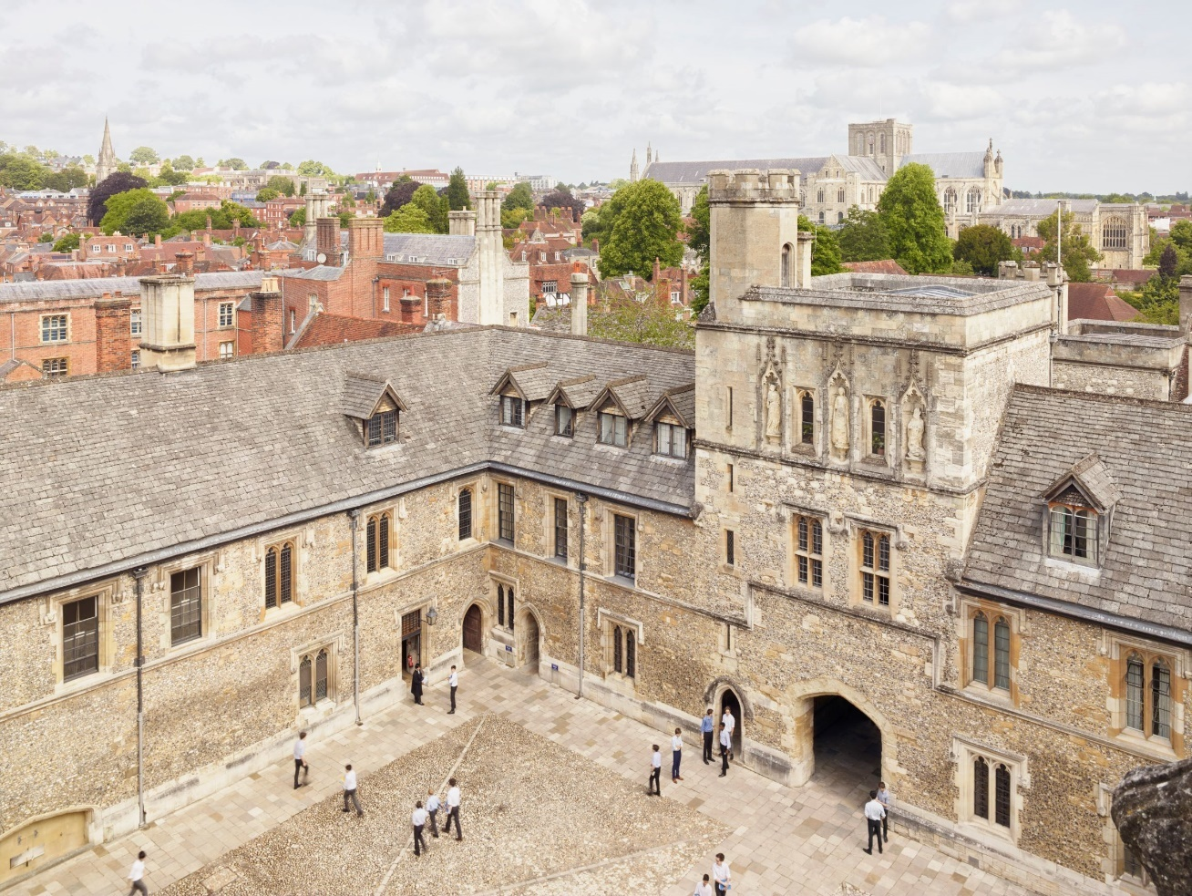

# 

**PART III: BENEFITS, TERMS AND APPLICATION**

**Start date**

As soon as possible.

**Hours of Work and Salary**

1. **Position A**
   1. 25 hours per week. Term-time plus, with a requirement to work in July and two days at the beginning and end of each month
   2. The working hours are Monday - Friday, 07.00 - 12.00
   3. Salary is £13, 125.75 (gross) per annum. FTE is £22,222.20
2. **Position B**
   1. 7 hours per week. Term-time only, with the expectation that Exeats are worked
   2. The working hours are 08.00 - 15.00
   3. Salary is £2,991.45 (gross) per annum. FTE is £22,222.20

**Holidays**

The College leave year runs from 1 September to 31 August. This position will be entitled to the statutory holiday requirements. Any Public Bank Holiday occurring during term time is deemed to be a normal working day. All leave must be taken by prior arrangement with the postholder’s line-manager and must be taken outside of the school’s term times.

**Probation and Notice Periods**

The first four working months of employment will be a probationary period. During this time, conduct and performance will be reviewed. The College may extend the probationary period if it is deemed to be required. During the probationary period the notice required to terminate employment will be one week (by either the employee or employer). Once employment is confirmed, the notice period will increase to one month.

**Induction and Continuous Training and Development**

The school is fully committed to the induction, training and development of all our staff, with staff supported to grow and reach their full potential.

We deliver a range of training, run by both our own staff and external providers, varying from highly practical First Aid courses to seminars and learning lunches, as well as access to Udemy, an online learning platform.

There is an annual cycle of appraisal offering the opportunity to reflect on professional practice and development opportunities.

The school also offers a wide range of apprenticeships supporting staff development and progression.

**Pension and Life Cover**

On employment, employees will be auto-enrolled into the College’s pension scheme according to legislative thresholds. Those who are not eligible for auto-enrolment may still elect to join the College’s pension scheme.

Initially, when joining the College’s pension scheme, employees will become a member of the College’s Group Personal Pension Plan (GPP). For this Plan, known as Tier 1, the employee contributes 5% and the employer 3%.

After 9 month’s membership of the Tier 1 plan, employees may opt to join Tier 2, which is also a GPP, where the employee contributes 5% and the employer 9%.

Employees in Tier 1 automatically qualify for a Life Cover of 2 times salary. On entry to Tier 2, Life Cover changes to 4 times salary.

**Wider Benefits**

* Free staff lunches during term time
* Free use of some sports facilities and discounted hire charges for others
* Tour of the College, with discounted rates available for booking venues within the school’s grounds for hospitality events.
* Cycle to work scheme
* Access to a rich programme of cultural, musical, theatrical and sporting talks and events
* Employee Referral Scheme, with a reward of up to £250 for staff (subject to scheme conditions)
* Free Library membership with access to a range of online journals and magazines.
* Reduced green fee rates for local golf course

**Enhanced Disclosure Check**

As Winchester College is an educational establishment, a condition of employment will be that the successful candidate must consent to the school obtaining an Enhanced Level Disclosure Check through the Disclosure and Barring Service (DBS). This will reveal all spent and unspent convictions, warnings, cautions and bind-overs. A policy on the recruitment of ex-offenders is available on the school’s website.

Safeguarding is one of the primary responsibilities of this role. The jobholder is responsible for promoting and safeguarding the welfare of children and young persons for whom they are responsible, or with whom they come into contact with, and will need to adhere to and ensure compliance with the school’s [Child Protection and Safeguarding Policy](https://www.winchestercollege.org/assets/files/uploads/child-protection-and-safeguarding-policy-september-2024.pdf) at all times. A Head of PRS should be conversant with the responsibilities and procedures detailed in this policy and with the [Department for Education’s Keeping Children Safe in Education](https://assets.publishing.service.gov.uk/media/66d7301b9084b18b95709f75/Keeping_children_safe_in_education_2024.pdf).  If, in the course of carrying out the duties of the post, the Head of PRS becomes aware of any actual or potential risks to the safety or welfare of children in the school, they must report any concerns to the school’s Designated Safeguarding Lead or in their absence the Deputy Designated Safeguarding Lead.

**References and Other Pre-employment Checks**

The appointment will be dependent upon the receipt of a successful medical check and satisfactory references. The College will usually seek references from shortlisted candidates before interview and may approach previous employers for information to verify particular experience or qualifications. At least one referee must be the current or most recent employer. Where applicants are not currently working with children but have done so in the past, one referee must be the person by whom they were most recently employed when working with children.

**HOW TO APPLY**

Only applications completed on the school website will be accepted.

Closing date for applications: **Midnight on Monday 21st July 2025**

Please note that applications will be dealt with as they arrive. Winchester College reserves the right to appoint prior to the closing date.

**[APPLY HERE](https://www.winchestercollege.org/employment-opportunities/my-application/vacancy/6626453lLR)**

Those wishing for an informal conversation about this role are invited to contact Mark Eves, Facilities Manager, [M_Eves@wincoll.ac.uk](mailto:M_Eves@wincoll.ac.uk)

If you have any questions about this vacancy or the recruitment process, please email [recruitment@wincoll.ac.uk](mailto:recruitment@wincoll.ac.uk).

Further information about the school can be found at [www.winchestercollege.org](http://www.winchestercollege.org).

**Data Protection**

Winchester College collects and processes relevant personal data as part of its everyday operations and is obliged to process it in accordance with the Data Protection Act 2018. The school is the Data Controller of this data under the Act and is registered with the Information Commissioner’s Office; its registration number is Z5751669.

Any queries about this policy or how personal data is processed by the school should be referred to the Data Protection Liaison Officer.

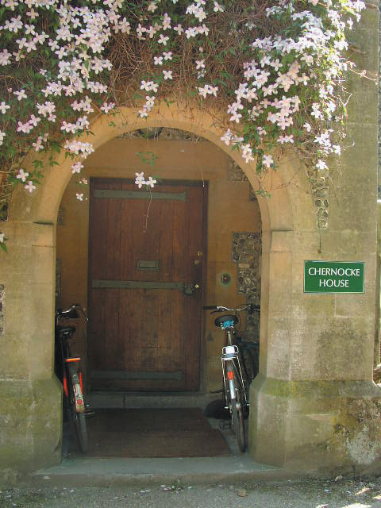



**PART IV: ABOUT WINCHESTER COLLEGE**

Winchester College was a pioneering institution when it was founded in 1382 and continues to be a global leader in education today. Renowned for its intellectual excellence and impressive academic record, Winchester is sought after for its combination of superb teaching, outstanding pastoral care, and an exceptional breadth of sports and other activities.

Winchester currently has 735 pupils from Junior Part (Year 9) to Sixth Book (Years 12 and 13). The majority of these pupils are boarders, with around day pupils (boys and girls) in each year in Sixth Book. The first girl boarders will join in 2026.

At all levels Winchester encourages pupils to look beyond the curriculum. We are famous for Div, our unique programme of cultural studies which promotes independence and flexibility of mind and offers an excellent preparation for university study. In these lessons, pupils engage in wide-ranging inquiry across disciplinary lines, from English Literature to Ancient History to the History of Science.

Pupils in the Sixth Form study linear A-level courses and will ordinarily study three A-level subjects and Div, with the option of Extended Project Qualification (EPQ). Linear A-levels are complemented by the flexibility of both Div and the EPQ where pupils are able to explore their cross-curricular research interests more deeply.

Music has been central to life at Winchester ever since its foundation, and the school is unique in having maintained its Choral Foundation to the present day. The Music Department is now one of the leading departments in the country and offers outstanding opportunities to all.

Sport is a major part of Winchester life, supported by the recent opening of a state-of-the-art Sports Centre. There are many fixtures against other schools and excellent facilities allow all pupils to enjoy and participate in a variety of sports and enable the most talented and driven pupils to train and compete at the highest level.

Much energy is also invested in the Combined Cadet Force, the Duke of Edinburgh Award Scheme, Community Service, and in links with local primary and secondary maintained schools. This commitment provides pupils with many opportunities to work for the benefit of others, inside and outside the classroom, developing the knowledge and skills, and the rights and responsibilities, which will enable them to grow into valuable and productive members of society.

Pupils eat all meals in their boarding houses, talking with their Housemaster/mistress, and interacting with friends, visitors and teachers. We believe that conversational ability, developed both inside and outside the community, equips pupils to talk to anyone, about anything, in practically any situation. This unparalleled combination attracts pupils from across the world, making Winchester a truly international and diverse community which celebrates every pupil’s individuality, passions and potential.

Winchester College is committed to maintaining the Founder’s original intention of offering an outstanding education to any pupil who would benefit from it, regardless of their financial circumstances, and many of the pupils in the College are being helped financially through the school with substantial bursaries.

Winchester College is committed to providing a respectful and inclusive workplace and a fair and supportive environment for all. We attract staff with a diverse range of backgrounds, experiences and perspectives, and we work hard to recruit from the widest possible pool of talent, believing that this is for the benefit of our pupils and every member of our community.

**Sustainability**: You can learn more about our goal of creating a more sustainable school [here](https://www.winchestercollege.org/stories/a-more-sustainable-school).

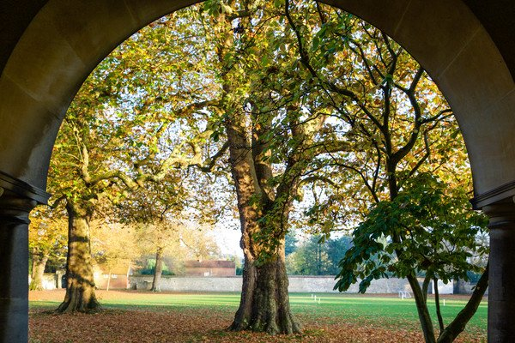



Twitter: [@WinColl](https://twitter.com/WinColl) Winchester College

Instagram: [@winchestercollege](https://www.instagram.com/winchestercollege/?hl=en) College Street

Winchester

SO23 9NA