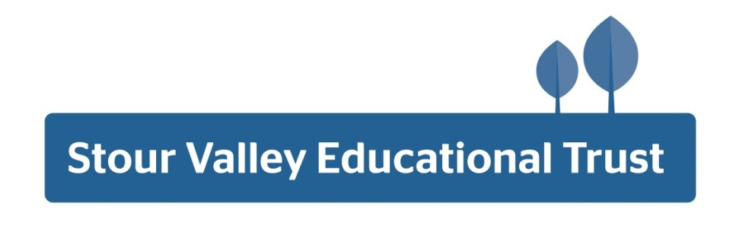
Introduction from the Headteacher
Thank you for your interest in the Assistant Headteacher position at Stour Valley Community School. This is an exciting time for the school. This position has become available following a Deputy Headteacher leaving the school. I have used this opportunity to reshape the structure of our senior team and the successful candidate will be joining in a newly created post.
We are a relatively small 11-16 secondary school in the beautiful town of Clare, in rural West Suffolk, situated between Sudbury and Haverhill. We are a community school, and our ethos is built on a philosophy of knowing our students and developing a real sense of community. We are over-subscribed and have 115 students in each year group. We divide Key Stage Three (Years 7 – 9) into five teaching groups which gives us the flexibility for targeted support and intervention in the early years and we are committed to offering a broad and balanced curriculum throughout KS3 and into KS4 which allows for all students to be able to pursue their interests and explore new areas of knowledge. Music, Drama, Sport, Art, Design and Technology and Languages are all important and valued curriculum areas alongside Maths, Science and English.

Developing the whole child and nurturing students to value differences, be caring and kind, able to navigate a world of social media distraction and complicated political and social divide is as important to us as ensuring that our students gain the best qualifications they can to open the door to their next stage of learning, be that vocational or academic. Our PSHE (Personal, Social and Health Education) curriculum and our RS (Religious Studies) curriculum is compulsory for all and they are regularly revised to respond to national and regional areas of concern where educating the students in our care to make responsible and healthy choices as they make their way through their teenage years is an integral part of our safeguarding strategy.
We take professional pride in providing inspiring teaching, a secure and caring environment, expert advice and guidance, and rich and motivating enrichment opportunities. We work hard to develop the skills, talents and values of every individual so that they can achieve impressive levels of personal success and go on to make a positive contribution to society.
Our staff recognise the importance of networking for developing subject expertise and remaining up-to-date as well as connecting to our local and national community. We are proud partners with CTSN (Cambridge Training School Network), The OAKS Consortium for Initial Teacher Training and Saffron Teaching School Hub.
The challenge to us all at Stour Valley is to always improve. We recognise that we need to reinforce the status of our wonderful profession and promote teacher wellbeing in order to unlock the skills and passion of all our staff. Our commitment to staff continuing professional development is to ensure we are all able to be the best we can be. This in turn leads to improved organisational performance and improved outcomes for students.
Please do not hesitate to call to make further enquiries about the position, or for a tour of the school.

