

**Deputy Headteacher**



Thornleigh Salesian College

Tel: 01204 301351

Fax: 01204 595351

Sharples Park, Bolton, BL1 6PQ

Headteacher

Mrs A Burrowes

*Email:* [contact@thornleigh.bolton.sch.uk](mailto:contact@thornleigh.bolton.sch.uk) www.thornleigh.bolton.sch.uk

March 2019

Dear Applicant

Thank you for your enquiry about the position of Deputy Headteacher at Thornleigh Salesian College. I hope you find the information enclosed in this pack helpful to support your application decision.

This is a very exciting opportunity, at a very exciting time, for our school. We are looking for an outstanding teacher, with a proven track record of successful leadership of school improvement and raising achievement to join our Senior Leadership Team.

Thornleigh Salesian College is a successful 11-18 Catholic school which is under the trusteeship of the Salesians of Don Bosco. The school is popular and oversubscribed. We are highly regarded both within the local community and the Diocese of Salford. We have achieved a positive Progress 8 score for three consecutive years and our attainment is above the national average. Ofsted acknowledged the strengths of the school in 2015 and recognised that we are a good school ‘that is characterised by ambition and where the individual is cherished’.

The current Headteacher, Alison Burrowes, has led the school to its current heights and leaves the school in the strongest possible position. As I take up the role of Headship in September, I will continue to focus on achieving excellence for all members of the school community. We now have the opportunity to re-structure the Senior Leadership Team and so are seeking the appointment of another Deputy Headteacher who will work alongside us to further develop all areas of our wonderful school.

Thornleigh Salesian College is a great place to work. The relationships that exist between colleagues and students are excellent. We are truly committee to the continued professional development of all our staff and we are determined to develop first class teachers who can deliver a world class curriculum.

If you are excited at the prospect of taking up a key leadership role in our school and can demonstrate that you have the skills and experience to really make a difference, we look forward to receiving your application. Please ensure that you have completed the application form in full and submit a supporting statement that responds to the person specification and includes evidence of the impact that you have made in your current school.

We have put an extended timescale on the application deadline to cover the variety of Easter holidays that schools may have. We warmly welcome visits to our school and advise that these should take place before we take our Easter holidays on 5th April 2019.

The closing date is the 23rd April 2019 and interviews will take place on Wednesday 1st and Thursday 2nd May 2019.

We look forward to hearing from you. If you wish to speak to me then please contact Natalie Hamer, the Headteachers PA, at [nhamer@thornleigh.bolton.sch.uk](mailto:nhamer@thornleigh.bolton.sch.uk), to arrange a convenient time.

Yours sincerely



Mrs Andrea O’Callaghan

Headteacher Designate



Engage Enable Empower



The Governors of Thornleigh Salesian College are seeking to appoint an exceptional Deputy Headteacher.

We are keen to hear from leaders with a wide range of skills who will work alongside a highly focused and driven Leadership Team who are passionate about achieving excellence for all our students. We welcome applications from ambitious senior leaders who can demonstrate high levels of impact in their current role.

The successful candidate will be

- Truly committed to the Catholic values and beliefs of Thornleigh Salesian College

-Outstanding classroom practitioners with a passion for innovative teaching and learning

- A strong team member

-Committed to the development of young people’s character

-Able to strategically lead, establish and sustain effective systems, policy and practice

-Emotionally intelligent

**Closing date for applications:**

12noon Tuesday 23rd April 2019.

**Interview dates:**

Wednesday 1st and Thursday 2nd May 2019

**Application packs can be downloaded from the school website**

[**www.thornleigh.bolton.sch.uk**](http://www.thornleigh.bolton.sch.uk)

**or via**

[**recruitment@thornleigh.bolton.sch.uk**](mailto:recruitment@thornleigh.bolton.sch.uk)

This school is committed to safeguarding and promoting the welfare of children and young people and expects all staff and volunteers to share this commitment. The successful applicant will be required to complete an enhanced DBS check.

**Deputy Headteacher**

**Permanent**

**Full time**

**Leadership range L24-L28**

**Start date September 2019**

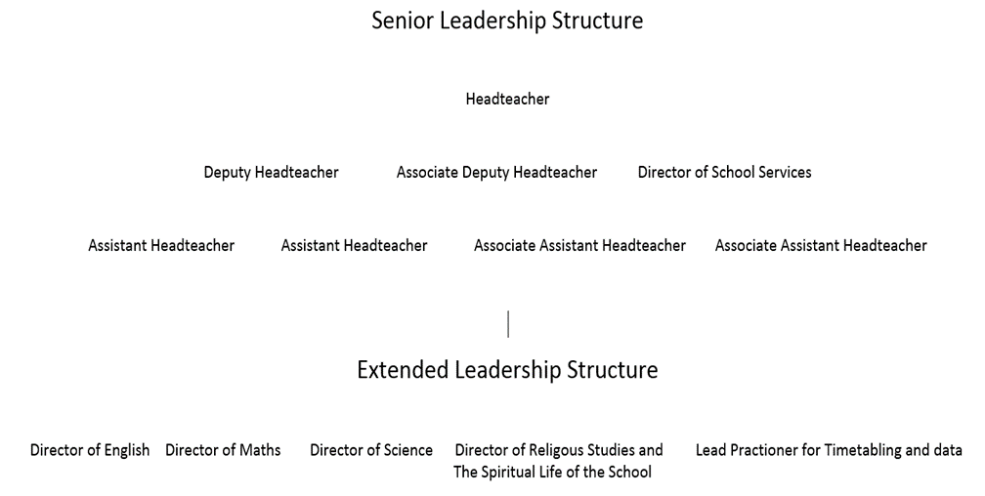



The successful candidate must be able to demonstrate that he/she has the qualifications, experience, knowledge, abilities and personal qualities outlined below. This will be determined initially through the Application and subsequently, for selected candidates, through the interview process. References obtained about candidates will also be used in the assessment of their suitability for the post.

**A Qualifications, Experience and Professional Development**

|  |  |
| --- | --- |
|  | Essential - **E**  Desirable - **D** |
| * Practising Catholic * Catholic Teacher’s Certificate * Degree * Qualified Teacher status * Recent participation in relevant professional development in preparation for Deputy Head/Headship * Experience as a Deputy/Assistant Headteacher * Successfully led, planned, managed and evaluated change, which has had a significant impact at whole-school level * Demonstrated the ability to work strategically and successfully at a senior leadership level * Demonstrated a clear understanding of the distinctive nature of a Catholic school * Worked in more than one school, at least one of which is Catholic | E  D  E  E  E  E  E  E  E  D |

**B Professional Experience, Knowledge and Understanding**

Applicant should be able to demonstrate appropriate experience, knowledge and understanding of

|  |  |
| --- | --- |
|  | Essential - **E**  Desirable - **D** |
| * Can demonstrate the strategic thinking and planning that builds, communicates and carries forward, a coherent and shared vision for an effective Catholic school. * Evidence of being an outstanding classroom practitioner * Evidence of very good examination outcomes for classes taught * Experience of successfully implementing effective strategies for improving the quality of teaching and learning, including promoting excellence and challenging poor performance * Experience of effective monitoring and evaluating the effectiveness of teaching and learning, including its outcomes in terms of standards and achievement and the social, moral, spiritual and cultural development of all students. * Sound understanding of educational thinking, recent developments and key initiatives * Understands the significance of interpersonal relationships and strategies for promoting individual and team development * Has a clear understanding of the impact of change and different leadership styles on individuals and organisations * Demonstrates a personal enthusiasm and commitment to Leadership around making positive differences to young people * Successful experience of the delegation of Leadership responsibilities and management tasks, as appropriate, and monitoring, evaluating and reviewing their implementation * Understand how to establish and sustain effective systems, policy and practice * Knowledge of, and commitment to, the implementation of the Safeguarding agenda * Ability to develop, implement and evaluate strategic plans and priorities | E  E  E  E  E  E  E  E  E  E  E  E  E |

continued . . .

|  |  |
| --- | --- |
|  | Essential - **E**  Desirable - **D** |
| * Demonstrates a clear understanding of the principles and practice of quality assurance systems, including school review, self-evaluation and performance management, and have evidence of effective involvement in all aspects of school improvement * Shows a practical understanding of how to analyse and use the full range of evidence, including performance data and external evaluations, to support, monitor, evaluate and improve aspects of the school, including challenging poor performance. * Can contribute information to ensure that the Headteacher and Governors are well-informed about school policies and progress measures * Experience of holding individuals, teams and whole-school to account for student learning outcomes * Experience of building and sustaining effective relationships with parents/carers to support their children’s learning * Experience of building and sustaining effective relationships with parents, carers, other schools and partners and the wider community that enhance the education of students | E  E  E  E  E  E |

**C Personal Skills and Attributes**

Applicant should have the ability to

|  |  |
| --- | --- |
|  | Essential - **E**  Desirable - **D** |
| * Embed successful change across the school by effectively completing tasks and evaluating outcomes within agreed timescales * Improve, challenge, motivate and empower teams and individuals to achieve high goals * Prioritise, plan and organise themselves and others * Think analytically and creatively and demonstrate initiative in solving problems * To be approachable and have a genuine desire to enable everyone to be the best that they can be * To be a strong, visible presence in all areas of the school * Be aware of their own strengths and areas for development, and listen to, and reflect constructively, and act upon as appropriate, feedback from others * Demonstrate a capacity for sustained hard work with energy and vigour * Demonstrates resilience and optimism * Demonstrates impact and presence * Have a sense of perspective and enjoy a laugh! | E  E  E  E  E  E  E  E  E  E  E |



Every member of staff at Thornleigh is expected to endeavour to maintain and develop the Catholic and Salesian character of the school, and to support and promote the aims and mission of the school in and through the exercise of all contractual duties and any voluntary activities.

This is a broad job description. Specific areas of responsibility and leadership will be agreed on appointment.

|  |  |
| --- | --- |
| **Post Title** | **DEPUTY HEADTEACHER** |
|  |  |
| **Post Holder** | **L24-L28** |
|  |  |
| **Reporting to** | **School Governing Body and Headteacher** |
|  |  |
| **Overall** | **To support and assist the Headteacher**   * In providing dynamic and professional leadership for the school ensuring high quality education for all students |
| **Purpose** | **To support and assist the Headteacher**   * To ensure that the vision and strategic direction of education focus on an holistic approach to learning, which is broader than examination results and targets and recognises the school’s role in developing responsible citizens and an effective workforce * In consultation with staff and governors to create and maintain the ethos, vision and aims of the school * Work with the Headteacher and Governing Board to create a shared vision which expresses core educational values and is inclusive of all stakeholders * Work with the Headteacher to establish effective relationships and communication in order to build a positive learning atmosphere throughout the school * To ensure that the school benefits from a rigorous self-evaluation framework, which substantially contributes to raising standards * To have high expectations and lead by example * To maintain a secure, caring, welcoming, happy, stimulating and challenging learning environment * Contribute to the formulation of school policies, ethos and procedures, ensuring their consistent implementation throughout the school. * To keep under review, the work and organisation of the school, and monitor and evaluate the effectiveness of the curriculum in light of pupil needs, national and local priorities * Contribute towards the school improvement process and documentation and the school’s self-evaluation process and documentation. * To make a positive contribution to the spiritual development of students through collective worship and assemblies. * To ensure implementation of key statutory policies, including equal opportunities, anti-racism and additional educational needs to promote an understanding of multi-culturism * To ensure that guidance and support is provided to all students * To ensure that the current educational initiatives are incorporated effectively within the whole-school drive for improvement * To ensure attendance at, and participation in, meetings relative to the curricular, administrative, organisational, pastoral and managerial arrangements for the school * To plan, manage and monitor the use of finances and resources effectively to achieve the aims of the school * To lead the educational development of the school and ensure that each student’s educational programme meets their individual needs * To monitor and evaluate the standards of teaching and learning and pupil progress across the school * To work with the Headteacher and middle leaders to support staff in the development of their teaching skills, based on areas of development identified in observations * To provide for the emotional, social and personal development of pupils to compliment academic development * To ensure a culture and ethos of challenge and support where all students can achieve success and become engaged in their own learning * To implement strategies, which ensure high standards of behaviour and attendance * To manage and motivate all staff to ensure the educational programme is delivered effectively * To provide opportunities for continuing professional development for all staff * To lead and support the leadership team, individually and collectively * To ensure the operation of an effective performance management system for all staff * To manage the performance of the deputy/assistant headteachers and middle leaders * To work closely with the Governing Body to ensure the school operates effectively and efficiently, leading to high standards across the school * To develop positive relationships with parents, the local authority and the local community * To work effectively with other professionals to ensure the best possible skills and resources are available for all students in order to maximise their potential * To create a welcoming, safe and stimulating environment, in which students, staff and visitors feel comfortable and which is conducive to learning * To engage actively in Performance Management and Continuing Professional Development, to ensure professional skills are kept up-to-date and developed |

Whilst every effort has been made to explain the main duties and responsibilities of the post, each individual task may not be identified.

This job description details duties and responsibilities but does not indicate the amount of time to be spent carrying them out. No part of it may be so construed. In allocating time to the performance of duties and responsibilities, the post holder must use directed time in accordance with the school’s policy as published in the Staff Handbook and having regard to the School Teachers’ Pay and Conditions Document.

This job description is current at the date shown, but in consultation with the post holder, may be changed by the Headteacher to reflect or anticipate changes in the job commensurate with the grade and job title.

|  |  |
| --- | --- |
| **Date Job Description prepared/updated** | March 2019 |
| **Job Description prepared by** | A O’Callaghan |