
Hodgson Academy

Imagine...Believe...Achieve






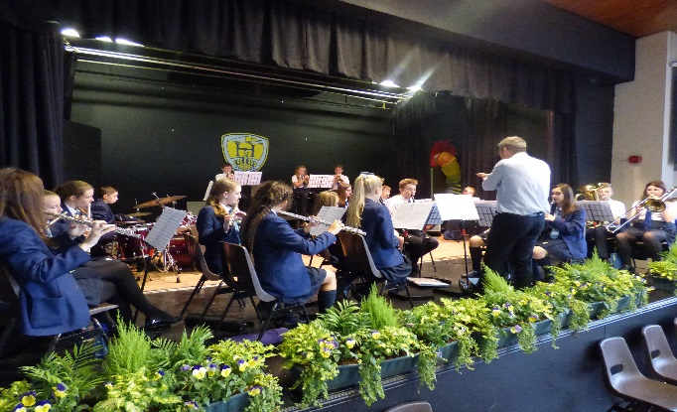

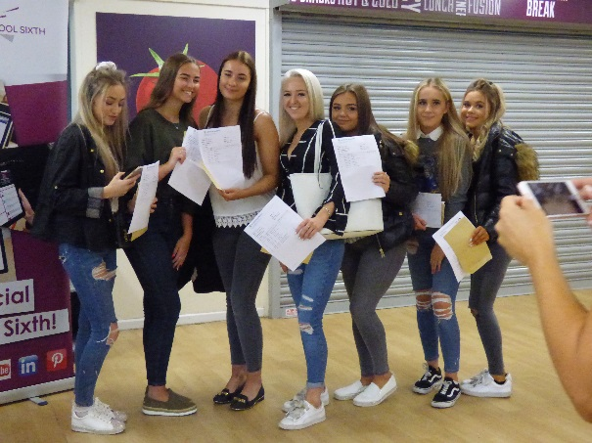

Appointment of School Librarian
Fixed Term – until 27.8.2024 in the first instance
ASAP
January 2024

Moorland Road, Poulton-le-Fylde, FY6 7EU

We are seeking to appoint an exceptional School Librarian to join our successful staff team due to the promotion of our current postholder
School Librarian
Full Time or Part-Time (negotiable)

Hodgson Academy is seeking to appoint an experienced, hardworking Librarian to start as soon as possible who can work on their own initiative to manage and develop a well-resourced library.

We are looking for someone who has a love of reading and the ability to impart this to others as well as a confident, organised, professional and approachable communicator that is determined to do their best to help all our students achieve their potential.

If you feel that you can do this then we would love to hear from you.
Further details and an application pack are available on the academy website:
https://www.hodgson.lancs.sch.uk/about-us/staff-vacancies/
In addition to the academy application form, candidates are invited to submit a letter outlining their experience and suitability for this particular post (1500 words maximum).
Applications can be emailed to Julia Hardy - j.hardy@hodgson.lancs.sch.uk
Closing date for applications: 29th January (9.00am)
We are planning to conduct interviews the same week

The school is strongly committed to safeguarding and promoting the welfare of children and young people and expects all staff and volunteers to share this commitment. You shall be required to undertake an enhanced DBS disclosure and a range of other recruitment checks.

4 Letter from the Headteacher
Contents

5 Job Description

6 Person Specification



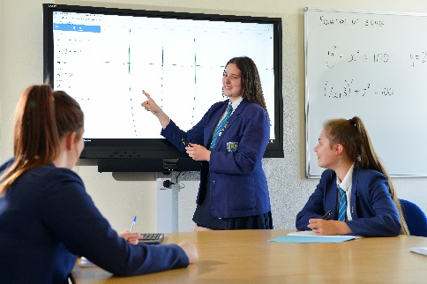

Letter from the Headteacher
Dear Colleague,

I would like to thank you for taking an interest in this post and offer you a very warm welcome to Hodgson Academy. I joined Hodgson in 2010, initially as Head of Mathematics before becoming a member of the Senior Leadership Team in 2012. I was appointed as Headteacher from September 2019 and I am excited about the opportunities and challenges that lie ahead for the academy as we continue to endeavour to give our students the very best education available. In my time, we have enjoyed many successes: attainment is high, behaviour is good and leadership is strong. We also continue to face challenges – aspects of student progress require close attention and we must continue to strive to improve boys’ achievement as well as that of our disadvantaged students.

Against that background, Hodgson continues to have a very outward-facing philosophy that I aim to continue and enhance under my leadership. We were a cohort one National Teaching School (in partnership with Blackpool Sixth Form College) and acted as the sponsor of the Fylde Coast Academy Trust, an arrangement that has recently been discontinued as the trust has reached maturity and a level of success that means that a sponsor is no longer required but we retain a close working relationship. We also operate SCITT provision which enables us to recruit and train the best available teachers to a high standard here on the Fylde Coast.

This is an exciting time for Hodgson Academy and the appointment of new staff in key positions such as this one is very important to us. Reading at Hodgson takes a prominent place at our school as we believe that reading is the key to unlocking the curriculum. Not only is reading and wider reading expected in every subject, but our students read in their form groups four times a week and the books they read reflect the context of our school and our students’ needs.

Our expectations, of all our stakeholders, are high as I am determined to give our students the very best education possible and require the very best staff available in our team to help me to deliver this vision. If you feel excited about this challenge and able to deliver in this role then I would very much like to read an application from you.

Yours faithfully,

Iain Siddall
Headteacher
Person Specification
Job Description

POST: School Librarian
RESPONSIBLE TO: Headteacher
Leadership postholder as required

SALARY: NCJ Grade 6 (Term time only + 5 days)

The academy is strongly committed to safeguarding and promoting the welfare of children and young people and expects all staff and volunteers to share this commitment.
You shall be required to undertake an enhanced DBS disclosure and a range of other recruitment checks.
Please note we are also a non-smoking site.

- Maintain the good order and develop the service of the library
  - Ensure that the library represents a calm and quiet working environment at all times
  - Work with teachers to induct students into the workings and standards of behaviour expected in the library
  - Work with the Head of English and Heads of Departments to develop an appropriate range of books and periodicals, and to make a fair and effective use of the allocated budget
  - Issue books to students, maintaining accurate records of loans and pursuing overdue books using an appropriate system
  - Catalogue all books properly according to the agreed systems and order them properly on the shelves
  - Promote the use of the library by students for subject reading, wider academic reading, general reading of fiction and reading for well-being
  - Organise the books and resources for Reg and Read (our whole school reading strategy)
- Support and develop students in their ability to study independently and effectively
  - Support students in accessing resources for their studies
  - Support class sessions in the library as required
- Support the Head of PSHE and students in facilitating high quality progression research
  - Work with the Head of PSHE to maintain the careers and higher education
  - Support students in their careers research and in making their applications
- Maintain and develop Hodgson Academy’s community and parental engagement
  - Work with teachers to promote and celebrate successes at Hodgson Academy with the wider community through its online presence
  - Ensure that the social media accounts are updated with key messages daily
  - Promote the use of the library and reading at Hodgson Academy
- Complete a range of clerical and administrative duties in support of the school generally

The above represents a broad outline of the specific duties and responsibilities currently attached to the role of Librarian. Depending on the needs of the academy, these may be altered from time to time in consultation with the Headteacher.

Job Description prepared by: Iain Siddall Date: June 2023

Person Specification: School Librarian

Qualifications, Knowledge and Experience | Essential | Desirable
Education to at least Level 3 (A Level, BTEC, Apprenticeship etc) | *
Qualified librarian or significant library experience and familiarity with library management systems |  | *
Chartered librarian or equivalent |  | *
Experience of working closely with or supervising the activities of students in a secondary school |  | *
Knowledge of the school curriculum |  | *
Knowledge of or experience in administration. | *
Knowledge of copyright, data protection, safeguarding and representing diversity as considerations in access to resources |  | *
Awareness of e-learning resources |  | *
Working knowledge of word processing and spreadsheet packages. | *
Proactive and imaginative in approach to promoting library and progression resources | *
Abilities and Aptitudes
Self-motivated and able to work independently and as part of a team. | *
Excellent interpersonal skills with both students and colleagues and ability to work cooperatively as part of a team. | *
Aptitude to provide coaching to students in their research work or in organising their private study time | *
In communication, ability to assess any given situation and to respond in the appropriate manner. | *
Ability to organise and prioritise work, and to adhere to deadlines and targets. | *
An understanding of the requirements in shaping the public image of an organisation, when working as a 'first point of contact' member of staff. | *
Ability to complete accurate financial and arithmetic calculations. | *
Ability to handle information securely and confidentially, and to file and retrieve information efficiently | *

